Fluid dynamics
University of Bath 26-27, MA32051/MA52129
Fluid dynamics
University of Bath 26-27, MA32051/MA52129
Dept. of Math. Sci., University of Bath
October 22, 2026
: Course website
PrefaceOfficial descriptionOfficial descriptionfrontmatter-3
FigureRayleigh’s 1883 experiment on turbulence, as duplicated in World of Flosws (Darrigol, 2005).fig-rayleigh
0.10.80.1 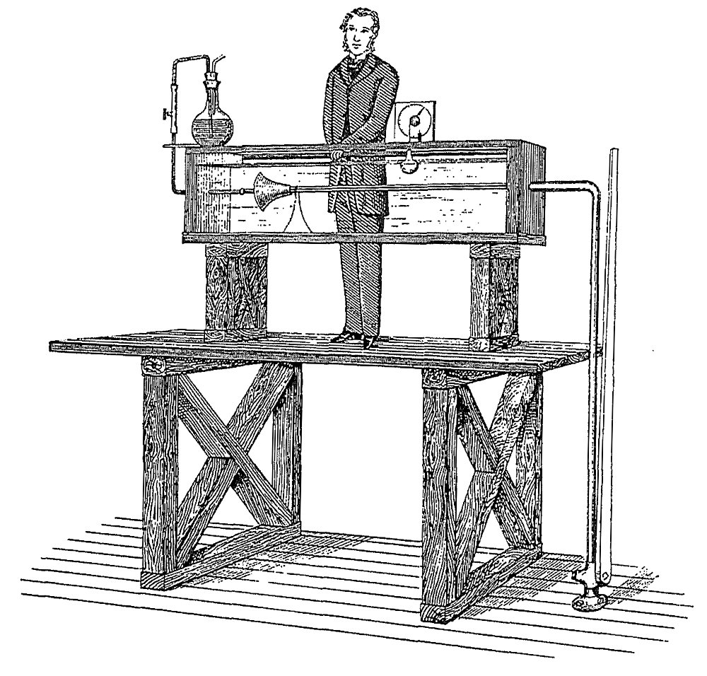
The description of this unit in the official catalogue is the following:
Aimsfrontmatter-3-3-2-1 In this unit you will explore the mathematical theory of fluid dynamics, with a view towards applications to physical phenomena such as flight, vortex motion and water waves. You will study the mathematics of conservation laws and the derivation of governing fluid dynamical equations. This unit will provide you with a foundation for further study of more advanced theory of fluid dynamics and continuum mechanics, and its application in scientific areas including engineering, physics and biology.
Outcomesfrontmatter-3-3-2-2 (i) Demonstrate an understanding of the principles of mathematical fluid dynamics; (ii) discuss and apply techniques from vector calculus and complex variable theory to analyse and solve fluid flow problems; (iii) give a qualitative and quantitative account of a range of phenomena in fluid dynamics.
Contentfrontmatter-3-3-2-3 Complex analysis primer: Cauchy-Riemann equations; harmonic functions; complex maps; residue integration. The mathematics of fluid phenomena and its applications: derivation and interpretation of governing equations; reduction of governing equations to equations of simpler formulation; potential flow; vortical flow. Two-dimensional incompressible and irrotational flow: velocity potential; stream function; complex potential. Conformal mapping. Vortex motion: vortex lines and tubes; Kelvin circulation theorem; Helmholtz’ principal. Water waves: free surfaces; harmonic waves; finite depth; instability; group velocity. Computational fluid dynamics.
PrefaceHistory of the unitHistory of the unithistory Previously at Bath in the Mathematical Sciences, there were two units meant to teach continuum and fluid mechanics (or dynamics) to students. Prior to 2025, there was the MA30253 Continuum Mechanics module. This was then continued into the MA40255 Viscous fluid dynamics module.
As part of the curriculum transformation (with the first change to Year 3 in 2025), we are attempting to unify these two treatments, providing a more streamlined teaching of elementary fluid dynamics, which is oriented towards a broad range of styles of emphasis, from applied mathematics, to physics and engineering. The hope is that this new course on Fluid Dynamics provides you with a strong foundation in different basic fluid flows and their mathematical formulation and study.
PrefaceRelated units at BathRelated units at Bathfrontmatter-5 We will only mention units from Year 2 onwards in this. Apart from the key pre-requisites of MA22016 (Differential equations and vector calculus) and/or MA20223 (the older Vector calculus and partial differential equations), we make an effort to keep the material in the module self-contained. You are recommended to have taken MA22021 (partial differential equations).
- MA22016: Differential equations and vector calculus.
- This unit forms a standard second-year module on differential equations and vector calculus, and is a key pre-requisite for this module. In addition to teaching and reviewing basic techniques for solving ordinary differential equations, you will learn about some of the core methods in vector calculus (directional derivatives; gradients; potentials; line integrals; divergence; curl; surface and volume integrals; curvilinear coordinates; integral theorems).
- Note prior to curriculum transformation, this would have been part of the MA20223 unit (with additional material from the below MA22021).
- MA22021: Partial differential equations.
- This module teaches basic techniques and theory for the core PDEs (Laplace, heat, wave equations). Generally, we will make with your broad familiarity of PDE different equation types and terminology (e.g. boundary conditions). This unit will be useful, as it will teach you some basic familiarity with partial differential equations. However, the current fluid dynamics module assumes you may not have taken it, and attempts to fill in any necessary gaps.
- MA32045: Complex analysis.
- This module covers some of the theory and applications behind complex-valued functions. You will have encountered complex functions, e.g. $f(z)=z^{2},e^{z},logz,…$ in an ad-hoc way, perhaps in earlier courses on Analysis. Again, we will attempt to cover all the necessary pre-requisites, and also provide you with helpful references.
PrefaceMoodle and other referencesMoodle and other referencesfrontmatter-6 Besides this document, the main resource for this unit is the Moodle page. Links to the video recordings, course notes, and other resources are collected there.
There are countless fluid mechanics or fluid dynamics courses and textbooks, and for the most part, the development of a first course on fluid dynamics tends to be quite similar between universities and treatments. If you would like additional references, here are a few useful ones.
However, note that our goal is to be as self-sufficient as possible via the lecture notes.
- David Acheson’s (1990) book Elementary fluid dynamics []: a significant part of this course follows some of the now-classic treatments that would have been developed simultaneous to the design of this book by Acheson (often used by Oxford UG students). It is written in quite an informal style.
- 0.350.30.35 
- Multimedia Fluid Mechanics Online, edited by G. M. Homsy []: a collection of videos and explanations of various fluid mechanics phenomena. This is an online resource available through the University of Bath library system.
- 0.350.30.35 
- Milton Van Dyke’s (1982) book "An album of fluid motion" []: a classic album showing beautiful black and white images of fluid motion. Published by an iconic private press and sold (by design by Van Dyke) at affordable prices!
- 0.350.30.35 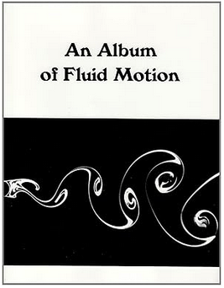
- Kreyszig, E. (2007) book "Advanced engineering mathematics" [] covers all the necessary essentials in terms of Vector Calculus and Complex Variables. This is one of my favourite reference texts for mathematical methods just on account of how straightfoward it is. Despite the "engineering" in the title, the style of presentation here fits in well with the style of UK applied mathematics.
- 0.350.30.35 
PrefaceDownloadsDownloadsdownloads This set of notes is written to be read online, but two downloadable versions are also available for accessibility purposes:
- PDF version, typeset for printing.
- Word (.docx) version, generated automatically and provided as a convenience — equations and figures may need manual tidying.
Both are regenerated whenever the online version is updated, so they may occasionally lag behind this page. Note that the lecturers will be keeping a close eye on the online notes, and it is not always possible to check the PDF as the course proceeds. If there are severe issues it is helpful to send an email to the lecturers. The Word version is mainly provided for accessibility reasons and typically requires additional help by Accessibility assistance at the University of Bath.
ChapterIntroductionIntroductionch-chapter01-introduction
Now I think hydrodynamics is to be the root of all physical science, and is at present second to none in the beauty of its mathematics.

As evidenced by the quotation above, during the great Victorian era, Lord Kelvin had predicted that the field of hydrodynamics (predominantly, the study of liquids) would reign over all the physical sciences. Today that is not quite true, in the sense that hydrodynamics is only one of many sub-branches of the wider study of fluid motion. However, Kelvin’s prediction is certainly true in spirit: there are very few branches in the physical sciences, from biology and chemistry, to engineering and physics, where the study of fluid mechanics does not possess strong historical and scientific connections. The principles, language, and techniques of fluid mechanics begin from the fundamental laws of conservation; in their form, one can argue that all of nature can be derived from them---this grandiose point is, to some extent, what Kelvin had meant when he referred to being the "root of all physical science".
Moreover, countless areas of mathematics, from the 19th century and onwards, have been developed as a direct consequence of the need to investigate the beautiful nature of fluid motion. These include everything from the theory of ordinary and partial differential equations, calculus, complex analysis, mathematical methods and approximation theory, geometry and topology, analysis, numerical methods and numerical analysis, industrial and applied mathematics, and so forth and so on.
RemarkFluid mechanics vs. fluid dynamics.ch-chapter01-introduction-2-4 Why is this course called fluid dynamics and yet fluid mechanics? What is the difference?
In general, fluid mechanics includes both "statics" (fluids at rest) and "dynamics" (things in motion). This is a distinction that, in the authors’ opinions, mathematicians rarely use (we probably refer to "fluid mechanics" more commonly so as to avoid being specific); these distinctions are perhaps more important in engineering. For example, the study of the shape of a soap film or bubble between a wire hoop is a question of statics; but the behaviour of the soap or bubble if it moves or pops is a question of dynamics!
A tree diagram of different subfields and their applications might be made as follows.
Fluid Mechanics ├── Fluid Statics │ ├── Hydrostatics → Pressure in tanks and dams │ ├── Buoyancy → Ship and submarine design │ └── Manometry → Pressure measurement in pipelines │ └── Fluid Dynamics ├── Inviscid Flow │ ├── Potential Flow → Aerodynamics of airfoils │ └── Compressible Flow (ideal gases) → Supersonic jet nozzles │ ├── Viscous Flow │ ├── Internal Flows (pipe/duct flow) → Water distribution networks │ ├── External Flows (boundary layers) → Drag on cars and airplanes │ └── Lubrication Theory → Bearings in machines │ ├── Turbulence │ ├── Atmospheric Turbulence → Weather prediction │ └── Industrial Turbulence → Mixing in chemical reactors │ └── Multiphase Flow ├── Gas–Liquid Flow → Oil & gas pipelines ├── Liquid–Solid Flow → Slurry transport in mining └── Gas–Solid Flow → Fluidized bed reactors
It is not uncommon for some scientists and mathematicians to devote their entire careers to an entire subbranch of fluid mechanics. Some university departments will focus solely on certain subbranches as well! Hence fluid mechanics is, for many, a lifelong pursuit!
What is the course about?
Our first task, starting in Chapter [ch-chapter02-kinematics] and Chapter [ch-chapter03-equations], is to derive the so-called Euler equation, given by
$$ρ\left(\frac{∂u}{∂t}+(u⋅∇)u\right)=−∇p+ρg.$$
Euler’s equation relates the velocity of a fluid, $u$, with its density $ρ$, pressure $p$, and associated forces, $g$. It is an expression of the conservation of momentum of fluid, and is completed with an accompanying equation for conservation of mass. Together, the two equations are solved with the specification of additional boundary conditions to describe many liquids, from the water in your bathtub, to the water in the ocean as a ship travels across the surface.
Slowly, we will begin to appreciate the use of conservation laws, and the mathematics necessary, to derive the above equations (compressing some hundred years of scientific work into only a handful of lectures!). We will also appreciate that, despite their compact form, the above equations are certainly not easy to solve!
FigureFlow around an airfoil is an example of potential flow theory. From Van Dyke (1982) "An Album of Fluid Motion" [].ch-chapter01-introduction-2-8
010 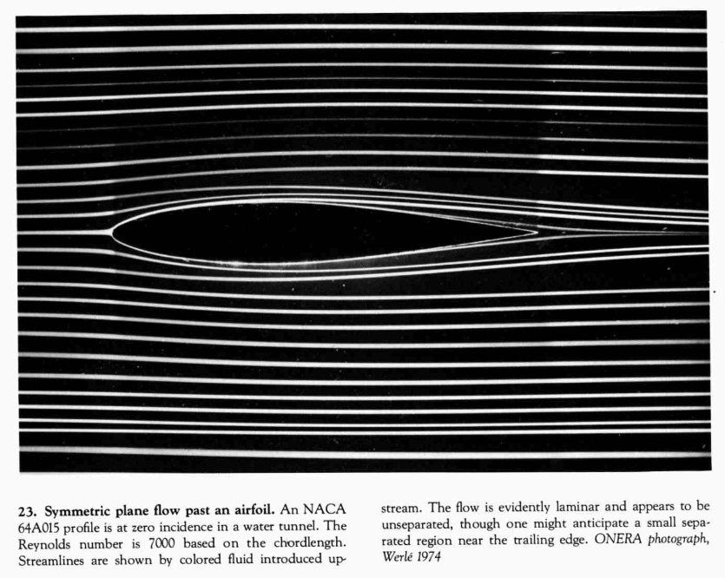
Our next task, starting in Chapter [ch-chapter04-potentialflows] is to study a particular simplification of the Euler equation that yields the flow of an ideal or potential fluid. Under such constraints, instead of solving the above difficult equations, we solve a much simpler equation:
$$∇^{2}ϕ=0,$$
for a so-called velocity potential, $ϕ$, related to the velocity by $u=∇ϕ$. Potential flow theory would have occupied some of the greatest minds of our time, from Euler, Lagrange, Bernoulli, d’Alembert, and Laplace of the 18th century; to the great Victorian scientists of the 19th century: Kelvin, Green, Stokes, Helmholtz; then towards the modern 20th century workers such as Prandtl, Lighthill, Milne-Thomson, and so forth. It is the simplest framework for studying the motion of a liquid, such as water, but enjoys incredibly deep connections with the beautiful theory of complex variables. We will study some of these connections, leading to learning about things such as conformal mapping theory.
FigureIn 1887, Kelvin famously predicted that the waves trailing a ship produce a wedge of approximately $2×{19.5}^{∘}$. This theory belongs to the analysis of linear water waves (though it is unlikely we will have time to reproduce Kelvin’s approximation!) From Van Dyke (1982) "An Album of Fluid Motion" [].ch-chapter01-introduction-2-10
0.150.70.15 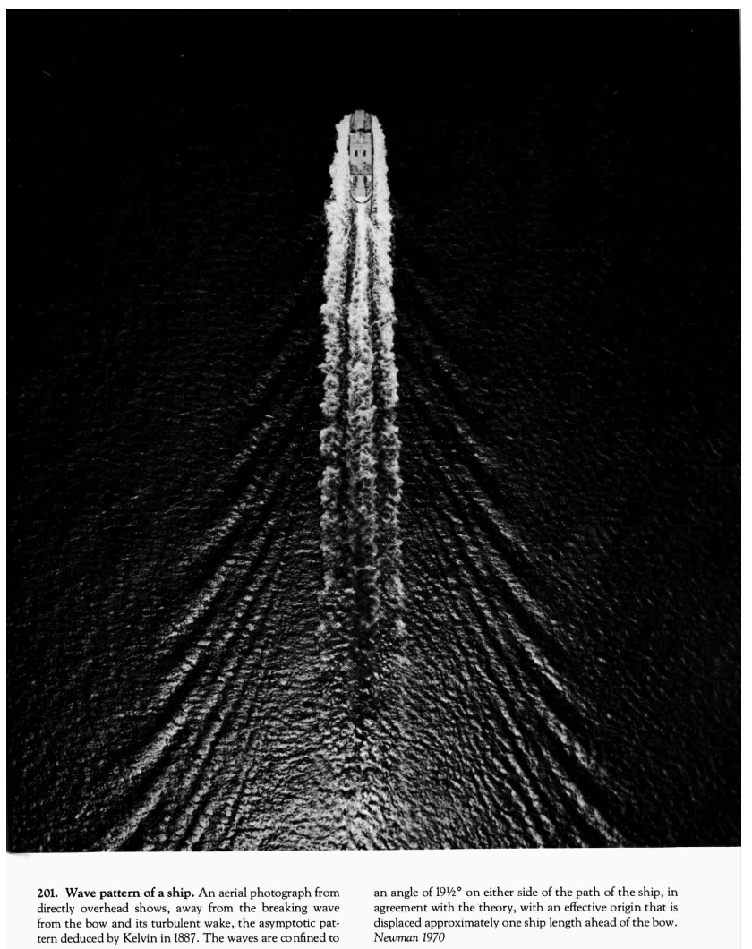
Water waves are probably the application that was at the forefront of Lord Kelvin’s thoughts when he discussed the state of hydrodynamics in the quotation that begins in Chapter [ch-chapter05-waves]. The study of the surface motion of water introduces a seemingly minor complexity that is responsible for great heartache: the fluid is now bounded by an unknown free surface, which much now be solved as part of the problem! The theory of water waves was at the heart of many minds in the 19th century, given its importance in all applications naval and oceanic. The study of water waves begins with so-called linear wave theory, and moves towards numerical solutions of the full Euler equations.
FigureWater ejected from a nozzle forms a vortex sheet that rolls up into two vortex rings. From Van Dyke (1982) "An Album of Fluid Motion" [].ch-chapter01-introduction-2-12
0.150.70.15 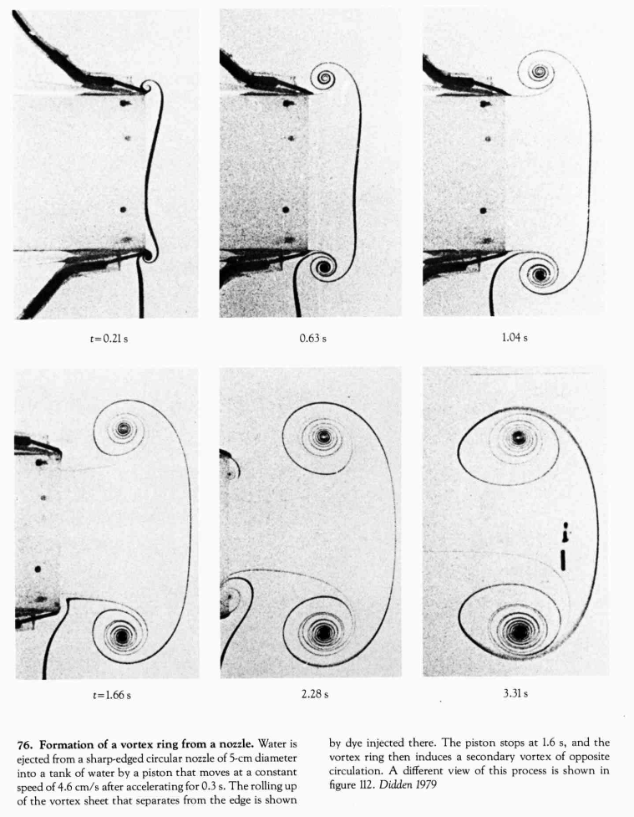
In the above applications, our attention will be focused on so-called irrotational flows: flows that either do not contain or do not introduce new rotational characteristics. Of course, real-life fluids are rarely so well-behaved and indeed, the study of vortices is an important domain in its own right, leading to models for tornados, flight, and many other fluid phenomena. The principal character here is the vorticity, $ω=∇×u$, which measures the local rotation of the fluid. We introduce it in Definition [def-vorticity], but a full study of vortex dynamics lies beyond the scope of this course.
FigureAs illustrated in Figure [fig-rayleigh], in 1883 Rayleigh performed a famous experiment of stability of flow in a tube, showing the emergence of an instability as the speed of the flow is increased. This leads to turbulence, which is predicted, in principle, from the Navier-Stokes equations of viscous flows. From Van Dyke (1982) "An Album of Fluid Motion" [].ch-chapter01-introduction-2-14
0.150.70.15 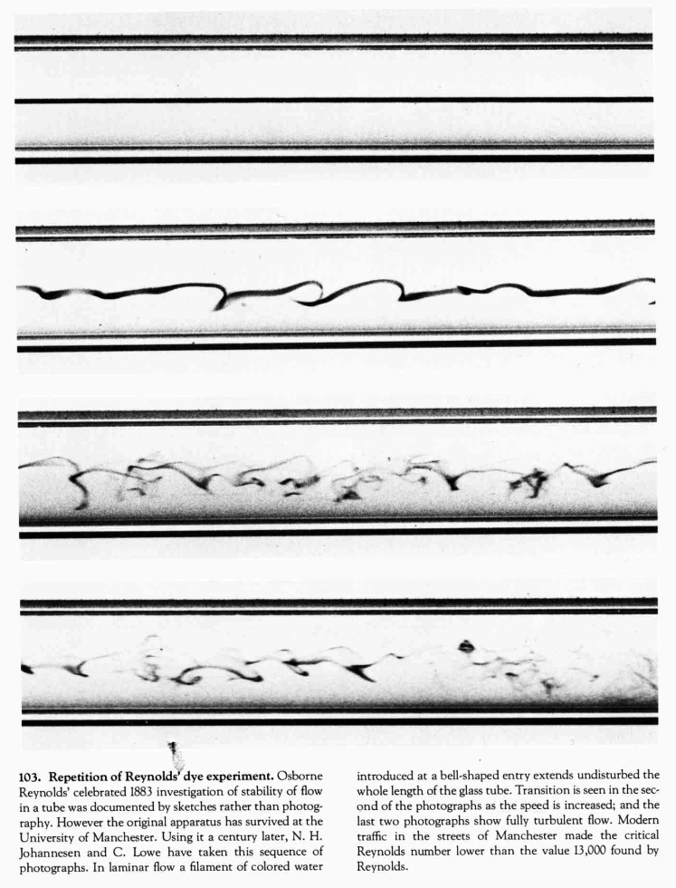
Finally, the last part of this course will open up to the important discipline of viscous flows in Chapter [ch-viscousflows]. For this, the Euler equations are no longer sufficient, and we must include a dissipative component,
$$ρ\left(\frac{∂u}{∂t}+(u⋅∇)u\right)=−∇p+ρg+μ∇^{2}u,$$
with $μ$ being the viscosity of the fluid. The above equation, together with an equation for conservation of mass, forms the so-called Navier-Stokes equations. All fluids are viscous to some extent, though some more so than others. You will learn about the connections between viscous flow theory and inviscid theory, and some of the simple viscous flows that are foundational in this subbranch.
SectionA reminder of vector calculusA reminder of vector calculussec-preliminary-vector-calculus
FigureGeorge Green’s monumental work on electricity and magnetism, making use of many new concepts in vector calculus, 1828.fig-intro-green
0.250.50.25 
During the first week, we will provide a very brief review of some of the necessities that you may require in terms of vector calculus. Many of you will have taken the MA20223 Vector Calculus and Partial Differential Equations module, and a version of the 2026-27 lecture notes has been updated for easy reference on Moodle.
We will assume that you are familiar enough with how to interpret many of the vector calculus identities found in Sec. 10 of the University of Bath book of tables, which can be accessed on Moodle or via this link.
In general, over the next few weeks, you will want to be familiar with recalling/looking up concepts like:
- The use of identities like $∇⋅(∇×A)=0$ and $∇×(∇ϕ)=0$. Some of these are found on p.24 of the above tables.
- The notion of line integrals, surface integrals, and volume integrals.
- The divergence theorem and Stokes’ theorem. (p.24)
- Conversion of vector operations and integrals into different coordinate systems (p.25)
SectionA reminder of complex variablesA reminder of complex variablessec-preliminary-complex-variables
In Chapter [ch-chapter04-potentialflows], we will leverage the power of complex variables to study certain problems in fluids (flow of a potential flow). This section is not necessary to read at this stage, but you might find it useful to refresh your knowledge of basic identities for complex-valued quantities.
FigureAn image from Tristan Needham’s "Visual Complex Analysis" [] showing how complex mappings transform shapes from one region to another.fig-intro-needham
0.10.80.1 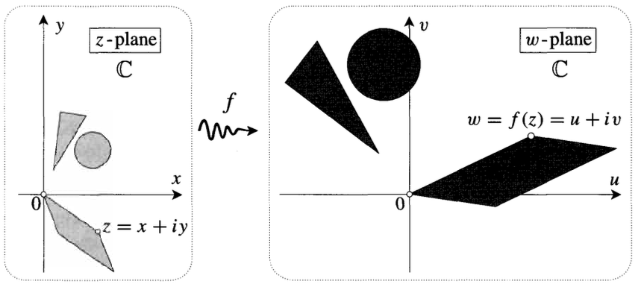
SubsectionBasic complex representationsBasic complex representationssec-preliminary-complex-variables-3 Generally, we write the Cartesian and polar form of a complex number as,
$$z=x+iy=re^{iθ},$$
for magnitude $r>0$ and angle $θ$. Below, we will consistently refer to $z∈C$. The decomposition of the complex exponential is given by Euler’s identity:
$$e^{iθ}=cosθ+isinθ.$$
The usual trigonometric functions can be extended to the complex plane by considering their definition in terms of complex exponentials and Euler’s identity. For example, we have
$$cosz=\frac{e^{iz}+e^{−iz}}{2} \text{and} sinz=\frac{e^{iz}−e^{−iz}}{2i}.$$
Another important function we shall consider is the complex logarithm, defined as
$$logz≡logr+iθ,$$
where $z=re^{iθ}$. That this definition is sensible is verified by checking that the logarithm is the inverse of the exponential. That is,
$$e^{logz}=e^{logr+iθ}=e^{logr}e^{iθ}=z.$$
Note that the definition ([eqn-intro-complex-log]) is troubling because it is not single-valued. For example, writing $z=1e^{i⋅0}$ and $z=1e^{i⋅2π}$ gives two different possible values of $logz$ for the same value of $z=1$. In order to restrict the logarithm to a well-defined single-valued function, we typically establish what is called a branch cut -- this restricts the evaluation of the function from encircling the origin more than once.
For example, it is common to define the complex logarithm with the branch cut either along the negative real axis or the positive real axis.
SubsectionComplex functionsComplex functionssec-preliminary-complex-variables-4 A complex function maps points on the complex plane to points on the complex plane. For instance, the square function,
$$f(z)=z^{2}=r^{2}e^{2iθ},$$
can be better understood by its effect on points on the unit circle, $|z|=1$.
Consider a particle that orbits around the unit circle in the $z−$plane at unit speed. If the particle rotates by half a revolution, with $θ=π$, then in the image plane, the image particle has rotated by a full revolution, with $f(z)=(e^{iπ})^{2}$ in this same unit time. This is illustrated by the image in Figure [fig-intro-z2map].
FigureA revolution of $π$ in the pre-image produces a full rotation in the image plane.fig-intro-z2map
010 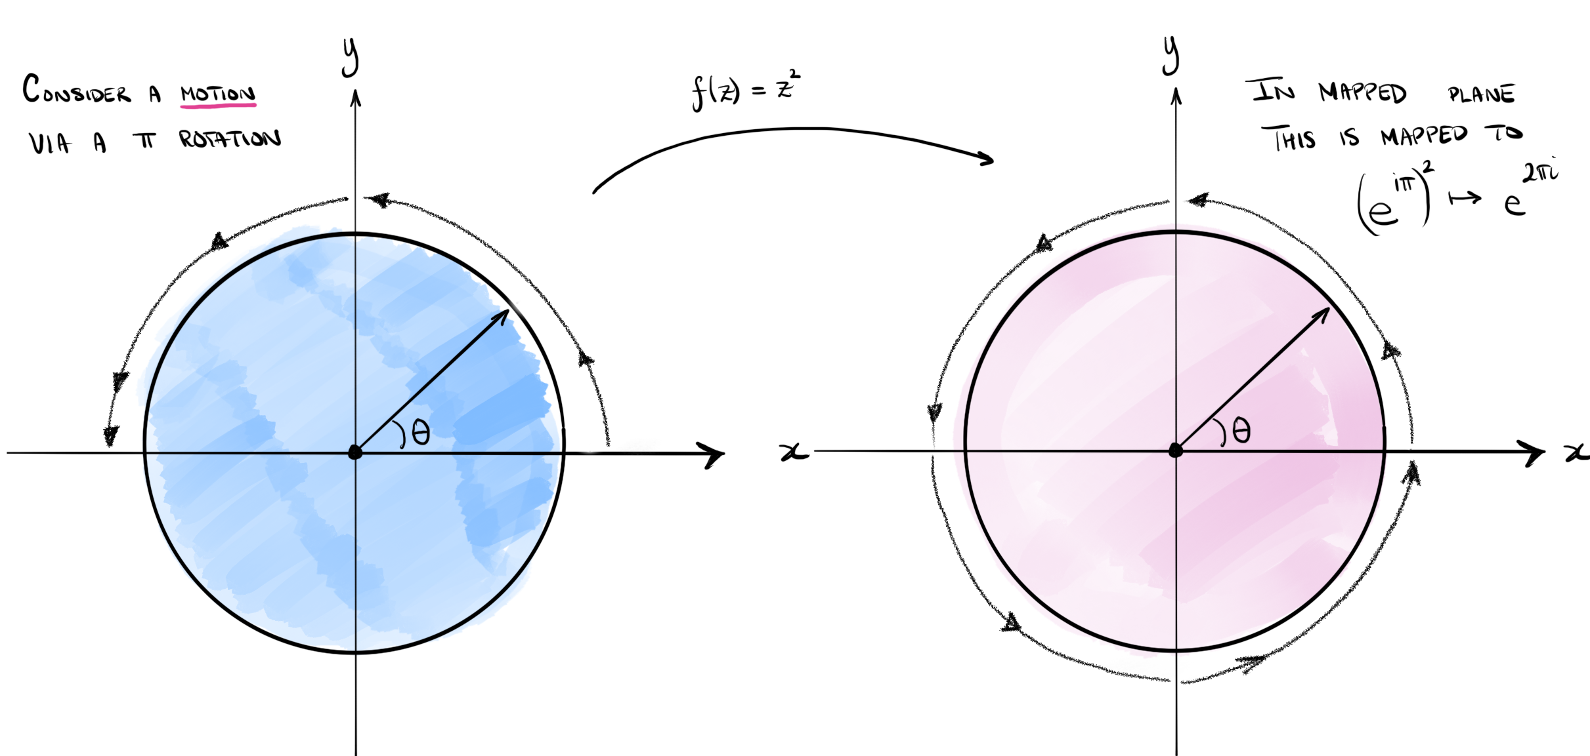
Now we continue rotating around the unit circle in the $z−$plane, performing an additional $π$ rotation. Within the image plane, the particle has now completed another full rotation around the unit circle. This is shown in Figure [fig-intro-z2map_02].
FigureA revolution of $π$ in the pre-image produces a full rotation in the image plane.fig-intro-z2map_02
010 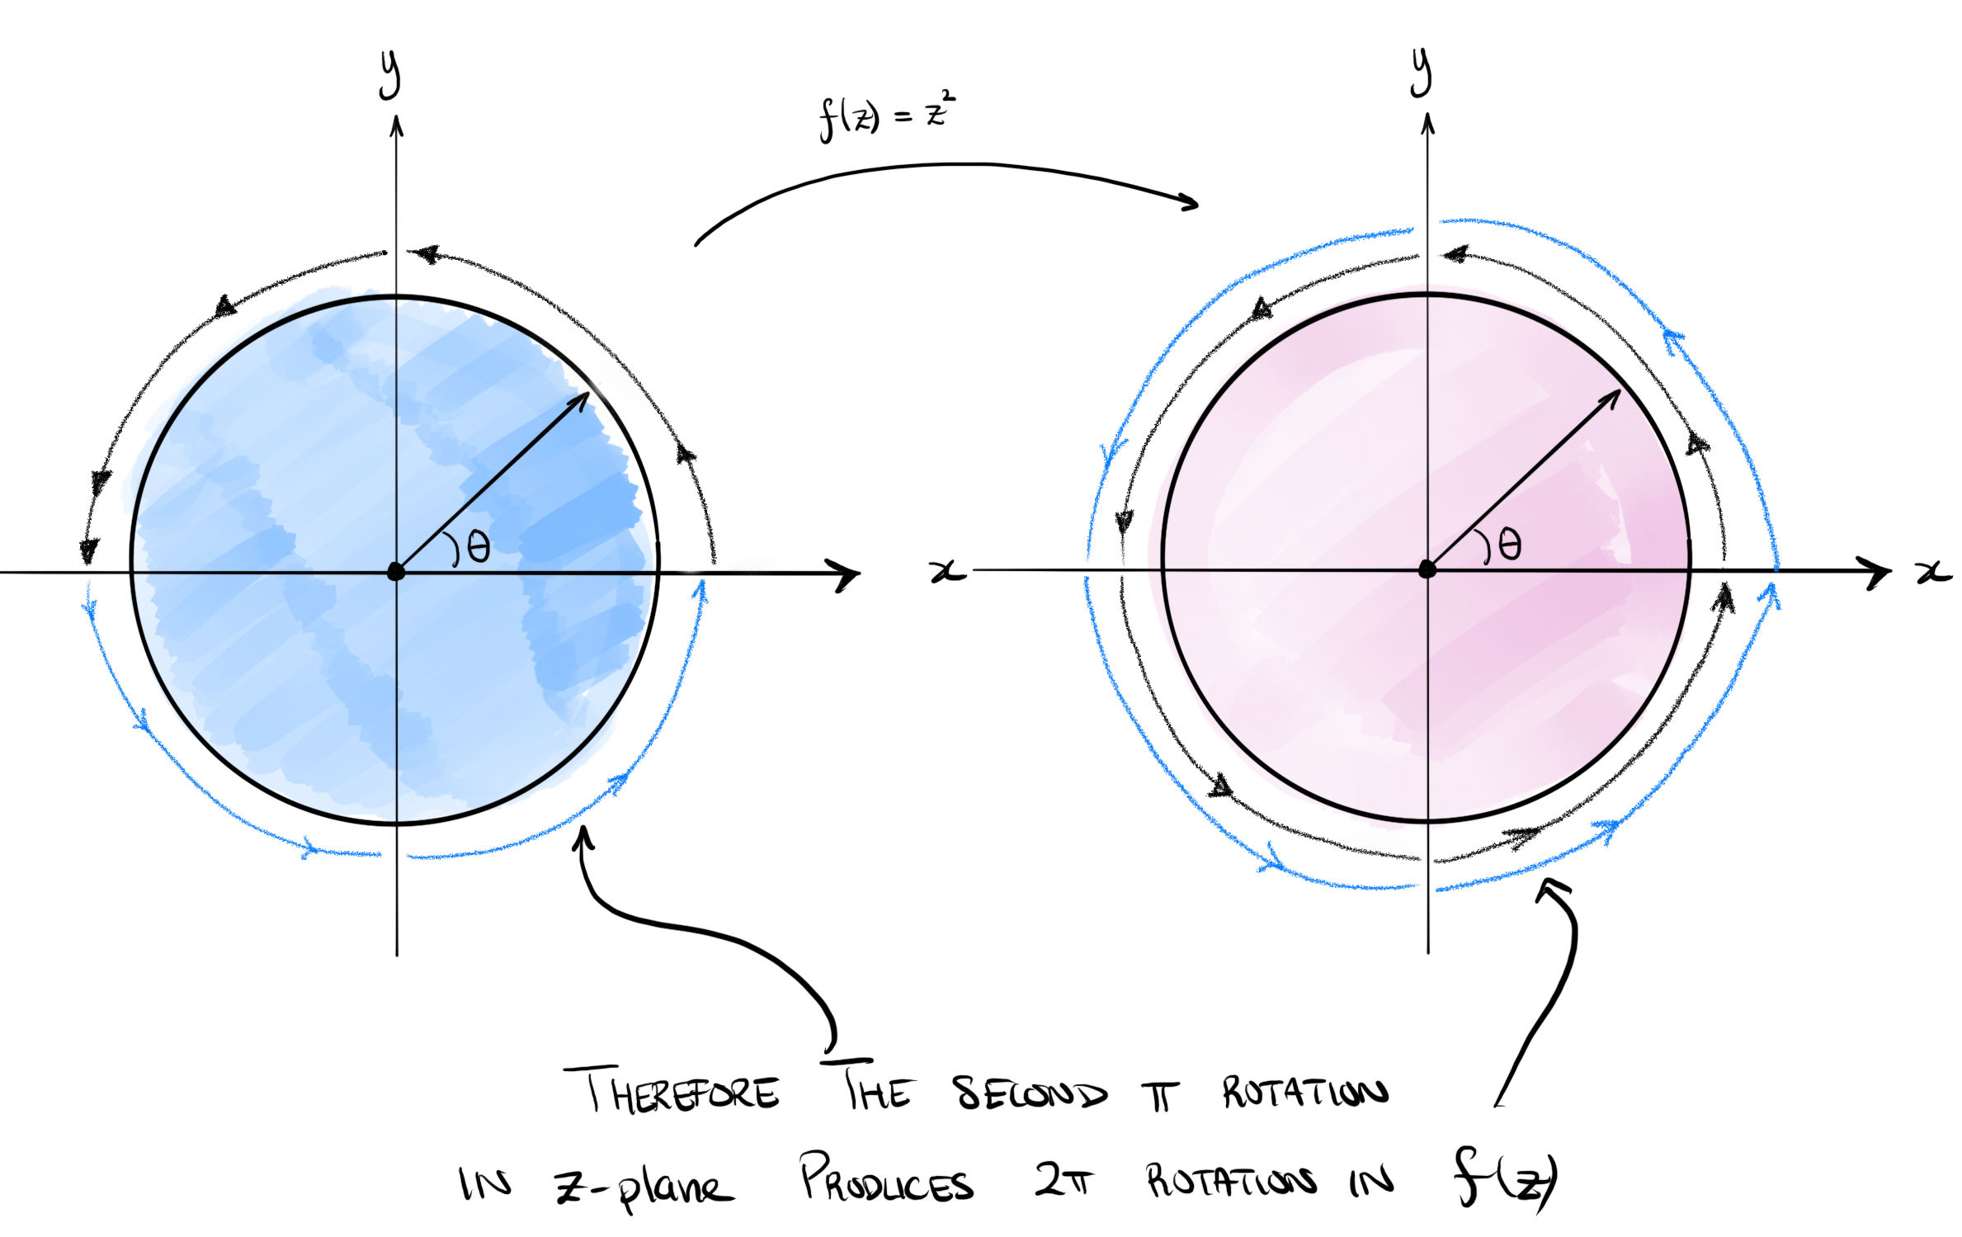
ExercisesExercisesExercisesws-intro
RemarkSolutions and feedback.remark-solutions-feedback-introduction There are no exercises in this chapter. Exercises, with full solutions in Appendix [solutions] at the back of the book, begin in Exercises [ws-kinematics].
ChapterKinematicsKinematicsch-chapter02-kinematics
Fluid kinematics refers to the study of fluid motions without considering the associated forces (or energies) that cause such a fluid to move. In a nutshell, it relates to studying e.g. the general velocity and acceleration fields of a fluid, visualising the fluid trajectories, and so forth.
FigureEulerian description of flow from the NCFMF video.fig-euler-vid
0.150.70.15 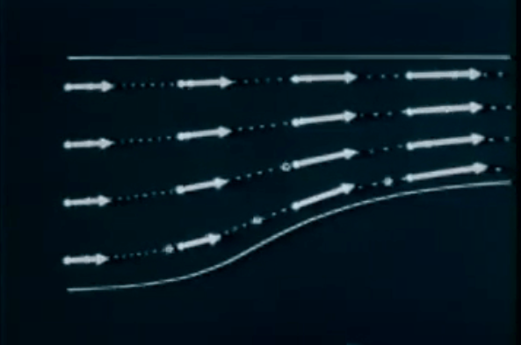
There are some unintuitive challenges when it comes to defining even the most basic quantities in fluid dynamics. Consider the following two thought experiments.
In the first experiment, we consider a tube filled with water, where the bottom is released at time $t=0$. One can imagine that the entire column of fluid will fall under the effect of gravity.
Figure(a) Tube filled with fluid with a plate to be removed; (b) fluid falls under the effect of gravity with uniform acceleration everywhere.kinematic-tube01
0.10.80.1 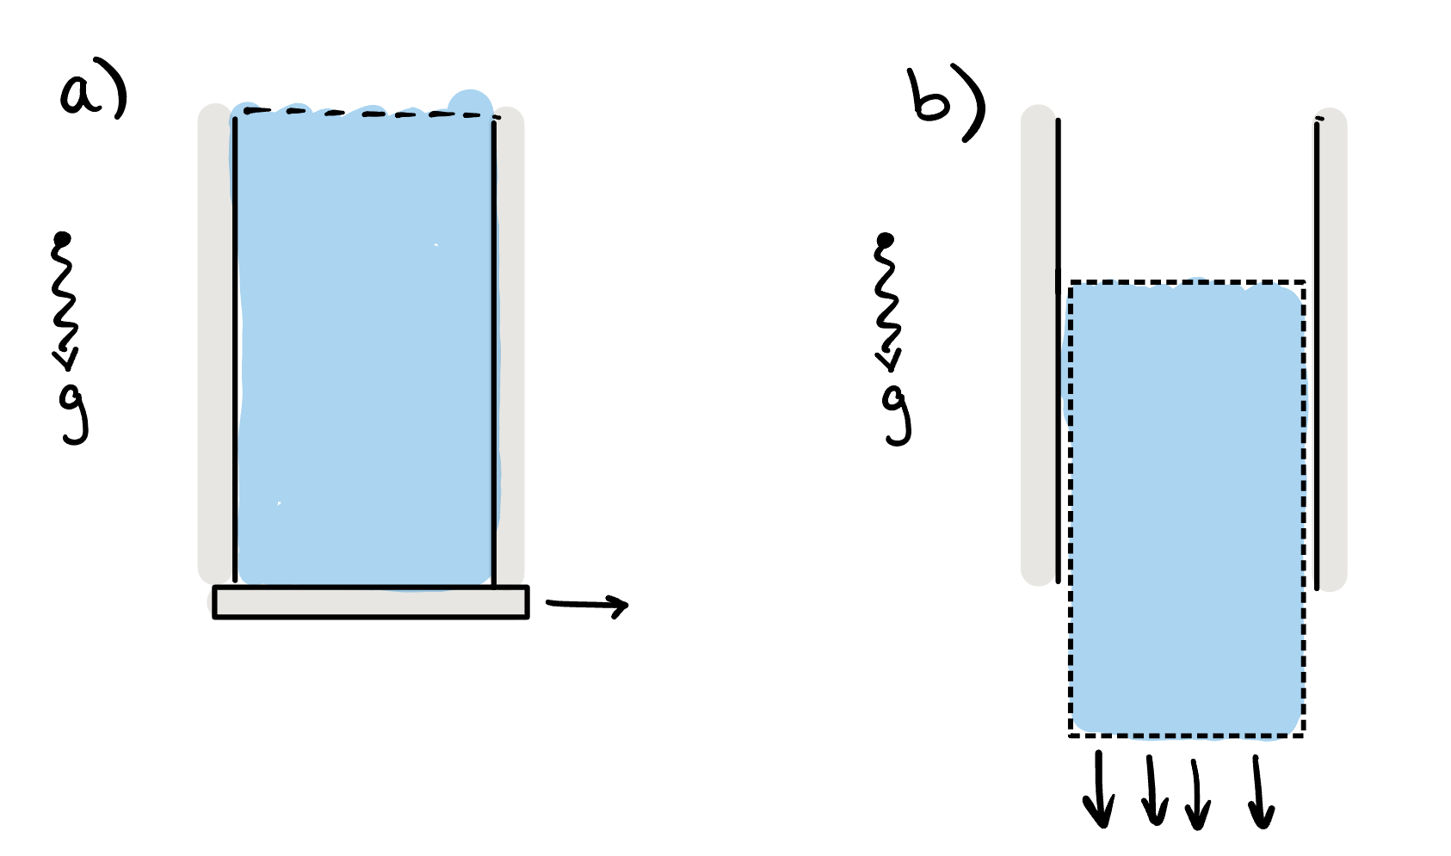
Each particle within the fluid is accelerated downwards at a constant rate (gravity). Therefore the velocity of the fluid is given by $u=(0,0,−U(t)).$ In this case, we imagine that acceleration can be defined simply as the partial derivative, in time, of the velocity field, or
$$a=\frac{∂u}{∂t}=(0,0,−\dot{U}(t))=(0,0,−g),$$
where we have used the over-dot notation for a derivative in time.
However, consider now the second thought experiment of fluid being pumped through the vessel shown in the figure below. The fluid has reached a steady-state (so the streamlines of the flow, if you can imagine them, are constant and travelling from left-to-right).
FigureFluid pumped through a tube with variable cross-sectional area, $A_{1},A_{2}$ and corresponding velocities $U_{1},U_{2}$.kinematic-tube02
0.10.80.1 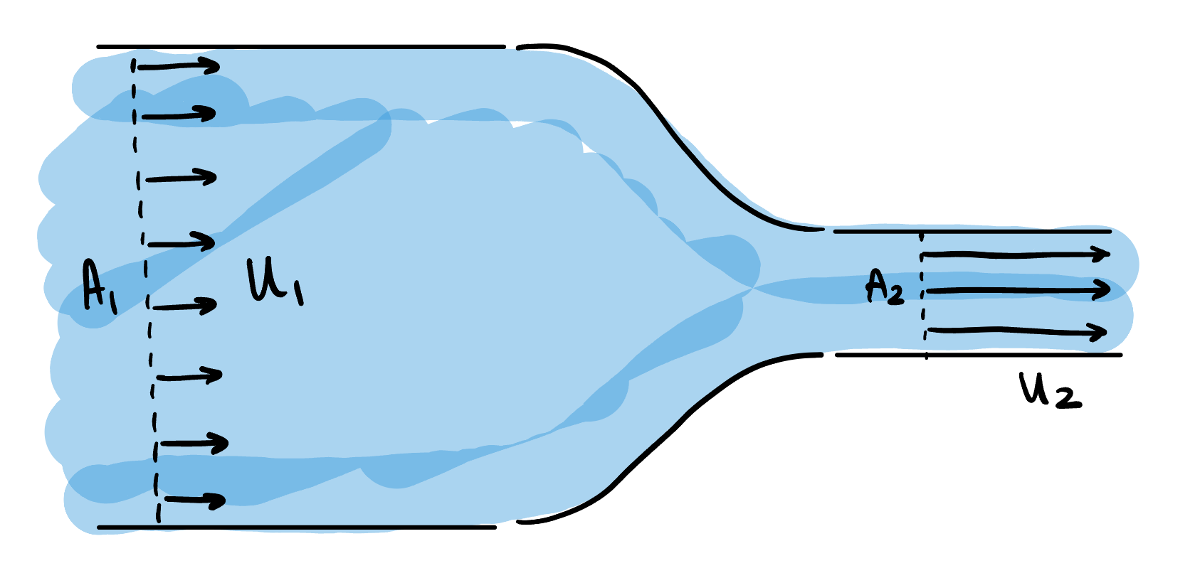
Upstream of the bottleneck, the volume flowrate is equal to the velocity times area, or
$$\text{Upstream flow rate (area times velocity)}=A_{1}U_{1}.$$
This is the amount of fluid that is flowing through a cross section of the pipe upstream. Similarly, we have
$$\text{Downstream flow rate (area times velocity)}=A_{2}U_{2}.$$
However, since mass must be conserved, the fact that there is a smaller cross-sectional area downstream must mean that the velocity is higher downstream. Therefore, $U_{2}>U_{1}$, and to achieve this, the fluid must therefore have been accelerated somewhere within the channel.
However, a moment’s thought about the situation might convince you that the velocity field in the channel is time-independent: it only changes as a function of its position and is therefore of the form $u=u(x)$. Indeed, at every fixed point in the channel, the velocity at that point is not changing in time. Therefore, if we use our previous definition that $a=\dot{u}$ we see that the acceleration would be zero everywhere!
The crux of the issue, and the difference between the two thought experiments, is that velocity is both a function of space and time, i.e. $u=u(x,t)$. The change in velocity (acceleration) can therefore derive from changes in $u$ at fixed space and variable time; but also due to changes in $u$ at fixed time and variable space. Disentangling this leads us to define the nature of Eulerian and Lagrangian coordinates, presented next.
SectionEulerian and Lagrangian coordinatesEulerian and Lagrangian coordinatessec-eulerlagrang
There are essentially two natural ways to think of motion in a fluid. We can imagine positioning ourselves at a fixed point in space, $x=(x,y,z)$. At this point, we then attempt to measure a fluid quantity such as the density, $ρ(x,t)$, or temperature, $T(x,t)$. This is essentially the Eulerian frame. One can imagine, for example, fixing a sensor station into the ocean bottom, and obtaining measurements of the water temperature.
Figure(a) The Eulerian interpretation; (b) the Lagrangian interpretation.sec-eulerlagrang-2-2
010 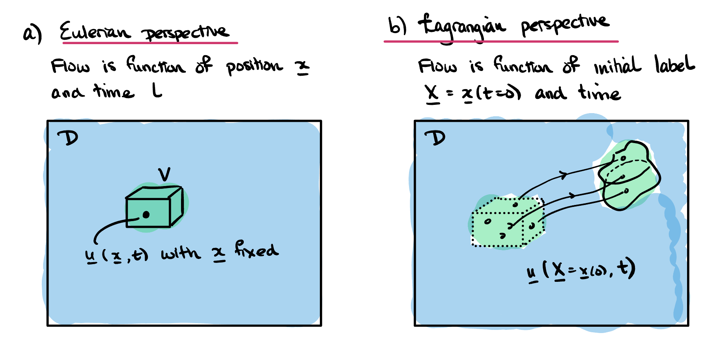
Alternatively, we can imagine tracking a single particle (or a fluid element) within the flow. The particle begins at some position. Let us define a label to describe the particle’s initial position. For example, if the particle’s position is given by
$$(x,y,z)=(x_{1}(t),y_{1}(t),z_{1}(t)),$$
we can define the corresponding Lagrangian label as
$$X=(X,Y,Z)=(x_{1}(0),y_{1}(0),z_{1}(0)).$$
We then ask for the corresponding measurement of the fluid quantity that corresponds to the label $X$. For example, this is equivalent to tagging a free-floating buoy in the ocean with the label $X$, then measuring the temperature of the water as the buoy drifts in the ocean. This Lagrangian temperature could be written $T(X,t),$ where $X$ is simply a fixed quantity for the particular buoy.
We are now in a position to define the Eulerian velocity field of a fluid.
Definitiondef-velocity The Eulerian velocity $u(x,t)$ is the velocity of the fluid at the point with spatial coordinates $x$ at time $t$. Note that, in physical terms this velocity is the average velocity at the time $t$ of the fluid particles (e.g. molecules, ions) in a small box centred on the point $x$. See also Remark [rem-continuum] for a discussion of the continuum assumption.
It will be useful to introduce the concept of steady flow.
Definitiondef-steady-flow A velocity field $u$ is defined as steady if it can be written $u=u(x)$ .
Note that steady flow does not mean that the fluid particles are not moving. It simply means that at a fixed point in space, the Eulerian velocity does not change in time. The Lagrangian velocity of a fluid particle will generally change in time, even in a steady flow.
A simple example of the conversion between the Eulerian and Lagrangian reference frames is in Exercise .3.
SubsectionThe convective derivativeThe convective derivativesubsec-laglabel Let us now be more specific. We wish to consider how different quantities in our flow change with time, but the matter is made complicated by the two above perspectives (fixed or following the flow).
Again, let us consider a scalar property of the fluid (for example, its density, temperature, velocity component, pressure, etc.), and let us suppose that this quantity is a function of both position, $x$, and time, $t$, and denote it by $f(x,t)$. This is the Eulerian description of the property since it is defined by specifying a fixed position in space. Fixing $x$ and then measuring $f$ is akin to standing in the fluid at a fixed location and measuring the property value in time.
We can alternatively write the property by its Lagrangian description. That is, given a label $X$, we obtain the current position of the particle associated with this label, $x(X,t)$, then obtain its property value. This we can write as the following:
$$F(X,t)≡f(x(X,t),t).$$
Now, fixing $X$ and changing $t$ corresponds to tracking the scalar property at a material point in the flow, or, equivalently, how $f$ changes as we move with the particle along the deforming fluid.
There are thus two ways of considering time derivatives.
Definitiondef-eulerlag We use the normal partial derivative notation to refer to an Eulerian time derivative, considered at a fixed point in space:
$$\frac{∂}{∂t}≡\frac{∂}{∂t}|_{x}=\text{rate of change with }x\text{ held constant}.$$
On the other hand, the Lagrangian time derivative is defined at a fixed material point in the fluid.
$$\frac{D}{Dt}≡\frac{∂}{∂t}|_{X}=\text{rate of change with }X\text{ held constant}.$$
We often refer to the Lagrangian time derivative as the convective derivative or the material derivative.
Remarksubsec-laglabel-7 The reason the above derivatives are introduced is that, for the purpose of much of fluid dynamics, it is easier to work with Eulerian coordinates and quantities. However, for the purpose of deriving many governing equations, it turns out to be much easier to work with Lagrangian variables. This is because physical forces act on physical particles, or material elements, of the fluid.
The natural question is how the two derivatives relate to one another. This is given by the following theorem.
TheoremThe material/convective derivative.thm-material-derivative The material or convective derivative can be defined in terms of Eulerian derivative in the following way:
$$\frac{D}{Dt}=\frac{∂}{∂t}+(u⋅∇).$$
Proof. Proofthm-material-derivative-3 This is a result of the chain rule. For a scalar function $f=f(x,t)$, we have the fact that
$$\begin{aligned}\frac{Df}{Dt}&=\frac{Dt}{Dt}\frac{∂f}{∂t}+\frac{Dx}{Dt}⋅∇f \\ &=\frac{∂f}{∂t}+u⋅∇f.\end{aligned}$$
◻
The proof of Theorem [thm-material-derivative] seems to use magic vector operations! In Exercise .2, we ask you to check this more carefully by expanding the vector operations explicitly.
We can now apply the above result to the question of how to calculate the acceleration within the fluid (more specifically, we are enquiring about the acceleration of a volume or particle within the fluid). The acceleration is given by the convective or material derivative of the velocity:
$$a≡\frac{Du}{Dt}=\frac{∂u}{∂t}+(u⋅∇)u.$$
You will practice using this formula in Exercise .4 of the problem set.
RemarkVector gradient.remark-vector-gradient In the formula for the acceleration in ([eqn-accel]), the quantity
$$∇u$$
appears. This is a tensor (matrix). One should not be too intimidated as it is just a convenient notation.
It is worth considering what this must be by considering each individual element of the acceleration. The acceleration is calculated simply by taking the velocity,
$$u=(u,v,w)=(u_{1},u_{2},u_{3}).$$
and working out the material derivative for each individual component. So we have
$$\frac{Du_{i}}{Dt}=\frac{∂u_{i}}{∂t}+u⋅∇u_{i}.$$
So the above gives each of the three components of $\frac{Du}{Dt}$.
You may prefer to see the above written in terms of the notation for $u=(u,v,w)$, so it is
$$\begin{aligned}\frac{Du}{Dt}&=u_{t}+(uu_{x}+vu_{y}+wu_{z}) \\ \frac{Dv}{Dt}&=v_{t}+(uv_{x}+vv_{y}+wv_{z}) \\ \frac{Dw}{Dt}&=w_{t}+(uw_{x}+vw_{y}+ww_{z})\end{aligned}$$
You can also re-arrange the above in something closer to "matrix" form. So
$$\frac{Du}{Dt}=\frac{∂}{∂t}(u,v,w)+(u,v,w)⋅\left(\begin{matrix}∇u \\ ∇v \\ ∇w\end{matrix}\right),$$
and where the last quantity corresponds to
$$∇u≡\left(\begin{matrix}∇u \\ ∇v \\ ∇w\end{matrix}\right)=\left(\begin{matrix}u_{x} & u_{y} & u_{z} \\ v_{x} & v_{y} & v_{z} \\ w_{x} & w_{y} & w_{z}\end{matrix}\right).$$
And hence the vector gradient can be defined as a matrix, where each row of the matrix is the gradient of the elements of the vector.
It is likely that you will find it easier to remember that the material derivative is applied via ([eqn-material-deriv-ui]) -- than it is for you to try and untangle the multiplication of matrices via ([eqn-grad-bu]).
SectionFlow visualisation, fluxes, and forcesFlow visualisation, fluxes, and forcessec-flowexamples
There are different ways to visualise the dynamics of a fluid. Given the velocity, $u(x,t)$, we can plot a vector field at each point in space, and at a fixed moment in time. Little arrows are used to indicate the direction and the length of the arrow can be chosen to represent the magnitude. Joining these up at a fixed moment in time into smooth curves gives the streamlines of the flow. This is often the easiest type of visualisation to perform mathematically, but the hardest experimentally.
Another representation of the flow is using particle paths or pathlines. Given a point and time, the particle path is the trajectory that would result if a particle were dropped into the flow at that chosen point and time. It is thus found by solving an equation where at every point on the trajectory, the particle’s velocity is the specified velocity of the fluid.
A third representation is a streakline. If dye were continuously released into a fluid from a fixed chosen point, the streakline at a given time is the line that would be made by the dye. It is thus found by finding the current position of those particles whose pathline has visited the chosen point at any past time. This is often the easiest type of visualisation to perform experimentally, but the hardest to perform mathematically.
Note that in a steady flow, the streamlines, pathlines and streaklines all coincide. However, in an unsteady flow, they are all different. In Exercise .1 you will study a video showing this concept.
SubsectionDefinitions of streamlines, pathlines, streaklinesDefinitions of streamlines, pathlines, streaklinessec-flowexamples-3 In the definition below, we define these concepts more concretely.
DefinitionParticle streamlines.def-streamline Consider a fixed time, $t=t_{1}$.
Select an initial point, $x_{1}$ at this time.
The streamline, $x=x(s)$ through the above point is given by solving the parametric equation
$$\frac{dx}{ds}=u(x(s),t_{1}), \text{with }x(s=0)=x_{1}\text{,}$$
where $s$ is a parameter along the streamline. Choosing a variety of different initial points, $x_{1}$, and solving the above equation gives a family of streamlines at time $t_{1}$.
Basically, given a velocity field, we freeze time. The streamlines are those curves that are traced out by the velocity field in the "snapshot".
DefinitionPathline or particle path.def-particle-path Consider now a particle that begins at the location $x_{2}$ at time $t=0$.
We consider the partical path or pathline of the particle, given by the curve $x=x(t)$ and found by solving the equation
$$\frac{dx}{dt}=u(x(t),t), \text{with }x(0)=x_{2}\text{.}$$
Choosing a variety of initial points, $x_{2}$, yields a family of pathlines.
The pathline or particle path from an initial point is what we would physically expect if we were to dye the point with a colour and follow the dye colour as time increases.
DefinitionStreakline.def-streakline Consider now fixing a location $x_{3}$.
The streakline for a point $x_{3}$ is given by solving the equation
$$\frac{dx}{dt}=u(x(t),t), \text{with }x(t_{3})=x_{3},$$
for a variety of values of $t_{3}$. This gives the current position of all particles that have passed through the point $x_{3}$ at any time $t_{3}$ in the past.
If it is the case that the velocity is time-independent, i.e. $u=u(x)$, then the three above definitions coincide.
You will practice the theory of these concepts in Exercise .5 and do a worked example in Exercise .6 of the problem set.
SubsectionExamples of streamlines, pathlines, and streaklinesExamples of streamlines, pathlines, and streaklinessubsec-examples-streamlines Let us practice these concepts.
ExampleStagnation point flow.subsec-examples-streamlines-3 Consider a fluid described by the two-dimensional velocity field
$$u(x,t)=(x,−y,0).$$
Derive and plot the streamlines of the flow. Discuss what occurs with particle paths and streaklines.
Solution.There are many online applications, such as this one that will allow you plot a two-dimensional direction field. It is also good to do it yourself by hand.
FigureAn example of a direction fieldsubsec-examples-streamlines-3-3-2
0.050.90.05 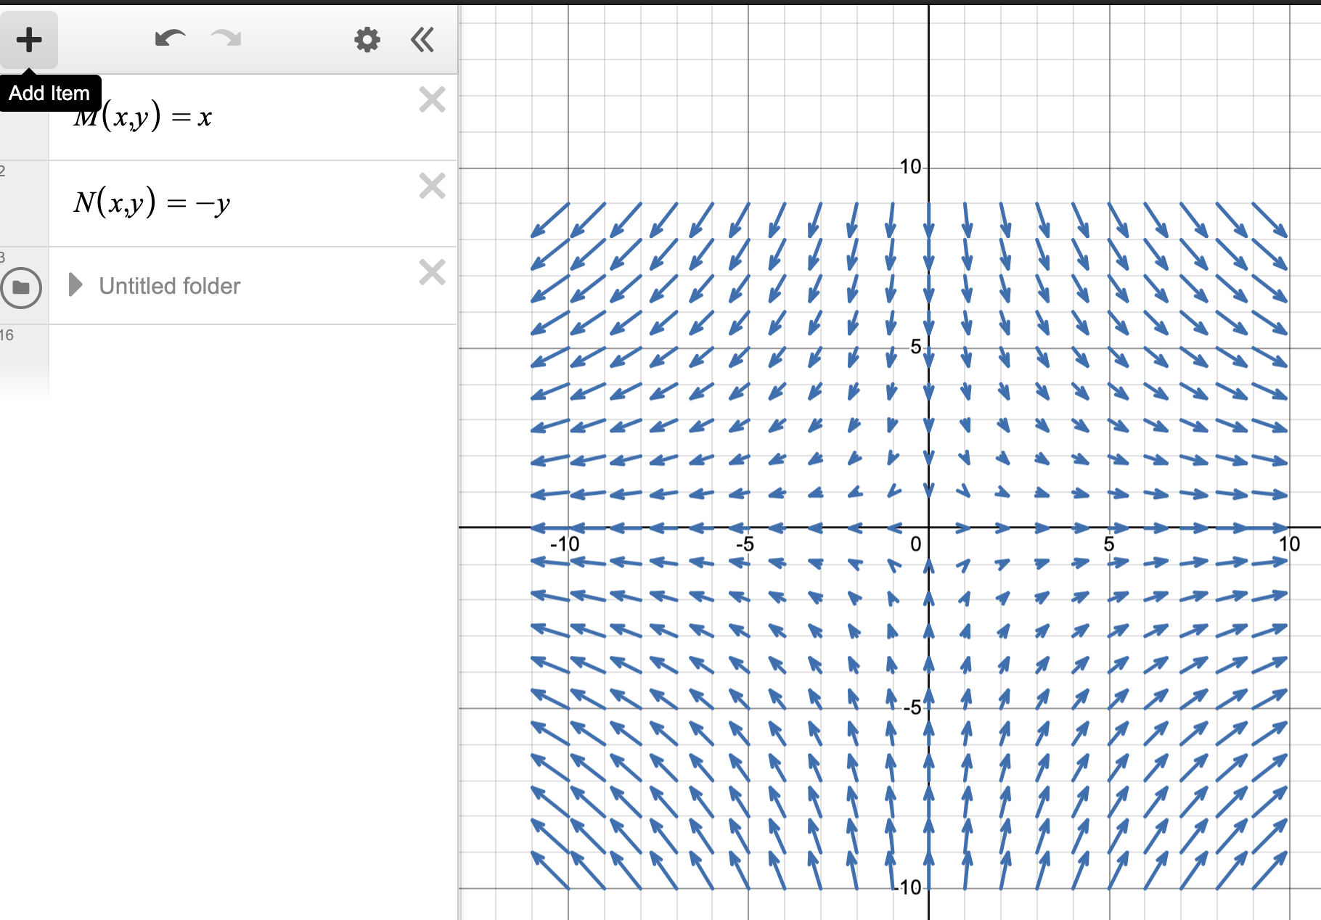
The streamlines follow from Definition [def-streamline]. We seek to solve the equations
$$\begin{aligned}\frac{dx}{ds}&=x, \\ \frac{dy}{ds}&=−y, \\ \frac{dz}{ds}&=0.\end{aligned}$$
Solving thus gives $x=Ae^{s},y=Be^{−s},z=C,$ for constants $A,B,C$.
You can put initial conditions to determine the constant and plot the trajectories for different values of $s$.
However, in this case, it is easier to remove the time-like variable, $s$, entirely. Notice that
$$xy=AB=\text{constant}.$$
Therefore, the trajectories lie along hyperbolae.
Notice that in this case, the velocity field is time-independent, and therefore the particle paths coincide with the streamlines and streaklines.
For instance, the particle path through a particle at $x_{2}=(1,1,0)$ is given by (replacing $s$ with $t$):
$$x(t)=(e^{t}, e^{−t}, 0).$$
Similarly, the streakline through the point $(1,1,0)$ is precisely the set of points above.
ExampleStraight streamlines and circular pathlines.subsec-examples-streamlines-4 Consider the unsteady flow given by
$$u(x,t)=(cost,sint,0)\text{.}$$
Plot the streamlines of the flow on the plane $z=0$, and also the particle trajectories. What occurs with the streaklines?
Solution.In this case, the velocity field is changing in time. Consider firstly the concept of the streamline in Definition [def-streamline].
We solve the governing equations for the streamlines $x=x(s)$,
$$\frac{dx}{ds}=cost, \frac{dy}{ds}=sint, \frac{dz}{ds}=0,$$
for fixed $t$.
This gives
$$x(s)=A+scost, y(s)=B+sint, z(s)=C,$$
for constants $A,B,C$. Therefore the streamlines are given by straight lines in the $(x,y)$ plane, if $z=C$ is fixed.
Consider instead the definition of particle paths via Definition [def-particle-path]. We seek to solve
$$\frac{dx}{dt}=cost, \frac{dy}{dt}=sint, \frac{dz}{dt}=0,$$
yielding
$$x(t)=A+sint, y(t)=B−cost, z(t)=C,$$
for constants $A,B,C$. Therefore, we see that the particle paths are closed circles (in the $xy$-plane) of unit radius encircling the point $(A,B,0)$.
The fact that the streamlines are straight lines while the particle paths are circular can be visualised in Figure [fig-streamlines-example-02]
FigureStreamlines and particle pathsfig-streamlines-example-02
0.250.50.25 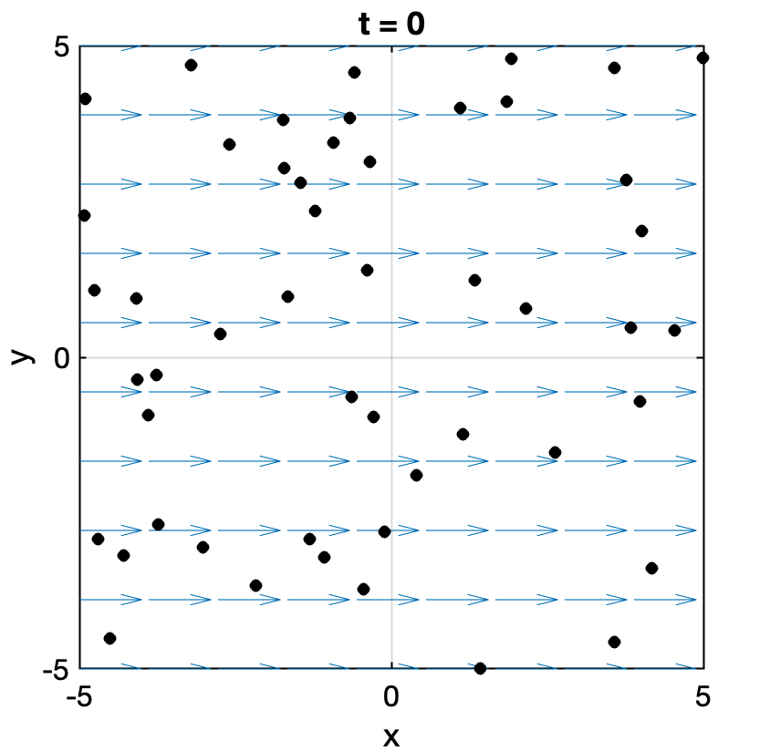
In this case, considering the streakline via Definition [def-streakline], we conclude that the streakline coincides with the particle path. Can you reason why this must be the case in this situation? What is necessary in order for this not to be true?
ExampleAn oscillating hose/plate.subsec-examples-streamlines-5 Water flows out of an oscillating hose, held along the edge $y=0$, such that the velocity field produced is given by
$$u=(u_{0}sin(ω(t−y/v_{0})),v_{0}),$$
where $u_{0}$ and $v_{0}$ are constants.
Determine the streamline that passes through the origin at $t=0$ and $t=π/(2ω)$.
Determine the pathline of the particle that was at the origin at $t=0$; at $t=π/(2ω)$.
Qualitatively describe the shape of the streakline that passes through the origin?
Solution.Streamlines. At a fixed time $t$, streamlines satisfy
$$\frac{dx}{dy}=\frac{u}{v}=\frac{u_{0}}{v_{0}}sin\left(ω(t−y/v_{0})\right),$$
which integrates to $x=\frac{u_{0}}{ω}cos\left(ω(t−y/v_{0})\right)+C$. Requiring the streamline to pass through the origin gives
$$x=\frac{u_{0}}{ω}\left[cos\left(ω(t−y/v_{0})\right)−cos(ωt)\right].$$
At $t=0$ this is $x=\frac{u_{0}}{ω}\left[cos(ωy/v_{0})−1\right]$, and at $t=π/(2ω)$ it is $x=\frac{u_{0}}{ω}sin(ωy/v_{0})$. Both are sinusoidal curves.
Pathlines. Take the particle that leaves the origin at time $τ$. Since $\frac{dy}{dt}=v_{0}$, we have $y=v_{0}(t−τ)$. So $ω(t−y/v_{0})=ωτ$ is constant along the path, and $\frac{dx}{dt}=u_{0}sin(ωτ)$ gives
$$x=u_{0}sin(ωτ)(t−τ)=\frac{u_{0}}{v_{0}}sin(ωτ) y.$$
Each particle travels in a straight line. For $τ=0$ this is the $y$-axis, $x=0$; for $τ=π/(2ω)$ it is the line $x=(u_{0}/v_{0}) y$ (see Figure [fig-hose01]).
Streakline. At time $t$, the streakline through the origin is made up of all particles released there at earlier times $τ≤t$. Eliminating $τ=t−y/v_{0}$ from the pathline gives
$$x=\frac{u_{0}}{v_{0}} ysin\left(ω(t−y/v_{0})\right), y≥0.$$
This is a wave travelling in the $y$-direction at speed $v_{0}$, with amplitude growing linearly with distance from the hose (see Figure [fig-hose02]). Unlike the streamlines and pathlines, it is the oscillating pattern you actually see in the water jet.
FigureIsolated pathlines show that particles move along straight paths.fig-hose01
0.10.80.1 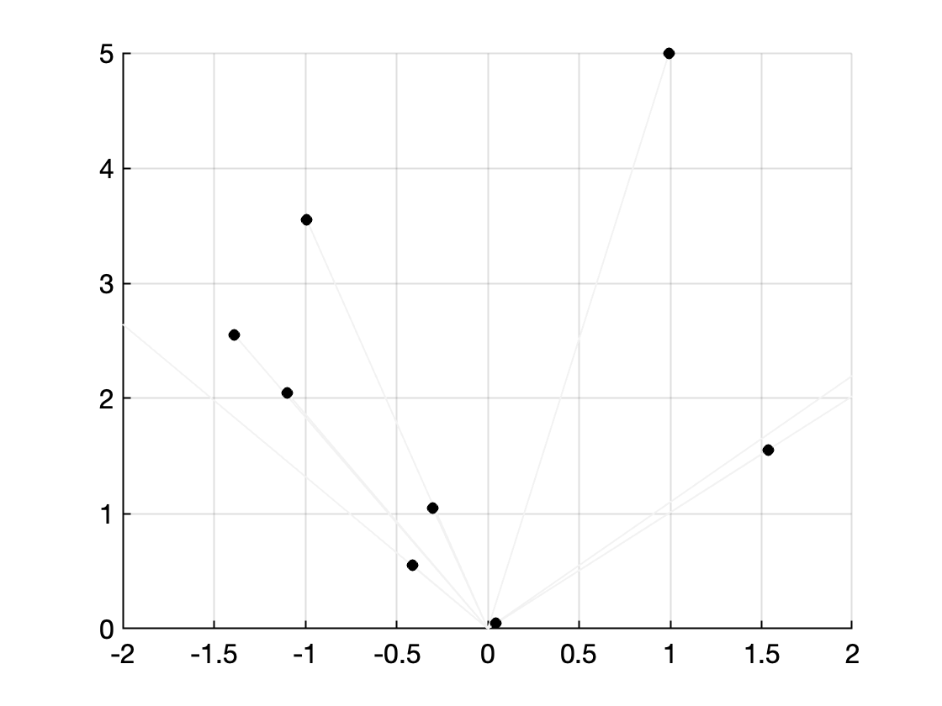
FigureHowever, viewed in terms of the streakline, the visible pattern is oscillatory.fig-hose02
0.10.80.1 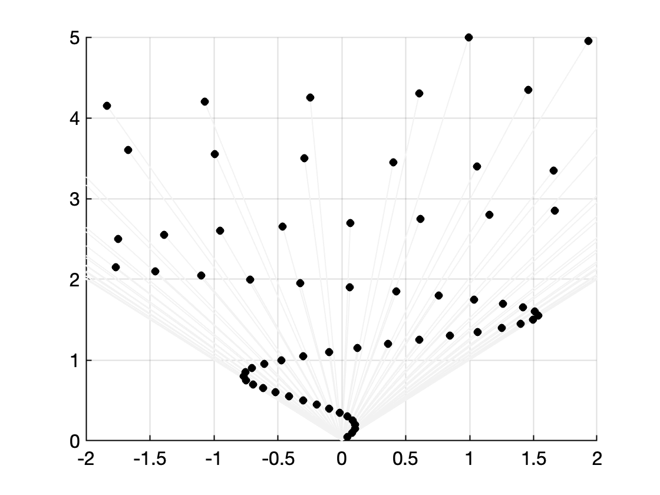
SubsectionFluxes and forcesFluxes and forcessubsec-fluxes-and-forces Before we go on, we remind the reader of two important quantities that will be used in the following chapters. These are typically introduced in the prior modules on vector calculus.
The first is the notion of flux through a surface. Given a surface $S$ and a velocity field $u$, the flux through the surface is the amount of flow through the surface per unit time. It is given by the integral
flux through S=S​u⋅n dS,
and $n$ is the outer unit normal.
In 2D, the flux due to a 2D velocity field can also be written as
flux through C=C​u⋅n ds.
In the two above formulae, refer to your previous vector calculus notes for the procedures to calculate the area element $dS$ or the line element $ds$.
Finally, we may like to also calculate the total force on a surface or on a contour. If $F$ is the pointwise force applied at every point, the total force is given by
Total force=S​F dS.
The above remains a vector quantity.
ExampleFlux through a surface.example-flux-surface Consider the velocity field $u=(x+y^{2}, 0, 0)$. Let $S$ be the flat rectangular surface lying in the plane $x=2$, with $0≤y≤1$ and $0≤z≤3$, oriented with outward unit normal $n=(1,0,0)$. Calculate the flux of $u$ through $S$.
Solution.On the surface $S$ we have $x=2$, so
$$u⋅n=(2+y^{2},0,0)⋅(1,0,0)=2+y^{2}.$$
The flux is therefore
flux through S&=S​u⋅n dS=0301(2+y2) dy dz&=032y+y3301dz=0373 dz=7.
Notice that only the $x$-component of $u$ contributes, since $n$ points purely in the $x$-direction; the flux measures how much fluid crosses $S$ per unit time in that direction.
ExampleFlux through a curve.example-flux-curve Consider the uniform velocity field $u=(2,1)$. Let $C$ be the straight line segment from $(0,0)$ to $(3,4)$. Calculate the flux of $u$ through $C$, taking the normal to point away from the origin.
Solution.The segment has length $5$ (a 3-4-5 triangle), and a unit tangent vector along $C$ is $t=(3,4)/5$. Rotating $t$ by ${90}^{∘}$ so that the resulting normal points away from the origin gives
$$n=(4,−3)/5.$$
Since $u$ is uniform, $u⋅n$ is constant along $C$:
$$u⋅n=(2,1)⋅(4,−3)/5=\frac{8−3}{5}=1.$$
The flux is then this constant times the length of $C$:
flux through C=C​u⋅n ds=1×5=5.
The main subtlety here is orientation: rotating the tangent the other way would have given $n=(−4,3)/5$ and a flux of $−5$, correctly describing flow in the opposite sense across $C$.
ExampleTotal force.example-total-force Suppose a pointwise force $F=(x, y^{2}, 3)$ acts over the flat rectangular surface $S$ given by $0≤x≤2$, $0≤y≤1$, in the plane $z=0$. Calculate the total force on $S$.
Solution.Since $S$ lies in the plane $z=0$, the area element is simply $dS=dx dy$, and no normal vector is needed because $F$ is not dotted with anything in ([eqn-total-force]). We integrate each component of $F$ separately:
$$\begin{aligned}\int_{0}^{2}{\int_{0}^{1}{x}} dy dx&=\int_{0}^{2}{x} dx=2, \\ \int_{0}^{2}{\int_{0}^{1}{y^{2}}} dy dx&=2\int_{0}^{1}{y^{2}} dy=\frac{2}{3}, \\ \int_{0}^{2}{\int_{0}^{1}{3}} dy dx&=3×2×1=6.\end{aligned}$$
The total force is therefore
Total force=S​F dS=2, 23, 6.
Unlike the two flux calculations above, the total force remains a vector: each Cartesian component of $F$ is integrated on its own.
ExercisesExercisesExercisesws-kinematics
The kinematics chapter covered the basic essentials about the measurement and computation of fluid velocities and acceleration. We examined the difference between Eulerian and Lagrangian coordinates and derivatives. Examples of streamlines and velocity fields were examined.
RemarkSolutions and feedback.remark-solutions-feedback-kinematics Full solutions to these exercises can be found in the solutions to this chapter [solutions-kinematics] in Appendix [solutions] at the back of the book.
If you would like feedback on your work, the tutor will by default concentrate on the exercises highlighted with a yellow background in the online notes (the homework exercises), unless you specifically ask for feedback on a different exercise instead.
AsideOptional.ex-video-flow-visualisation-2-1 This question is optional. It is meant only to deepen your understanding of the processes discussed in this chapter.
Watch the first 13 and half minutes of the video "Flow visualisation" from the NCFMF archives.
- Name a few ways in which a fluid flow can be visualised (i.e. how does one produce, in an experiment, such a visualisation?)
- Define, in words, what pathline, streakline, timeline, and streamline means. At 6:30, the author comments that "there is no way to make a streamline visible". Discuss this point.
- Give the example, shown in the video, where the pathline, streakline, and streamlines all coincide. Draw pictures to illustrate the concept.
- Give an example, shown in the video, where the pathline, streakline, and streamlines do not coincide. Draw pictures to illustrate the concept.
- In the video, an intuitive explanation is given for what it means for the velocity to be incompressible. What is this explanation? (near 8:25)
Prove the Eulerian representation of the material derivative, as presented in Theorem [thm-material-derivative] by manually expanding the components of the function. That is, consider a scalar function $f(x,t)$. Let the spatial coordinate follow $x=x(X,t)$ and hence is defined by a specified material label $X$. Then derive the identity for $$\frac{Df}{Dt}=\frac{∂f}{∂t}|_{X},$$ according to Definition [def-eulerlag].
AsideRevised in 2026.ex-eulerian-lagrangian-2-1 In 2025, this question had a part (b) on expressing the position and velocity in polar coordinates. It has been removed for simplicity; polar coordinates will be introduced later in the course.
A velocity field is described in Eulerian terms in Cartesian coordinates by $u=(−y,x)$. What is the Lagrangian position of the particle that starts at the point $(x_{0},y_{0})$? Describe its path. What is its velocity? A fluid flows through the nozzle shown from $x=0$ to $x=L$ with one-dimensional velocity
$$u=U\left(1+\frac{x}{L}\right)$$
in the $x$-direction, where $U$ and $L$ are constants. Note that, in reality the flow would be two- or three-dimensional, but we ignore this here for simplicity.
FigureSketch of nozzle.fig-nozzle
0.20.60.2 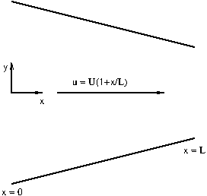
- What is the particle acceleration?
- If a particle starts at $x=0$ at time $t=0$, what is its position at time $t$?
- What is its Lagrangian velocity as a function of time?
- What is its Lagrangian acceleration as a function of time?
- Write the Lagrangian velocity and acceleration as a function of $x$. Compare with the corresponding Eulerian velocity and particle acceleration. What do you notice?
- How long does it take for a particle to travel from $x=0$ to $x=L$?
AsideRevised in 2026.ex-hw-particle-paths-streamlines-2-1 Parts (b) and (c) of this question, together with their hints and solutions, were cleaned up for 2026 to set up the pathline and streamline more carefully.
- Define the particle paths and streamlines for a velocity field $u(x,t)$. When do these coincide?
- Let $x=x(t)$ be a pathline of the fluid, so that $\frac{dx}{dt}=u(x(t),t)$ (see Definition [def-particle-path]), and consider $f$ evaluated along the pathline,
$$F(t)=f(x(t),t),$$
- which is the value of $f$ experienced by the fluid particle. By drawing a sketch of the pathline and marking the positions $x$ of the particle at time $t$ and $x+dx$ at time $t+dt$, show that
$$\frac{dF}{dt}=\frac{∂f}{∂t}+u⋅∇f=\frac{Df}{Dt}.$$
- Hence show that $f$ is preserved following the flow if and only if $\frac{Df}{Dt}=0$.
- Hint.Since $x(t)$ is a pathline, the displacement of the particle in a small time $dt$ is
$$dx=u(x,t) dt+O(dt^{2}).$$
- By definition of the derivative,
$$\frac{dF}{dt}=\lim_{dt→0}\frac{f(x+dx,t+dt)−f(x,t)}{dt}.$$
- To expand the numerator, use the Taylor series for a function of several variables:
$$f(x+dx,t+dt)=f(x,t)+dx⋅∇f(x,t)+dt \frac{∂f}{∂t}(x,t)+O\left(|dx|^{2}, |dx| dt, dt^{2}\right),$$
- where, in components, $dx⋅∇f=dx \frac{∂f}{∂x}+dy \frac{∂f}{∂y}+dz \frac{∂f}{∂z}$. Substitute for $dx$ and let $dt→0$.
- Let $x=x(s,t)$ be a streamline of the flow at fixed time $t$, so that $\frac{∂x}{∂s}=u(x(s,t),t)$, where $s$ is the parameter along the streamline (see Definition [def-streamline]). Consider $f$ evaluated on the streamline,
$$G(s)=f(x(s,t),t).$$
- Show that $f$ is constant along the streamline if and only if
$$u⋅∇f=0.$$
- Hint.Consider the points $x=x(s,t)$ and $x+dx=x(s+ds,t)$ on the same streamline, at the same instant $t$. Since the curve is a streamline,
$$dx=u(x,t) ds+O(ds^{2}).$$
- By definition of the derivative,
$$\frac{dG}{ds}=\lim_{ds→0}\frac{f(x+dx,t)−f(x,t)}{ds}.$$
- Because the time is the same at both points, the Taylor series now has no time term:
$$f(x+dx,t)=f(x,t)+dx⋅∇f(x,t)+O(|dx|^{2}).$$
The velocity of a two-dimensional fluid flow in Cartesian coordinates is $u=1$, $v=te^{−4x}$. Calculate and sketch the following:
- the streamlines at a fixed time $t>0$,
- the pathline of the particle starting from $(x_{0},y_{0})$. Hence find and sketch the pathline of the particle that starts from $(0,0)$,
- and the streaklines passing through $(0,0)$.
- Hint.The expression for a general pathline starting from $(x_{0},y_{0})$ is given by
$$x=x_{0}+t, y=y_{0}+\frac{1}{16}e^{−4x_{0}}−\frac{1+4t}{16}e^{−4(x_{0}+t)}.$$
- For a line/curve in the $(x,y)$, its timeline at time $t$ is the locus of the material elements at time $t$ that started on the line/curve at $t=0$. In experiments this can be visualised using a streak of dye placed initally along the line/curve. Tracking this over time gives the timelines.
- Calculate and sketch the timelines of the line (i) $y=0$, (ii) $x=0$.
AsideOptional.ex-video-radioactive-2-1 This question is optional. It is meant only to deepen your understanding of the processes discussed in this chapter.
Watch around 12:00 to around 19:00 of the video "Eulerian and Lagrangian Descriptions of Fluid Mechanics" from the NCFMF archives.
- In the video, the authors describe an experiment that one can setup to measure decay of a substance, say $C(x,t)$ along a 1D segment in a river.
- In the first situation, it is assumed that $C$ is distributed uniformly in the river, but is a naturally decaying substance with some uniform rate of change, $\frac{dC}{dt}$. Explain what is the (material) change in $C$ that would be measured via two sensors, one upstream and one downstream.
- Next, the authors imagine a situation where $C$ is not uniformly distributed. They give a visual and analytical explanation of the material derivative,
$$\frac{DC}{Dt}=\frac{∂C}{∂t}+u\frac{∂C}{∂x},$$
- where $u$ is the horizontal velocity within the infinitesimal 1D section. Write your own explanation of the above.
ChapterEquations of motionEquations of motionch-chapter03-equations
In this chapter, we develop the basic equations of fluid dynamics. The equations are derived from applying principles of conservation of mass and momentum. In the simplest scenario, where the fluid is assumed to be inviscid, this leads to Euler’s equations for a perfect (or ideal) fluid. Later, in Chapter [ch-viscousflows], we relax this assumption to incorporate the effects of viscosity.
Let $D$ be a 2D or 3D region filled with fluid. The fluid is in motion and we wish to describe this motion.
Let $x∈D$ be a point in $D$ and consider the particle of fluid that moves through the point $x$ at time $t$. In the figure below, we sketch the trajectory that this particle might take within the fluid. Also at the point $x$ at time $t$, we let $u(x,t)$ be the velocity of the particle. At each fixed time, we can imagine the velocity vectors drawn at each point in the fluid; thus we call $u$ the velocity field of the fluid.
FigureImage of the fluid domain $D$.ch01-fluid
0.250.50.25 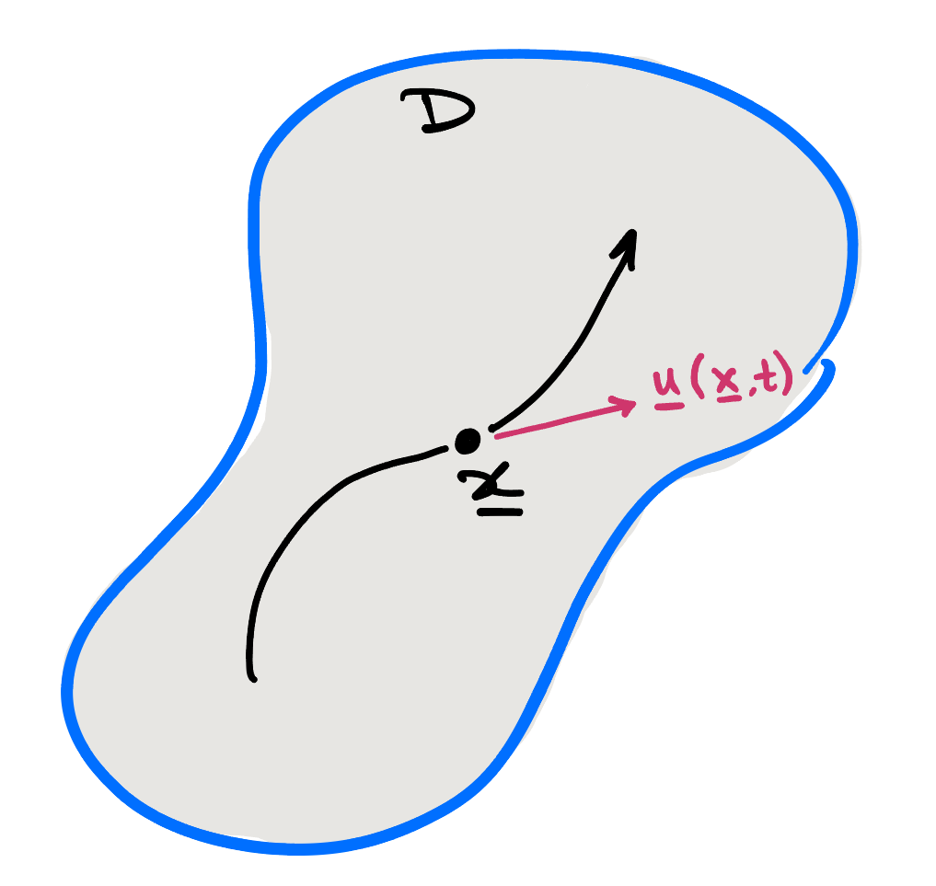
At each point in space and moment in time, we assume that the fluid has a well-defined mass density, $ρ(x,t)$. Let $V(t)⊆D$ be a subregion of $D$, possibly moving with time. Then the mass of the fluid in $V$ at time $t$ is given by
m(t)=V(t)​ρ(x,t) dV.
RemarkSmoothness and well-posedness.ch-chapter03-equations-2-6 Throughout this chapter, we assume that $u$, $ρ$ and the other functions describing the fluid are sufficiently smooth that the standard operations of calculus can be applied to them. Can you think of some situations in fluid dynamics where smoothness might not be guaranteed?
RemarkContinuum assumption.rem-continuum The assumption that the fluid can be described by a smooth scalar density field, $ρ$, is a continuum assumption. This is indeed one of the core assumptions that underlies this course, but it is worth noting that this is only an assumption (albeit a widely accepted one, applicable to most real-life scenarios). At the other extreme is the view that the fluid is composed of a discrete set of molecules, all bouncing around, and hence fluid dynamics might be posed as the study of the kinetic motion of molecules!
The derivation of the governing equations for a fluid is then based on three basic principles of physics:
- Conservation of mass: mass is neither created nor destroyed.
- Conservation of momentum: the rate of change of momentum of a portion of the fluid is equal to the applied force (Newton’s second law).
- Conservation of energy: energy is neither created nor destroyed. (We will not need energy conservation in this course.)
Before starting, though, our first task is to derive some helpful results on the differentiation of quantities such as ([eqn-mass]).
SectionReynolds’ Transport TheoremReynolds’ Transport Theoremsec-RTT
SubsectionJacobian of the Lagrangian-to-Eulerian mapJacobian of the Lagrangian-to-Eulerian mapsubsec-jacob Consider a volume of fluid that, at time $t=0$, occupies the region $V(0)⊆D$ and is dyed a certain colour. As the fluid evolves, this packet of fluid occupies the region $V(t)$ for $t>0$.
As an example, we may express the density of the fluid as
$$ρ=ρ(x,t), x∈V(t)$$
i.e. the density is given as a function of position in space and time, for points in the (possibly moving) region $V(t)$. This is the natural description for an observer at a fixed point in space, and is the Eulerian viewpoint.
Alternatively, we can write
$$ρ=ρ(X,t), X∈V(0)$$
which is the density of fluid for those particles making up an originally chosen volume, $V(0)$. This is a natural quantity to study if we were to move with the fluid; for instance, if we were to colour the volume $V(0)$ with a dye and track its density in time. This is the Lagrangian viewpoint.
Strictly, $ρ(X,t)$ and $ρ(x,t)$ are different functions of their arguments; we follow the common convention of using the same symbol for both, and the arguments make clear which is meant.
The correspondence between the Eulerian and Lagrangian coordinates is written as
$$x=x(X,t).$$
TheoremJacobian of the Lagrangian-to-Eulerian map.thm-jacobian Since we assume the medium is continuous, we would generally require that the mapping from Lagrangian to Eulerian coordinates is continuous and one-to-one; then the map assigns every element (label) in the original reference configuration, denoted $X$, a unique position, $x$, in the deformed state.
From Multivariable Calculus, the map is locally invertible provided the Jacobian of the transformation,
$$J=\frac{∂x}{∂X}=\frac{∂(x,y,z)}{∂(X,Y,Z)}=∣\begin{matrix}\frac{∂x}{∂X} & \frac{∂x}{∂Y} & \frac{∂x}{∂Z} \\ \frac{∂y}{∂X} & \frac{∂y}{∂Y} & \frac{∂y}{∂Z} \\ \frac{∂z}{∂X} & \frac{∂z}{∂Y} & \frac{∂z}{∂Z}\end{matrix}∣$$
is finite and non-zero. Since $J=1$ at $t=0$ (when $x=X$) and $J$ varies continuously in time, this means $J>0$, i.e.
$$0<J<∞.$$
The following requires a bit of algebra, and you are not required to prove the result.
TheoremEuler’s identity.thm-Euleridentity The material derivative of the Jacobian of the transformation $x=x(X,t)$ is given by
$$\frac{DJ}{Dt}=J∇⋅u,$$
where $u=\frac{Dx}{Dt}$.
Proof. Proofthm-Euleridentity-3 (Not examinable) The material derivative is the time derivative with $X$ held fixed, so $\frac{∂x}{∂t}=u$, $\frac{∂y}{∂t}=v$ and $\frac{∂z}{∂t}=w$. By the product rule, $\frac{DJ}{Dt}$ is a sum of three determinants, each with one row of $J$ differentiated.
Consider the first. A typical entry of its differentiated row is
$$\frac{D}{Dt}\frac{∂x}{∂X}=\frac{∂u}{∂X}=\frac{∂u}{∂x}\frac{∂x}{∂X}+\frac{∂u}{∂y}\frac{∂y}{∂X}+\frac{∂u}{∂z}\frac{∂z}{∂X},$$
using the chain rule; the entries for the $Y$ and $Z$ columns are the same, with $X$ replaced by $Y$ and $Z$ respectively. So the new first row is
$$\frac{∂u}{∂x} (\text{row 1})+\frac{∂u}{∂y} (\text{row 2})+\frac{∂u}{∂z} (\text{row 3}).$$
A determinant with two equal rows vanishes, so only the first term survives, and this determinant equals $\frac{∂u}{∂x}J$.
In the same way, the other two determinants give $\frac{∂v}{∂y}J$ and $\frac{∂w}{∂z}J$. Adding them gives $\frac{DJ}{Dt}=J ∇⋅u$. ◻
SubsectionReynolds’ Transport TheoremReynolds’ Transport Theoremsubsec-RTT We are now ready to derive a key result that eases our path towards developing the governing equations for a fluid. The result is as follows.
TheoremReynolds’ Transport Theorem.thm-RTT Consider a time-dependent volume, $V(t)$, that is transported by the fluid so that it always consists of the same fluid particles. Then, for any function, $f(x,t)$, continuously differentiable with respect to its arguments, Reynolds’ Transport Theorem is as follows:
ddtV(t)​f dx dy dz=V(t)​∂f∂t+∇⋅(fu) dx dy dz.
Proof. Proofthm-RTT-3 We transform the integral in Eulerian coordinates to Lagrangian coordinates, integrating in the label space:
I(t)≡V(t)​f dxdydz=V(0)​fJ dXdYdZ,
and notice that we now only need to integrate over the fixed volume as defined in Lagrangian space, at the expense of adding the Jacobian factor. We now write
dIdt&=V(0)​D(fJ)Dt dXdYdZ
and the material derivative passes through since the domain is fixed. The material derivative theorem, Theorem [thm-material-derivative], now allows us to convert the material derivative to regular partial derivatives. By the product rule:
$$\begin{aligned}\frac{D(fJ)}{Dt}&=\frac{Df}{Dt}J+f\frac{DJ}{Dt} \\ &=\left[\frac{∂f}{∂t}+u⋅∇f\right]J+f\left[J∇⋅u\right] \\ &=\left[\frac{∂f}{∂t}+∇⋅(fu)\right]J\end{aligned}$$
and we have differentiated the Jacobian via Euler’s identity Theorem [thm-Euleridentity] in the second line. The last line follows from the vector identity:
$$∇⋅(fu)=f∇⋅u+∇f⋅u.$$
We can now revert from Lagrangian to Eulerian integration, and this completes the proof of Reynolds’ Transport Theorem. ◻
Notesubsec-RTT-4 It is helpful for you to convince yourself that the vector identity used in the proof is the only possible arrangement of operations that makes sense, i.e. in order for $∇⋅(fu)$ to return a scalar.
In summary, Reynolds’ Transport Theorem gives an identity for how time differentiation can pass through the integral when the domain of integration is changing in time!
ExampleReynolds’ Transport Theorem for a stretching cube.ex-rtt-stretching-cube-example
AsideNew in 2026.ex-rtt-stretching-cube-example-2-1 This worked example is a new addition to the notes in 2026.
Consider the steady velocity field
$$u=\left(x, −1/2y, 0\right).$$
At $t=0$ the fluid occupying the unit cube $V(0)=[0,1]^{3}$ is dyed, and $V(t)$ denotes the material volume occupied by this dyed fluid at later times. Let
f(x)=x2+y, I(t)=V(t)​f dx dy dz.
- Find the pathlines $x=x(X,t)$ and hence show that $V(t)$ remains a cuboid. Find its dimensions.
- Compute the Jacobian $J=\frac{∂(x,y,z)}{∂(X,Y,Z)}$ and verify Euler’s identity ([eqn-euler-identity]). Is the flow incompressible?
Hint.The natural next step is to compute $I(t)$ and $dI/dt$. Since $V(t)$ is a box with known dimensions, $I(t)$ can be found by integrating $f$ directly over $V(t)$. Alternatively, map back to the fixed cube $V(0)$ using the Jacobian from part (b), exactly as in the proof of Theorem [thm-RTT]. To verify Reynolds’ Transport Theorem, compute $∇⋅(fu)$ (note that $\frac{∂f}{∂t}=0$) and integrate it over $V(t)$; the two answers should agree. You will carry this out in Exercise .7.
Solution.(a) The pathlines satisfy $\dot{x}=x$, $\dot{y}=−y/2$, $\dot{z}=0$ with $(x,y,z)=(X,Y,Z)$ at $t=0$, so
$$x=Xe^{t}, y=Ye^{−t/2}, z=Z.$$
Each coordinate is mapped independently of the others, so the faces of the cube remain planes and
$$V(t)=[0, e^{t}]×[0, e^{−t/2}]×[0, 1].$$
The cube is stretched in $x$ and squashed in $y$, as shown in Figure [fig-rtt-stretching-cube].
FigureThe material volume $V(t)$ at $t=0,0.5,1$; the dotted line is the pathline of the corner initially at $(1,1,0)$.fig-rtt-stretching-cube
0.10.80.1 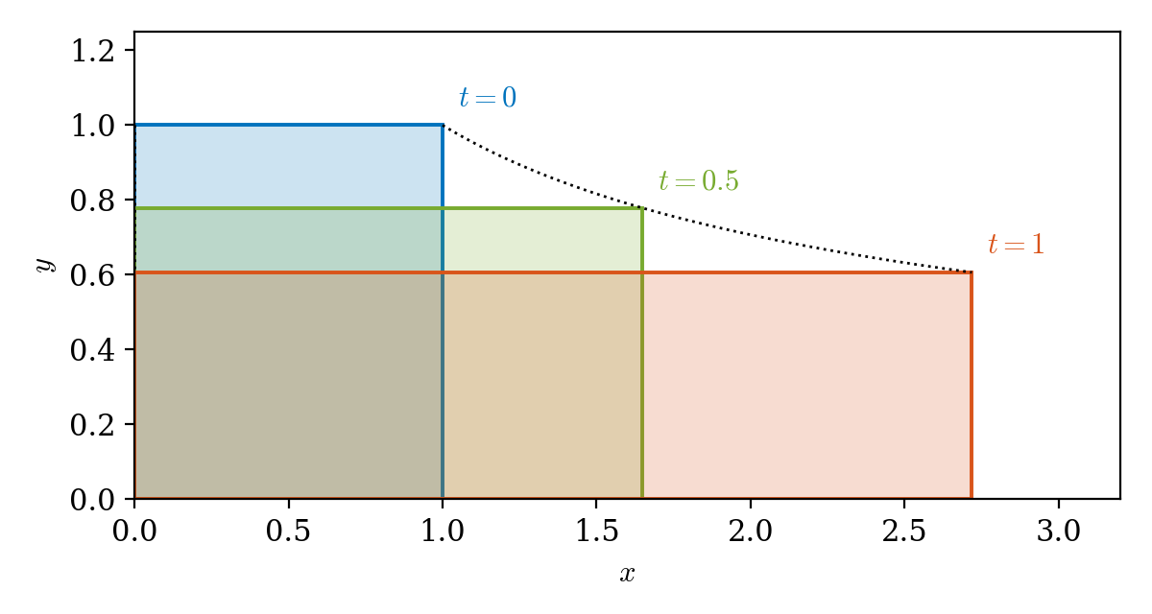
(b) The Jacobian matrix is diagonal, so
$$J=∣\begin{matrix}e^{t} & 0 & 0 \\ 0 & e^{−t/2} & 0 \\ 0 & 0 & 1\end{matrix}∣=e^{t/2}.$$
Since $J$ does not depend on $X$, we have $\frac{DJ}{Dt}=\frac{dJ}{dt}=1/2e^{t/2}$. Meanwhile, $∇⋅u=1−1/2=1/2$, so
$$J∇⋅u=1/2e^{t/2}=\frac{DJ}{Dt},$$
as required by Euler’s identity Theorem [thm-Euleridentity]. The flow is not incompressible: the volume of the box is $|V(t)|=J|V(0)|=e^{t/2}$, which grows in time.
RemarkA 1D version of Reynolds’ Transport Theorem.subsec-RTT-7 In 1D, Reynolds’ Transport Theorem reduces to an identity known as Leibniz’s rule. This is presented as an exercise in Exercise .2.
RemarkRTT and conserved quantities.subsec-RTT-8 Reynolds’ Transport Theorem is particularly useful when the integral quantity
B=V(t)​f dx dy dz
is a conserved quantity. A conserved quantity is something for which we can apply a principle of conservation. In practice for this course, this is usually mass or linear momentum:
- Mass: $f=ρ$ and the left-hand side of ([eqn-RTT]) is zero because mass is conserved.
- Linear momentum: $f=ρu$ is now a vector quantity and, by Newton’s second law, the left-hand side of ([eqn-RTT]) equals the sum of all the forces acting on the fluid in the material volume $V(t)$, which are:
  - Surface forces: Forces acting on the surfaces of the fluid, which could be reaction forces from the walls of a container, or forces due to pressure or stress from surrounding fluid. (Note that we will cover stress in Chapter [ch-viscousflows].)
  - Body forces: Forces acting over the interior of the fluid, and in this course you will usually only need to consider the force of gravity, although in principle other body forces could act such as an electromagnetic force. In addition, if working in a non-inertial frame of reference, other apparent forces need to be added (forces due to linear acceleration, angular acceleration and the Coriolis and centrifugal forces).
SectionConservation of massConservation of massch-chapter03-equations-4
Our task in this section is to prove the following equation for the conservation of mass of a fluid:
TheoremContinuity equation.thm-mass The differential form of the law of conservation of mass, otherwise known as the continuity equation, is
$$\frac{∂ρ}{∂t}+∇⋅(ρu)=0,$$
where $ρ=ρ(x,t)$ is the density of the fluid and $u=u(x,t)$ is the velocity of the fluid.
The above form is equivalent, on expanding $∇⋅(ρu)$ and using the definition of the material derivative, to
$$\frac{Dρ}{Dt}+ρ(∇⋅u)=0.$$
In fact, as it turns out, the proof of this result is trivial if we use Reynolds’ Transport Theorem and Lagrangian formulation following Theorem [thm-RTT].
Proof. Proofch-chapter03-equations-4-2-4 Consider the mass contained in an arbitrary material volume $V(t)$,
V(t)​ρ dV.
Since $V(t)$ always consists of the same fluid particles, conservation of mass requires that this mass does not change in time, i.e. its time derivative is zero.
By Reynolds’ Transport Theorem (Theorem [thm-RTT]), we can pass the time derivative through the integral. This gives
0=ddtV(t)​ρ dV=V(t)​∂ρ∂t+∇⋅(ρu) dV.
Since this holds for every material volume $V(t)⊆D$, the bump lemma (Lemma [lem-bump]) implies that the integrand must be zero. This gives ([eqn-consvmass1]).
The proof of ([eqn-consvmass2]) follows immediately from application of the definition of the material derivative ([eqn-DDt]). ◻
Within the above proof, we use an idea used throughout this chapter, which is that if an integral of a quantity (the integrand) is zero for all possible domains of integration, then the integrand, itself, is zero. This is sometimes referred to as the "Bump lemma".
LemmaBump lemma.lem-bump Let $f(x)$ be a sufficiently smooth function defined on $Ω⊆R^{n}$. Suppose it is the case that
V​f(x) dV=0,
for all $V⊆Ω$. Then
$$f(x)≡0$$
in $Ω$.
In Exercise .1, you will prove the above lemma.
SubsectionDerivation of mass conservation using Eulerian methodsDerivation of mass conservation using Eulerian methodsch-chapter03-equations-4-3 The derivation we have just shown for Theorem [thm-mass], using the Lagrangian viewpoint and Reynolds’ Transport Theorem, is deceptively simple, and it is instructive to see how the result is proved purely from the perspective of Eulerian coordinates.
For this, let us consider $V$ to be a fixed and closed subregion of the overall fluid, $D$, that does not change with time. An illustration of this is shown in Figure [fig-normalvolume].
FigureThe fixed fluid volume, $V$ (blue), with boundary $∂V$. On a small patch of the boundary, the velocity $u$ has normal component $u⋅n$, where $n$ is the outward unit normal; this gives the outward flux.fig-normalvolume
0.20.60.2 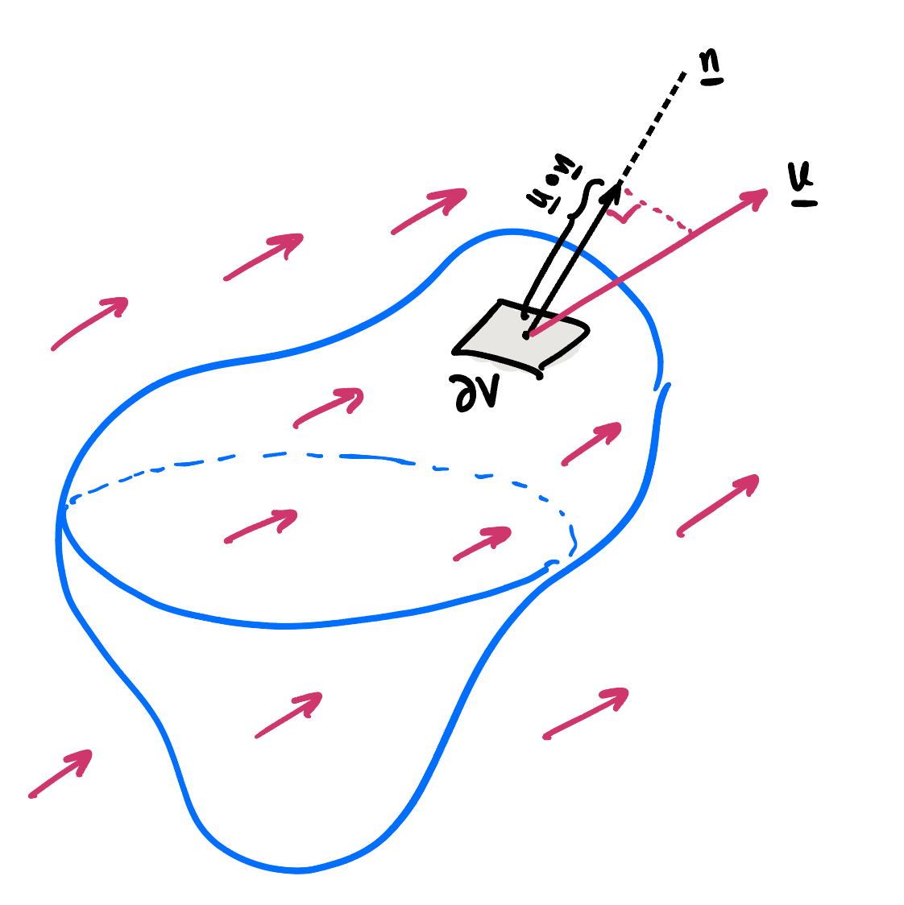
We want to prove the following result, which essentially equates the change in mass, due to density changes, to the flow of mass in or out of the volume.
TheoremIntegral form of the law of conservation of mass.ch-chapter03-equations-4-3-6 Given a fixed volume $V$ with boundary $∂V$, the integral form of the law of mass conservation is
ddtV​ρ dV=−∂V​ρu⋅n dS.
Proof. Proofch-chapter03-equations-4-3-6-3 The rate of change of mass in $V$ is
ddtV​ρ(x,t) dV=V​∂ρ∂t dV,
and note the derivative passes through the integral since the volume, $V$, does not change with time.
Let the boundary of $V$ be given by $∂V$, and let $n$ denote the outward unit normal defined along the boundary $∂V$. At each point on the boundary, the volume flow rate per unit area (known as the flux) across the boundary is given by $u⋅n$, and therefore the mass flow rate per unit area is $ρu⋅n$.
We now sum the total mass flow across the entire boundary. This is given by the surface integral
rate of mass flow outward across ∂V=∂V​ρu⋅n dS.
The flux out of the boundary is also sketched in Figure [fig-normalvolume].
Finally, we apply mass conservation: the rate of change of mass in $V$ must equal the rate at which mass flows inward across $∂V$. Since the surface integral above measures the outward flow, this gives the minus sign in ([eqn-integralconservation]). ◻
We now want to transform the integral form in ([eqn-integralconservation]) into the form of a partial differential equation. To do this, apply the Divergence theorem to the right-hand side of the above integral, converting the surface integral to a volume integral. Moving all quantities to the left-hand side now yields
V​∂ρ∂t+∇⋅(ρu) dV=0.
Since the above integral equation holds for all possible $V$, it must be equivalent to the integrand equated to zero (Lemma [lem-bump]). This recovers the continuity equation of Theorem [thm-mass].
SubsectionCorollary of the Transport TheoremCorollary of the Transport Theoremsubsec-cor-consvmass There is a useful corollary to Reynolds’ Transport Theorem (Theorem [thm-RTT]) in the case where the integrand is proportional to the density, i.e. $f=ρh$.
Corollarycor-convmass Let $V(t)$ be a material volume, let $ρ$ satisfy the continuity equation ([eqn-consvmass1]), and let $h(x,t)$ be any continuously differentiable function. Then
ddtV(t)​ρh dV=V(t)​ρDhDt dV.
Proof. Proofcor-convmass-2 This proof just follows from expansion. Pass the derivative through the integral and use the formula of Reynolds’ Transport Theorem. Then expand the quantity:
$$∇⋅(fu)=∇f⋅u+f∇⋅u,$$
where $f=ρh$. Finally use the continuity equation on $ρ$. ◻
SectionMomentum balanceMomentum balancesubsec-euler-momentum
With mass conservation now handled, we turn our eyes towards a law that governs the conservation of momentum. This is Newton’s second law: the rate of change of momentum of a body is equal to the sum of all forces acting on the body.
Our task in this section is to prove the following equation for the conservation of momentum of a fluid:
TheoremMomentum equation.thm-momentum The differential form of the law of conservation of momentum is
$$ρ\frac{Du}{Dt}=ρ\left(\frac{∂u}{∂t}+(u⋅∇)u\right)=−∇p+ρg,$$
where $ρ=ρ(x,t)$ is the density of the fluid, $u=u(x,t)$ is the velocity of the fluid, $p=p(x,t)$ is the pressure, and $g$ is the acceleration due to a body force (typically gravity).
Note that the term $(u⋅∇)u$ above can also be written as $u⋅∇u$, using the notation $∇u$ for the gradient of a vector. This is explained in Remark [remark-vector-gradient].
SubsectionProof of the momentum equation for an inviscid fluidProof of the momentum equation for an inviscid fluidsubsec-euler-momentum-3 Consider again a material volume $V(t)$ of the fluid. Then the rate of change of net momentum of this volume is equal to
ddtV(t)​ρu(x,t) dV.
It is helpful to remember that the mass of a volume element is $ρdV$ and the acceleration of a fluid particle is $\frac{Du}{Dt}$, so the above is similar to mass times acceleration. However, we work with the more general form above to allow for changes in the density throughout the fluid, and also for variable fluid elements, $V(t)$.
We must equate the above to the sum of all surface and body forces applied to the fluid element.
An example of a body force is the force of gravity. For a small volume element of mass $ρdV$, the force of gravity is equal to $(ρdV)g$. Therefore, the total external force due to gravity on the volume is equal to
V(t)​ρg dV.
There may be other external body forces. For example, if your fluid is electrically conductive (like a plasma), there may be electromagnetic forces that must be considered. In any case, $g$ can be considered as the analogous body force per unit mass.
The final type of forces we should consider are surface forces, which are applied to the boundary of the fluid element, denoted $∂V$. Let us assume that at each point on the boundary, there is a surface force per unit area, $F$, that decomposes into a component normal to the boundary, $F_{n}n$, and a component tangential to the boundary, $F_{t}t$. So the surface forces, summed over the boundary, will be
∂V​Fnn+Ftt dS.
In the above, the interpretation is that the force on a small patch of surface area $dS$ is equal to the per-area force, say $F_{n}$, multiplied by the area, then directed into the normal direction, $n$.
At this point, we make a key assumption that is applied in the particular case of inviscid fluids.
TheoremForces in inviscid fluids.thm-inviscid-force In the case of inviscid fluids, we assume that the surface force exerted on (interior) volume elements is accounted for solely by a pressure, $p$, which acts in the inward normal direction at each point, with
$$F_{n}n=−pn.$$
Consequently, the surface force, given by ([eqn-momentum-force]), is
∂V​(−p)n dS=V​(−∇p) dV.
In particular, for the case of inviscid fluids, we ignore tangential internal forces.
Proof. Proofthm-inviscid-force-3 The divergence theorem in its usual form applies to the flux of a vector field, ∂V​F⋅n dS=V​∇⋅F dV, whereas the left-hand side of ([eqn-momentum-pressure]) is a vector. We therefore take its dot product with an arbitrary constant vector $c$, which reduces the problem to scalars.
Since $c$ is constant, it may be moved inside the integral, giving
c⋅∂V​(−p)n dS=∂V​(−pc)⋅n dS.
Now apply the divergence theorem with $F=−pc$. Again using that $c$ is constant, $∇⋅(−pc)=−c⋅∇p$, and hence
∂V​(−pc)⋅n dS=V​(−c⋅∇p) dV=c⋅V​(−∇p) dV.
Combining the two results,
c⋅∂V​(−p)n dS−V​(−∇p) dV=0.
This holds for every constant vector $c$. Choosing $c=e_{1},e_{2},e_{3}$ in turn shows that each component of the bracketed vector is zero, so the vector itself is zero, which is ([eqn-momentum-pressure]). ◻
Finally, summing the forces above, Newton’s second law gives
ddtV(t)​ρu(x,t) dV=−V(t)​∇p dV+V(t)​ρg dV.
We can now apply Corollary [cor-convmass] to each component of momentum, taking $h=u,v,w$ in turn (i.e. $f=ρu,ρv,ρw$). This allows us to conclude that
V(t)​ρDuDt+∇p−ρg dV=0.
Again, the above holds for all material volumes $V(t)$ and therefore it must follow that the integrand is zero. We conclude thus with the following result as stated in Theorem [thm-momentum]:
$$ρ\frac{Du}{Dt}=−∇p+ρg.$$
In Exercise .3, you will practise the derivation of the mass and momentum equations.
SectionThe Euler equationsThe Euler equationssec-incompressible
The conservation laws derived so far, for mass (Theorem [thm-mass]) and momentum (Theorem [thm-momentum]), hold for any inviscid fluid, but they do not yet form a closed system: there are more unknowns than equations. In this section, we close the system by introducing the notion of an incompressible fluid and, in particular, assuming that the density is constant. The result is the Euler equations, first written down by Leonhard Euler in 1757. Together with the boundary conditions at the end of this section, they form a complete mathematical model of an ideal liquid.
The Euler equations are the central model for much of this course. In Section [sec-bernoulli], we integrate them to obtain Bernoulli’s equation, which links pressure to velocity. When the flow is also irrotational, they reduce to Laplace’s equation for a velocity potential, which is the basis of Chapter [ch-chapter04-potentialflows] and the water wave theory of Chapter [ch-chapter05-waves]. Finally, in Chapter [ch-viscousflows], the Euler equations are extended to the Navier–Stokes equations by adding the effects of viscosity.
SubsectionIncompressible fluids and the Euler equationsIncompressible fluids and the Euler equationssec-incompressible-3 Recall from Theorem [thm-jacobian] and the proof of Reynolds’ Transport Theorem that the Jacobian relates infinitesimal volumes in the Eulerian and Lagrangian frames via
$$dxdydz=JdXdYdZ.$$
So the Jacobian is a measure of the local expansion or contraction of a fluid (relative to its original state). Combining this with Euler’s identity (Theorem [thm-Euleridentity]), we are led to an important interpretation for what it means for a fluid to satisfy $∇⋅u=0$. This leads us to defining the notion of an incompressible fluid. (You have already encountered an intuitive definition for an incompressible flow as part of Exercise .1).
TheoremIncompressible fluids.def-incompressible A fluid is said to be incompressible if it preserves infinitesimal volumes. Since such volumes are related via ([eq-dxyz-Jacobian]), then this is equivalent to
$$\frac{DJ}{Dt}≡0,$$
within the relevant fluid (and temporal) domain.
The following equivalence (iff) then follows:
$$\text{Fluid is incompressible} ⇔ ∇⋅u=0.$$
Proof. Proofdef-incompressible-3 Note that if $\frac{DJ}{Dt}=0$, then indeed an infinitesimal volume element must have constant volume for all time according to ([eq-dxyz-Jacobian]). Then by Euler’s identity in Theorem [thm-Euleridentity], this implies $∇⋅u=0.$ Conversely, if $∇⋅u=0$, then again by the identity the fluid is incompressible. ◻
So in conclusion, for an incompressible fluid, the mass conservation equation of Theorem [thm-mass] reduces to
$$∇⋅u=0,$$
together with $\frac{Dρ}{Dt}=0$, as shown in the corollary below. If, in addition, the density is constant, then it suffices to solve ([eqn-divu]).
To see this, consider what happens to the mass conservation equation in Theorem [thm-mass] if the fluid is incompressible. This leads to the following corollary.
CorollaryConstant density following the flow.cor-incompressible-density For an incompressible fluid, the density of each fluid particle is constant in time (i.e. constant along particle paths):
$$\frac{Dρ}{Dt}=\frac{∂ρ}{∂t}+(u⋅∇)ρ=0.$$
Proof. Proofcor-incompressible-density-3 This follows from setting $∇⋅u=0$ in ([eqn-consvmass2]). ◻
Let us now count equations and unknowns. We have the scalar mass conservation equation of Theorem [thm-mass] (or alternatively the simpler equation ([eqn-divu]) for incompressible fluids), together with the vector momentum equation of Theorem [thm-momentum]. This yields four scalar equations for five unknowns: the pressure $p$, density $ρ$, and the three velocity components $u$.
One way of proceeding is to attempt to establish or to intuit a relationship between pressure and density. For instance, for a gas, one may use the ideal gas law, $p=RTρ$ (which can be derived from kinetic theory and is well supported empirically), relating pressure linearly to density, and depending on the temperature, $T$, and a (gas) constant $R$. Other assumptions of the form $p=p(ρ)$ are possible, and this is involved in the study of gases and compressible fluids.
However, empirically, we observe that in most liquids, the density only varies within a few percent under typical variations of temperature and pressure. Therefore, it is common to assume:
NoteConstant density assumption.sec-incompressible-3-10 For liquids, we often assume that the density is constant, $ρ=\text{constant}$.
Note, then, that in the case of constant-density fluids, if we consider the mass conservation equation ([eqn-consvmass1]), it follows that $∇⋅u=0$. Therefore, from the definition Theorem [def-incompressible], we conclude that the fluid is indeed incompressible.
Remarksec-incompressible-3-12 Confusingly, many references define a fluid to be incompressible if $ρ$ is constant. However, incompressibility does not require constant density: a fluid can be incompressible, so that $\frac{Dρ}{Dt}=0$, without $ρ$ being constant. An example is the ocean, where density varies with depth due to salinity and temperature.
We are finally ready to state the Euler equations.
DefinitionEuler equations.def-euler The Euler equations consist of the incompressibility condition ([eqn-divu]) and the momentum equations ([eqn-consvmoment]), considered in the situation of an incompressible fluid of constant density:
$$\begin{aligned}∇⋅u&=0, \\ \left(\frac{∂u}{∂t}+(u⋅∇)u\right)&=−\frac{1}{ρ}∇p+g.\end{aligned}$$
These are four scalar equations for four unknowns: the three components of $u$ and the pressure $p$. Although incompressibility does not in general require constant density (see the remark above), in this course we shall take incompressible fluids to have constant density, $ρ$. The above Euler equations include the (gravitational) body force $g$.
Simple applications of the Euler equations are given in Exercise .4 and Exercise .5.
You will consider the derivation of the Euler equations as part of Exercise .3.
ExampleComputer graphics and fluid simulations.sec-incompressible-3-17 There is a long-standing link between the research field of fluid mechanics and the entertainment field, where cutting-edge applications in animation, movie, and video-game graphics use ideas from fluid mechanics to model fluids. Many fluid simulators will use things like the Euler equations (or simplified versions of them) to simulate fluids. In some cases, such simulations can even happen in real time. Here is an example of a real-time Euler equation solver coded in JavaScript.
SubsectionBoundary conditionsBoundary conditionssubsec-euler-BCs A great deal of the complexity of fluid motion comes from the conditions that we must consider between the fluid and its bounding surfaces. For water in the ocean, bounding surfaces might range from the ocean floor and the hull of a boat, down to the vegetation in the water or the sand on a beach. This can get quite complex! In this module, and when we first learn fluid dynamics, we only consider simple bounded fluid regions (fluid above a plate, fluid in a box, fluid in a channel, etc.).
In the case of a water wave, a bounding surface will also include the free surface of the wave, itself, which interacts with the surrounding atmospheric gas. This leads to the situation of free-boundary or free-surface conditions.
At a solid boundary, we impose the following condition.
NoteNo-flux condition through a boundary.note-noflux-BC For a fluid in contact with a fixed rigid boundary, $∂V$, we require that the normal velocity of the fluid there must be zero:
$$u⋅n=0 \text{on }∂V,$$
where $n$ is the unit normal to $∂V$. This condition states that the fluid cannot flow through $∂V$ or separate from $∂V$ (hence leaving a vacuum).
It turns out that the above no-flux condition is sufficient to provide well-posed boundary conditions for most inviscid fluids. Note that in particular, we have not constrained the tangential velocity of the fluid, i.e. $u⋅t$, where $t$ is any tangent vector to the boundary.
Later in Chapter [ch-viscousflows], you will study the situation of a viscous fluid, where it will be important to consider the tangential fluid velocity.
SectionBernoulli’s equationBernoulli’s equationsec-bernoulli
The Euler equations are a system of nonlinear partial differential equations, in which the velocity $u$ and the pressure $p$ are coupled together. Solving them in general is difficult. In many problems of interest, however, the velocity can be found by other means. For example:
- in flow through a pipe or out of a tank, mass conservation often determines the speed;
- in Chapter [ch-chapter04-potentialflows], the velocity follows from solving Laplace’s equation;
- in Chapter [ch-chapter05-waves], the motion of the free surface is linked to the velocity by a kinematic condition.
In each case, the remaining task is to find the pressure, for instance to calculate the force on a body, or to impose that the pressure is atmospheric at a free surface.
Bernoulli’s equation does exactly this. It is a first integral of the momentum equation: rather than a differential equation, it is an algebraic relation between the pressure, the speed and the height of the fluid,
$$B=\frac{p}{ρ}+\frac{1}{2}|u|^{2}+χ.$$
In this section, we first rewrite the momentum equation in a form from which $B$ emerges naturally. We then show that, under different assumptions, $B$ is constant along streamlines, constant everywhere, or a function of time only. Finally, we apply these results to some practical problems.
SubsectionA first integral of the momentum equationA first integral of the momentum equationsubsec-bernoulli-first-integral We will first need a vector identity.
Identityident-ugradu Note the following identity:
$$(u⋅∇)u=∇\left(\frac{1}{2}|u|^{2}\right)+(∇×u)×u.$$
Proof. Proofident-ugradu-2 The proof follows from direct expansion of both sides. ◻
The second term on the right-hand side involves the curl of the velocity, which has its own name.
DefinitionVorticity.def-vorticity The vorticity, $ω$, of the velocity field $u$ is defined by
$$ω≡∇×u.$$
The vorticity is a measure of the local rotation of the flow.
DefinitionIrrotational flows.def-irrotational A flow is said to be irrotational if the vorticity is identically zero:
$$\text{flow is irrotational}⇔ω=∇×u≡0.$$
In Chapter [ch-chapter04-potentialflows], we will show that an irrotational flow in a simply connected region can always be written as $u=∇ϕ$ for some scalar function $ϕ$, called the velocity potential (Theorem [thm-exist-potential]). We use this fact below.
Let us recall the definition of a conservative force.
DefinitionConservative forces.def-conservative-force A force $F$ is a conservative force if and only if there exists a potential $χ$, such that
$$F=−∇χ,$$
in a simply connected region where the quantities are defined.
Note the restriction to a simply connected region. The above is not quite the usual definition of a conservative force (typically defined to be a force for which the work done on an object between two points is independent of path). For now, this is not an important distinction since we will focus on fluid regions that are free of holes. Until told otherwise, we will always assume that the fluid is simply connected and therefore the above serves as a definition of conservative forces.
Remarksubsec-bernoulli-first-integral-11 For the typical gravity force directed in the $−z$ direction, we can write $g=−g[0,0,1]=−ge_{z}$. So in this case, the (gravitational) potential is $χ=gz$.
TheoremThe momentum equation in Bernoulli form.thm-bernoulli-form Consider an inviscid, incompressible fluid of constant density $ρ$, subject to a conservative body force $g=−∇χ$. Define the Bernoulli function
$$B(x,t)≡\frac{p}{ρ}+\frac{1}{2}|u|^{2}+χ.$$
Then the momentum equation ([eqn-euler-momentum]) can be written as
$$\frac{∂u}{∂t}+ω×u=−∇B.$$
Proof. Proofthm-bernoulli-form-3 Start from the momentum equation ([eqn-euler-momentum]), with $g=−∇χ$,
$$\frac{∂u}{∂t}+(u⋅∇)u=−\frac{1}{ρ}∇p−∇χ.$$
Using the vector identity ([eqn-ugradu]), and noting that $\frac{1}{ρ}∇p=∇(p/ρ)$ since $ρ$ is constant, gives
$$\frac{∂u}{∂t}+(∇×u)×u=−∇\left(\frac{p}{ρ}+\frac{1}{2}|u|^{2}+χ\right).$$
Using the definitions of the vorticity ([eqn-vorticity]) and of $B$ ([eqn-bernoulli-B]) gives the result. ◻
Every version of Bernoulli’s equation follows from ([eqn-bernoulli-vorticity]) by removing terms from the left-hand side.
AsideRemoved in 2026.subsec-bernoulli-first-integral-14 In previous years, this section also derived the vorticity equation, $\frac{Dω}{Dt}=(ω⋅∇)u$, which describes how vorticity evolves in an inviscid fluid. This was removed from the notes in 2026 and is no longer part of the course.
SubsectionThree forms of Bernoulli’s equationThree forms of Bernoulli’s equationsubsec-bernoulli-forms Table [table-bernoulli-forms] summarises the three forms of Bernoulli’s equation derived in this subsection, together with where each is used in the course. In each case, the assumptions of Theorem [thm-bernoulli-form] also apply.
TableThe three forms of Bernoulli’s equationtable-bernoulli-forms
Additional assumptions | Conclusion | Used in
Steady | $B$ is constant along each streamline | [subsec-bernoulli-applications]
Steady and irrotational | $B$ is constant everywhere | [ch-chapter04-potentialflows]
Irrotational, possibly unsteady | $\frac{∂ϕ}{∂t}+B=F(t)$ everywhere | [ch-chapter05-waves]
TheoremBernoulli’s equation for steady flow.thm-bernoulli-steady For a steady flow,
$$B(x)=\frac{p}{ρ}+\frac{1}{2}|u|^{2}+χ=\text{constant along streamlines}.$$
Proof. Proofthm-bernoulli-steady-3 Since the flow is steady, the first term of ([eqn-bernoulli-vorticity]) vanishes. This leaves
$$ω×u=−∇B.$$
We now take the dot product of both sides of the equation with $u$. We use the fact that,
$$u⋅(ω×u)=0,$$
since it is a triple scalar product with two repeated entries. It therefore results in the fact that
$$u⋅∇B=0.$$
Since $B$ does not depend on time, $\frac{DB}{Dt}=u⋅∇B$, so this states that $\frac{DB}{Dt}=0$. Hence $B$ is constant along streamlines of the flow (which, for steady flow, coincide with particle paths). ◻
TheoremBernoulli’s equation for steady irrotational flow.thm-bernoulli-potential For a steady and irrotational flow,
$$B(x)=\frac{p}{ρ}+\frac{1}{2}|u|^{2}+χ=\text{constant everywhere}.$$
Proof. Proofthm-bernoulli-potential-3 For steady flow, the first term of ([eqn-bernoulli-vorticity]) vanishes. If, in addition, the flow is irrotational, then $ω=0$, and therefore
$$∇B=0.$$
Since all spatial derivatives of $B$ are zero, $B$ is constant throughout the (connected) fluid domain. ◻
TheoremBernoulli’s equation for unsteady potential flow.thm-bernoulli-unsteady-potential For an irrotational, possibly unsteady, flow with velocity potential $ϕ$, so that $u=∇ϕ$,
$$\frac{∂ϕ}{∂t}+\frac{1}{2}|∇ϕ|^{2}+\frac{p}{ρ}+χ=F(t),$$
for some function $F(t)$.
Proof. Proofthm-bernoulli-unsteady-potential-3 Set $ω=0$ and $u=∇ϕ$ in ([eqn-bernoulli-vorticity]). Since space and time derivatives commute, $\frac{∂}{∂t}(∇ϕ)=∇\left(\frac{∂ϕ}{∂t}\right)$, and so
$$∇\left(\frac{∂ϕ}{∂t}+\frac{1}{2}|∇ϕ|^{2}+\frac{p}{ρ}+χ\right)=0.$$
The quantity in brackets therefore has no spatial dependence, i.e. it is a function of $t$ alone. ◻
RemarkThe function $F(t)$.subsec-bernoulli-forms-7 The function $F(t)$ can be absorbed into the potential. Replacing $ϕ$ by $ϕ−∫F dt$ does not change the velocity $u=∇ϕ$, but sets $F≡0$. Equivalently, $F(t)$ may be chosen for convenience, as is done in Chapter [ch-chapter05-waves].
RemarkConstant $B$ on every streamline.subsec-bernoulli-forms-8 In the steady case, $B$ can be constant everywhere even when the flow is not irrotational. This happens in many practical problems, where every streamline starts in a large reservoir in which the fluid is at rest, so that $B$ takes the same value on every streamline.
SubsectionApplicationsApplicationssubsec-bernoulli-applications In each example below, we state which form of Bernoulli’s equation is used and why its assumptions hold.
ExampleHydrostatics and Pascal’s bursting barrel.ex-bernoulli-hydrostatics For a fluid at rest, $u=0$. The flow is then trivially steady and irrotational, so Theorem [thm-bernoulli-potential] gives
$$\frac{p}{ρ}+gz=\text{constant everywhere}.$$
If the free surface is at $z=H$, where $p=p_{\text{atm}}$, then
$$p=p_{\text{atm}}+ρg(H−z).$$
The pressure at depth $d=H−z$ is $p_{\text{atm}}+ρgd$. It depends only on depth, not on the shape of the container or the amount of fluid above.
This explains Pascal’s bursting barrel. A long thin vertical tube is attached to a sealed barrel full of water, and the tube is then filled. Although the column in the tube holds very little water, it raises the pressure throughout the barrel by $ρgh$. For a $10$ m column, that is about ${10}^{5}$ Pa, roughly one atmosphere. Acting on a lid of diameter $0.5$ m, this is a force of about $2×{10}^{4}$ N, the weight of roughly two tonnes.
Watch this short video demonstration from Princeton, showing the power of hydrostatic pressure.
ExampleTorricelli’s law.ex-bernoulli-torricelli A large open tank of cross-sectional area $A$ holds water of depth $h(t)$ above a small hole of area $a≪A$ in its base.
- Find the speed $u$ of the jet leaving the hole.
- If the initial depth is $h_{0}$, find the time for the tank to drain.
Solution.(a) The free surface falls at speed $U$, where mass conservation gives $AU=au$, so $U/u=a/A≪1$. The flow therefore changes slowly, and we treat it as steady. Taking a streamline from the free surface ($z=h$) to the jet ($z=0$), where the pressure is atmospheric at both ends, Theorem [thm-bernoulli-steady] gives
$$\frac{p_{\text{atm}}}{ρ}+\frac{1}{2}U^{2}+gh=\frac{p_{\text{atm}}}{ρ}+\frac{1}{2}u^{2}.$$
Using $U=(a/A)u$,
$$u=\sqrt{\frac{2gh}{1−(a/A)^{2}}}≈\sqrt{2gh}.$$
This is Torricelli’s law (1643): the jet leaves at the speed of a particle falling freely from height $h$.
(b) Mass conservation gives
$$A\frac{dh}{dt}=−a\sqrt{2gh}.$$
Separating variables and using $h(0)=h_{0}$ gives
$$\sqrt{h}=\sqrt{h_{0}}−\frac{a}{A}\sqrt{\frac{g}{2}} t,$$
so the tank empties at time
$$T=\frac{A}{a}\sqrt{\frac{2h_{0}}{g}}.$$
In practice, the jet from a sharp-edged hole contracts just after leaving it (the vena contracta), and the measured flow rate is about $0.6$ of this prediction.
You will practise an application of Bernoulli’s equation in Exercise .6, which combines the calculation of Example [ex-bernoulli-torricelli] with a choice of jar shape that makes the water level fall at a constant rate.
ExampleUrination across species.subsec-bernoulli-applications-6 Watch this short video describing the work by Yang et al. on "Duration of urination does not change with body size".
Yang et al. model the bladder as a pressurised reservoir that drains through a long, narrow tube, the urethra. Applying Bernoulli’s equation between the bladder and the exit of the urethra, gravity acting over the length of the urethra adds to the bladder pressure, much as the depth $h$ drives the jet in Torricelli’s law (Example [ex-bernoulli-torricelli]). Larger animals have longer urethras, so urine leaves faster, which compensates for their larger bladders. As a result, the duration of urination is roughly the same, about $21$ s, for animals heavier than about $3$ kg. For smaller animals, viscosity and surface tension dominate and urine is released as drops, so this argument no longer applies.
ExampleThe limits of Bernoulli’s equation: airflow into or out of a room.subsec-bernoulli-applications-7 Watch this short video by Matthias Wandel about airflow into and out of a room.
Bernoulli’s equation treats flow into and out of an opening in the same way, but in practice the two look very different. Air pushed out through an opening forms a narrow jet that travels a long way, whereas air drawn in through an opening arrives from all directions. The difference comes from the flow separating at the edges of the opening, a viscous effect that inviscid theory cannot capture. We meet viscosity in Chapter [ch-viscousflows].
ExercisesExercisesExercisesws-equations
RemarkSolutions and feedback.remark-solutions-feedback-equations Full solutions to these exercises can be found in the solutions to this chapter [solutions-equations] in Appendix [solutions] at the back of the book.
If you would like feedback on your work, the tutor will by default concentrate on the exercises highlighted with a yellow background in the online notes (the homework exercises), unless you specifically ask for feedback on a different exercise instead.
This chapter focused on deriving the conservation laws for a fluid from first principles using vector calculus, leading to the Euler equations for an inviscid and incompressible flow. We then studied different forms of the Euler equations and their consequences.
AsideRemoved in 2026.ws-equations-1-3 A problem on deriving the vorticity equation was removed from this set of exercises in 2026, as the vorticity equation is no longer part of the course.
Within our derivations of the governing equations, we often make use of the so-called "Bump lemma" given in Lemma [lem-bump].
Give a proof of the lemma. Reynolds’ Transport Theorem Theorem [thm-RTT], which relates to the passage of a time derivative through an integral, is a general form of the 1D Leibniz rule:
$$\begin{align}
\frac{\mathrm{d}}{\mathrm{d}t} & \int_{a(t)}^{b(t)} f(x, t) \, \mathrm{d}{x} \notag\\
& = \int_{a(t)}^{b(t)} \frac{\partial f}{\partial t} \, \mathrm{d}{x} +
f(b(t), t) \dot{b}(t) - f(a(t), t)\dot{a}(t).\label{eqn-leibnitz-rule}
\end{align}$$
- Examine the figure in Figure [ex-fig-leibnitz]. Can you associate the quantities in Leibniz’s rule with the circled elements in the figure?
- FigureVisual "proof" of Leibniz’s ruleex-fig-leibnitz
- 0.050.90.05 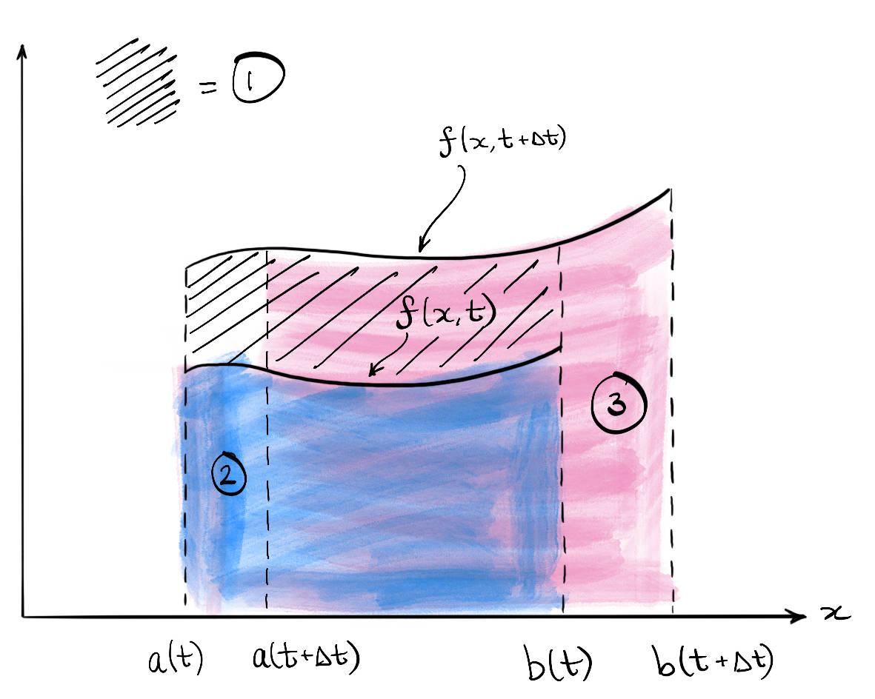
- Derive Leibniz’s rule ([eqn-leibnitz-rule]). You may assume that $f$ and $\frac{∂f}{∂t}$ are continuous, and that $a(t)$ and $b(t)$ are differentiable.
- Hint.Let $I(t)=\int_{a(t)}^{b(t)}{f}(x,t) dx$ and start from the definition of the derivative,
$$\frac{dI}{dt}=\lim_{Δt→0}\frac{I(t+Δt)−I(t)}{Δt}.$$
- Write $I(t+Δt)$ as an integral from $a(t+Δt)$ to $b(t+Δt)$, and split it into three integrals: one over the fixed interval $[a(t),b(t)]$, and one over each of the two small intervals near the end points. These correspond to the three circled regions in Figure [ex-fig-leibnitz]. For small $Δt$, the two small intervals are narrow, so each of their integrals can be approximated by the area of a single rectangle.
- A fully rigorous proof is not required here. It is fine to use approximations such as these, provided you explain why they become exact as $Δt→0$.
- Can you now connect the form of the rule in ([eqn-leibnitz-rule]) to the Reynolds’ Transport Theorem in ([eqn-RTT])?
This is a re-derivation of what is already presented in the notes, giving you valuable practice to understand the concepts.
Starting from conservation of mass and momentum for a material volume moving in an inviscid fluid, use Reynolds’ Transport Theorem ([eqn-RTT]) to derive the equations:
$$\begin{matrix}\frac{∂ρ}{∂t}+∇⋅(ρu)=0, \\ \frac{Du}{Dt}=−\frac{1}{ρ}∇p+g.\end{matrix}$$
What additional assumptions are required to transform the set of equations to the Euler equations of Definition [def-euler]? Apply these assumptions and conclude with the Euler equations. An inviscid, incompressible fluid of constant density $ρ$, in a gravitational field with acceleration vector $g=−gk$ (with $k$ being the unit vector in the positive $z$-direction) has uniform velocity
$$u=(a+bt, t^{3}, e^{t}).$$
The pressure at the origin is fixed at $p_{0}$.
- Using the Euler equations in Definition [def-euler], find the pressure field in terms of $x,y,z,t,a,b,g,ρ$ and $p_{0}$.
- What can you say about the surfaces of constant pressure? Sketch this at a fixed time $t$, and hence describe the pressure field.
The piston shown in the diagram below is pushed with a force $F(t)$ into a pipe of length $L$ and cross-sectional area $A$ containing incompressible and irrotational fluid of density $ρ$.
FigureSchematic of piston and pipe system.fig-piston
010 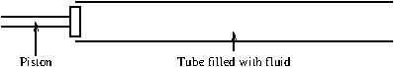
Assume that the pressure at the open end is held at atmospheric pressure, $p=p_{\text{atm}}$.
Assume the fluid moves as a rigid body and neglect friction and the mass of the piston.
Assume that the velocity takes the form of $u=(X(t),0,0)$ at the position of the piston.
Using the Euler equations in Definition [def-euler], write down a differential equation governing the position, $X(t)$, of the piston at time $t$. You may neglect gravity. You do not need to solve the equation (it could be solved using Python or similar). One of the earliest means for measuring the passage of time, invented by the ancient Egyptians, was the clepsydra (or ‘water thief’): a large jar with a hole in its base was filled with water. The shape of the jar was such that the interval of time taken for the water surface to pass two equally-spaced markers on the side of the jar is constant.
FigureClepsydrafig-clepsydra
0.250.50.25 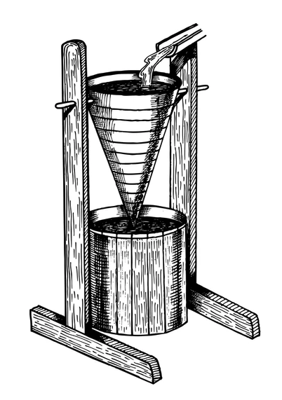
In this question you will determine the shape of jar required to achieve this. In particular, we denote the radius of the (axisymmetric) jar at height $z$ above the hole by $r=a(z)$. Note that, in general, the radius of the hole, $a_{h}$, differs from $a(0)$.
- Explain why the curve $r=a(z)$ is a streamline.
- If the surface of the water lies at $z=h(t)$, use an appropriate form of Bernoulli’s principle to calculate the speed of liquid, $u$, leaving the jar at $z=0$.
- Use the principle of conservation of mass to link $u_{S}$, $u$, $a_{h}$ and $a(h(t))$; thereby determine the correct shape for a clepsydra.
AsideNew in 2026.ex-rtt-stretching-cube-2-1 This exercise is a new addition to the notes in 2026.
This exercise completes Example [ex-rtt-stretching-cube-example]. Consider the steady velocity field $u=\left(x, −1/2y, 0\right)$, and let $V(t)$ be the material volume that initially occupies the unit cube $V(0)=[0,1]^{3}$. From the example, $V(t)=[0, e^{t}]×[0, e^{−t/2}]×[0, 1]$ and the Jacobian is $J=e^{t/2}$. Let
f(x)=x2+y, I(t)=V(t)​f dx dy dz.
- By integrating directly over $V(t)$, compute $I(t)$ and hence $dI/dt$.
- Evaluate the right-hand side of Reynolds’ Transport Theorem ([eqn-RTT]) and confirm that it agrees with your answer to the previous part.
AsideNew in 2026.ex-bernoulli-pitot-2-1 This exercise is a new addition to the notes in 2026. It is optional and not part of the homework.
Aircraft measure their airspeed using a Pitot tube: a thin tube that points forwards into the oncoming air, with its open tip facing the flow. The pressure inside the tube is compared with the pressure of the surrounding air. In the simplest version of the device, shown below, this comparison is made with a U-tube of water (a manometer). One arm of the U-tube is connected to the Pitot tube, and the other arm is open to the surrounding air.
FigureA Pitot tube connected to a U-tube of water. Video © 2008 Cornell University.fig-pitot-cornell
0.20.60.2 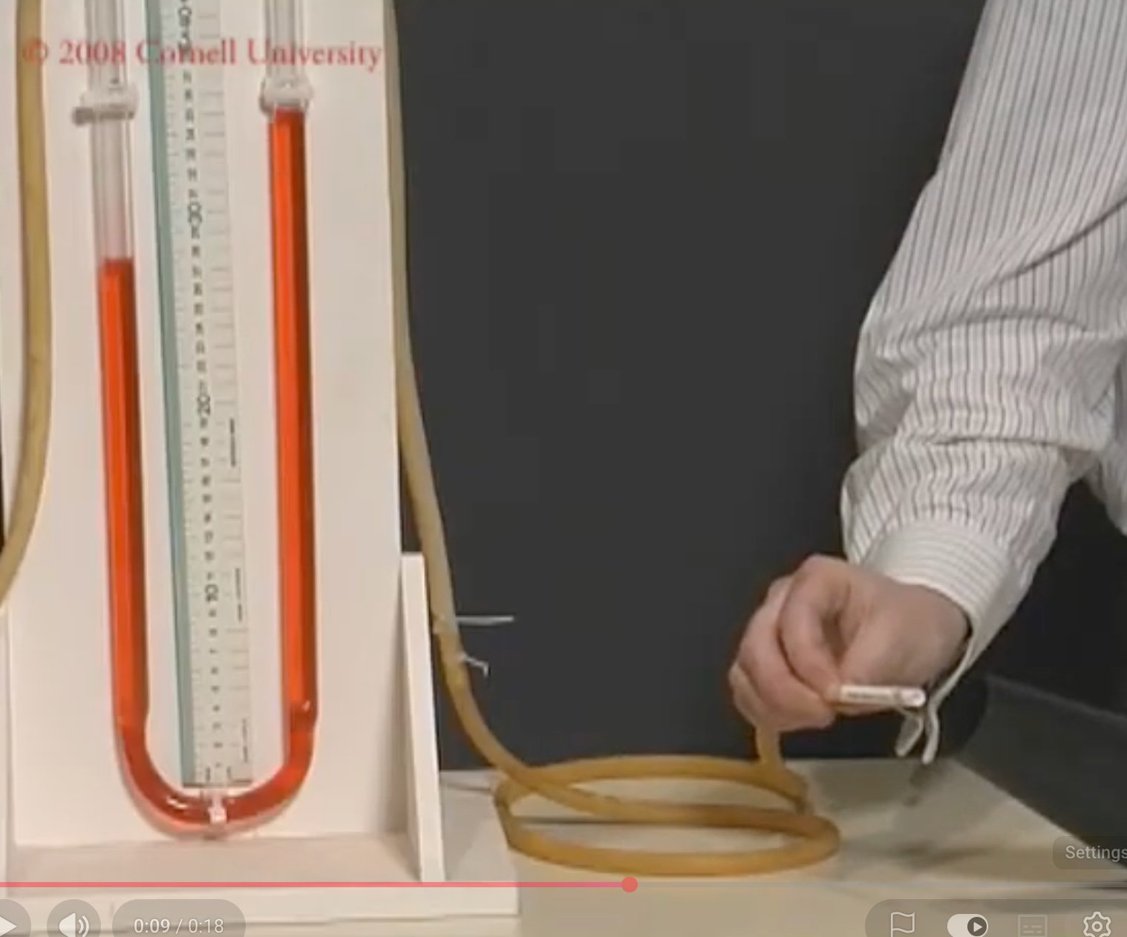
Watch this short video demonstration from Cornell University.
Suppose that air of constant density $ρ_{\text{air}}$ approaches the tip of the tube with uniform speed $U$ and pressure $p_{∞}$. The flow is steady, and the air entering the tube pushes the water down in the arm connected to the tube and up in the open arm. Measured from the same reference level, let the water surface be at height $h_{1}$ in the arm connected to the tube and at height $h_{2}$ in the open arm, so that the height difference is $Δh=h_{2}−h_{1}>0$. The water has density $ρ_{w}$.
- Explain why the air is brought to rest at the open tip of the tube. Hence, use an appropriate form of Bernoulli’s equation to show that the pressure at the tip is
$$p_{0}=p_{∞}+\frac{1}{2}ρ_{\text{air}}U^{2}.$$
- Hint.Follow the streamline that ends at the tip of the tube, where the air is brought to rest. Then treat the water in the U-tube as a fluid at rest, as in Example [ex-bernoulli-hydrostatics].
- The air inside the tube is at rest, so the pressure $p_{0}$ is transmitted to the water in one arm of the U-tube. The other arm is open to air at pressure $p_{∞}$. Neglecting the weight of the air in the tubes, show that
$$p_{0}−p_{∞}=ρ_{w}gΔh.$$
- Deduce that
$$U=\sqrt{\frac{2ρ_{w}gΔh}{ρ_{\text{air}}}}.$$
- Evaluate $U$ when the water levels are at $h_{1}=0.25$ m and $h_{2}=0.75$ m, taking $ρ_{\text{air}}=1 {\text{kg/m}}^{3}$, $ρ_{w}=1000 {\text{kg/m}}^{3}$, and $g=10 {\text{m/s}}^{2}$.
ChapterPotential flowsPotential flowsch-chapter04-potentialflows
The most basic introduction to fluid dynamics usually involves the study of two-dimensional incompressible and irrotational flows, otherwise known as potential flows. There is a good reason for this: the theory is elegant, visualisable, and uses to its benefit the enormous power of complex-variable theory.
Previously, we defined the concept of vorticity via $ω=∇×u$, which serves as a measure of the local angular velocity of the flow. It turns out that in 2D, irrotational flows, with $ω=0$, provide a powerful restriction to the complexity of flows, allowing the development of the above potential flow theory.
FigureFrom "Fundamental Principles of Flows" and "Characteristics of the Laminar and Turbulent Flows" by Hunter Rouse. Courtesy of IIHR, University of Iowa.ch-chapter04-potentialflows-2-3
20.0750.0750.17
0.47
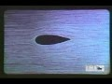
0.21

Standalone
In Context
SectionThe velocity potentialThe velocity potentialsec-Potential-and-streamfunction
In this chapter, we focus on 2D flows where the velocity vector is given by
$$u(x,y,t)=u(x,y,t)i+v(x,y,t)j=[u,v].$$
With the velocity given as above, the vorticity is then
$$ω=∇×u=\left(\frac{∂v}{∂x}−\frac{∂u}{∂y}\right)k.$$
If we assume that the flow is irrotational according to Definition [def-irrotational], then $∇×u=0$ and
$$\frac{∂v}{∂x}−\frac{∂u}{∂y}=0.$$
Further, we know that if the flow is irrotational, then there exists a velocity potential, $ϕ$, such that $u=∇ϕ$. Thus the velocities are expressed as
$$u=\frac{∂ϕ}{∂x} \text{and} v=\frac{∂ϕ}{∂y}.$$
The above result about irrotational flows is a standard result in Vector Calculus, but we will re-state the result here for reference, and provide a review of its proof.
TheoremExistence of a potential.thm-exist-potential Consider a three-dimensional time-dependent velocity field, $u=u(x,t)$ defined on a simply connected domain $x∈D⊂R^{3}$.
Then $u$ is irrotational, i.e. $∇×u=0$, if and only if there exists a scalar potential $ϕ$, defined on $D×R^{+}$, such that $u=∇ϕ$.
Proof. ProofProof (non-examinable).thm-exist-potential-3 Define
ϕ(x,t)≡ϕ0(t)+C​u⋅dx,
where $C$ is any contour connecting an arbitrary origin point to the point $x$ (changing the origin point will change the "constant" of integration $ϕ_{0}(t)$).
We can verify, using the definition of differentiation, and the fundamental theorem of calculus, applied along each of the three coordinate directions, that $∇ϕ=u$ as desired.
The key is to prove that the above definition is independent of the choice of contour $C$. To this end, consider two contours, $C_{1}$ and $C_{2}$, both with the same origin point, $O$, and end point $P$. Then the contour $C_{1}−C_{2}$ is a closed contour beginning and ending at $O$.
FigureProof of the uniqueness of the potentialfig-potential-proof
0.10.80.1 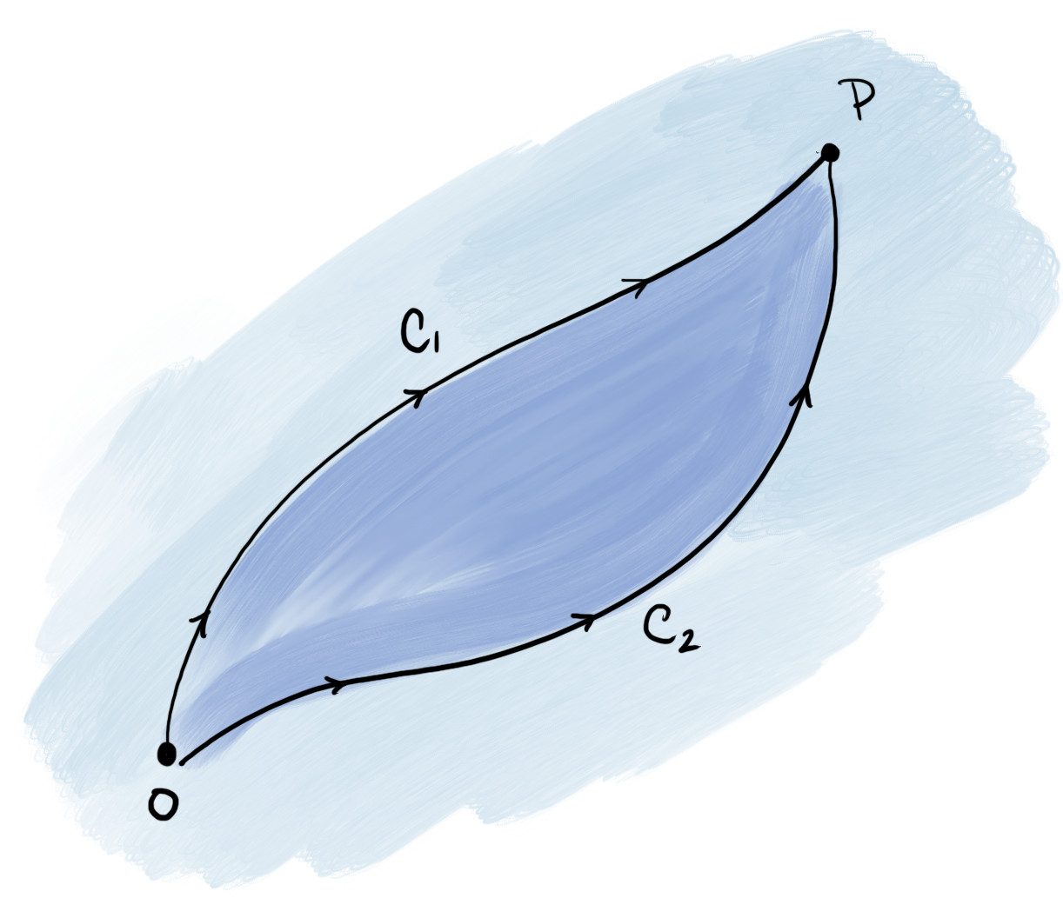
By Stokes’ theorem,
C1−C2​u⋅dx=S​(∇×u)⋅n dS,
where $S$ is any surface with bounding curve $C_{1}−C_{2}$ (such a surface lying in $D$ exists because $D$ is simply connected), and with unit normal $n$ positively oriented with the bounding curve. However, the right-hand side is zero by irrotationality, and therefore
C1​u⋅dx=C2​u⋅dx,
and our choice of curve in the definition of the potential is irrelevant.
The converse direction of the theorem follows directly from the fact that "curl grad equals zero", i.e. $∇×∇ϕ=0$. ◻
Let us return to discussing the setting of potential flow.
In addition to being irrotational, we further assume that the flow is incompressible. Therefore from Theorem [def-incompressible],
$$∇⋅u=\frac{∂u}{∂x}+\frac{∂v}{∂y}=\frac{∂^{2}ϕ}{∂x^{2}}+\frac{∂^{2}ϕ}{∂y^{2}}=0.$$
This is the crucial result, which is that in potential flows, we need only solve the Laplace equation:
$$∇^{2}ϕ=0,$$
within the flow region. This is effectively a single linear equation for the single unknown $ϕ$. However, for different problems, the boundary conditions can render even this "simple" problem difficult.
Once the velocity potential $ϕ$ has been found, the velocities in the flow can be recovered from the relationship ([eqn-vel-potential]). The pressure in the flow also follows from Bernoulli’s equation. For the situation of a steady potential flow, following Theorem [thm-bernoulli-potential], it is
$$\frac{p}{ρ}+\frac{1}{2}|∇ϕ|^{2}+χ=\text{constant}.$$
SubsectionElementary flowsElementary flowssec-Potential-and-streamfunction-3 The next three examples will introduce you to the elementary flows consisting of uniform flow, stagnation point flow, and line source/sink flows. You will also investigate the notion of a source "strength".
ExampleUniform flow.example-potential-uniform Find the velocity potential $ϕ$ and the velocity $u$ of a uniform flow of speed $U$ directed at angle $α$ to the $x$-axis.
Solution.The velocity is constant, $u=U[cosα,sinα]$. Integrating $\frac{∂ϕ}{∂x}=Ucosα$ and $\frac{∂ϕ}{∂y}=Usinα$ gives, up to a constant, the linear function
$$ϕ(x,y)=Uxcosα+Uysinα,$$
which clearly satisfies $∇^{2}ϕ=0$. The streamlines are shown below.
FigureStreamlines (or velocity field) of uniform flow with $U=1$ and $α=π/4$.fig-potential-uniform
0.050.90.05
ExampleStagnation point flow.example-potential-stagnation Show that $ϕ=\frac{1}{2}(x^{2}−y^{2})$ is the velocity potential of an incompressible flow, and find the velocity $u$.
Solution.Since $\frac{∂^{2}ϕ}{∂x^{2}}+\frac{∂^{2}ϕ}{∂y^{2}}=1−1=0$, Laplace’s equation is satisfied. The velocity is
$$u=∇ϕ=[x,−y],$$
which vanishes at the origin. This is stagnation point flow, shown below.
FigureStreamlines (or velocity field) of stagnation point flow.fig-potential-stagnation
0.050.90.05
ExampleLine source.example-potential-linesource A line source ejects fluid from the origin equally in all directions. Find a radially symmetric potential $ϕ=ϕ(r)$ satisfying Laplace’s equation, and the corresponding velocity $u$. By computing the flux of fluid across a circle centred at the origin, relate the constant in $ϕ$ to the rate $Q$ at which fluid is produced.
Solution.In plane polar coordinates,
$$∇^{2}ϕ=\frac{1}{r}\frac{∂}{∂r}\left(r\frac{∂ϕ}{∂r}\right)+\frac{1}{r^{2}}\frac{∂^{2}ϕ}{∂θ^{2}}=0.$$
With $ϕ=ϕ(r)$, direct integration gives
$$ϕ=\frac{Q}{2π}logr,$$
where we have set an additive constant to zero, and written the leading constant as $Q/(2π)$ in anticipation of the result below. The velocity is
$$u=∇ϕ=\frac{∂ϕ}{∂r}e_{r}+\frac{1}{r}\frac{∂ϕ}{∂θ}e_{θ}=\frac{Q}{2πr}e_{r}=\frac{Q}{2πr^{2}}[x,y],$$
using $e_{r}=[cosθ,sinθ]$. The flow is directed radially outwards. It is called a "line" source because in $(x,y,z)$ the source runs parallel to the $z$-axis.
FigureStreamlines (or velocity field) of line source flow.fig-potential-linesource
0.050.90.05
The flux (the flow per unit time) of fluid crossing a closed contour $C$ with unit normal $n$ is C​u⋅n ds. Take $C$ to be the circle $r=a$, on which $n=e_{r}$ and the arc-length element is $ds=a dθ$. Then
C​u⋅n ds=02πQ2πa (a dθ)=Q.
Therefore, $Q$, the strength of the source, is the rate at which fluid is produced. If $Q<0$, we refer to the flow as a line sink.
Crucially, the governing equation is Laplace’s equation, which is linear, so any sum of elementary flows is also an admissible flow.
ExampleLine source in a uniform flow.example-potential-movingsource Find the velocity potential $ϕ$ and the velocity $u$ of a line source of strength $Q$ at the origin placed in a uniform flow of speed $U$ in the $x$-direction.
Solution.Adding the potentials of Example [example-potential-uniform] (with $α=0$) and Example [example-potential-linesource],
$$ϕ=Ux+\frac{Q}{2π}logr=Ux+\frac{Q}{2π}log\sqrt{x^{2}+y^{2}},$$
and so
$$u=[U,0]+\frac{Q}{2π(x^{2}+y^{2})}[x,y].$$
The streamlines are shown below. Where do you think the stagnation point lies in this flow?
FigureStreamlines (or velocity field) of a line source in a uniform flow with $U=1$ and $Q=1$.fig-potential-movinglinesource
0.050.90.05
SectionThe streamfunctionThe streamfunctionsec-streamfunction
Our next task is to introduce the concept of the streamfunction. Remember that in 2D, the irrotational flow led to the equation ([eqn-2d-irrotational]) and this led to the existence of the potential function. If we begin with incompressibility, however, we have ([eqn-2d-divu]), which can be written as
$$\left(∇×[−v,u,0]\right)⋅k=\frac{∂u}{∂x}+\frac{∂v}{∂y}=0.$$
We can therefore deduce the existence of an analogous function, the streamfunction, $ψ(x,y,t)$, satisfying
$$u=\frac{∂ψ}{∂y} \text{and} v=−\frac{∂ψ}{∂x}.$$
Alternatively and more conveniently, we can write
$$u=∇×(ψk).$$
To establish the existence of the streamfunction, we follow a similar proof as in Theorem [thm-exist-potential] but now with the definition that
$$ψ(x,y,t)=ψ_{0}(t)+\int_{0}^{x}{(}udy−vdx),$$
where again $ψ_{0}(t)$ is an arbitrary function of $t$. The proof is otherwise identical, relying on establishing the independence of path of the integral using Stokes’ theorem.
Why all this work? The streamfunction has an intuitive interpretation via the following result.
TheoremThe streamfunction is constant along streamlines.thm-streamfunction The streamfunction, $ψ(x,y,t)$, is constant along streamlines of the flow (i.e. curves that are everywhere tangent to $u$ at a fixed time $t$).
Proof. Proofthm-streamfunction-3 The proof follows simply by the fact that
$$u⋅∇ψ=\left(\frac{∂ψ}{∂y},−\frac{∂ψ}{∂x}\right)⋅\left(\frac{∂ψ}{∂x},\frac{∂ψ}{∂y}\right)=0,$$
where the first equality uses ([eqn-2d-uv-streamfunction]).
Since $∇ψ$ is normal to the level sets of $ψ$, and $u$ is orthogonal to $∇ψ$, the velocity $u$ is tangent to the level sets. These level sets are therefore streamlines. ◻
A graphical depiction of the property in Theorem [thm-streamfunction] is shown below.
FigureFlow between two streamlines, the streamlines $ψ=ψ_{1}$ and $ψ=ψ_{2}$. Later, we will consider the flux through the contour $C$ illustrated in the figure along with its unit normal $n$.fig-streamfunction
0.150.70.15 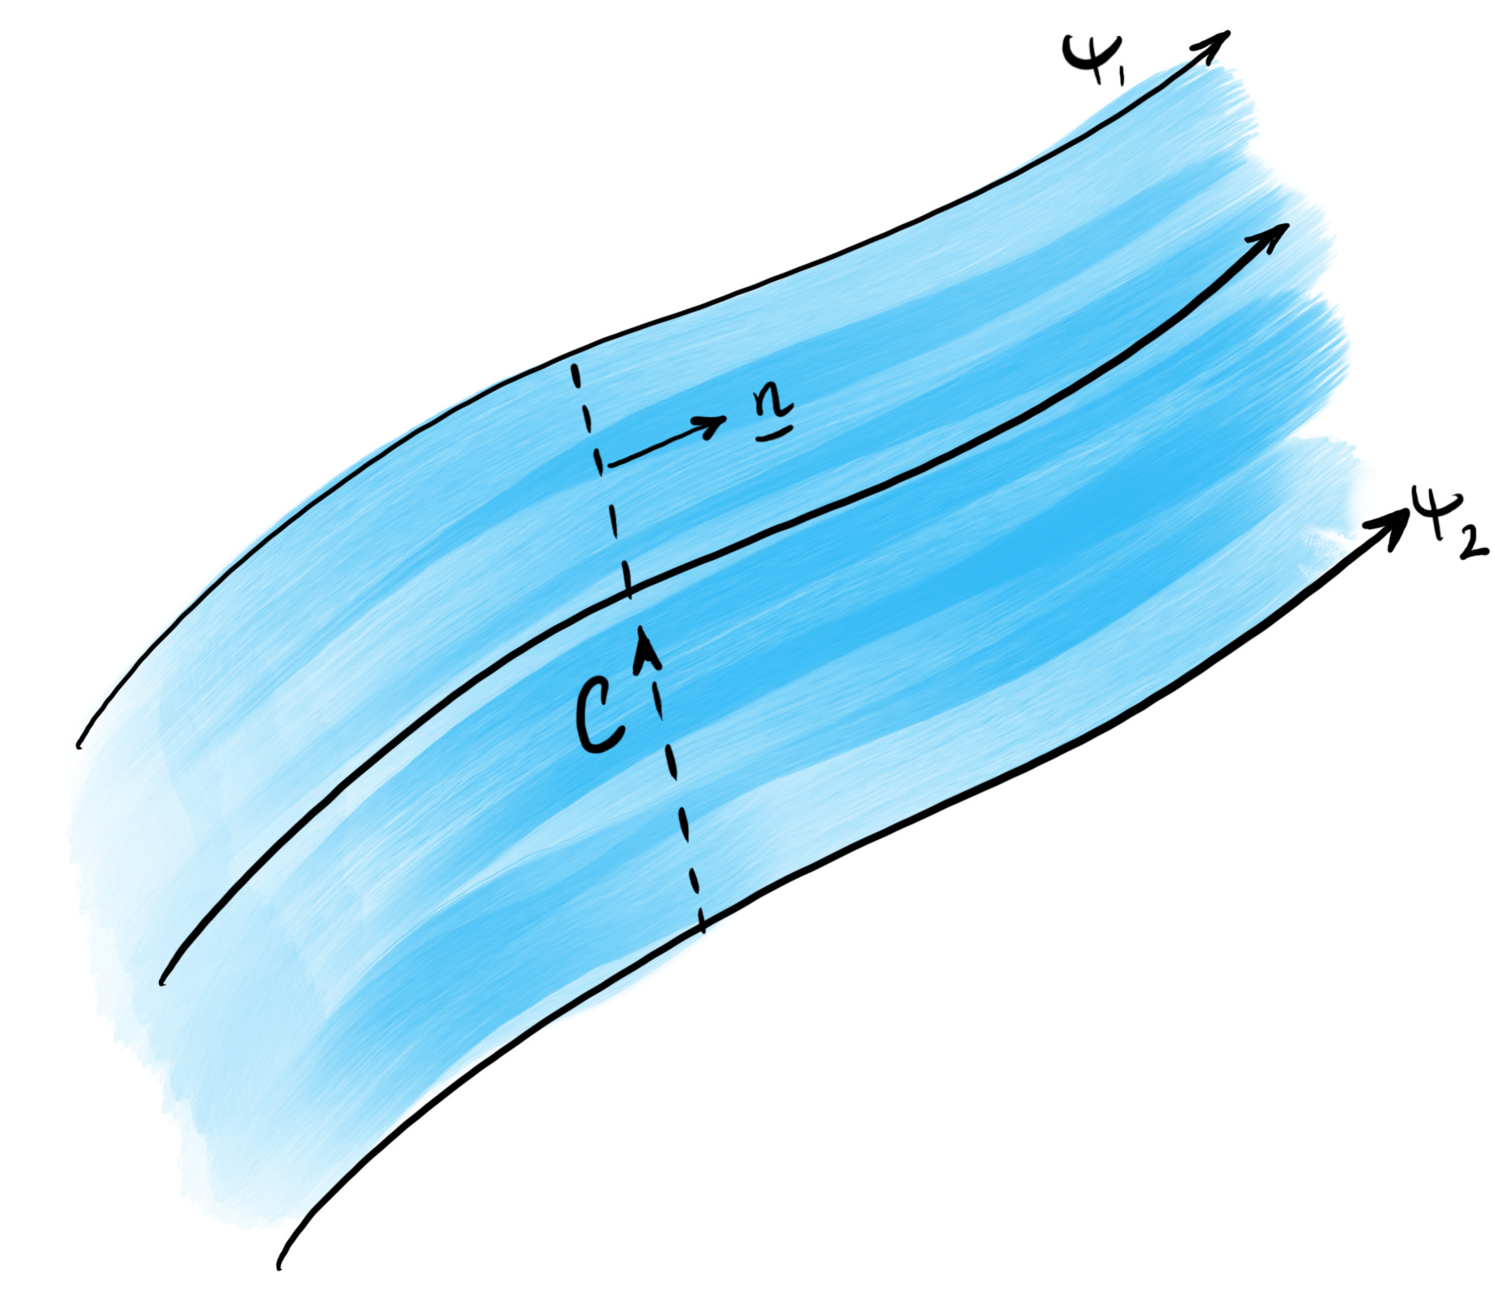
The streamfunction is thus constant on streamlines. Consider two streamlines. The following theorem relates the flux between the streamlines to the values of $ψ$ on them.
TheoremFlux between streamlines.thm-flux-streamlines Consider two streamlines $ψ=ψ_{1}$ and $ψ=ψ_{2}$. We assume that the streamlines pass through the points A and B respectively. Consider a contour $C$ connecting A and B. The flux (net flow of fluid) through $C$ and hence between the streamlines is
$$|\text{flux}|=|ψ_{2}−ψ_{1}|.$$
We have not specified the sign of the flux as it depends on the direction chosen through $C$.
Proof. Proofthm-flux-streamlines-3 By definition, the flux is given by the integral
C​u⋅n ds,
where $C$ is any smooth path joining the two streamlines with unit normal $n$, as shown in Figure [fig-streamfunction].
Note that given the curve, and in consideration of a small arclength element $ds$, the tangent and normal are given by
$$t=\frac{[dx,dy]}{\sqrt{dx^{2}+dy^{2}}}=\frac{[dx,dy]}{ds}, n=\frac{[dy,−dx]}{ds}.$$
Therefore we can write $nds=[dy,−dx]$. Then the flux is re-written as the following:
flux&=C​∂ψ∂y,−∂ψ∂x⋅[dy,−dx],&=C​∂ψ∂x dx+∂ψ∂y dy,&=[ψ]C,&=ψ(B)−ψ(A),&=ψ2−ψ1.
In the third line above, $[ψ]_{C}$ is the change of $ψ$ along the contour. Note that there is a somewhat arbitrary choice of direction for the contour $C$, as related to the selection of the normal direction $n$, and the positivity or negativity of the flux. To be safe, we have taken the absolute value in the statement of the theorem. ◻
An example of the use of the above theorem is given in Exercise .2.
ExampleFlux from the streamfunction.sec-streamfunction-2-9 Let the velocity of a two-dimensional flow be given by the formula
$$u=[3ax^{2}−3ay^{2}, −6axy]$$
where $a$ is a positive constant. By finding the streamfunction, $ψ$, calculate the volume flux across a curve connecting points $A=(0,0)$ and $B=(1,1)$ using Theorem [thm-flux-streamlines].
Solution.We can check, using the integration of velocity components that
$$ψ=3ax^{2}y−ay^{3}+C.$$
Hence the flux is
$$Q=ψ(B)−ψ(A)=2a.$$
We can verify this flux should be positive if the normal is oriented to the right of the curve from A to B.
Finally, note that the velocity potential was governed by Laplace’s equation, $∇^{2}ϕ=0$. The streamfunction is also governed by the same Laplace’s equation.
TheoremStreamfunction satisfies Laplace’s equation.thm-streamfunction-laplace If the flow is also irrotational, then, like the velocity potential, the streamfunction satisfies Laplace’s equation:
$$\frac{∂^{2}ψ}{∂x^{2}}+\frac{∂^{2}ψ}{∂y^{2}}=∇^{2}ψ=0.$$
Proof. Proofthm-streamfunction-laplace-3 Substitute the relationship ([eqn-2d-uv-streamfunction]) into ([eqn-2d-irrotational]). ◻
For some flows, such as the line source in Example [example-potential-linesource], it is easier to work in polar coordinates. Since we know that $u=∇×(ψk)$ by ([eqn-2d-streamfunction]), we can use the conversion of the curl to polar coordinates in ([eqn-identity-curlpolar]) to give
$$u_{r}=\frac{1}{r}\frac{∂ψ}{∂θ} \text{and} u_{θ}=−\frac{∂ψ}{∂r},$$
which allows us to relate the radial and angular velocities to the streamfunction.
SubsectionElementary flowsElementary flowssec-streamfunction-3 Let us return to each of the examples in Section [sec-Potential-and-streamfunction] and reconsider their corresponding streamfunctions.
ExampleUniform flow.sec-streamfunction-3-3 Find the streamfunction $ψ$ for the uniform flow of Example [example-potential-uniform], and sketch its streamlines.
Solution.Integrating $u=ψ_{y}=Ucosα$ and $v=−ψ_{x}=Usinα$ gives, up to an arbitrary constant,
$$ψ=Uycosα−Uxsinα.$$
Lines of constant $ψ$ are $y=xtanα+\text{constant}$, as in Figure [fig-potential-uniform].
ExampleStagnation point flow.sec-streamfunction-3-4 Find the streamfunction $ψ$ for the stagnation point flow of Example [example-potential-stagnation], and sketch its streamlines.
Solution.Integrating $u=ψ_{y}=x$ and $v=−ψ_{x}=−y$ gives, up to an arbitrary constant, $ψ=xy$. Curves of constant $ψ$ are the hyperbolae shown in Figure [fig-potential-stagnation].
ExampleLine source.example-streamfunction-linesource Find the streamfunction $ψ$ for the line source of Example [example-potential-linesource], and sketch its streamlines.
Solution.From ([eqn-identity-grad-polar]), the velocity is entirely radial,
$$u=\frac{∂ϕ}{∂r}e_{r}=\frac{Q}{2πr}e_{r}.$$
Using ([eqn-streamfunction-polar]), we integrate $\frac{1}{r}\frac{∂ψ}{∂θ}=\frac{Q}{2πr}$ (with $\frac{∂ψ}{∂r}=−u_{θ}=0$) to give
$$ψ=\frac{Q}{2π}θ.$$
The lines of constant $ψ$ are the radial lines of constant $θ$, as in Figure [fig-potential-linesource].
Note that $ψ$ is a multi-valued function in Example [example-streamfunction-linesource], gaining a jump of $Q$ every time the origin is encircled. This is a warning that the standard proof, analogous to Theorem [thm-exist-potential], leading to the existence of a unique streamfunction via ([eqn-streamfunction-def-psi]), would not apply, because the flow domain (the plane with the origin removed) is not simply connected. However, despite this, the streamfunction provides well-defined predictions of streamlines on the cut plane with e.g. $θ∈[0,2π)$.
ExampleLine source in a uniform flow.sec-streamfunction-3-7 Find the streamfunction $ψ$ for the line source in a uniform flow of Example [example-potential-movingsource], and the equation of its streamlines.
Solution.By linearity, we add the streamfunctions of the uniform flow (with $α=0$) and the line source:
$$ψ=Uy+\frac{Q}{2π}θ.$$
The streamlines are given by
$$Uy+\frac{Q}{2π}θ=\frac{Q}{2π}C,$$
having chosen the constant on the right-hand side for convenience. Then using $y=rsinθ$, we have
$$r=\left(\frac{Q}{2πU}\right)\frac{C−θ}{sinθ}.$$
Our previous examples were reliant on considering the flows generated by the velocity potentials studied previously. However, we can also consider "fundamental solutions" of the equation $∇^{2}ψ=0$ in their own right. Recall that in deriving the velocity potential of the line source in Example [example-potential-linesource], we considered a radially symmetric problem, where $ϕ=ϕ(r)$ is only dependent on the distance from the origin. The same argument shows that a radially symmetric streamfunction $ψ=ψ(r)$ is also a solution. This leads us to the following example.
ExampleLine vortex.example-streamfunction-linevortex The radially symmetric streamfunction
$$ψ=−\frac{Γ}{2π}logr,$$
defined up to a constant, corresponds to a line vortex. Find its velocity $u$, and compute the circulation around a circle of radius $a$ centred at the origin.
Solution.The streamlines are circles of constant $r$, shown in Figure [fig-streamfunction-linevortex]. From ([eqn-streamfunction-polar]),
$$u=−\frac{∂ψ}{∂r}e_{θ}=\frac{Γ}{2πr}e_{θ},$$
so the fluid orbits the origin, with speed $|Γ|/(2πr)$ increasing as $r→0$.
FigureStreamlines (or velocity field) of a line vortex with $Γ=1$.fig-streamfunction-linevortex
0.050.90.05
The circulation around a contour $C$ is
C​u⋅dx=C​(u dx+v dy),
i.e. the sum of the velocity components tangential to $C$. By Stokes’ theorem it equals the flux of vorticity through any surface bounded by $C$. Since the flow is irrotational away from the origin, all of this vorticity is concentrated at the origin. On the circle $r=a$, $dx=ae_{θ}dθ$, so
C​u⋅dx=02πΓ2πaeθ⋅eθadθ=Γ.
The quantity $Γ$ is called the vortex strength, analogous to the source strength $Q$ in Example [example-potential-linesource]. Notice that $Γ>0$ corresponds to flow in the anticlockwise sense, and $Γ<0$ to flow in the clockwise sense.
In Exercise .1, you will practise the computation of fluxes using line integrals.
SectionThe complex potentialThe complex potentialsec-complex-potential
AsideChanged in 2026.sec-complex-potential-2-1 This section was streamlined and shortened.
In the previous two sections, we studied the velocity potential $ϕ$ and streamfunction $ψ$ of two-dimensional potential flows using real-valued Vector Calculus. You may have noticed a certain symmetry between the formulae for $ϕ$ and $ψ$. Complex analysis makes this symmetry transparent, and provides a much more elegant and powerful framework for studying two-dimensional flow.
RemarkExaminable content.sec-complex-potential-2-3 The proofs in this section are non-examinable, but you are expected to understand the theorems and their relevance to potential flow.
SubsectionAnalytic functions and Laplace’s equationAnalytic functions and Laplace’s equationsubsec-complex-introduction We write a complex function as $f(z)=u(x,y)+iv(x,y)$, where $z=x+iy$ and $u$ and $v$ are the real and imaginary parts of $f$, and use subscripts for partial derivatives, e.g. $u_{x}=\frac{∂u}{∂x}$. The derivative is defined as for real functions,
$$f^{′}(z)=\lim_{Δz→0}\frac{f(z+Δz)−f(z)}{Δz},$$
with the crucial difference that the limit must exist, and take the same value, however $Δz→0$ in the complex plane. For further details, see [] and [].
DefinitionAnalyticity.def-analytic A function $f$ is analytic in a domain if it is differentiable at every point of the domain.
TheoremCauchy-Riemann equations.thm-CR1 If $f(z)=u(x,y)+iv(x,y)$ is analytic in a domain, then the Cauchy-Riemann equations
$$u_{x}=v_{y} \text{and} u_{y}=−v_{x}$$
hold in that domain. Conversely, if $u$ and $v$ have continuous first partial derivatives satisfying ([eqn-CR]), then $f$ is analytic.
Proof. ProofProof (non-examinable).thm-CR1-3 Approaching $z$ along the real direction, $Δz=Δx$, the definition ([eqn-complex-derivative]) gives $f^{′}(z)=u_{x}+iv_{x}$. Approaching along the imaginary direction, $Δz=iΔy$, gives $f^{′}(z)=−iu_{y}+v_{y}$. Equating the real and imaginary parts of the two results yields the Cauchy-Riemann equations. For the converse, see []. ◻
TheoremAnalyticity and Laplace’s equation.thm-complex-laplace If $f(z)=u(x,y)+iv(x,y)$ is analytic in a domain $D$, then $u$ and $v$ satisfy Laplace’s equation,
$$∇^{2}u=u_{xx}+u_{yy}=0 \text{and} ∇^{2}v=v_{xx}+v_{yy}=0,$$
in $D$.
Proof. ProofProof (non-examinable).thm-complex-laplace-3 Analytic functions are infinitely differentiable (see []), so we may differentiate ([eqn-CR]) to obtain
$$u_{xx}=v_{yx} \text{and} −u_{yy}=v_{xy}.$$
The second derivatives are continuous, so $v_{xy}=v_{yx}$, and therefore $u_{xx}+u_{yy}=0$. Laplace’s equation is analogously proved for $v$. ◻
This remarkable result is a major reason why complex analysis played such an important role in applied mathematics and physics, since Laplace’s equation governs gravitation, electrostatics, fluid mechanics, and more. In particular, any function that is analytic in a region, whether a polynomial, exponential, logarithm, or otherwise, can be associated with (some kind of) potential flow there.
SubsectionExamples of elementary flowsExamples of elementary flowssubsec-complex-examples Let us return to the examples of flows studied in Section [sec-Potential-and-streamfunction] and re-interpret them using the theory of analytic functions.
We will associate the velocity potential, $ϕ$, and streamfunction $ψ$ with an analytic function in the following way.
DefinitionComplex potential.def-complex-potential Let $ϕ(x,y)$ and $ψ(x,y)$ be the respective velocity potential and streamfunction for some potential flow. We define
$$f(z)=ϕ(x,y)+iψ(x,y),$$
and call $f$ the complex potential. Since $ϕ_{x}=ψ_{y}=u$ and $ϕ_{y}=−ψ_{x}=v$, the functions $ϕ$ and $ψ$ satisfy the Cauchy-Riemann equations, so $f$ is analytic.
Note that by differentiating in the horizontal and vertical directions, we have
$$\frac{df}{dz}=\frac{∂}{∂x}(ϕ+iψ)=−i\frac{∂}{∂y}(ϕ+iψ).$$
Therefore it follows that the horizontal and vertical velocity components of the flow, related via $u=[u,v]$, are given by
$$\frac{df}{dz}=u−iv.$$
ExampleUniform flow.subsec-complex-examples-5 Show that the complex potential of the uniform flow of Example [example-potential-uniform] is $f(z)=Ue^{−iα}z$, and recover $ϕ$, $ψ$ and $u$.
Solution.With $z=x+iy$,
$$Ue^{−iα}z=U(xcosα+ysinα)+iU(ycosα−xsinα),$$
whose real and imaginary parts are the $ϕ$ and $ψ$ of Example [example-potential-uniform] and the corresponding example in Section [sec-streamfunction]. Also $f^{′}(z)=Ue^{−iα}=Ucosα−iUsinα$, so $u=U[cosα,sinα]$.
ExampleStagnation point flow.subsec-complex-examples-6 Show that the complex potential of the stagnation point flow of Example [example-potential-stagnation] is $f(z)=z^{2}/2$, and recover $ϕ$, $ψ$ and $u$.
Solution.We have $z^{2}/2=\frac{1}{2}(x^{2}−y^{2})+ixy$, so $ϕ=\frac{1}{2}(x^{2}−y^{2})$ and $ψ=xy$. Also $f^{′}(z)=z=x+iy=u−iv$, so $u=[x,−y]$.
ExampleLine source.subsec-complex-examples-7 Show that the complex potential of the line source of Example [example-potential-linesource] is
$$f(z)=\frac{Q}{2π}logz,$$
and recover $ϕ$, $ψ$ and $u$.
Solution.The complex logarithm is not analytic at $z=0$, a branch point, but is analytic away from the origin once a branch cut is chosen. Writing $z=re^{iθ}$ in polar form, it is evaluated via
$$logz=logr+iθ.$$
Hence
$$ϕ=Re[f]=\frac{Q}{2π}logr \text{and} ψ=Im[f]=\frac{Q}{2π}θ.$$
Indeed, the streamlines are the rays $θ=\text{constant}$. From ([eqn-complex-velocity]), multiplying the top and bottom by the conjugate of $z$,
$$u−iv=\frac{Q}{2π}\frac{1}{z}=\frac{Q}{2π}\frac{x−iy}{x^{2}+y^{2}}.$$
ExampleLine vortex flow.example-complexpotential-linevortex Show that the complex potential of the line vortex of Example [example-streamfunction-linevortex] is
$$f(z)=−\frac{iΓ}{2π}logz,$$
and recover $ϕ$, $ψ$ and $u$.
Solution.Using ([eqn-complex-logarithm]) with $z=re^{iθ}$,
$$f(z)=\frac{Γ}{2π}(θ−ilogr),$$
so $ϕ=Γθ/(2π)$ and $ψ=−(Γ/2π)logr$, which is constant on circles $r=\text{constant}$. The velocity follows from
$$u−iv=−\frac{iΓ}{2πz}=−\frac{iΓ}{2πr}e^{−iθ},$$
so $u+iv=\frac{Γ}{2πr}ie^{iθ}$, i.e. $u=\frac{Γ}{2πr}e_{θ}$, as in ([eq-u-line-vortex]).
SectionThe method of imagesThe method of imagessec-method-of-images
The preceding sections may give the misleading impression that solving potential-flow problems for two-dimensional flows is easy. This is not the case, and the primary reason is the presence of boundary conditions. The elementary flows we have previously considered were unconfined and/or we did not consider additional constraints on their behaviours at infinity. In reality, a real physical fluid, whether in the ocean, the air, or in a container, is confined in some direction, and we must often consider subtle questions about the mechanism that produces the fluid motion.
In this section, we consider the situation of solving for the potential flow in a fluid region with boundaries. Recall that this is equivalent to finding a velocity potential satisfying $∇^{2}ϕ=0$ or an analytic complex potential, $f(z)$.
Recall from Note [note-noflux-BC] that on solid boundaries, we must impose the no-flux condition that
$$u⋅n=∇ϕ⋅n=0 \text{on }∂V.$$
SubsectionPlanar boundaries: a half-planePlanar boundaries: a half-planesubsec-images-planar Consider the situation illustrated in Figure [image-planar01].
FigureA flow region in the right half-plane, with a single source placed at $x=d$.image-planar01
0.10.80.1 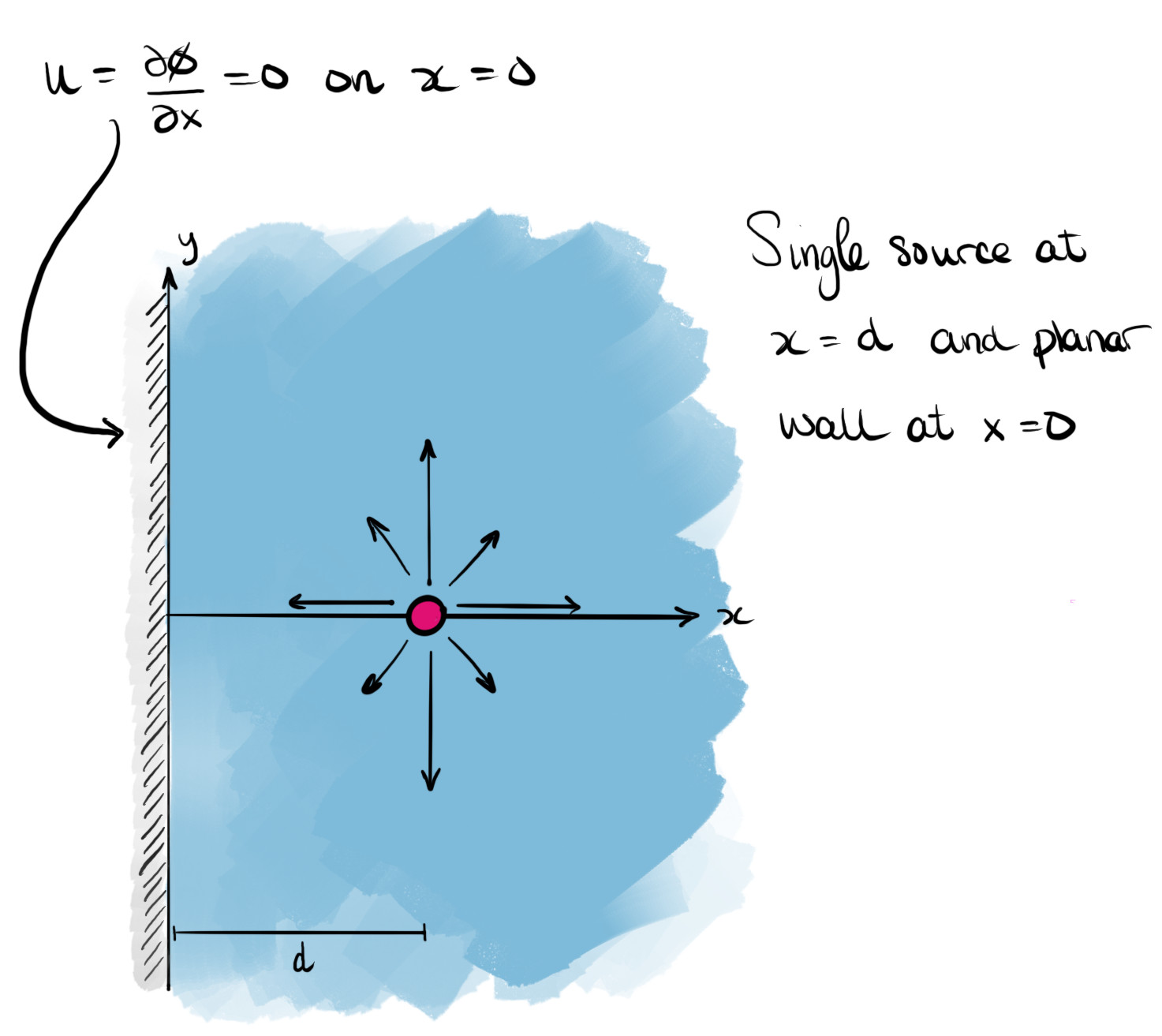
We envision a semi-infinite region of fluid bounded on the left by a wall at $x=0$. A single (line) source of strength $Q$ is placed at $x=d$. Therefore from ([eqn-complex-linesource]), we would expect that at least near $x=d$, the complex potential behaves as
$$f(z)∼\frac{Q}{2π}log(z−d) \text{as }z→d.$$
However, the above potential does not satisfy the required boundary condition at $x=0$, since its horizontal velocity penetrates through $x=0$. This can be checked by inspecting the velocity or the streamlines (see Exercise .4).
Rephrased in terms of the streamlines, the boundary condition at $x=0$ is equivalent to the constraint that
$$Imf(z)=ψ=\text{constant at }x=0.$$
The solution to this problem uses the method of images.
NoteMethod of images.note-method-of-images Given a potential flow problem, we consider the superposition of elementary sinks/sources, i.e.
$$f(z)=\frac{1}{2π}\sum_{j=0}^{N−1}{Q_{j}}log(z−z_{j}),$$
and/or vortices,
$$f(z)=−\frac{i}{2π}\sum_{j=0}^{N−1}{Γ_{j}}log(z−z_{j}).$$
The strengths and locations of the individual contributions are chosen so that boundary conditions on the required boundaries (including at infinity) can be met.
Notice that the linearity of the potential flow problem is crucial: any analytic function is associated with a velocity potential that satisfies Laplace’s equation, $∇^{2}ϕ=0$, and therefore the superposition of such functions also yields a permissible complex potential, $f$.
ExampleLine source near a wall.example-images-source-wall Find the complex potential of a line source of strength $Q$ at $z=d$ in the half-plane $x>0$, bounded by a wall at $x=0$, and verify the no-flux condition on the wall.
Solution.We add a "fictitious" image source of the same strength at the reflected point $z=−d$, which lies outside the fluid region. This gives the complex potential
$$f(z)=\frac{Q}{2π}log(z−d)+\frac{Q}{2π}log(z+d),$$
illustrated in Figure [fig-image-planar02].
FigurePlacement of the image source at $x=−d$ ensures that the boundary condition on $x=0$ is satisfied.fig-image-planar02
0.10.80.1 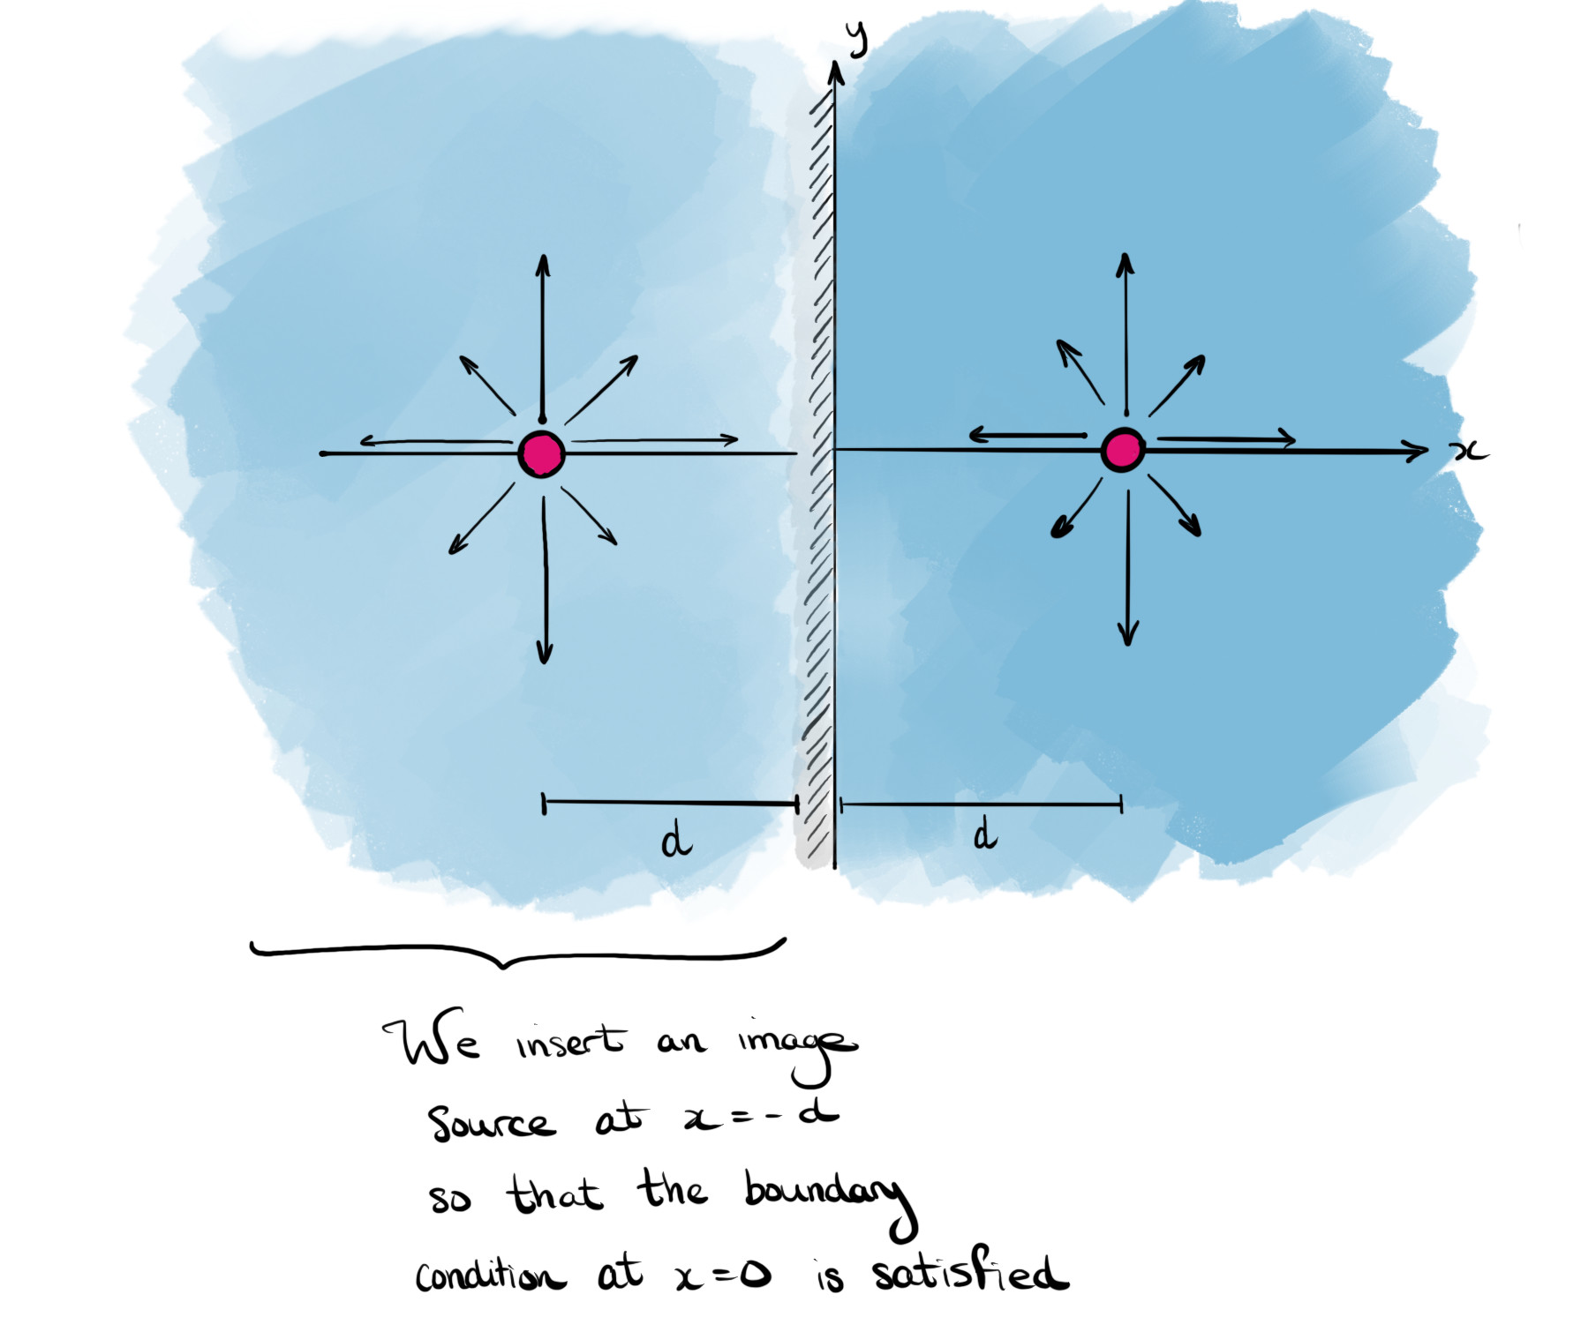
The corresponding complex velocity is
$$u−iv=f^{′}(z)=\frac{Q}{π}\frac{z}{z^{2}−d^{2}}.$$
On the wall $x=0$, we have $z=iy$, and
$$u−iv=−i\frac{Q}{π}\frac{y}{y^{2}+d^{2}},$$
so the velocity is entirely vertical. Hence the condition $u⋅n=0$ on the wall is satisfied.
To develop an equation for the streamlines, we must first navigate the fact that the complex logarithm is only well-defined in a slit complex plane. Let
$$z−d=r_{1}e^{iθ_{1}} \text{and} z+d=r_{2}e^{iθ_{2}},$$
as shown in Figure [fig-image-duallog]. Using ([eqn-complex-logarithm]),
$$f(z)=\frac{Q}{2π}\left[logr_{1}+logr_{2}\right]+i\frac{Q}{2π}\left[θ_{1}+θ_{2}\right].$$
For each logarithm to be well defined, the angles must be restricted to an interval of length $2π$. We thus restrict $θ_{1}∈[0,2π)$ and $θ_{2}∈[−π,π)$.
FigureWhen considering the evaluation of the flow, we must take care of the fact that the logarithm is multi-valued. A branch cut from each of the two branch points is imposed.fig-image-duallog
010 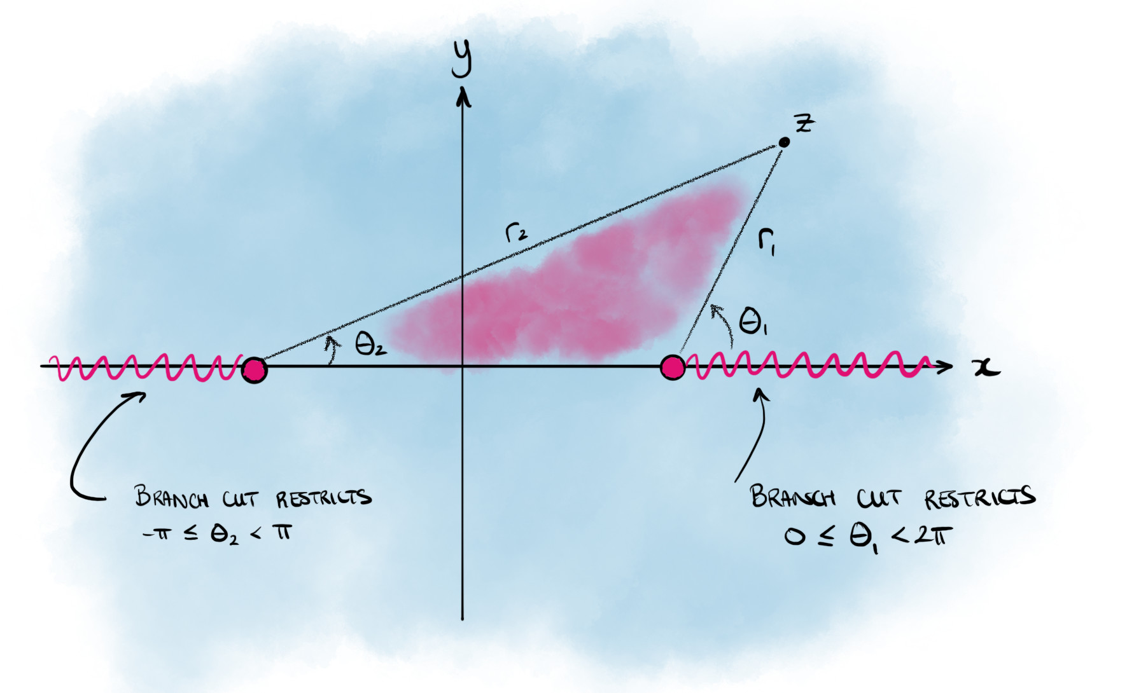
In Exercise .5, you will be asked to develop an equation for the streamlines of this flow.
ExampleLine vortex near a wall.example-images-vortex-wall Find the complex potential of a line vortex of strength $Γ$ at $z=d$ in the half-plane $x>0$, bounded by a wall at $x=0$, and verify the no-flux condition on the wall.
Solution.Near $z=d$, we expect $f(z)∼−\frac{iΓ}{2π}log(z−d)$, but this potential alone does not satisfy the no-flux condition at $x=0$. We add an image vortex at $z=−d$ of opposite sign:
$$f(z)=−\frac{iΓ}{2π}log(z−d)+\frac{iΓ}{2π}log(z+d).$$
For $Γ>0$, this flow is composed of a line vortex circulating anticlockwise on the right, and a line vortex circulating clockwise on the left. The complex velocity is
$$u−iv=−\frac{iΓd}{π(z^{2}−d^{2})},$$
and on $z=iy$, $u−iv=iΓd/[π(y^{2}+d^{2})]$, so $u=0$ and there is no flux through the wall.
You will study a related problem with two vortices in Exercise .6.
RemarkUniqueness of solutions.subsec-images-planar-12 You may be wondering whether a potential found by the method of images, with its ’fictitious’ image points, is the only solution. It is unique (up to a constant) once we prescribe the singularities in the flow region (sources and vortices, with their strengths), the no-flux condition on the walls, and the behaviour at infinity, e.g. $u→0$. This follows from the uniqueness of solutions to Laplace’s equation with this type of boundary condition (a Neumann problem).
The condition at infinity matters. In the examples above, adding a uniform flow parallel to the wall, $f=−iUz$ (for which $ψ=−Ux$ is constant on $x=0$), still satisfies the no-flux condition, but changes the flow far from the source or vortex.
SectionConformal mappingConformal mappingsec-conformal-mapping
The essential idea of conformal mapping is as follows. Suppose that we are given a two-dimensional potential flow problem in a region, $R⊆C$, with impermeable boundary $∂R$. There may be singularities in $R$ corresponding to sinks, sources, vortices, etc. We then seek a conformal mapping from the $z$-plane to the $ζ$-plane via
$$ζ=g(z),$$
so that the region $R$ is mapped to a new region $\hat{R}⊆C$, as shown in Figure [fig-conformal-general].
The hope is that within the $ζ$-plane, the fluid region is sufficiently simple that a complex potential, say $F(ζ)$, can be found. This is aided by the fact that sources, sinks and vortices are preserved by the map (Proposition [prop-conformal]). Typically, we wish for $\hat{R}$ to be e.g. the upper half-plane or the unit disc, and $∂\hat{R}$ the real axis or circumference of the unit disc, respectively. Once found, the complex potential in the $z$-plane is obtained by composing $F$ with the map, i.e.
$$f(z)=F(g(z))=ϕ(x,y)+iψ(x,y).$$
This simple idea turns out to yield many insights into potential flows in two dimensions.
FigureA general conformal mapping from the $z$-plane to the $ζ$-plane. The object is to map the region $R$ to the region $\hat{R}$, which is geometrically simpler.fig-conformal-general
010 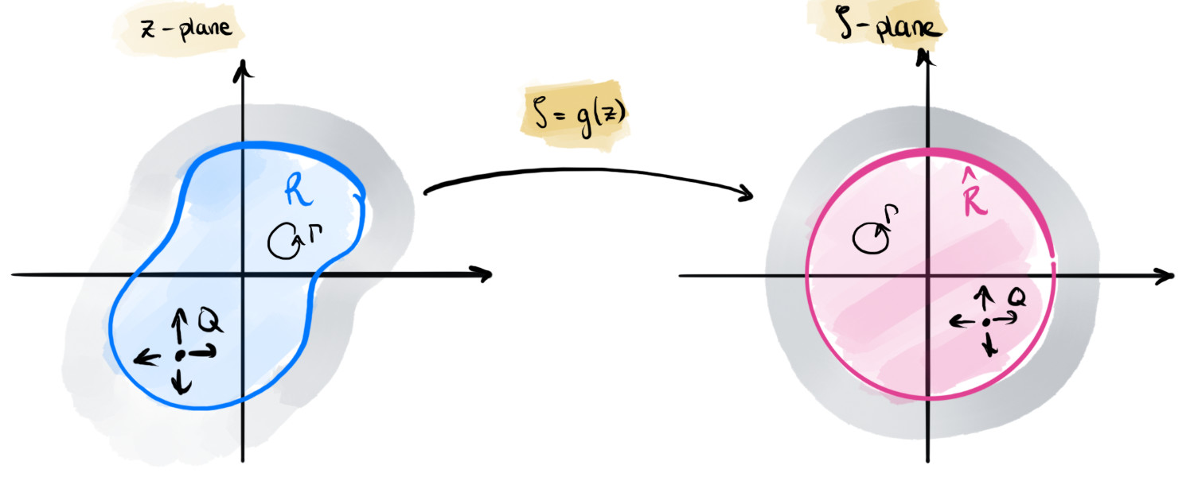
SubsectionThe conformal mapping methodThe conformal mapping methodsubsec-conformal-theory The method relies on the following properties of conformal maps.
DefinitionConformal map.def-conformal-mapping A conformal map is a mapping $ζ=g(z)$ with $g$ analytic and $g^{′}(z)≠0$ in a region $R$.
The derivative $g^{′}$ may vanish or be infinite at corners of the boundary (e.g. $z^{π/α}$ at $z=0$ in Example [example-conformal-wedge]), which is how the map straightens corners.
PropositionProperties of conformal maps.prop-conformal
- Conformal maps preserve angles.
- If the boundary $∂\hat{R}$ is a streamline in the $ζ$-plane, then the corresponding boundary $∂R$ is a streamline in the $z$-plane (and vice versa).
- A source of strength $Q$ (or vortex of strength $Γ$) at $ζ=g(c)∈\hat{R}$ in the $ζ$-plane corresponds to a source (or vortex) of the same strength at $z=c∈R$ in the $z$-plane (and vice versa).
Proof. ProofProof (non-examinable).prop-conformal-3 (1) Near a point $z_{0}$, $g(z)−g(z_{0})≈g^{′}(z_{0})(z−z_{0})$, so small line elements are all rotated by $argg^{′}(z_{0})$ and scaled by $|g^{′}(z_{0})|$; angles between them are unchanged. (2) If $ImF$ is constant on $∂\hat{R}$, then $Imf=ImF(g(z))$ is constant on $∂R$. (3) Near $c$, $g(z)−g(c)=g^{′}(c)(z−c)\left(1+O(z−c)\right)$, so $log(g(z)−g(c))=log(z−c)$ plus a function analytic near $c$. ◻
SubsectionSource in a wedgeSource in a wedgesec-conformal-mapping-4
ExampleSource in a wedge.example-conformal-wedge Fluid is contained in a wedge with walls at $θ=0$ and $θ=α>0$, with the fluid in $0<θ<α$. Find the complex potential of a source of strength $Q$ at the point $z=c$ in the wedge.
Solution.Consider the map
$$ζ=g(z)=z^{π/α}.$$
With $z=re^{iθ}$, we have $ζ=r^{π/α}e^{iπθ/α}$, so $0<θ<α$ is mapped to $0<argζ<π$, the upper half-$ζ$-plane. The ray $θ=0$ is mapped to the positive real axis and the ray $θ=α$ to the negative real axis, as shown in Figure [fig-conformal-wedge].
FigureThe map from the wedge-shaped region in the $z$-plane (left) and the upper half-$ζ$-plane (right).fig-conformal-wedge
010 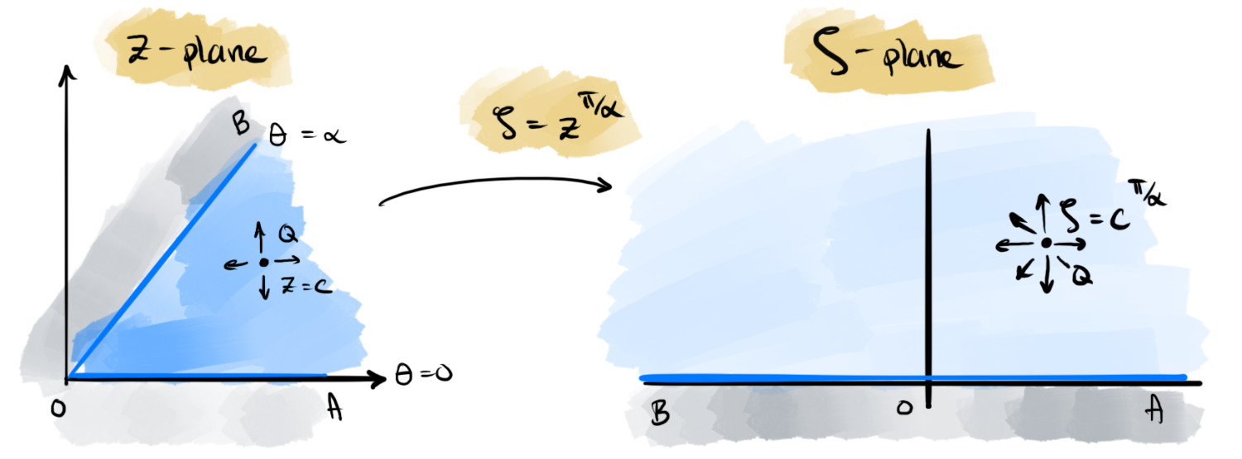
In the $ζ$-plane, we must solve for flow in the upper half-plane with a source of strength $Q$ at $ζ_{c}=c^{π/α}$, and an impermeable boundary on the real $ζ$-axis. By the method of images (Section [sec-method-of-images]), we place sources at both $ζ_{c}$ and its complex conjugate, $\overline{ζ_{c}}$:
$$F(ζ)=\frac{Q}{2π}log(ζ−ζ_{c})+\frac{Q}{2π}log(ζ−\overline{ζ_{c}}).$$
Composing with the map, the complex potential in the $z$-plane is
$$f(z)=F(g(z))=\frac{Q}{2π}log(z^{π/α}−c^{π/α})+\frac{Q}{2π}log(z^{π/α}−\overline{c^{π/α}}).$$
By construction (Proposition [prop-conformal]), the walls of the wedge are streamlines.
SubsectionStandard conformal mapsStandard conformal mapssec-conformal-mapping-5 The exponential map is used to map a channel to a half-plane. Consider a channel of width $h$ in the region $0<Imz<h$ in the $z$-plane. Then
$$ζ=g(z)=e^{πz/h},$$
maps this channel to the upper half-$ζ$-plane. The correspondence of critical points and points at infinity in the pre-image and the image is shown in Figure [fig-conformal-exp]. It is good to see the map as essentially ’unfolding’ the infinite channel, sending points AD to the origin, while sending B to negative infinity and C to positive infinity. The conformal map will preserve the orientation of the boundary, so as we traverse along ABCD, the fluid region is always on the right.
FigureThe exponential map maps the infinite strip of height $h$ to the upper half-plane.fig-conformal-exp
010 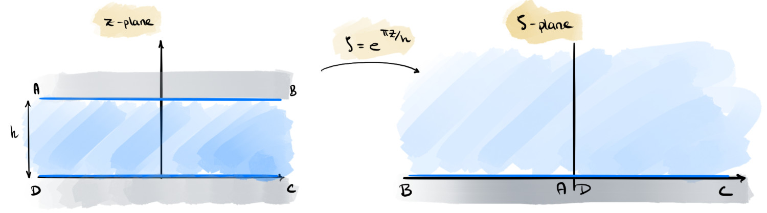
Trigonometric maps are used to map semi-infinite channels into a half-plane. For example, the map
$$ζ=g(z)=sin\left(\frac{πz}{2a}\right)$$
sends the semi-infinite channel of width $2a$ in Figure [fig-conformal-sin] to the upper half-plane. The two corners at $z=±a$ are mapped to $ζ=±1$, respectively.
FigureThe sinusoidal transformation maps the semi-infinite strip of width $2a$ to the upper half-plane.fig-conformal-sin
010 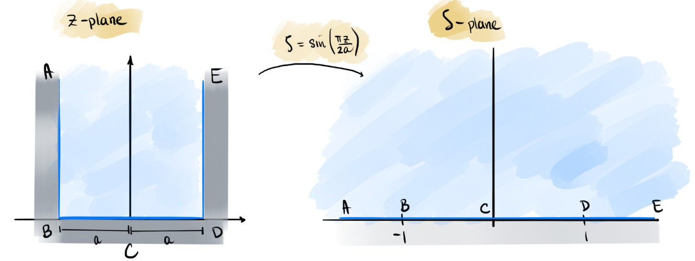
In Exercise .8, you will verify this.
ExampleVortex flow in a semi-infinite channel.example-conformal-sinh-vortex Consider the channel shown in the left of Figure [fig-conformal-sinh]. Insert a vortex of strength $Γ$ at the point $z=d∈R^{+}$. Verify that an appropriate conformal map is given by
$$ζ=g(z)=sinh\left(\frac{πz}{2a}\right),$$
and find where the map sends the relevant critical points of the pre-image. Using the conformal map, find the complex velocity of the flow.
FigureThe sinh transformation maps the semi-infinite channel with height $2a$ to the right half-plane. (There is a typo in the sketch: the vortex and its image in the $ζ$-plane are at $ζ=±sinh(πd/2a)$, not $ζ=±d$.)fig-conformal-sinh
010 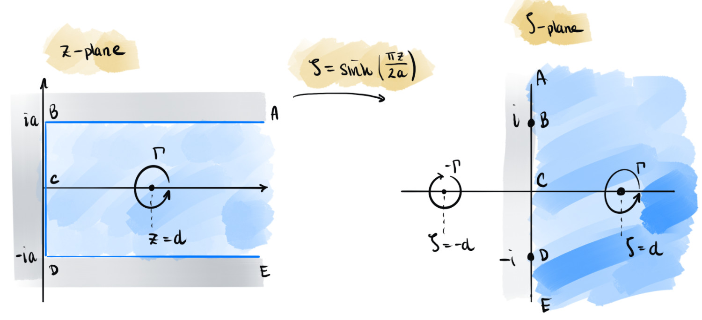
Solution.The map sends $z=0$ and $z=±ia$ to $ζ=0$ and $ζ=±i$. On $x=0$, $ζ=isin(πy/2a)$ covers the segment between $±i$, and on $y=±a$, $ζ=±icosh(πx/2a)$ covers the rest of the imaginary axis. The channel is therefore mapped to the right half-plane, and the vortex to $ζ_{d}=sinh(πd/2a)>0$.
By the method of images (Example [example-images-vortex-wall]), with an image vortex of strength $−Γ$ at $−ζ_{d}$,
$$F(ζ)=−\frac{iΓ}{2π}\left[log(ζ−ζ_{d})−log(ζ+ζ_{d})\right].$$
The complex velocity is then
$$u−iv=f^{′}(z)=F^{′}(ζ) g^{′}(z)=−\frac{iΓ}{2π} \frac{2ζ_{d}}{ζ^{2}−ζ_{d}^{2}}⋅\frac{π}{2a}cosh\left(\frac{πz}{2a}\right).$$
Using $\sinh^{2}A−\sinh^{2}B=sinh(A−B)sinh(A+B)$, this simplifies to
$$u−iv=−\frac{iΓsinh(πd/2a)cosh(πz/2a)}{2asinh\left(π(z−d)/2a\right)sinh\left(π(z+d)/2a\right)}.$$
SectionCircle mapsCircle mapssec-circle-maps
In Section [sec-method-of-images], we used the method of images to construct flows bounded by straight walls, and in Section [sec-conformal-mapping] conformal maps extended this to wedges and channels. Many problems of interest instead involve flow past a body. In this section, we consider the simplest such body, a circular cylinder. Milne-Thomson’s Circle Theorem provides the image system for a circle, much as the method of images does for a plane wall, and immediately gives uniform flow past a cylinder. We then add a line vortex inside the cylinder, which shifts the stagnation points and leads to the Magnus effect.
TheoremMilne-Thomson’s Circle Theorem.thm-circle-theorem Let $f(z)$ be a given complex potential such that any singularities in $f$ occur in $|z|>a$. Then we can construct the following potential:
$$w(z)=f(z)+\overline{f(a^{2}/\overline{z})},$$
and this potential has the following properties: (i) it has the same singularities as $f$ in the region $|z|>a$; and (ii) the circle $|z|=a$ is a streamline.
Proof. Proofthm-circle-theorem-3 (i) If $|z|>a$, then $|a^{2}/\overline{z}|<a$. Therefore the argument of the second term of $w$ is within the circle of radius $a$, and by assumption $f$ is not singular there. The second term is also analytic in $z$, since the two conjugations cancel.
(ii) On the circle itself, $z=ae^{iθ}$. Then $a^{2}/\overline{z}=ae^{iθ}=z$. Therefore, we have
$$w(z)=f(z)+\overline{f(z)}=2Re[f(z)].$$
Therefore the complex potential is entirely real. It follows that $Imw=0$ on $|z|=a$, establishing that the circle is a streamline. ◻
The above theorem then allows us to easily construct certain flows past circular cylinders. Here is an example.
ExampleUniform flow past a circular cylinder.example-uniform-past-circle Use the Circle Theorem to find the complex potential for uniform horizontal flow of speed $U$ past a circular cylinder of radius $a$, centred at the origin.
Solution.We begin with the complex potential $f(z)=Uz$, which corresponds to horizontal uniform flow. It is non-singular for all finite $z$, so it satisfies the requirements of the Circle Theorem. Hence
$$w(z)=ϕ+iψ=Uz+\overline{\frac{Ua^{2}}{\overline{z}}}=Uz+\frac{Ua^{2}}{z}.$$
The streamlines of the flow, found by taking the imaginary part of the above, are shown in Figure [fig-conformal-circle-flow].
FigureUniform flow past a circlefig-conformal-circle-flow
0.150.70.15 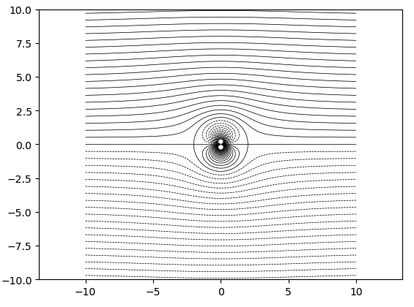
ExampleUniform flow past a cylinder with circulation.example-uniform-past-circle-with-vortex Consider the flow of Example [example-uniform-past-circle], with complex potential
$$w(z)=Uz+\frac{Ua^{2}}{z}.$$
- Confirm, by use of the streamfunction $ψ$, that the circle boundary is a streamline of the flow.
- It will be useful to remind yourself that
$$cosθ=\frac{e^{iθ}+e^{−iθ}}{2}.$$
- Solution.We set $z=ae^{iθ}$ into the complex potential. This gives
$$ϕ+iψ=Ua\left(e^{iθ}+e^{−iθ}\right)=2Uacosθ.$$
- Therefore $ψ=Imw=0$ on the surface of the cylinder.
- Derive the complex velocity, $u−iv$, and use it to show that on the surface of the cylinder, the velocity is given by
$$u−iv=2Ue^{i(π/2−θ)}sinθ,$$
- where $z=ae^{iθ}$.
- It is helpful for you to remember that
$$sinθ=\frac{e^{iθ}−e^{−iθ}}{2i}.$$
- Solution.Differentiating gives the complex velocity,
$$w^{′}(z)=u−iv=U\left(1−\frac{a^{2}}{z^{2}}\right).$$
- Substituting $z=ae^{iθ}$ and simplifying gives
$$u−iv=Ue^{−iθ}\left(e^{iθ}−e^{−iθ}\right)=2Ue^{i(π/2−θ)}sinθ.$$
- Conclude that on the surface of the cylinder, the maximum velocity is $|u|=2U$. Where does this maximum velocity occur? Where do stagnation points in the flow (where the velocity is zero) occur?
- Solution.From the above, the magnitude is $|u−iv|=2U|sinθ|$, so the maximum speed on the cylinder is $2U$. This value is obtained at the top and bottom, $θ=±π/2$. The stagnation points are where the speed is zero, at the fore and aft points, $θ=π$ and $θ=0$.
- Show that on the surface of the cylinder, the pressure is given by
$$p=p_{∞}+\frac{1}{2}ρU^{2}(1−4\sin^{2}θ),$$
- where $p_{∞}$ is the pressure at infinity.
- Solution.From Bernoulli’s equation (Theorem [thm-bernoulli-potential]), without gravity,
$${\left(p+\frac{ρ}{2}|u|^{2}\right)}_{\text{cylinder}}={\left(p_{∞}+\frac{ρ}{2}U^{2}\right)}_{\text{infinity}},$$
- where $p_{∞}$ is the pressure at infinity. Substituting the speed on the cylinder, $|u|^{2}=4U^{2}\sin^{2}θ$, gives
$$p=p_{∞}+\frac{ρ}{2}U^{2}(1−4\sin^{2}θ)$$
- as desired.
- It is possible to add a line vortex to the interior of the circular cylinder, centred at $z=0$, by adding to ([eqn-flow-over-circle-problem]) an additional term:
$$w(z)=U\left(z+\frac{a^{2}}{z}\right)−\frac{iΓ}{2π}logz.$$
- Verify again that the above modification does not change the streamline properties of $|z|=a$.
- Does the above flow satisfy the condition that the flow is of uniform speed $U$ far upstream?
- Solution.The streamfunction of the vortex is constant on circles centred at the origin, so the cylinder remains a streamline. Indeed, on the surface, the added term is
$$−\frac{iΓ}{2π}(loga+iθ)=\frac{Γθ}{2π}−\frac{iΓ}{2π}loga.$$
- Therefore the imaginary part is still a constant, and hence the boundary of the cylinder is still a streamline of the flow.
- To verify that the upstream flow is not altered, we take a derivative to obtain the complex velocity:
$$w^{′}(z)=u−iv=U\left(1−\frac{a^{2}}{z^{2}}\right)−\frac{iΓ}{2πz}.$$
- So in the limit $|z|→∞$, the velocity is horizontal with speed $U$.
- By studying the velocity of the flow with the vortex added, verify that the complex velocity on the surface is given by
$$u−iv=ie^{−iθ}\left(2Usinθ−\frac{Γ}{2πa}\right).$$
- Conclude that a point on the cylinder that satisfies the equation
$$sinθ=\frac{Γ}{4πaU},$$
- is a stagnation point of the flow.
- Solution.Using the previous task and adding the vortex term,
$$u−iv=2Uie^{−iθ}sinθ−\frac{Γi}{2πa}e^{−iθ}=ie^{−iθ}\left(2Usinθ−\frac{Γ}{2πa}\right).$$
- A stagnation point requires that $|u−iv|=0$, so setting the terms in brackets to zero implies
$$sinθ=\frac{Γ}{4πaU},$$
- as desired. This requires $|Γ|≤4πaU$; for larger $|Γ|$, the stagnation point leaves the cylinder.
- (Not examinable) Use a computational tool to investigate the streamlines of the flow for $Γ=0$, $2πaU$, $4πaU$, and $6πaU$.
- The fact that the stagnation point shifts, moving on the top or bottom of the circular cylinder, depending on the value of $Γ$, will result in an asymmetry in the pressure, causing a net force on one side of the cylinder. This is related to the well-known Magnus effect, which is used by athletes to make a ball’s path curve.
- Solution.The point of this task is to note that when $Γ≠0$, the location of the stagnation point shifts. For example, if $Γ=4πaU$, then the stagnation points are found at
$$sinθ=1⇒θ=π/2,$$
- i.e. the top of the cylinder. For $Γ=6πaU$, the stagnation point lies off the cylinder.
- FigureFlow past a circular cylinder with interior line vortex of different strengths.fig-circle-with-vortex
- 010 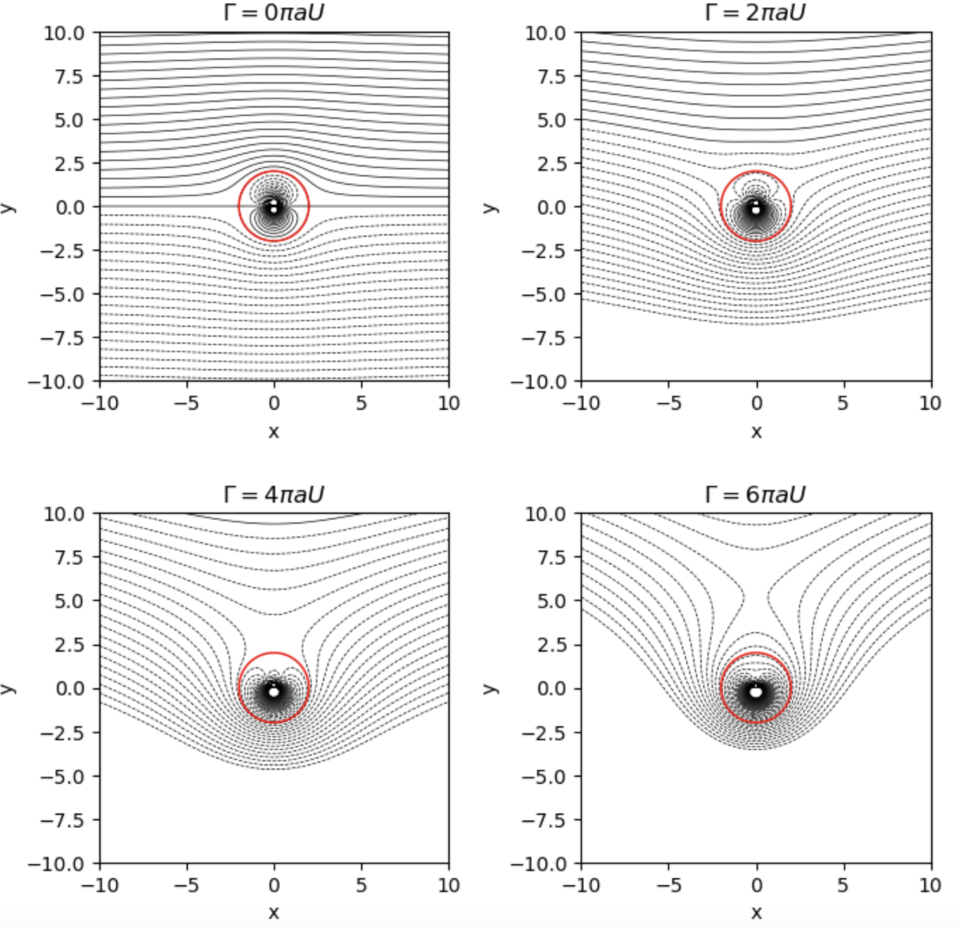
RemarkMapping the circle to an aerofoil.remark-joukowski In classical teaching of potential flow theory, one would also show how the circle can be conformally mapped to an aerofoil-like shape, including a flat plate, for example using the Joukowski map. The flows past a circular cylinder constructed in this section then give the flow past the aerofoil.
AsideRemoved in 2026.sec-circle-maps-8 The material on the Joukowski map and flow past an aerofoil is not included in this year’s delivery, and has been removed from the notes.
ExercisesExercisesExercisesws-potentialflows
RemarkSolutions and feedback.remark-solutions-feedback-potentialflows Full solutions to these exercises can be found in the solutions to this chapter [solutions-potentialflows] in Appendix [solutions] at the back of the book.
If you would like feedback on your work, the tutor will by default concentrate on the exercises highlighted with a yellow background in the online notes (the homework exercises), unless you specifically ask for feedback on a different exercise instead.
There is an excellent website at www.potentialflows.com that allows you to plug in different flow elements (sources/sinks, vortices, etc.) into a potential flow and observe the streamlines and potential-flow lines. In your exercises, use this to help you visualise the flow.
Potential flows, part 1. These exercises cover approximately around sections 4.1 (the velocity potential) to 4.3 (the complex potential).
1Basic calculations.ex-hw-streamfunction-flux-compute The following question relates to two-dimensional potential flow. Remember that the fluid flux through a surface given by contour $C$ is given by ([eqn-2d-flux]), or
C​u⋅n ds.
You will get some practice on calculating this quantity below.
For each of the following elementary flows, state or calculate:
- the complex potential, $f(z)$;
- the velocity vector, written in vector form $u=[u,v]$;
- the flux through a surface consisting of a circle of unit radius;
- Hint: the unit normal for the circle is $n=[cosθ,sinθ]$; when converting to polar coordinates remember that $ds=rdθ$.
- the flux through a surface consisting of a plate given by the line $y=−x+1$ with $0≤x≤1$.
- Uniform flow of velocity $U$ oriented at an angle of $π/4$ to the horizontal.
- Hint.Circle. Parametrise the unit circle by $[x,y]=[cosθ,sinθ]$ for $0≤θ<2π$. Explain why the outward unit normal is $n=[cosθ,sinθ]$ and why $ds=dθ$, so that the flux becomes $\int_{0}^{2π}{u}⋅n dθ$. Before integrating, can you predict the answer?
- Plate. Parametrise the plate by $r(t)=[t,1−t]$ for $0≤t≤1$. Show that the tangent is $r^{′}(t)=[1,−1]$, and hence that a unit normal, pointing away from the origin, is $n=[1,1]/\sqrt{2}$. Show also that $ds=|r^{′}(t)| dt=\sqrt{2} dt$, so that the flux becomes $\int_{0}^{1}{u}⋅n \sqrt{2} dt$.
- A line source of strength $Q$ located at the origin.
- Hint.For the plate, use the same parametrisation and normal as in part (a), and write the velocity in Cartesian form, $u=\frac{Q}{2π}\frac{[x,y]}{x^{2}+y^{2}}$. You may use, without proof, that
$$\int_{0}^{1}{\frac{dt}{t^{2}+(1−t)^{2}}}=\frac{π}{2}.$$
- Stagnation point flow with a stagnation point at the origin.
- A line vortex flow of strength $Γ$ placed at the origin.
- Hint.For the plate, you should find an integral of the form $\int_{0}^{1}{\frac{2t−1}{t^{2}+(1−t)^{2}}} dt$. Compare the numerator with the derivative of the denominator, or consider what happens under the substitution $t↦1−t$.
2Evaluation of the flux.ex-hw-potential-fluxcalc Return to the previous question and, instead of directly calculating the flux via a line integral, use Theorem [thm-flux-streamlines] to calculate the flux for the two geometries (unit circle and straight plate) for each of the flows given.
3Doublet.ws-potentialflows-2-5 A line source of strength $Q$ is at $z=a$ and a line sink of the same strength is at $z=−a$ where $a>0$.
- Write down the complex potential, $f(z)$. Find $f^{′}(z)$. Locate any stagnation points and derive an equation for the streamlines of the flow. Finally, use a plotter, such as the one at the potential flow simulator to sketch the streamlines.
- Let $a→0$ and $Q→∞$ while keeping the product $aQ$ fixed. This gives the flow due to a doublet. Show that its complex potential is $μ/z$ where $μ$ is expressed in terms of $a$ and $Q$. It will be useful for you to use the fact that
$$log(1+α)=α+O(α^{2})$$
- considered as an appropriate approximation when $α$ is small. Show that the streamlines are circles through the origin with centres on the $y$-axis.
Potential flows, part 2. These exercises will cover the second part of Chapter 4, from sec. 4.4 (the method of images).
4Single source in a semi-infinite flow.ex-hw-image-planar01 Verify that a single source of strength $Q$ placed at the point $z=d>0$ is insufficient to describe flow bounded in the semi-infinite region, $x>0$, with a planar boundary at $x=0$. What is the horizontal and vertical velocities on the boundary? Find an equation for the streamlines and sketch the flow.
5A source in a semi-infinite flow.ps-image-planar02 Consider the situation of two point sources of identical strength, $Q$, placed at $z=±d$, with $d>0$.
- Develop equations for the complex potential, $f(z)=ϕ+iψ$, and complex velocity, $u−iv$.
- Note: the algebra quickly becomes awkward, whatever form you use. In this part, you are not expected to simplify beyond writing the streamfunction in a form such as $ψ=\frac{Q}{2π}Arg\left[(x+iy)^{2}−d^{2}\right]$. You may then confirm the shape of the streamlines, $ψ=\text{constant}$, with a plot.
- Let $β$ denote the constant value of $Arg(z^{2}−d^{2})$ along a given streamline. Show that, on this streamline,
$$\frac{2xy}{x^{2}−y^{2}−d^{2}}=tanβ.$$
- Hint.Start from part (a): explain why $ψ=\text{constant}$ means that $Arg(z^{2}−d^{2})$ is constant along a streamline.
- Next, substitute $z=x+iy$ and expand $z^{2}−d^{2}$ to find its real and imaginary parts.
- Finally, recall that any complex number can be written as $w=a+ib=|w|e^{iβ}$, where $β=Argw$. Comparing real and imaginary parts gives $a=|w|cosβ$ and $b=|w|sinβ$, so that $b/a=tanβ$.
- Hence show that the streamlines are hyperbolae, and find their equation.
- Hint.Multiply out the result of part (b), writing $k=cotβ$, and rearrange it into the form $Ax^{2}+Bxy+Cy^{2}=D$. Recall that such a conic is a hyperbola when $B^{2}−4AC>0$.
6Two vortices and a dividing boundary.ex-hw-image-planar03 Consider the situation of two point vorticies of identical strength, but opposite direction, placed at $z=±d$, with $d>0$. Develop equations for the complex potential, $f(z)=ϕ+iψ$, and complex velocity, $u−iv$.
Demonstrate that the streamlines are given by
$$ψ=\frac{Γ}{2π}log\left(\frac{r_{2}}{r_{1}}\right).$$
7A line source in a flow; stagnation points.ex-hw-linesource-stagnation Incompressible inviscid fluid occupies the region $y>0$, and there is a rigid plane wall at $y=0$. There is a uniform flow, speed $U$, in the positive $x$-direction, and a line source of strength $Q$ at $(0,a)$, where $a>0$. Find the complex potential $f(z)$ and calculate $f^{′}(z)$. Let $β=Q/(2πaU)$. Show that if $β>1$ there are two stagnation points, both on the wall, while if $β<1$ there is only one, in the fluid, a distance $a$ from the origin. Try to sketch the streamlines in either case
8The exponential and sinusoidal conformal maps.ps-conformal-check-exp-sin Check where each of the labeled points in the associated diagrams for the exponential map ([eqn-conformal-exp-map]) and ([eqn-conformal-sin-map]) are sent, from the $z$-plane to the $ζ$-plane. In each of these cases, verify that an interior (within the fluid domain) is sent to the upper half-plane.
Construct the complex potential that corresponds to a single line source placed within the fluid in each of these cases (an infinite strip of height $h$ and a semi-infinite strip).
9Elementary conformal maps.ex-hw-conformal-elementary Define the term conformal map.
Write down the conformal maps from the wedge $0<\text{arg}(z)<α$ into the upper half-plane. Find all the points at which the map is not conformal.
10Flow past a flat plate.ws-potentialflows-3-9
- Show that the circle $|ζ|=a$ is mapped to a line segment
$$S=\{z:Imz=0,−2a≤Rez≤2a\}$$
- along the real $z$-axis by the Joukowski transformation
$$z=ζ+\frac{a^{2}}{ζ}.$$
- Deduce that the exterior of the line segment is mapped to the exterior of the circle $|ζ|=a$ by the transformation
$$ζ=\frac{1}{2}\left(z+\sqrt{z^{2}−4a^{2}}\right).$$
- Carefully define the function $\sqrt{z^{2}−4a^{2}}$ and determine where the mapping above is conformal.
- Construct a flow, by providing the complex potential $ϕ+iψ$, that consists of: uniform flow oriented at an angle $α$ to the horizontal at infinity; a line source of strength $Q$ placed in the flow; and a horizontal flat plate of length $4a$ on the axis, $−2a<z<2a$. Sketch what you believe will be the streamlines of such a flow.
ChapterWater wavesWater wavesch-chapter05-waves
In the mid-nineteenth century, George Gabriel Stokes made significant contributions to the study of water waves, establishing much of the theoretical foundation that underpins modern fluid mechanics. His analysis of periodic, finite-amplitude waves on the surface of an incompressible fluid led to what are now known as Stokes waves, which describe how real waves deviate from purely sinusoidal motion as their amplitude increases. Stokes’ work marked a shift from qualitative observation to quantitative description, providing a systematic framework for understanding the balance of gravity, inertia, and nonlinearity in wave motion.
Our main task in this chapter is to introduce the fundamental principles governing water waves and the mathematical models that describe their behavior across different regimes.
Notech-chapter05-waves-2-3 As part of our lecture, we will study the related video on the NCFMF database on Waves in Fluids. The particular section of relevance is at the start, concerning the particle trajectories in waves of deep water.
SectionGoverning equations of water wavesGoverning equations of water wavessec-waterwaves-equations
We shall consider the case of waves on the free surface of a two-dimensional potential fluid (hence inviscid, incompressible, and irrotational). The free surface bounds the water from above, and is assumed to be given by
$$y=η(x,t) −∞<x<∞.$$
Since the fluid satisfies the assumptions of potential flow, there exists a velocity potential $u=∇ϕ$ where
$$∇^{2}ϕ=\frac{∂^{2}ϕ}{∂x^{2}}+\frac{∂^{2}ϕ}{∂y^{2}}=0 \text{in the fluid}.$$
What makes water-wave problems unique (and challenging) is that not only do we need to solve for the potential (and hence velocities) within the fluid, as given by Laplace’s equation above, but that we must do so in an a priori unknown domain, where the free-surface location $y=η(x,t)$ must also be solved in parallel. Key considerations, then, must relate to the precise boundary conditions to impose.
SubsectionBoundary conditionsBoundary conditionssubsec-waterwaves-boundaryconditions
SubsubsectionBottom boundary conditionsBottom boundary conditionssubsubsec-waterwaves-otherBC If we consider waves on a fluid of infinite (or deep) depth, then far below the free surface, we expect that the velocity tends to zero. Hence a suitable boundary condition is
$$u=∇ϕ→0 \text{as }y→−∞.$$
On the other hand, for the case of fluid bounded below by a flat bed, say at $y=−H$, we have
$$u⋅n=0⇒\frac{∂ϕ}{∂y}=0 \text{on }y=−H.$$
SubsubsectionDynamic boundary conditionsDynamic boundary conditionssubsubsec-waterwaves-dynamicBC There are now two boundary conditions to consider at the free surface. The dynamic boundary condition corresponds to the requirement of satisfying a force balance at the free surface. At the free surface, the pressure within the liquid must be equal to the pressure within the air. This leads to the dynamic boundary condition that
$$p=p_{\text{atm}} \text{at }y=η(x,t),$$
where $p_{\text{atm}}$ is the atmospheric pressure above the fluid (assumed to be constant).
Typically, we need the above pressure condition expressed in terms of $ϕ$, and this suggests using Bernoulli’s equation. Recall from Theorem [thm-bernoulli-unsteady-potential] that, for an unsteady potential flow,
$$\frac{∂ϕ}{∂t}+\frac{1}{2}|∇ϕ|^{2}+\frac{p}{ρ}+χ=F(t),$$
for some function $F(t)$, where $g=−∇χ$ is the conservative body force.
Below, we will set the body force indeed to be gravity. Thus if we write
$$χ=gy⇒g=−∇χ=\left[0,−g\right],$$
and gravity is then directed in the negative $y$-direction.
We now evaluate Bernoulli’s equation ([eqn-bernoulli-unsteady-potential]) on the free surface, $y=η$. This gives
$$\frac{∂ϕ}{∂t}+\frac{1}{2}|∇ϕ|^{2}+\frac{p_{\text{atm}}}{ρ}+gη=F(t), \text{on }y=η.$$
It is convenient to set the arbirary function $F(t)=\frac{p_{\text{atm}}}{ρ}$, yielding the final result:
$$\frac{∂ϕ}{∂t}+\frac{1}{2}|∇ϕ|^{2}+gη=0, \text{on }y=η,$$
which is a re-phrasing of the necessary dynamic boundary condition on the free surface.
SubsubsectionKinematic boundary conditionsKinematic boundary conditionssubsubsec-waterwaves-kinematicBC In the case of fluids near solid surfaces, we require a no-penetration condition, which enforces that the fluid velocity is zero in a direction normal to the surface, $u⋅n=0$. For the case of a free boundary, such as the one at $y=η(x,t)$, there is a similar constraint, and it may be shown that this is equivalent to imposing that the material fluid elements on the free surface must remain on the free surface.
Thus, if $y=η$ for some fluid particle at time $t$, then $y=η$ for the same particle for all time. Thus we need
$$\frac{D(y−η)}{Dt}=0, \text{on }y=η.$$
Expansion and use of the material derivative then implies the kinematic boundary condition
$$v=\frac{∂η}{∂t}+u\frac{∂η}{∂x}, \text{at }y=η.$$
SubsectionSummary of the governing equationsSummary of the governing equationssubsec-summary-of-potential-flow Let us summarise the governing water-wave equations in one section.
TheoremWater wave equations in potential flow.thm-waterwaves-governing Consider two-dimensional free-surface flow of a potential (inviscid, incompressible, irrotational) fluid. The fluid satisfies Laplace’s equation,
$$∇^{2}ϕ=0, \text{in the fluid domain}.$$
On the free surface, we have the kinematic boundary condition and dynamic boundary conditions:
$$\begin{aligned}\frac{∂η}{∂t}+u\frac{∂η}{∂x}=v, &y=η(x,t) \\ \frac{∂ϕ}{∂t}+\frac{1}{2}|∇ϕ|^{2}+gη=0, &y=η(x,t).\end{aligned}$$
Finally there is typically a condition in the far field, either at infinity in the case of infinite depth, or a condition on a channel bottom in the case of finite depth. For example, in the case of infinite depth and an otherwise motionless fluid at infinity, we would require
$$∇ϕ→0, \text{as }y→−∞.$$
While for the case of a finite channel bottom at $y=−h$, we would require
$$\frac{∂ϕ}{∂y}=0 \text{on }y=−h.$$
SectionWave parametersWave parameterssec-wave-parameters A general travelling wave is written as
$$η=asin\left[kx−ωt\right].$$
An additional phase, e.g. in $sin(kx−ωt−β)$ can be included but this can be removed through a shift in space or time. What do the quantities $k$ and $ω$ represent?
We can factor out the $k$ and obtain
$$η=asin\left[k\left(x−\frac{ω}{k}t\right)\right].$$
The quantity $k$ is called the wavenumber. If we define it instead to be
$$k≡\frac{2π}{λ},$$
then we see that shifting $x$ by $±λ$ does not change the wave. The quantity $λ$ is called the wavelength.
Let us now turn to the quantity $ω/k$. If we introduce
$$c≡\frac{ω}{k},$$
then $c$ is called the phase speed. It corresponds to the speed at which the "phase" of the wave (the crests and troughs) propagate.
At a fixed location in space, what is the time that it takes for the condition at this point to repeat itself? It is the time required for the wave to travel one wavelength, $λ$. Hence this is defined as the period of the wave:
$$T≡\frac{λ}{c}.$$
These concepts can be generalised to wave in a three-dimensional fluid, where we would write instead
$$η=asin(kx+ly+mz−ωt)=asin(K⋅x−ωt).$$
In this case, $K=(k,l,m)$ is the wavenumber vector and has magnitude $K=\sqrt{k^{2}+l^{2}+m^{2}}$. The wavelength is then
$$λ=\frac{2π}{K}.$$
The phase velocity is given by
$$c=\frac{ω}{K}\frac{K}{K}.$$
SectionStokes wavesStokes wavessec-waterwaves-stokeswaves
SubsectionLinearisation of the water-wave equationsLinearisation of the water-wave equationssubsec-waterwaves-linearisation Our task in this section is to linearise the water-wave equations given in Theorem [thm-waterwaves-governing]. The culprit to the difficulty in seeking solutions concerns two main issues. The first is the nonlinearity in Bernoulli’s equation (i.e. the term $|∇ϕ|^{2}$). The second is to do with the specification of the unknown free surface, $η(x,t)$, and the need to solve the extra equations on this unknown location.
The idea of linearisation relies upon the consideration that if disturbances in the fluid are small, then the quadratic terms in the free-surface conditions can be neglected. One way to see this is to introduce a scaling on all the associated quantities. For example, we consider the free surface as written as
$$η(x,t)=δ\overline{η}(x,t),$$
where $δ≪1$ ($δ$ is a small number). The parameter $δ$ is simply a notational device to help remind us of the smallness of the free surface.
Now since we assume the motion in the fluid is also small, then we introduce a similar scaling on the potential function. We assume
$$ϕ(x,y,t)=δ\overline{ϕ}(x,y,t),$$
within the fluid. As a consequence, all velocities are small and of order $δ$.
Now consider the evaluation of the vertical velocity on the surface. By Taylor’s formula, we can expand:
$$v=\frac{∂ϕ(x,η,t)}{∂y}=\frac{∂ϕ(x,0,t)}{∂y}+\frac{∂^{2}ϕ(x,0,t)}{∂y^{2}}η+\text{higher-order terms}.$$
In fact, if we use our assumptions ([etasmall]) and ([phismall]), we can see the size of the vertical velocity more explicitly:
$$v=δ\frac{∂\overline{ϕ}(x,0,t)}{∂y}+δ^{2}\frac{∂^{2}\overline{ϕ}(x,0,t)}{∂y^{2}}\overline{η}+O(δ^{3}).$$
We will essentially ignore all terms of $δ^{2}$ or smaller.
Let us consider now the kinematic condition ([wwfull02]). Since the term with the horizontal velocity $u\frac{∂η}{∂x}=O(δ^{2})$, then we see that the kinematic approximation now yields
$$δ\frac{∂\overline{η}}{∂t}=δ\frac{∂\overline{ϕ}}{∂y}+O(δ^{2}), \text{on }y=0.$$
As we indicated, the use of $δ$ is only to aid with ordering. We see that if we return back to the original variable scalings, then the above indicates that the approximate kinematic condition to be considered is:
$$\frac{∂η}{∂t}∼\frac{∂ϕ}{∂y} \text{on }y=0.$$
It is typical, when dealing with linear water waves, to dispense with the notation indicating "approximate", i.e. $∼$ here, on the understanding that the solutions are satisfied only approximately.
Remarksubsec-waterwaves-linearisation-7 The development of the linearised equation(s) seem quite lengthy, as presented above, but with understanding, you will see that they are quite simple. In essence, you have replaced the exact free-surface condition of
$$\frac{∂η}{∂t}+u\frac{∂η}{∂x}=v, \text{on }y=η(x,t),$$
with
$$\frac{∂η}{∂t}=v, \text{on }y=0,$$
on the assumption the flow is linearised about $ϕ=0$ and $η=0$.
You will be able to practice this linearisation in the exercises.
The linearisation of Bernoulli’s equation in ([wwfull03]) is done similarly, and the end result is that the term,
$$|∇ϕ|^{2}={\left(\frac{∂ϕ}{∂x}\right)}^{2}+{\left(\frac{∂ϕ}{∂y}\right)}^{2},$$
is assumed to be small compared to the other terms of the equation.
Using the linearisation techniques, similar to the kinematic equation and its linear variation ([eqn-waves-kinematiccondition01]), Bernoulli’s equation in ([wwfull03]) is then approximated as
$$\frac{∂ϕ}{∂t}+\frac{1}{2}|∇ϕ|^{2}+gη=0 \text{on }y=0.$$
This yields the set of governing linear equations as follows.
TheoremLinear water wave equations.thm-waterwaves-equations Consider two-dimensional potential flow (inviscid, incompressible, irrotational) of fluid. A model for linear water waves is as follows:
$$\begin{aligned}∇^{2}ϕ=0& −∞<y<0 \\ \frac{∂ϕ}{∂t}+\frac{1}{2}|∇ϕ|^{2}+gη=0& \text{on }y=0 \\ \frac{∂η}{∂t}+u\frac{∂η}{∂x}=v& \text{on }y=0\end{aligned}$$
where the free surface is located at $y=η(x,t)$.
In water of infinite depth, we require that
$$∇ϕ→(0,0) \text{as }y→−∞,$$
while for the case of finite depth, we have
$$\frac{∂ϕ}{∂y}=0 \text{on }y=−h.$$
SubsectionSolving for linear waves in infinite depthSolving for linear waves in infinite depthsubsec-linear-waves-solution We now seek to solve the linear water wave equations in Theorem [thm-waterwaves-equations].
We assume that the wave takes the form of a simple harmonic wave:
$$η(x,t)=Acos(kx−ωt).$$
Examining the free-surface conditions in ([ww02]) and ([ww03]) suggests that the potential should take the form of a sinusoidal:
$$ϕ(x,y,t)=f(y)sin(kx−ωt),$$
which we shall verify is appropriate.
Firstly, substitution of ([eqn-linear-wave-phi]) into Laplace’s equation ([ww01]) yields
$$f^{″}(y)−k^{2}f(y)=0.$$
Turning now to the two free-surface conditions ([ww02]) and ([ww03]), as well as the condition of infinite depth, we have the following necessary constraints:
$$\begin{aligned}f^{′}(0)&=ωA, \\ ωf(0)&=gA, \\ f(−∞)&→0.\end{aligned}$$
The solution of ([eqn-linear-wave-laplace-01]) yields
$$f(y)=Be^{ky}+De^{−ky},$$
and so the infinite depth condition ([ww04-inf]) yields $D≡0$. We substitute now $f(y)=Be^{ky}$ into the two remaining conditions and simplify, yielding the matrix equation:
$$\left(\begin{matrix}ω & −k \\ g & −ω\end{matrix}\right)\left(\begin{matrix}A \\ B\end{matrix}\right)=\left(\begin{matrix}0 \\ 0\end{matrix}\right).$$
Therefore, in order for there to be nontrivial solutions, the determinant of the matrix must be zero, and this yields
$$ω^{2}=gk,$$
or alternatively if we take the positive root,
$$ω=\sqrt{gk}.$$
The above expression is known as the dispersion relation for water waves in deep water.
SectionGeneralisations of water wavesGeneralisations of water wavessec-waterwaves-generalisations During the lectures and exercises, you will cover some of the following variants.
- Linear water waves in finite depth: part of Exercise .2 and done in Problem Class Week 6.
- In lectures and the exercise, you will confirm that the dispersion relation in finite depth is modified to:
$$ω=ω_{\text{finite}}=\sqrt{gktanh(kh)}.$$
- In the limit $h→∞$, since $tanh(kh)→1$, this approaches the deep-water dispersion relation of
$$ω_{\text{deep}}=\sqrt{gk},$$
- as shown in ([eqn-dispersion-deep]).
- Linear water waves in a current: part of Exercise .3 and done in Week 6 Thursday video.
- In these problems, you will modify the setup to include a horizontal current at infinity, with $ϕ∼Ux$ as $x→−∞$. The main difference in this case is that there are additional terms to be included in the linear kinematic and dynamic conditions. As shown in the exercise, the dispersion relation is modified to
$$ω=ω_{\text{current}}=Uk∓\sqrt{gktanh(kh)}.$$
- There are now two distinct wavespeeds. In the version where there is zero current, $U=0$, the wavespeeds reduce to a single one (i.e. a single $|c|$, with both left- and right-travelling waves; remember that we usually drop the $±$).
- Linear water waves in two fluids of different densities: part of Exercise .4 and done in Week 7 Problem Class.
- Consider that the interface $y−η$ separates two fluids of different densities, say $ρ_{1}$, lying in the lower portion, $y<η$, and $ρ_{2}$ in the upper portion, with $y>η$. The main modification in the governing equations happens in Bernoulli’s equation ([eqn-bernoulli-unsteady-potential]).
- In this case, the linear Bernoulli equation on the surface is
$$ρ_{1}\left(\frac{∂ϕ_{1}}{∂t}+gη\right)=ρ_{2}\left(\frac{∂ϕ_{2}}{∂t}+gη\right), \text{on }y=0.$$
- The procedure is the same for this version, but the algebra is noticeably more involved. In this case, the dispersion relation is
$$ω=±\sqrt{\left(\frac{ρ_{1}−ρ_{2}}{ρ_{1}+ρ_{2}}\right)gk}.$$
- Linear water waves with surface tension: part of Exercise .5 and done in Week 7 Problem Class.
- For the case of deep water waves, this modifies the dispersion relation to
$$ω=\sqrt{gk+\frac{Tk^{3}}{ρ}}.$$
ExercisesExercisesExercisesexercises-water-waves
RemarkSolutions and feedback.remark-solutions-feedback-waves Full solutions to these exercises can be found in the solutions to this chapter [solutions-waves] in Appendix [solutions] at the back of the book.
If you would like feedback on your work, the tutor will by default concentrate on the exercises highlighted with a yellow background in the online notes (the homework exercises), unless you specifically ask for feedback on a different exercise instead.
In this question, you will derive the kinematic boundary condition on a free surface, which ensures that fluid particles on the free surface must remain on the free surface. Consider a vector that points to a location on a 2D free surface given by
$$r(s,t)=(x,η(x,t)).$$
Introduce the curve $F(x,y,t)=y−η(x,t)$. For any particle on the surface, it must be the case that $F(x,y,t)≡0$. By applying the material derivative show that the condition that
$$\frac{DF}{Dt}=0,$$
for particles on the free surface is equivalent to the kinematic condition
$$v=\frac{∂η}{∂t}+u\frac{∂η}{∂x} \text{on }y=η(x,t).$$
Consider small 2D water waves on the free surface of a potential (incompressible and irrotational) fluid with velocity potential $ϕ(x,y,t)$, with $ϕ$ satisfying $∇^{2}ϕ=0$. Let the free surface be at $y=η(x,t)$ and assume the water is confined above a flat channel of depth $y=−h$. Show that on the free surface, $y=η(x,t)$, the kinematic equation is given by
$$\frac{∂ϕ}{∂y}=\frac{∂η}{∂t}+\frac{∂ϕ}{∂x}\frac{∂η}{∂x},$$
while the dynamic (Bernouilli) equation is
$$\frac{∂ϕ}{∂t}+\frac{1}{2}|∇ϕ|^{2}+gη=0.$$
Show that when the problem is linearised by ignoring quadratic terms, then instead the boundary conditions can be simplified to be
$$\begin{aligned}\frac{∂ϕ}{∂y}&=\frac{∂η}{∂t}, \\ \frac{∂ϕ}{∂t}+gη&=0,\end{aligned}$$
and now applied on $y=0$.
Show that travelling harmonic waves, with $η=Acos(kx−ωt)$ and $ϕ=f(y)sin(kx−ωt)$, are possible and derive the associated dispersion relation,
$$ω^{2}=gktanh(kh).$$
In deriving the above, it will be convenient for you to use the hyperbolic cosine and sine functions:
$$coshz=\frac{e^{z}+e^{−z}}{2} \text{and} sinhz=\frac{e^{z}−e^{−z}}{2},$$
and note that the cosh function is even at $z=0$ (and therefore has a zero derivative). The use of hyperbolic functions is used in the solution of $f(y)$ and is a common trick when solving boundary-value problems with exponentials. We now consider linear waves in a channel of depth $h$, as in the previous question. This time, however, assume that there is a uniform flow of speed $U$ at infinity.
- Begin by writing down the boundary conditions that you expect at $y=−h$ and also far upstream, with $x→−∞.$
- Therefore, this time, we shall consider the velocity as expressed as
$$u=U+\frac{∂ϕ}{∂x}, v=\frac{∂ϕ}{∂y},$$
- and again linearise the necessary equations.
- Linearise the associate free-surface equations, and show that this time, they produce
$$\frac{∂ϕ}{∂y}=\frac{∂η}{∂t}+U\frac{∂η}{∂x}, \text{on }y=0,$$
- and
$$\frac{∂ϕ}{∂t}+U\frac{∂ϕ}{∂x}+gη=0, \text{on }y=0.$$
- When considering the second of the two equations above (Bernoilli’s) return to the original Bernoulli equation:
$$\frac{∂ϕ}{∂t}+\frac{1}{2}|∇ϕ|^{2}+\frac{p}{ρ}+gy=F(t),$$
- and choose your constant $F$ more strategically.
- Show finally that the dispersion relation predicts possible waves of speeds
$$c_{±}=U±{\left(\frac{g}{k}tanh(kh)\right)}^{1/2}.$$
- The regime where the flow speed is less than $\sqrt{gh}$ is known as subcritical. The regime where flow is greater than $\sqrt{gh}$ is supercritical. What can you anticipate about the waves in these two regimes based on the wave speeds above?
Inviscid incompressible fluid of density $ρ_{2}$ lies in the region $y>0$ above a fluid with greater density $ρ_{1}$ for $y<0$. Assume there there is a small-amplitude disturbance the two fluids with the surface given by $y=η(x,t)$. Assuming $η$ and the fluid velocities are small, assume that the linearised boundary conditions on the approximated boundary at $y=0$ are given by
$$\begin{aligned}\frac{∂η}{∂t}=\frac{∂ϕ_{1}}{∂y}=\frac{∂ϕ_{2}}{∂y}& \text{at }y=0, \\ ρ_{1}\left(\frac{∂ϕ_{1}}{∂t}+gη\right)=ρ_{2}\left(\frac{∂ϕ_{2}}{∂t}+gη\right)& \text{at }y=0.\end{aligned}$$
(Notice that these are three conditions; two kinematic conditions for the two fluids, and a dynamic (Bernoulli) condition).
If $η(x,t)=Acos(kx−ωt)$ with $k>0$, derive the dispersion relation
$$ω^{2}=\left(\frac{ρ_{1}−ρ_{2}}{ρ_{1}+ρ_{2}}\right)gk.$$
Suppose now that there is surface tension $T$ between the two fluids of Exercise .4. In lectures, it was shown that the linear dynamic boundary condition is given by
$$ρ_{1}\left(\frac{∂ϕ_{1}}{∂t}+gη\right)−ρ_{2}\left(\frac{∂ϕ_{2}}{∂t}+gη\right)=T\frac{∂^{2}η}{∂x^{2}}, \text{on }y=0.$$
consider the specific situation where the top fluid is air, with $ρ_{2}=0$. Then the dynamic condition is
$$\frac{∂ϕ}{∂t}+gη=\frac{T}{ρ}\frac{∂^{2}η}{∂x^{2}}, \text{on }y=0,$$
and only need to consider the single potential $ϕ_{1}=ϕ$.
The linear kinematic condition should be unchanged from the usual linear kinematic condition, $\frac{∂η}{∂t}=v=\frac{∂ϕ}{∂y}$ on $y=0$.
For the case of deep water waves, show that the frequency $ω$ is now related to the wavenumber $k$ by the equation
$$ω^{2}=gk+\frac{Tk^{3}}{ρ}.$$
The following is a classic elementary demonstration of dispersive effects when considering the addition of two sinusoidals with two nearly-identical values of the wavenumber. It can be used to motivate the definition of group and phase velocities.
Consider two sinusoidal waves with nearly the same wavenumber and frequency:
$$η(x,t)=sin(k_{1}x−ω_{1}t)+sin(k_{2}x−ω_{2}t).$$
- Use the trig angle identity
$$sinA+sinB=2sin\left(\frac{A+B}{2}\right)cos\left(\frac{A−B}{2}\right),$$
- to put the wave $η$ into the form of a product of sinusoidal waves.
- Consider now
$$k_{1,2}=k±Δk \text{and} ω_{1,2}=ω+Δω,$$
- i.e. each wavenumber and frequency are centred about either $k$ or $ω$, respectively.
- In the limit that $Δk,Δω≪1$ (are small), argue that the wave consists of a rapidly oscillating waveform within a slowly-varying envelope.
- show that the envelope developed in the last part exhibits maxima as
$$x(t)=\frac{Δω}{Δk}t,$$
- and therefore in the limit $Δk,Δω→0$, the velocity of such maxima (called the group velocity) is given by
$$v_{g}=\frac{dω}{dk}.$$
ChapterViscous flowsViscous flowsch-viscousflows
So far in this course, you have been considering inviscid flows, that is flows in which the fluid viscosity is not important. In this chapter we introduce the effect of viscosity into the dynamics. Fluid viscosity is a friction effect internal to the fluid, and it arises due to layers of fluid sliding over each other during fluid motion. Including viscosity in our fluid model will lead to the famous NavierStokes equations, which are the governing equations for many fluid flows of practical interest. In many real life applications, the effect of viscosity completely changes the nature of the fluid flow from that which would be observed with an inviscid fluid, and this effect can be confined to a region of the fluid or can be throughout the entire flow.
FigureSteady, laminar flow of a viscous fluid through a uniform, circular pipe. The velocity profile is parabolic. A similar profile is found for flow between two parallel plates. Credit Fu, Liang, Zhang (Symmetry, 2020).ch-viscousflows-2-2
0.20.60.2 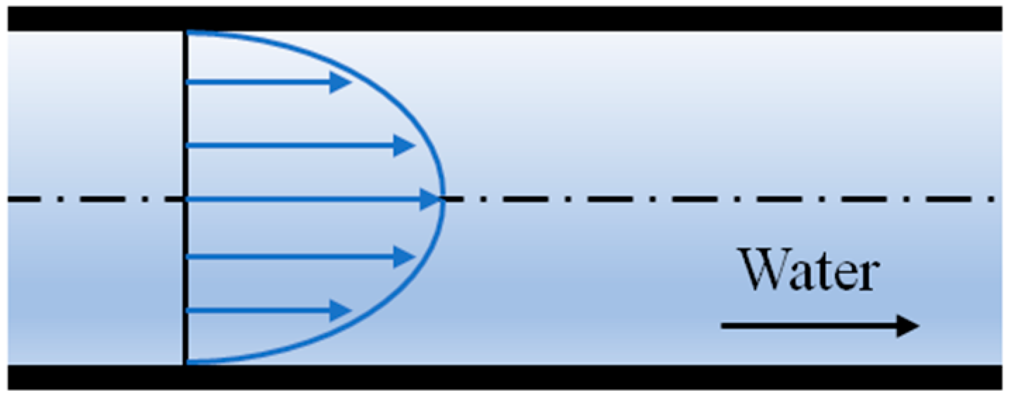
2000
0.5
FigureSphere falling through viscous fluid at low Reynolds number. Credit Kraaiennest.figure-falling-ball
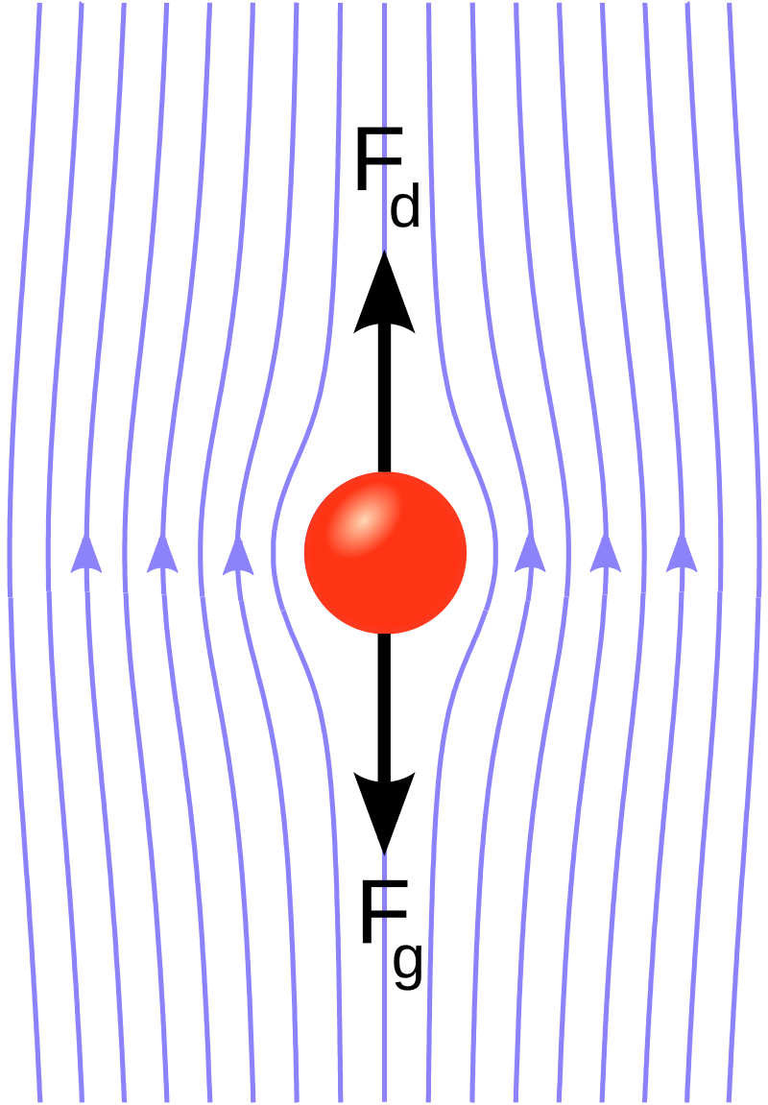
0.5
FigureThin film flow / lubrication theory. If the thickness of a fluid layer is much less than the lengthscale in the other two dimensions, we may considerably simplify the governing equations. Credit J Mo Painting.ch-viscousflows-2-3-2
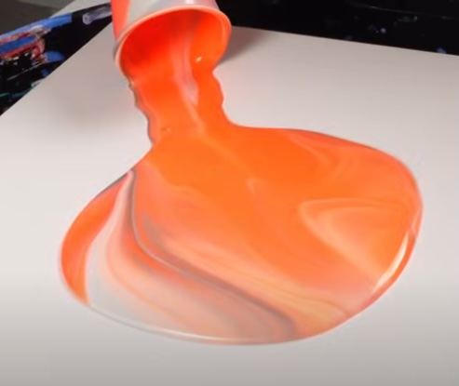
Flows that can be described as inviscid include:
- free surface flows, such as water waves in the ocean,
- aerodynamic flow, such as flow past an aircraft wing or a car body at high speed.
Even in some of these flows, the effect of viscosity is important, for example in the flow past an aerodynamic body there is a thin layer of fluid close to the body surface, called a boundary layer, in which viscous effects are important. Flows that are completely dominated by viscosity are called viscous flows, and these tend to include flows that are on a small spatial scale, have a low velocity scale, or are of a particularly viscous fluid, for example:
- Many flows in internal physiology, for example the flow of blood through blood vessels, especially capillaries (the smallest vessels), the flow of mucus in the respiratory system, fluid flows within tissues, the flow of synovial fluid in joints. These are often on a small spatial scale and have a low velocity scale.
- Several manufacturing processes, for example paint, adhesives or food products, since the spatial scales involved are not large and the fluids are often quite viscous.
- Other examples include lubricating flows, such as ball bearings and glacier flow.
SectionImportant definitionsImportant definitionsdefinitions
SubsectionViscosityViscosityviscosity Viscosity quantifies the fluid’s internal resistance to flow when a force is applied (the higher the resistance the higher the viscosity). One of the most common mathematical models of an idealised fluid is a Newtonian fluid, which will be defined precisely in Section [subsec-newtonian-fluids]. For these fluids, the shear viscosity $μ$ (sometimes called dynamic viscosity, or just viscosity) is a scalar quantity. In S.I. units, it is measured in $\text{Pa} \text{s}=kg m^{−1} s^{−1}$.
ExampleThought experiment to measure viscosity.example-viscosity We could imagine a thought experiment to measure the shear viscosity of a fluid as follows, see also Figure [fig-viscosity-measurement]. A solid block of area $A$ floats on the surface of a thin layer of the fluid of thickness $h$. The block is pushed with a force $F$ parallel to the surface of the fluid, causing it to move with a steady velocity $U$. The shear viscosity is given by
$$μ=\frac{Fh}{AU}.$$
In principle this formula could be used to determine the viscosity of a fluid experimentally; however, in practice it is more common to use a falling ball viscometer (see Exercise .3 in the worksheet at the end of this chapter).
FigureExperiment to determine the shear viscosity of a fluid.fig-viscosity-measurement
0.20.60.2 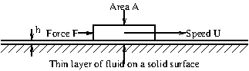
DefinitionKinematic viscosity.viscosity-4 It is sometimes mathematically more convenient to work in terms of the kinematic viscosity $ν$ (measured in $m^{2} s^{−1}$). This is related to the shear viscosity via
$$ν=\frac{μ}{ρ}.$$
TableShear viscosities at $1 atm$ pressure and $20 ^{∘}C$.viscosity-5
 | $μ$ ($kg m^{−1} s^{−1}$) | $ρ$ ($kg m^{−3}$) | $ν$ ($m^{2} s^{−1}$)
Air | $1.8×{10}^{−5}$​ | $1.2$​ | $1.51×{10}^{−5}$​
Water | $1.0×{10}^{−3}$​ | $998$​ | $1.01×{10}^{−6}$​
Blood | $2.5×{10}^{−3}$​ | $1050$​ | $2.4×{10}^{−6}$​
Glycerol | $1.5$​ | $1260$​ | $1.19×{10}^{−3}$​
Honey | $10$​ | $1420$​ | $7.04×{10}^{−3}$​
Tar | $1000$​ | $1420$​ | $0.70$​
The shear viscosity of air increases with increasing temperature, whereas that of water decreases with increasing temperature. This is typical behaviour for gases and liquids, respectively. Many real fluids have more complicated viscosity properties, for example blood, mucus, shampoo, egg white and custard. In this course we mainly consider Newtonian fluids, thereby avoiding a lot of complexity!
Remarkviscosity-7 Note that we have not yet formally defined the shear viscosity, although the example given in Example [example-viscosity] provides an informal definition. This concept will be formalised in Section [sec-stress].
SubsectionReynolds numberReynolds numberreynolds-number This is one of the most important flow parameters in the study of fluid dynamics, as its order of magnitude determines many of the qualitative features of the flow. In a given flow, it quantifies the relative importance of inertial and viscous effects.
DefinitionThe Reynolds number.reynolds-number-3 The Reynolds number is a dimensionless quantity, defined by
$$\text{Re}=\frac{ρUL}{μ}=\frac{UL}{ν},$$
where $U$ is a characteristic (or typical) velocity of the flow and $L$ is a characteristic lengthscale. It equals the typical size of an inertial acceleration divided by a typical size of a viscous acceleration in the flow.
RemarkChoice of characteristic scales.example-choice-of-scales What do we pick as the characteristic length and velocity scales? This is something that gets easier with increasing experience. For a given problem there are usually ‘natural’ scales that arise within it.
As an illustrative example of how we might think about choosing suitable scales, consider a steady flow along a pipe with a circular cross-section. An appropriate choice of $L$ could be the pipe radius or diameter, while an appropriate value of $U$ could be the velocity along the centreline (axis) of the pipe or the average velocity across the pipe cross-section (equal to the volumetric flux (volume per unit time) of fluid passing along the pipe divided by the cross-sectional area of the pipe).
Different choices of scales (for example radius vs. diameter and centreline vs. average velocity in the pipe example given in Remark [example-choice-of-scales]) would lead to different numerical values of $\text{Re}$. However, note:
- The order of magnitude of the Reynolds number is the same for all choices. Thus, when describing a flow, the value of $\text{Re}$ is often quoted as an order-of-magnitude property.
- If we give detailed information about exactly which length and velocity scales are being used then we can directly compare different values of $\text{Re}$, even if they are of the same order of magnitude. For example, we might do this in a plot of a property of the flow against the Reynolds number. In this case, it would be good scientific practice to specify the choice of velocity and length scales used.
RemarkFlow characteristics at different Reynolds numbers.reynolds-number-5 Typical characteristics of the flow are strongly associated with the order of magnitude of the Reynolds number:
- Low-Reynolds-number flows ($Re≪1$):
  - Examples include several biological examples, such as flow in capillaries (the smallest blood vessels) swimming bacteria or other single cell organisms, lymphatic system flow, and other examples include microfluidics, glacier flow, and spreading honey on toast.
  - These flows are called Stokes flows (after G. G. Stokes who studied them) or creeping flows.
  - Low-Reynolds-number flows are also reversible, meaning that if a force is applied, followed by the reverse of that force then the fluid particles return to their original positions. This movie shows a low-Reynolds-number flow that is reversible, whereas this movie shows a flow with a higher Reynolds number that is not reversible.
  - Inertial effects are negligible and viscous effects are important.
- Flows with moderate Reynolds number ($1≪Re≪2,000$):
  - Examples include flows in most blood vessels that are not capillaries, small fish swimming, not-too-fast flow out of a domestic tap, stirring a cup of tea.
  - Flows in pipes with moderate Reynolds number are often described as laminar, meaning that the fluid moves in ‘layers’ sliding past each other (in fluid dynamics, the word ‘laminar’ is often used to mean that the flow is not turbulent).
- High-Reynolds-number flows (typically $Re$ above about $1,000$):
  - Examples include atmospheric and ocean flows, rivers, large industrial processes, flows around vehicles, airflow in trachea and ships or large animals swimming.
  - Inertial effects are important and viscous effects are small.
  - Since viscous effects are small, they may often be neglected in these flows, and the Euler equations Definition [def-euler] govern the dynamics.
  - These flows are often unstable or turbulent (especially for very high Reynolds numbers).
This movie shows flows for a range of Reynolds numbers.
RemarkTurbulent flow.reynolds-number-6 This is a qualitative type of flow that is characterised as having many different length scales, and the flow is mathematically chaotic. Chaotic flow means that fluid particles that start close together can become widely separated over time. As well as the scale of the whole experiment, the turbulence has eddies on all small length scales. Turbulent flows are analysed mathematically by decomposing the fluid velocity into a mean flow, which describes the large-scale flow and a fluctuating flow, which describes the eddies. Equations can be written for each of these, but this decomposition leads to the so-called closure problem, in which an assumption needs to be made to provide a final equation that governs the dynamics.
Turbulence is of great importance in applications such as aeronautical engineering, weather forecasting and large-scale industrial flows, basically because large and fast moving flows have a sufficiently high Reynolds number that turbulence is unavoidable and it dominates the flow characteristics.
The study of turbulence could constitute a lecture course in its own right, and therefore a detailed analysis is beyond the scope of this course.
SubsectionState relationsState relationsstate-relations
In addition to the balances implied by mass and momentum conservation that you have so far been working on in this course, there is an additional condition needed, and this is called a state relation. This relates the thermodynamic variables density $ρ$, pressure $p$ and temperature $T$. In this section, we give two of the most common state relations that are used mathematically, the first for liquids and the second for gases.
SubsubsectionLiquidsLiquidsstate-relations-3 Liquids are often assumed to be incompressible, that is we assume $ρ=\text{constant}$. This is the most common assumption made in this course. However, it is important to be aware that it is not always appropriate.
Remarkstate-relations-3-3 One of the most common reasons that making the assumption $ρ=\text{constant}$ does not capture the flow dynamics accurately is if there are significant temperature variations within the liquid. Typically, liquids expand as the temperature rises, and this leads to thermal convection, which needs to be taken into account in the mathematical analysis.
DefinitionThe Boussinesq approximation.def-boussinesq In a problem in which temperature variations are important in the fluid dynamics, it is often sufficient to assume the Boussinesq approximation:
- In the buoyancy term of the momentum conservation equation (that is the term $ρg$ appearing in the Euler equation), we assume the density is a linear function of the temperature. Thus we write
$$ρ=ρ_{0}(1−α(T−T_{0}))\text{,}$$
- where $T_{0}$ and $ρ_{0}$ are a reference temperature and density, respectively, and $α$ is the coefficient of thermal expansion.
- In all other appearances in the governing equations, $ρ$ is replaced by the constant value $ρ_{0}$.
SubsubsectionGasesGasesstate-relations-4 Gases (especially at high temperatures and low pressures) closely follow the ideal or perfect gas law.
DefinitionThe ideal or perfect gas law.state-relations-4-3 This law states
$$p=ρR_{\text{spec}}T,$$
where
- $R_{\text{spec}}=c_{p}−c_{v}=R/M$ is the specific gas constant,
- $c_{p}=1005$ m$​^{2}$/s$​^{2}$/K (for air) is the specific heat capacity at constant pressure,
- $c_{v}=718$ m$​^{2}$/s$​^{2}$/K (for air) is the specific heat capacity at constant temperature,
- $R=8.314$ J/mol/K is the universal gas constant,
- $M=28.96 \text{g/mol}=0.02896$ kg/mol for dry air.
Remarkstate-relations-4-4 You have probably previously encountered the ideal gas law in the form $pV=nRT$, where $V$ is the volume occupied by $n$ moles of a gas.
Proof that this is equivalent to ([eqn-idealgas]). The relationship $pV=nRT$ implies
$$p=\frac{n}{V}RT=\left(\frac{nM}{V}\right)\left(\frac{R}{M}\right)T=ρR_{\text{spec}}T,$$
since $nM$ is the mass of the gas molecules in $V$ and therefore $nM/V$ is the average density.
In fluid dynamics the form ([eqn-idealgas]) is more convenient than $pV=nRT$ because it can be applied at each point in the gas, whereas $pV=nRT$ is a law applying to a fixed finite volume.
SectionBoundaries, surfaces and interfaces of fluidsBoundaries, surfaces and interfaces of fluidsboundaries-surfaces-interfaces
This movie shows an experiment in which two dye streaks illustrate the motion of a viscous fluid. As can be seen:
- The end of dye streak at the solid wall does not move relative to the wall. This motivates the no slip condition at a solidfluid boundary Definition [def-fluid-solid-boundary].
- The two dye streaks on either side of the fluidfluid interface move together, illustrating that the velocity is continuous across a fluidfluid interface Definition [def-fluid-fluid-interface].
SubsectionBoundary conditions on the velocityBoundary conditions on the velocityboundary-conditions-velocity
DefinitionFluidsolid boundary.def-fluid-solid-boundary It is observed empirically that Newtonian viscous fluids interact with solid boundaries in such a way that
$$u_{\text{fluid}}=u_{\text{wall}}$$
are satisfied. This condition on the velocity components is called the no-slip condition. When solving problems in fluid mechanics we usually apply these relationships to provide boundary conditions.
Remarkboundary-conditions-velocity-3 In many cases, $u_{\text{wall}}=0$, so the no-slip conditions mean that the velocity is zero at the boundaries.
RemarkComparison with inviscid fluids.boundary-conditions-velocity-4 In the previous sections of the course, you studied inviscid fluids, for which the boundary conditions was
$$u_{\text{fluid}}⋅n=u_{\text{wall}}⋅n.$$
Note that this condition is weaker than the corresponding one for viscous fluids, since it only applies to one component of the velocity. As we will shortly see, the extra conditions for viscous fluids are mathematically necessary, since the equation for conservation of momentum for viscous fluids has spatial derivatives of higher order.
DefinitionFluidfluid interface.def-fluid-fluid-interface At the interface between two different viscous fluids, the velocities must match:
$$u_{\text{fluid 1}}=u_{\text{fluid 2}}.$$
RemarkComparison with inviscid fluids.boundary-conditions-velocity-6 For inviscid fluids, only the normal component balances:
$$u_{\text{fluid 1}}⋅n=u_{\text{fluid 2}}⋅n.$$
SubsectionForce balance at the boundary/interfaceForce balance at the boundary/interfaceboundaries-surfaces-interfaces-4 In addition to the boundary conditions on the velocity given in Subsection [boundary-conditions-velocity], we sometimes need to apply a force balance condition at the boundary of the fluid or at the interface between two fluids in a free boundary problem.
RemarkRigid boundaries.boundaries-surfaces-interfaces-4-3 Thankfully, in the case of a fluidsolid boundary, if the solid is rigid (which we often assume), the no-slip boundary conditions on the velocity are sufficient to solve the problem mathematically. If desired, a force balance can be performed after solving the problem, and this determines the stress (force per unit area) that the fluid exerts on the solid wall, and we can thus find the reaction force that the wall applies in order to maintain its position in the presence of the flowing fluid.
However, if the solid moves in response to the fluid, either because it is an elastic solid or because the solid is not tethered, then a force balance is required to solve the problem mathematically. This is called a fluidstructure interaction problem, and these are typically very difficult to solve.
Furthermore, at a fluidfluid interface, a force balance is typically required to solve the problem. The difference between the stresses of the two fluids on the interface (the forces each fluid exerts on the interface per unit area of the interface) is balanced by the surface tension that arises within the interface.
SubsectionSurface tensionSurface tensionboundaries-surfaces-interfaces-5 The interface between two immiscible fluids (e.g. air and water, or water and mercury) creates surface tension, a force per unit length. This is of considerable importance in many fluid mechanics problems, especially those involving small lengthscales.
FigureSurface tension is very important if you are small! Credit J. Bush and D. Hufig-water-strider
0.250.50.25 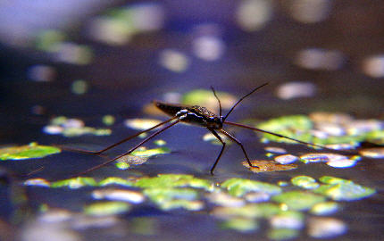
A cut of length $dl$ experiences forces $γ dl$ on each edge, with $γ$ being the surface tension coefficient.
FigureThought experiment to illustrate surface tensionfig-surfacetension
0.250.50.25 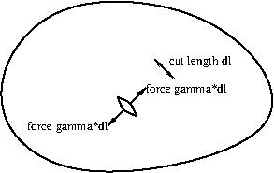
This movie shows the effect of different values of $γ$ on the shape of a droplet.
ExampleDroplet pressure.boundaries-surfaces-interfaces-5-7 A spherical fluid droplet of radius $R$ has coefficient of surface tension $γ$. What is the pressure difference between the inside and outside of the droplet?
$$Δp=p_{\text{in}}−p_{\text{out}}=\frac{2γ}{R}.$$
FigureSurface tension example: dropletfig-droplet
0.250.50.25 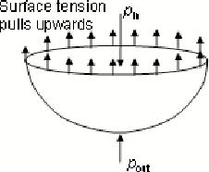
ExampleMeniscus.boundaries-surfaces-interfaces-5-8
FigureSurface tension example: meniscusfig-meniscus
0.250.50.25 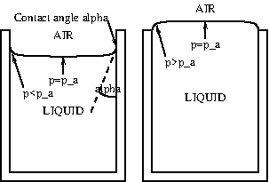
- Flat surface: no net surface tension force $→$ pressures equal.
- Concave up: resultant points outward $→$ pressure below surface lower than atmospheric.
- Concave down: resultant points inward $→$ pressure inside greater than atmospheric.
These agree with the hydrostatic pressure profile within the fluid. In principle, the shape of the meniscus can be calculated from this agreement.
SectionStress in a fluidStress in a fluidsec-stress
SubsectionStress at a surfaceStress at a surfacesec-stress-2
DefinitionDefinition of stress at a surface.def-stress-surface The fluid stress on a surface, $τ$, is the force per unit area exerted by the fluid; note that this is a vector quantity. It is often convenient to decompose the stress into two contributions, as these are often quite different both in magnitude and in physical origin:
- Shear stress: the components tangential to the surface
- Normal stress: the component perpendicular to the surface.
ExampleFluid stress in arteries.example-shear-stress The shear stress on arterial walls is everywhere maintained at around $∼1.5$ Pa, whereas the normal stress is typically much larger at ~11–16 kPa. The distribution of shear stress, although much smaller than the normal stress, is known to be of great importance to our health as it is linked to the development of atherosclerosis, which leads to heart attacks and strokes, two of the leading causes of death worldwide.
DefinitionCalculation of stress at a surface.def-stress-surface-calculation For Newtonian fluids at a no-slip surface:
- The wall shear stress equals the fluid shear viscosity multiplied by the normal derivative of the tangential velocity.
- Provided the surface is not accelerating, the normal stress equals the pressure.
Note that in 3D there are two shear components and one normal component.
ExampleShear stress at a flat wall.sec-stress-2-5 Flat wall at $z=0$ and fluid in $z>0$:
$$τ_{x}=μ\frac{∂u}{∂z}, τ_{y}=μ\frac{∂v}{∂z}.$$
Flat wall at $z=0$ and fluid in $z<0$:
$$τ_{x}=−μ\frac{∂u}{∂z}, τ_{y}=−μ\frac{∂v}{∂z}.$$
ExampleShear stress on a circular pipe.sec-stress-2-6 Flow in a circular pipe, wall at $r=a$ in cylindrical polar coordinates:
$$τ_{\text{axial}}=−μ\frac{∂u_{z}}{∂r}, τ_{\text{azimuthal}}=−μ\frac{∂u_{θ}}{∂r}.$$
ExampleCone-and-plate viscometer.sec-stress-2-7 Cone-and-plate viscometer: cone lowered into fluid, torque needed to rotate cone gives viscosity.
FigureCone and plate viscometerfig-cone-and-plate-viscometer
0.250.50.25 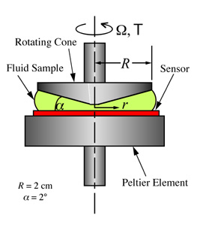
ExampleFalling ball viscometer.sec-stress-2-8 Falling-ball viscometer: measure terminal velocity of a ball in fluid at low Reynolds number (see Figure [figure-falling-ball]).
SubsectionThe stress tensorThe stress tensorsubsec-stress-tensor Cauchy showed that the state of stress at a point in a continuum body is completely defined by a rank two tensor (that is, a matrix with appropriate transformation properties) called the Cauchy stress tensor, $σ(x,t)$, given by
$$σ=\left(\begin{matrix}σ_{11} & σ_{12} & σ_{13} \\ σ_{21} & σ_{22} & σ_{23} \\ σ_{31} & σ_{32} & σ_{33}\end{matrix}\right),$$
which has nine scalar components.
DefinitionObtaining the stress from the stress tensor.subsec-stress-tensor-3 Definition [def-stress-surface] can be extended to any surface within the fluid. The stress is a vector (or rank one tensor), $τ$, given by
$$τ(n)=σn,$$
where $n$ is the unit normal vector to the surface, pointing into the fluid that is giving rise to the stress.
RemarkElement interpretation of the stress tensor.subsec-stress-tensor-4 The element $σ_{ij}$ of the stress tensor can be defined as the $i$th component of the stress on the plane with normal vector $e_{j}$ in the direction of increasing $x_{j}$.
Thus for example $σ_{23}(x,y,z_{0},t)$ is the $y$-component of the stress on the surface $z=z_{0}$ within the fluid, and acting on the fluid in $z>z_{0}$. There is an equal and opposite stress acting on the fluid in $z<z_{0}$.
RemarkNotes about the stress tensor.subsec-stress-tensor-5
- The stress $τ$ is the force per unit area exerted by the fluid on the right-hand side of the small imaginary surface $dS$ shown in the figure below upon the fluid on the left-hand side of $dS$.
- FigureImaginary surface in a flowing fluid, illustrating the concept of stress within a fluid.fig-stress-surface
- 0.20.60.2 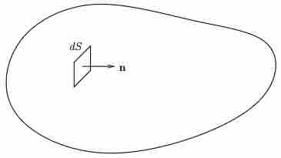
- The stresses acting on opposite sides of a surface (i.e. on the surfaces with normals $n$ and $−n$) are equal and opposite. This is required for linear equilibrium within the fluid.
- The stress tensor is symmetric, i.e. $σ_{ij}=σ_{ji}$. This is required for rotational equilibrium within the fluid, and can be derived from the principle of conservation of angular momentum.
- The elements on the principal diagonal of the stress tensor matrix are called the normal stresses. The other six elements are called the shear stresses. The diagram below illustrates this; a cuboid with side lengths $X$, $Y$ and $Z$ in the $x$-, $y$- and $z$-directions, respectively, is shown, and the $x$- and $y$-components of the stresses on those faces that can be seen are shown.
- FigureComponents of the stress on the faces of a small cuboid within a fluid.fig-stress-cuboid
- 0.20.60.2 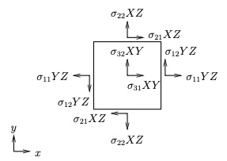
- In Figure [fig-stress-cuboid]:
  - The $z$-components of the stresses are not shown in order that the diagram does not get too complicated (also the stress on the back face is not shown).
  - The $z$-axis points outwards from the figure right-handed axes.
  - Note that these forces assume that the components of the stress tensor are uniform over the faces in question, which would not generally be the case, (although it is quite accurate in the case that the lengths $X$, $Y$ and $Z$ are small.
RemarkDefining the fluid pressure in terms of the stress tensor.subsec-stress-tensor-6 We can now write a mathematical definition of the fluid pressure in terms of the stress tensor:
$$p=−\frac{1}{3}\text{tr}\left(σ\right)=−\frac{1}{3}\text{tr}\left(σ\right).$$
This equation gives us a method by which we can (at least in our imagination) think about measuring the pressure at a particular point in the fluid. We consider three small, mutually orthogonal planes passing through the point (aligned perpendicular to the $x$-, $y$- and $z$-directions) and measure the three forces on the three surfaces. Dividing each force by the area of the respective plane leads to the stresses on the surfaces, which are, respectively,
$$\left(\begin{matrix}σ_{11} \\ σ_{21} \\ σ_{31}\end{matrix}\right), \left(\begin{matrix}σ_{12} \\ σ_{22} \\ σ_{32}\end{matrix}\right), \text{and} \left(\begin{matrix}σ_{13} \\ σ_{23} \\ σ_{33}\end{matrix}\right).$$
The normal components of the respective stresses are $σ_{11}$, $σ_{22}$ and $σ_{33}$, and hence the pressure is the average of the three normal components of the stresses. The interpretation of the pressure is different for compressible and incompressible fluids:
- Compressible fluids: From classical thermodynamics it is known that we can define the pressure of the fluid as a parameter of state, making use of an equation of state (for example $p=ρRT$ for an ideal gas).
- Incompressible fluids: For an incompressible fluid the pressure $p$ is an independent, purely dynamical, variable.
In this course we mainly consider incompressible fluids.
RemarkNotes about the stress tensor and pressure.subsec-stress-tensor-7 ([eq-defofp]) naturally leads to
$$σ_{ij}=−pδ_{ij}+d_{ij},$$
where $d=(d_{ij})$ is called the deviatoric stress tensor, and this part of the stress occurs entirely due to the fluid motion. Taking the trace of this equation gives $\text{tr}(σ)=−3p+\text{tr}(d)$, and ([eq-defofp]) implies that $\text{tr}(d)=0$.
RemarkSpecial case of a fluid at rest.subsec-stress-tensor-8 In a fluid at rest we have $d_{ij}=0$, and thus $σ=−pI$, where $I$ is the identity matrix, meaning that $σ$ is a multiple of the identity matrix and the only stresses are due to the pressure.
DefinitionThe constitutive relationship of a fluid.def-constitutive-relation This is an equation that describes the relationship between the stress tensor and the kinematic state of the fluid. It is found from experiments, and governs the mechanical behaviour of the fluid, that is the rheology of the fluid. Together with the equations of mass and momentum conservation, this closes the problem for the velocity and pressure fields. Every fluid obeying the continuum approximation has a constitutive relationship, which can be thought of as a definition of its mechanical properties.
SectionNewtonian fluidsNewtonian fluidssubsec-newtonian-fluids
In this section we define an important class of fluids called Newtonian fluids. Many common fluids, including water and air, may be described as Newtonian.
FigureIsaac Newton (1642-1727), who gave his name to a class of fluids that obey a linear constitutive relationship between stress and rate of strain. Newton was also responsible for the laws of motion and universal gravitation, and we make extensive use of these in fluid mechanics, particularly his second law of motion, which states that the rate of change of momentum of a body equals the net force acting on it.fig-newton
0.250.50.25 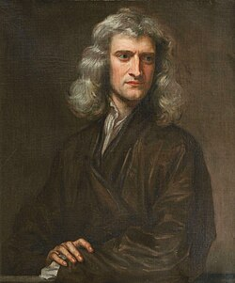
SubsectionIncompressible Newtonian fluidsIncompressible Newtonian fluidssubsec-incompressible-newtonian-fluids Many common fluids may be well described as incompressible Newtonian fluids.
DefinitionIncompressible Newtonian fluid.def-newtonian-fluid We can define a Newtonian fluid by stating its constitutive relationship.
$$σ_{ij}=−pδ_{ij}+μ\left(\frac{∂u_{j}}{∂x_{i}}+\frac{∂u_{i}}{∂x_{j}}\right),$$
where $μ$ is the dynamic shear viscosity. Alternatively, in vector form,
$$σ=−pI+2μe,$$
where $e$ is the rate-of-strain tensor,
$$e=\left(\begin{matrix}e_{11} & e_{12} & e_{13} \\ e_{21} & e_{22} & e_{23} \\ e_{31} & e_{32} & e_{33}\end{matrix}\right),$$
where
$$e=\frac{1}{2}\left(∇u+{\left(∇u\right)}^{T}\right) \text{or} e_{ij}=\frac{1}{2}\left(\frac{∂u_{j}}{∂x_{i}}+\frac{∂u_{i}}{∂x_{j}}\right),$$
or, alternatively,
$$e=\left(\begin{matrix}\frac{∂u}{∂x} & \frac{1}{2}\left(\frac{∂u}{∂y}+\frac{∂v}{∂x}\right) & \frac{1}{2}\left(\frac{∂u}{∂z}+\frac{∂w}{∂x}\right) \\ \frac{1}{2}\left(\frac{∂u}{∂y}+\frac{∂v}{∂x}\right) & \frac{∂v}{∂y} & \frac{1}{2}\left(\frac{∂v}{∂z}+\frac{∂w}{∂y}\right) \\ \frac{1}{2}\left(\frac{∂u}{∂z}+\frac{∂w}{∂x}\right) & \frac{1}{2}\left(\frac{∂v}{∂z}+\frac{∂w}{∂y}\right) & \frac{∂w}{∂z}\end{matrix}\right).$$
All three of these forms (([eq-rateofstrain]) and ([eq-cartesianrateofstrain])) are equivalent. Using ([eq-Newtonianstress-incompressible-vectorform]), we may write the stress tensor of an incompressible Newtonian fluid in component form in Cartesian coordinates as
$$σ=\left(\begin{matrix}−p+2μ\frac{∂u}{∂x} & μ\left(\frac{∂u}{∂y}+\frac{∂v}{∂x}\right) & μ\left(\frac{∂u}{∂z}+\frac{∂w}{∂x}\right) \\ μ\left(\frac{∂u}{∂y}+\frac{∂v}{∂x}\right) & −p+2μ\frac{∂v}{∂y} & μ\left(\frac{∂v}{∂z}+\frac{∂w}{∂y}\right) \\ μ\left(\frac{∂u}{∂z}+\frac{∂w}{∂x}\right) & μ\left(\frac{∂v}{∂z}+\frac{∂w}{∂y}\right) & −p+2μ\frac{∂w}{∂z}\end{matrix}\right).$$
RemarkDerivation of Newtonian fluid stress tensor from first principles.subsec-incompressible-newtonian-fluids-4 Non-examinable:
Newtonian fluids have the following properties:
- The deviatoric part of the stress tensor, $d$, is a linear function of the nine velocity gradients,
$$(∇u)_{ij}=\frac{∂u_{j}}{∂x_{i}}.$$
- This implies
$$d_{ij}=\sum_{l=1}^{3}{\sum_{k=1}^{3}{c_{ijkl}}}\frac{∂u_{l}}{∂x_{k}}$$
- for some unknown scalars $c_{ijkl}$.
- The fluid is homogeneous, i.e. $σ$ does not depend explicitly on $x$. This implies that the $c_{ijkl}$’s are constant in space. An example of when this would not be the case would be an inhomogeneous fluid, such as a fluid that is heated differentially.
- The fluid is isotropic, i.e. there is no preferred direction. Insisting that $d$ transforms correctly under rotations (and in fact we only need to consider rotations through ${90}^{∘}$ about the coordinate axes) implies that $c_{ijkl}$ is zero unless each subscript appears an even number of times. That is, the only non-zero terms are $c_{1111}$, $c_{2222}$, $c_{3333}$ (which must all be equal), and those $c_{ijkl}$’s in which two of the indices $i$, $j$, $k$, $l$ are ’1’ and two indices are ’2’, also terms with two 2’s and two 3’s, and terms with two 1’s and two 3’s (and these obey certain equalities too). An example of when this would not be the case would be an anisotropic fluid, such as nematic liquid crystals (long chain molecules that align in a magnetic field) or flowing blood in which the red blood cells align in the direction of flow).
Additionally requiring that $d$ is a symmetric matrix means that, in component form, we can reduce the $c_{ijkl}$’s down to just two independent scalar parameters, $λ$ and $μ$, and we have
$$σ_{ij}=−pδ_{ij}+λδ_{ij}\sum_{k=1}^{3}{\frac{∂u_{k}}{∂x_{k}}}+μ\left(\frac{∂u_{j}}{∂x_{i}}+\frac{∂u_{i}}{∂x_{j}}\right),$$
where $λ$ is the bulk viscosity of the fluid and $μ$ is the dynamic shear viscosity. In vector form
$$σ=−pI+λ\left(∇⋅u\right)I+2μe,$$
where $e$ is the rate-of-strain tensor, given by
$$e=\left(\begin{matrix}e_{11} & e_{12} & e_{13} \\ e_{21} & e_{22} & e_{23} \\ e_{31} & e_{32} & e_{33}\end{matrix}\right).$$
If the fluid is incompressible, then $∇⋅u=0$ and the bulk viscosity is undefined, meaning that ([eq-Newtonianstress]) reduces to ([eq-Newtonianstress-incompressible]).
RemarkFormula in cylindrical and spherical coordinates.subsec-incompressible-newtonian-fluids-5 In cylindrical polar coordinates the rate-of-strain tensor is given by
$$e=\left(\begin{matrix}\frac{∂u_{r}}{∂r} & \frac{1}{2}\left(r\frac{∂(u_{θ}/r)}{∂r}+\frac{1}{r}\frac{∂u_{r}}{∂θ}\right) & \frac{1}{2}\left(\frac{∂u_{z}}{∂r}+\frac{∂u_{r}}{∂z}\right) \\ \frac{1}{2}\left(r\frac{∂(u_{θ}/r)}{∂r}+\frac{1}{r}\frac{∂u_{r}}{∂θ}\right) & \frac{1}{r}\frac{∂u_{θ}}{∂θ}+\frac{u_{r}}{r} & \frac{1}{2}\left(\frac{∂u_{θ}}{∂z}+\frac{1}{r}\frac{∂u_{z}}{∂θ}\right) \\ \frac{1}{2}\left(\frac{∂u_{z}}{∂r}+\frac{∂u_{r}}{∂z}\right) & \frac{1}{2}\left(\frac{∂u_{θ}}{∂z}+\frac{1}{r}\frac{∂u_{z}}{∂θ}\right) & \frac{∂u_{z}}{∂z}\end{matrix}\right),$$
and in spherical polar coordinates it is
$$e=\left(\begin{matrix}\frac{∂u_{r}}{∂r} & \frac{1}{2}\left(r\frac{∂(u_{θ}/r)}{∂r}+\frac{1}{r}\frac{∂u_{r}}{∂θ}\right) & \frac{1}{2}\left(r\frac{∂(u_{ϕ}/r)}{∂r}+\frac{1}{rsinθ}\frac{∂u_{r}}{∂ϕ}\right) \\ \frac{1}{2}\left(r\frac{∂(u_{θ}/r)}{∂r}+\frac{1}{r}\frac{∂u_{r}}{∂θ}\right) & \frac{1}{r}\frac{∂u_{θ}}{∂θ}+\frac{u_{r}}{r} & \frac{1}{2}\left(\frac{1}{rsinθ}\frac{∂u_{θ}}{∂ϕ}+\frac{sinθ}{r}\frac{∂(u_{ϕ}/sinθ)}{∂θ}\right) \\ \frac{1}{2}\left(r\frac{∂(u_{ϕ}/r)}{∂r}+\frac{1}{rsinθ}\frac{∂u_{r}}{∂ϕ}\right) & \frac{1}{2}\left(\frac{1}{rsinθ}\frac{∂u_{θ}}{∂ϕ}+\frac{sinθ}{r}\frac{∂(u_{ϕ}/sinθ)}{∂θ}\right) & \frac{1}{rsinθ}\frac{∂u_{ϕ}}{∂ϕ}+\frac{u_{r}+u_{θ}cotθ}{r}\end{matrix}\right).$$
You do not need to know these matrices for this course. You might have to use them, but these formulae would be supplied. You do need to know the Cartesian equivalent ([eq-cartesianrateofstrain]).
RemarkNotes on the Newtonian fluids stress tensor.subsec-incompressible-newtonian-fluids-6
- For an incompressible Newtonian fluid the stress tensor has only one parameter, the shear viscosity, $μ$, and there are are only two parameters needed to describe the mechanical behaviour of the fluid: $μ$ and the fluid density, $ρ$.
- The shear viscosity, $μ$, is often a function of temperature, and sometimes of pressure too. For most common fluids the shear viscosity decreases with increasing temperature.
SubsectionStress at a surfaceStress at a surfacesubsec-stress-surface In Definition [def-stress-surface-calculation], we stated formulae for the stress that a fluid exerts on a rigid solid boundary. We are now in a position to check the formulae given there.
The normal stress on a surface with normal $n$ is given by
$$\left(σn\right)⋅n=−p+2μn⋅∇\left(u⋅n\right).$$
The last term represents $2μ$ times the derivative of the normal component of the velocity in the normal direction. Thus the normal stress is not necessary equal to the pressure!
However, if we assume that the surface is fixed then we may show that the normal stress of an incompressible Newtonian fluid does equal the pressure:
- By rotating the coordinate axes we may assume that $n=i$.
- From ([eq-normalstress]), the normal stress is $−p+2μ∂u/∂x$.
- Since the fluid is incompressible,
$$∇⋅u=\frac{∂u}{∂x}+\frac{∂v}{∂y}+\frac{∂w}{∂z}=0.$$
- The boundary conditions at the solid surface are $u=v=w=0$. Thus
$$\frac{∂v}{∂y}=\frac{∂w}{∂z}=0$$
- on the surface. The continuity equation implies that
$$\frac{∂u}{∂x}=0$$
- also.
- Hence the normal stress on the surface is $−p$.
At a fixed solid surface the shear stress of a Newtonian fluid equals the viscosity multiplied by the derivative of the component of velocity parallel to the surface with respect to the perpendicular coordinate. We can show this as follows:
- As before we may rotate the coordinate axes so that $n=i$.
- Using ([eq-cartesiannewtonianstress]), the stress at the surface is
$$τ=σn=\left(\begin{matrix}−p+2μ\frac{∂u}{∂x} \\ μ\left(\frac{∂u}{∂y}+\frac{∂v}{∂x}\right) \\ μ\left(\frac{∂u}{∂z}+\frac{∂w}{∂x}\right)\end{matrix}\right),$$
- and the shear stresses are given by the $y$- and $z$-components:
$$τ_{y}=μ\left(\frac{∂u}{∂y}+\frac{∂v}{∂x}\right), τ_{z}=μ\left(\frac{∂u}{∂z}+\frac{∂w}{∂x}\right).$$
- No slip boundary conditions at the solid surface are $u=v=w=0$. Thus
$$\frac{∂u}{∂y}=\frac{∂u}{∂z}=0$$
- on the surface.
- Hence the shear stresses on the surface are
$$τ_{y}=μ\frac{∂v}{∂x} \text{and} τ_{z}=μ\frac{∂w}{∂x},$$
- agreeing with the previous definitions.
SubsectionInviscid fluidsInviscid fluidsinviscid-fluids In previous chapters in this course, you studied inviscid or ideal fluids. These are fluids with $μ=0$. In this case, the constitutive law ([eq-cartesiannewtonianstress]) becomes
$$σ=−pI=\left(\begin{matrix}−p & 0 & 0 \\ 0 & −p & 0 \\ 0 & 0 & −p\end{matrix}\right),$$
and thus the stress in the fluid is not affected by the fluid motion.
SubsectionNon-Newtonian fluidsNon-Newtonian fluidssubsec-nonnewtonian-fluids Many fluids do not obey the assumptions underlying a Newtonian fluid, meaning that their constitutive relationship takes a more complicated form. Many foods and household products, e.g. egg white, custard, shampoo, toothpaste have a non-Newtonian rheology. In the case of foods, this is often because the non-Newtonian properties themselves lend a texture that makes them taste better! For household products the non-Newtonian properties help us use them (for example a Newtonian shampoo might drain off our hair before we have a chance to work it in).
The NavierStokes equations do not work for genuinely non-Newtonian flows, and the pressure and viscous terms must be replaced by a formula that captures the rheology. However, for a surprising variety of complex fluids, the NavierStokes equations do in fact provide a remarkably good description of the behaviour.
In general, however, the rheology of non-Newtonian fluids is often very complex, and is an area of active research. Categories include the following:
- Non-constant viscosity: This is perhaps the simplest way a fluid can be non-Newtonian. Examples include shear thinning fluids, e.g. blood, and shear-thickening fluids, e.g. fluids containing cornflour such as custard, or fluids whose viscosity depends on the temperature of the fluid.
- FigureExamples of Non-Newtonian fluidsfig-nonnewtonian
- 010 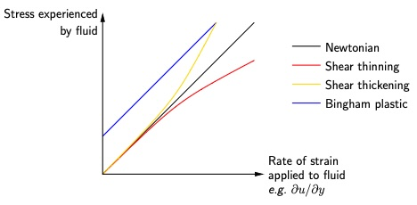
- A short video on shear thickening fluids is both fun and educational.
- Viscoelastic fluids: These are fluids that have both elastic and viscous properties, that is the molecules seem to have a memory and spring back when they are suddenly displaced (but not so much when they are slowly displaced); thus they are sometimes described as having a fading memory’. In this case the formula for the deviatoric part of the stress tensor involves an integral over the previous states of the fluid. Examples include ketchup, paint, mucus and vitreous humour.
- Anisotropic fluids: Some fluids respond differently to the same stress but applied in different directions. An example of this is blood, which contains red blood cells affecting the dynamics. When the blood is flowing the cells align, meaning the effective viscosity is much less in the direction of flow and more in the transverse direction (this is also related to the fact that blood is shear thinning). In large arteries it is usually acceptable to model blood as a Newtonian fluid because the diameter of the artery is many times that of the cells. However, for small arteries, such as that in Figure [fig-artery], the Newtonian model does not give an accurate picture.
- FigureComputer simulation of blood flow in a microvessel by the Biological Flow Studies Laboratory in Tohoku University, Japan. The left picture shows the view of the blood from the outside (with the vessel walls removed), whilst that on the right shows the view in the central plane of the vessel.fig-artery
- 0.050.90.05 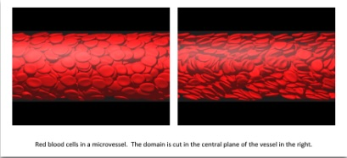
- Figure [fig-liquid-crystals] shows a schematic representation of nematic liquid crystals, which are used in computer displays, electronic signs etc. These align by themselves to a preferred direction for high enough temperatures, and a magnetic field can be used to set the direction.
- FigureSchematic representation of nematic liquid crystals, an example of an anisotropic fluid.fig-liquid-crystals
- 0.350.30.35 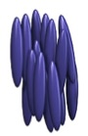
Subsectionexamplesexamplessubsec-examples
ExampleCalculating the stress due to a shear flow.subsec-examples-2
FigureShear flowfig-sample-flow1
0.250.50.25 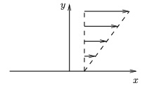
Consider an incompressible Newtonian fluid flowing in $y≥0$ in Cartesian coordinates $(x,y,z)$ in a uniform pressure field $p=p_{0}$ with $p_{0}$ constant, and whose velocity components are respectively given by
$$u=ky, v=0, w=0,$$
(it may be shown these satisfy the governing equations). Find the stress tensor at a general location. Hence find the stress at a general location on an imaginary surface with unit normal vector $n=(n_{x},n_{y},0)$. In this question you may neglect gravity.
Solution.The stress tensor is given by
$$σ=−pI+2μe,$$
where the rate-of-strain tensor $e$ is given by
$$e=\left(\begin{matrix}\frac{∂u}{∂x} & \frac{1}{2}\left(\frac{∂u}{∂y}+\frac{∂v}{∂x}\right) \\ \frac{1}{2}\left(\frac{∂u}{∂y}+\frac{∂v}{∂x}\right) & \frac{∂v}{∂y}\end{matrix}\right)=\left(\begin{matrix}0 & k/2 \\ k/2 & 0\end{matrix}\right).$$
Hence the stress tensor $σ$ is given by
$$σ=−pI+2μe=\left(\begin{matrix}−p_{0} & kμ \\ kμ & −p_{0}\end{matrix}\right).$$
Thus for a general unit vector
$$τ=σn=\left(\begin{matrix}−p_{0} & kμ \\ kμ & −p_{0}\end{matrix}\right)\left(\begin{matrix}n_{x} \\ n_{y}\end{matrix}\right)=\left(\begin{matrix}−p_{0}n_{x}+kμn_{y} \\ kμn_{x}−p_{0}n_{y}\end{matrix}\right).$$
Note:
- For example with $n=j$, we have $τ=(kμ,−p_{0})$. This makes sense as there is a background pressure $p_{0}$ pressing into the surface and a stress $kμ$ arising from the shear flow and running along the surface. It also agrees with the formulae for stress at a surface given in Definition [def-stress-surface-calculation].
- Likewise if $n=i$, we have $τ=(−p_{0},kμ)$. This formula cannot be compared with the formula given in Definition [def-stress-surface-calculation] as it would not be possible to put in a rigid surface with normal $n=i$ without changing the flow.
ExampleCalculating the stress due to flow in a pipe.subsec-examples-3 We consider a flow of an incompressible Newtonian fluid in a circular cylinder of radius $a$ and infinite length in the $z$-direction, working in cylindrical polar coordinates $(r,θ,z)$ with axis along the cylinder axis. The velocity components are given by
$$(u_{r},u_{θ},u_{z})=\left(0,0,\frac{G}{4μ}\left(a^{2}−r^{2}\right)\right),$$
where $G=−∂p/∂z$ is the axial pressure gradient. Find the stress tensor at a general point and comment on it. Note that this flow is a famous solution of the governing equations and is called HagenPoiseuille flow.
Solution.We have the rate-of-strain tensor given by ([eq-strainrate-cyl]) as
$$\begin{aligned}e=&\left(\begin{matrix}\frac{∂u_{r}}{∂r} & \frac{1}{2}\left(r\frac{∂(u_{θ}/r)}{∂r}+\frac{1}{r}\frac{∂u_{r}}{∂θ}\right) & \frac{1}{2}\left(\frac{∂u_{z}}{∂r}+\frac{∂u_{r}}{∂z}\right) \\ \frac{1}{2}\left(r\frac{∂(u_{θ}/r)}{∂r}+\frac{1}{r}\frac{∂u_{r}}{∂θ}\right) & \frac{1}{r}\frac{∂u_{θ}}{∂θ}+\frac{u_{r}}{r} & \frac{1}{2}\left(\frac{∂u_{θ}}{∂z}+\frac{1}{r}\frac{∂u_{z}}{∂θ}\right) \\ \frac{1}{2}\left(\frac{∂u_{z}}{∂r}+\frac{∂u_{r}}{∂z}\right) & \frac{1}{2}\left(\frac{∂u_{θ}}{∂z}+\frac{1}{r}\frac{∂u_{z}}{∂θ}\right) & \frac{∂u_{z}}{∂z}\end{matrix}\right) \\ =&\left(\begin{matrix}0 & 0 & −\frac{Gr}{4μ} \\ 0 & 0 & 0 \\ −\frac{Gr}{4μ} & 0 & 0\end{matrix}\right)\end{aligned}$$
and hence
$$σ=−pI+2μe=\left(\begin{matrix}−p & 0 & −\frac{1}{2}Gr \\ 0 & −p & 0 \\ −\frac{1}{2}Gr & 0 & −p\end{matrix}\right).$$
Incompressibility requires $G$ to be constant, and hence $p=p_{0}−Gz$, where $p_{0}$ is a constant, and giving
$$σ=\left(\begin{matrix}−p_{0}+Gz & 0 & −\frac{1}{2}Gr \\ 0 & −p_{0}+Gz & 0 \\ −\frac{1}{2}Gr & 0 & −p_{0}+Gz\end{matrix}\right).$$
Hence for imaginary surfaces with normal vectors $\hat{r}$, $\hat{θ}$, $\hat{z}$, respectively, the stress on the surface is given by
$$\begin{aligned}τ_{r}=&σ\hat{r}=\left(Gz−p_{0}\right)\hat{r}−\frac{1}{2}Gr\hat{z}, \\ τ_{θ}=&σ\hat{θ}=\left(Gz−p_{0}\right)\hat{θ}, \\ τ_{z}=&σ\hat{z}=\left(Gz−p_{0}\right)\hat{z}−\frac{1}{2}Gr\hat{r}.\end{aligned}$$
It is not possible to compare these formulae with the ones given in Definition [def-stress-surface-calculation]. The exception is the case when we find the stress on the wall ($r=a$), which we can do by setting the normal vector $n=−\hat{r}$, giving
$$τ=−σ\hat{r}=\left(p_{0}−Gz\right)\hat{r}+\frac{1}{2}Ga\hat{z},$$
that is a normal stress equal to minus the pressure and an axial shear stress $Ga/2$ (which is $−μ ∂u_{z}/∂r$, as expected).
SectionConservation of linear momentumConservation of linear momentumsec-linear-momentum-cons
FigureSmall cube used to derive the equations of motionfig-small-cube
0.250.50.25 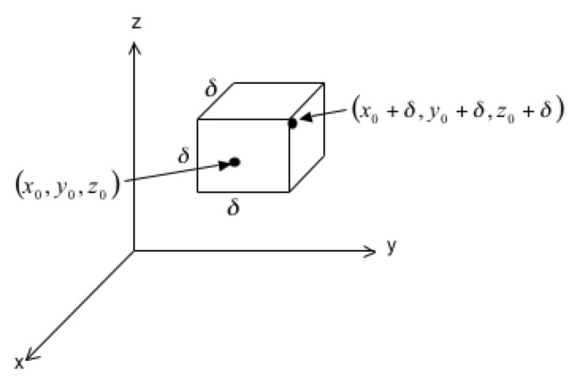
We consider the balance of linear momentum in a small cube of side length $δ$ for an incompressible fluid, see Figure [fig-small-cube]. To do this we employ the Reynolds Transport Theorem ([eqn-RTT]), with $f(x,t)$ equal to the linear momentum of the fluid per unit volume, $f=ρu$, and $V(t)$ being the small volume of fluid under consideration, which coincides with the cube at time $t$ (however, note that the volume of fluid we are following is not generally a cube at other times). Substituting $f=ρu$, the theorem states that:
ddtV(t)​ρu dx dy dz=V(t)​∂ρu∂t+∇⋅(ρu⊗u) dx dy dz.
SubsectionLeft-hand sideLeft-hand sidesubsec-rtt-lhs We note that V(t)​ρu dx dy dz is the integral of the linear momentum per unit volume over the volume and is therefore the total momentum of the fluid particles in $V(t)$. The left-hand side of this equation is thus the Lagrangian rate of change of momentum of these fluid particles. By Newton’s second law, this must equal the resultant force acting on the fluid in $V(t)$, which we denote by $F$. This force is the sum of different contributions, which can be categorised into body forces (which act on the whole volume of fluid) and surface forces (acting only on the surface of the fluid, and which arise from the fluid stress):
ddtV(t)​ρu dx dy dz=F=Fbody+Fsurface.
Body forces: In this course, these are equal to either zero (if gravity is not important) or equal to the gravitational force
$$F_{\text{surface}}=F_{\text{gravity}}=ρVg.$$
Surface forces: These arise from the stress exerted at the surface of the fluid parcel, and these can be computed by integrating the stress vector $τ$ over the surface of the cube. On the left face, we have $n=−i$, and, using ([eq-cartesiannewtonianstress]), the stress vector is
$$\begin{aligned}τ=&σn \\ =&\left(−pI+2μe\right)\left(−i\right) \\ =&\left(\begin{matrix}−p+2μ\frac{∂u}{∂x} & μ\left(\frac{∂u}{∂y}+\frac{∂v}{∂x}\right) & μ\left(\frac{∂u}{∂z}+\frac{∂w}{∂x}\right) \\ μ\left(\frac{∂u}{∂y}+\frac{∂v}{∂x}\right) & −p+2μ\frac{∂v}{∂y} & μ\left(\frac{∂v}{∂z}+\frac{∂w}{∂y}\right) \\ μ\left(\frac{∂u}{∂z}+\frac{∂w}{∂x}\right) & μ\left(\frac{∂v}{∂z}+\frac{∂w}{∂y}\right) & −p+2μ\frac{∂w}{∂z}\end{matrix}\right)\left(\begin{matrix}−1 \\ 0 \\ 0\end{matrix}\right) \\ =&−\left(\begin{matrix}−p+2μ\frac{∂u}{∂x} \\ μ\left(\frac{∂u}{∂y}+\frac{∂v}{∂x}\right) \\ μ\left(\frac{∂u}{∂z}+\frac{∂w}{∂x}\right)\end{matrix}\right),\end{aligned}$$
and the force on the left face is this expression multiplied by the area $δ^{2}$. Similarly, on the right-hand face, we have $n=i$, and the stress vector is
$$τ=σn=\left(\begin{matrix}−p+2μ\frac{∂u}{∂x} \\ μ\left(\frac{∂u}{∂y}+\frac{∂v}{∂x}\right) \\ μ\left(\frac{∂u}{∂z}+\frac{∂w}{∂x}\right)\end{matrix}\right),$$
with the contribution to the force being this expression multiplied by $δ^{2}$. Hence the contribution to the force from the left and right faces is
$$\begin{aligned}&{\left.\left(\begin{matrix}−p+2μ\frac{∂u}{∂x} \\ μ\left(\frac{∂u}{∂y}+\frac{∂v}{∂x}\right) \\ μ\left(\frac{∂u}{∂z}+\frac{∂w}{∂x}\right)\end{matrix}\right)δ^{2}\right|}_{x=x_{0}+δ}−{\left.\left(\begin{matrix}−p+2μ\frac{∂u}{∂x} \\ μ\left(\frac{∂u}{∂y}+\frac{∂v}{∂x}\right) \\ μ\left(\frac{∂u}{∂z}+\frac{∂w}{∂x}\right)\end{matrix}\right)δ^{2}\right|}_{x=x_{0}} \\ =&\frac{∂}{∂x}\left(\begin{matrix}−p+2μ\frac{∂u}{∂x} \\ μ\left(\frac{∂u}{∂y}+\frac{∂v}{∂x}\right) \\ μ\left(\frac{∂u}{∂z}+\frac{∂w}{∂x}\right)\end{matrix}\right)δ^{3} \\ =&\frac{∂}{∂x}\left(\begin{matrix}−p+2μ\frac{∂u}{∂x} \\ μ\left(\frac{∂u}{∂y}+\frac{∂v}{∂x}\right) \\ μ\left(\frac{∂u}{∂z}+\frac{∂w}{∂x}\right)\end{matrix}\right)V.\end{aligned}$$
After a similar calculation, the contributions from the front and back faces can be shown to be
$$\frac{∂}{∂y}\left(\begin{matrix}μ\left(\frac{∂v}{∂x}+\frac{∂u}{∂y}\right) \\ −p+2μ\frac{∂v}{∂y} \\ μ\left(\frac{∂v}{∂z}+\frac{∂w}{∂y}\right)\end{matrix}\right)V,$$
and from the top and bottom faces we get
$$\frac{∂}{∂z}\left(\begin{matrix}μ\left(\frac{∂w}{∂x}+\frac{∂u}{∂z}\right) \\ μ\left(\frac{∂w}{∂y}+\frac{∂v}{∂z}\right) \\ −p+2μ\frac{∂w}{∂z}\end{matrix}\right)V.$$
Hence the total force due to surface stresses is
$$\begin{aligned}F_{\text{surface}}=F_{\text{stress}}=&\frac{∂}{∂x}\left(\begin{matrix}−p+2μ\frac{∂u}{∂x} \\ μ\left(\frac{∂u}{∂y}+\frac{∂v}{∂x}\right) \\ μ\left(\frac{∂u}{∂z}+\frac{∂w}{∂x}\right)\end{matrix}\right)V+\frac{∂}{∂y}\left(\begin{matrix}μ\left(\frac{∂v}{∂x}+\frac{∂u}{∂y}\right) \\ −p+2μ\frac{∂v}{∂y} \\ μ\left(\frac{∂v}{∂z}+\frac{∂w}{∂y}\right)\end{matrix}\right)V+\frac{∂}{∂z}\left(\begin{matrix}μ\left(\frac{∂w}{∂x}+\frac{∂u}{∂z}\right) \\ μ\left(\frac{∂w}{∂y}+\frac{∂v}{∂z}\right) \\ −p+2μ\frac{∂w}{∂z}\end{matrix}\right)V \\ =&\left(\begin{matrix}−\frac{∂p}{∂x}+μ\left(\frac{∂^{2}u}{∂x^{2}}+\frac{∂^{2}v}{∂x∂y}+\frac{∂^{2}w}{∂x∂z}+∇^{2}u\right) \\ −\frac{∂p}{∂y}+μ\left(\frac{∂^{2}u}{∂x∂y}+\frac{∂^{2}v}{∂y^{2}}+\frac{∂^{2}w}{∂y∂z}+∇^{2}v\right) \\ −\frac{∂p}{∂z}+μ\left(\frac{∂^{2}u}{∂x∂z}+\frac{∂^{2}v}{∂y∂z}+\frac{∂^{2}w}{∂z^{2}}+∇^{2}w\right)\end{matrix}\right)V \\ =&\left(−∇p+μ\left(∇\frac{∂u}{∂x}+∇\frac{∂v}{∂y}+∇\frac{∂w}{∂z}\right)+μ∇^{2}u\right)V \\ =&\left(−∇p+μ∇∇⋅u+μ∇^{2}u\right)V \\ =&\left(−∇p+μ∇^{2}u\right)V,\end{aligned}$$
where the final equality was obtained using the incompressibility condition $∇⋅u=0$ ([eqn-incompressibledef]).
Hence, the left-hand side of the Reynolds Transport Theorem becomes
ddtV(t)​ρu dx dy dz=Fbody+Fsurface=ρg−∇p+μ∇2uV.
SubsectionRight-hand sideRight-hand sidesubsec-rtt-rhs We now evaluate the right-hand side of the Reynolds Transport Theorem:
&V(t)​∂(ρu)∂t+∇⋅(ρu⊗u) dx dy dz=&V(t)​ρ∂u∂t+(u⋅∇)u+u(∇⋅u) dx dy dz=&V(t)​ρ∂u∂t+(u⋅∇)u dx dy dz,
where the final equality was obtained using the incompressibility condition $∇⋅u=0$ ([eqn-incompressibledef]).
SubsectionEquating the two sidesEquating the two sidessubsec-rtt-equality Setting the two sides equal gives
ρg−∇p+μ∇2uV=V(t)​ρ∂u∂t+(u⋅∇)u dx dy dz,
and since this must hold for any small volume of fluid, we obtain
$$ρg−∇p+μ∇^{2}u=ρ\left[\frac{∂u}{∂t}+(u⋅∇)u\right].$$
Rearranging gives the incompressible NavierStokes equation:
$$\boxed{ρ\frac{Du}{Dt}=−∇p+μ∇^{2}u+ρg.}$$
RemarkClarification on the detail of the proof.subsec-rtt-equality-3 Note that there was some sleight of hand going on in this proof! We assumed that the stress was uniform over each face of the cube, meaning we could just multiply the stress on each face by the area of the face to get the force on that face. Indeed, if this were actually the case, then the stress would be uniform over the whole surface of the cube, and hence the net force on the surface would be zero. To resolve this, we would need to add higher-order contributions into the integrand when calculating the force on each face, which could result in higher-order contributions to the resultant force due to the sum of the stresses. We could do this by writing the stress as a Taylor series about the corner of the cube. Happily, with a bit more work (not included here), these higher order terms cancel and the result we obtained here holds.
Remarksubsec-rtt-equality-4 The incompressible NavierStokes equation ([eqn-navierstokes]) together with the incompressible continuity equation ([eqn-incompressibledef]) is often used to study problems encountered in fluid dynamics and it was developed by Claude-Louis Navier (17851836) and George Gabriel Stokes (18191903).
SubsectionDiscussion of the NavierStokes equationDiscussion of the NavierStokes equationsubsec-navierstokes-discussion
RemarkInertial terms.subsec-navierstokes-discussion-2 The terms on the left-hand side of ([eqn-navierstokes]) represent inertial effects, since the material derivative
$$\frac{Du}{Dt}=\frac{∂u}{∂t}+(u⋅∇)u$$
is the acceleration moving with the fluid. Thus the left-hand side is rate of change of momentum of the fluid particles per unit volume of the fluid. As remarked earlier in this course, it is not surprising that the material derivative appears in the governing equations, since forces act on fluid particles.
RemarkSolving the equations.subsec-navierstokes-discussion-3 The NavierStokes equation is notoriously difficult to solve, particularly as the term
$$ρu⋅∇u$$
is nonlinear. In fact, one of the famous Millennium Prize Problems is to prove that in three dimensions, given suitable initial and boundary conditions, there always exists a smooth solution of the NavierStokes equation for all time, or to provide an example where this does not hold. The problem is that the nonlinear term can lead to singularities developing in the solution, which would correspond to infinite velocities or pressures at some point in the fluid. This is not expected to happen in real fluids, but proving this rigorously is a major challenge.
You will be relieved to know that in this course we will only consider simple solutions of the NavierStokes equations (often ones in which the nonlinear term equals zero).
In a typical problem, there are four unknown variables: $u$, $v$, $w$ and $p$. There are four equations governing their behaviour, which are the incompressible continuity equation ([eqn-incompressibledef]) and the three components of the NavierStokes equation ([eqn-navierstokes]). In addition, we need to specify appropriate boundary conditions (for example, no slip conditions at a solid boundary) and initial conditions (the velocity and pressure at time $t=0$).
RemarkEquations in components.remark-navierstokes-components The NavierStokes and continuity equations ([eqn-navierstokes]) and ([eqn-incompressibledef]) can be written in component form as
$$\begin{aligned}&ρ\left(\frac{∂u}{∂t}+u\frac{∂u}{∂x}+v\frac{∂u}{∂y}+w\frac{∂u}{∂z}\right)=−\frac{∂p}{∂x}+μ\left(\frac{∂^{2}u}{∂x^{2}}+\frac{∂^{2}u}{∂y^{2}}+\frac{∂^{2}u}{∂z^{2}}\right)+ρg_{x}, \\ &ρ\left(\frac{∂v}{∂t}+u\frac{∂v}{∂x}+v\frac{∂v}{∂y}+w\frac{∂v}{∂z}\right)=−\frac{∂p}{∂y}+μ\left(\frac{∂^{2}v}{∂x^{2}}+\frac{∂^{2}v}{∂y^{2}}+\frac{∂^{2}v}{∂z^{2}}\right)+ρg_{y}, \\ &ρ\left(\frac{∂w}{∂t}+u\frac{∂w}{∂x}+v\frac{∂w}{∂y}+w\frac{∂w}{∂z}\right)=−\frac{∂p}{∂z}+μ\left(\frac{∂^{2}w}{∂x^{2}}+\frac{∂^{2}w}{∂y^{2}}+\frac{∂^{2}w}{∂z^{2}}\right)+ρg_{z}, \\ &\frac{∂u}{∂x}+\frac{∂v}{∂y}+\frac{∂w}{∂z}=0.\end{aligned}$$
Or, in two dimensions:
$$\begin{aligned}&ρ\left(\frac{∂u}{∂t}+u\frac{∂u}{∂x}+v\frac{∂u}{∂y}\right)=−\frac{∂p}{∂x}+μ\left(\frac{∂^{2}u}{∂x^{2}}+\frac{∂^{2}u}{∂y^{2}}\right)+ρg_{x}, \\ &ρ\left(\frac{∂v}{∂t}+u\frac{∂v}{∂x}+v\frac{∂v}{∂y}\right)=−\frac{∂p}{∂y}+μ\left(\frac{∂^{2}v}{∂x^{2}}+\frac{∂^{2}v}{∂y^{2}}\right)+ρg_{y}, \\ &\frac{∂u}{∂x}+\frac{∂v}{∂y}=0.\end{aligned}$$
The special case of an axisymmetric flow (one that is rotationally symmetric) is also much simpler to analyse (and sometimes this is also referred to as being two-dimensional).
RemarkComparison with analysis of the extensive properties.subsec-navierstokes-discussion-5 Non-examinable.
Some engineering problems can be analysed in terms of applying the principle of mass and linear momentum conservation to a defined region of the fluid, and this can be used for some engineering applications. In contrast, the NavierStokes and continuity equations, ([eqn-navierstokes]) and ([eqn-incompressibledef]), apply mass and linear momentum conservation at each point in the fluid.
RemarkThe Cauchy equation.subsec-navierstokes-discussion-6 Instead of working in terms of the stress tensor for Newtonian fluids, as we did in the derivation of the NavierStokes equation ([eqn-navierstokes]), we can instead work in terms of a general stress tensor to derive the Cauchy equation, which applies to any fluid. This states
$$ρ\frac{Du}{Dt}=∇⋅σ+ρf,$$
where $f$ is the body force per unit mass (for example, gravity). This is a more general equation than the NavierStokes equation, which applies only to Newtonian fluids obeying the consititutive law ([eq-cartesiannewtonianstress]). You will perform the derivation in this more general case in Exercise .10.
RemarkNon-inertial reference frames.subsec-navierstokes-discussion-7 The NavierStokes equations can be adapted for use in a non-inertial reference frame:
$$ρ\left(\frac{∂u_{n}}{∂t}+u_{n}⋅∇_{n}u_{n}\right)=−∇_{n}p+μ∇_{n}^{2}u_{n}+ρf_{\text{apparent}}+ρg_{n},$$
where $u_{n}$ and $∇_{n}$ are, respectively, the velocity and gradient operator in the non-inertial coordinates, and $f_{\text{apparent}}$ is the apparent additional force acting on the fluid due to the non-inertial nature of the reference frame, which has contributions due to the linear acceleration and angular accelerations of the non-inertial reference frame, and the Coriolis and centrifugal forces.
RemarkInviscid fluids.subsec-navierstokes-discussion-8 In the case of an inviscid fluid, $μ=0$, and we recover the Euler equation ([eqn-euler-momentum]).
RemarkNavierStokes and continuity equations in cylindrical coordinates.navier-stokes-continuity-cylindrical In cylindrical coordinates $(r,θ,z)$ the continuity equation is
$$\frac{1}{r}\frac{∂(ru_{r})}{∂r}+\frac{1}{r}\frac{∂u_{θ}}{∂θ}+\frac{∂u_{z}}{∂z}=0,$$
and the NavierStokes equations are
$$\begin{matrix}ρ\left(\frac{∂u_{r}}{∂t}+u_{r}\frac{∂u_{r}}{∂r}+\frac{u_{θ}}{r}\frac{∂u_{r}}{∂θ}+u_{z}\frac{∂u_{r}}{∂z}−\frac{u_{θ}^{2}}{r}\right)=−\frac{∂p}{∂r}+μ\left(∇^{2}u_{r}−\frac{u_{r}}{r^{2}}−\frac{2}{r^{2}}\frac{∂u_{θ}}{∂θ}\right)+ρf_{r}, \\ ρ\left(\frac{∂u_{θ}}{∂t}+u_{r}\frac{∂u_{θ}}{∂r}+\frac{u_{θ}}{r}\frac{∂u_{θ}}{∂θ}+u_{z}\frac{∂u_{θ}}{∂z}+\frac{u_{r}u_{θ}}{r}\right)=−\frac{1}{r}\frac{∂p}{∂θ}+μ\left(∇^{2}u_{θ}+\frac{2}{r^{2}}\frac{∂u_{r}}{∂θ}−\frac{u_{θ}}{r^{2}}\right)+ρf_{θ}, \\ ρ\left(\frac{∂u_{z}}{∂t}+u_{r}\frac{∂u_{z}}{∂r}+\frac{u_{θ}}{r}\frac{∂u_{z}}{∂θ}+u_{z}\frac{∂u_{z}}{∂z}\right)=−\frac{∂p}{∂z}+μ∇^{2}u_{z}+ρf_{z},\end{matrix}$$
where the Laplacian is defined by its action on a function $A(r,θ,z)$:
$$∇^{2}A=\frac{1}{r}\frac{∂}{∂r}\left(r\frac{∂A}{∂r}\right)+\frac{1}{r^{2}}\frac{∂^{2}A}{∂θ^{2}}+\frac{∂^{2}A}{∂z^{2}},$$
and $f=(f_{r},f_{θ},f_{z})$ represents the body forces per unit mass acting on the fluid. In the case of gravity we set $f=ρg$, where $g=(0,0,−g)$ is the acceleration due to gravity.
Note that the vector calculus operators in cylindrical (and also in spherical) coordinates are quite complicated. I would always recommend looking up the formulae, because they is very tricky to remember and extremely time-consuming to derive. A helpful website that lists these formulae along with many other useful formulae is here, and [] gives these formulae in the appendices, as do many other textbooks. Note in particular that the Laplacian of a vector quantity is not given by the Laplacians of its components individually.
RemarkNavierStokes and continuity equations in spherical coordinates.navier-stokes-continuity-spherical In spherical coordinates $(r,θ,ϕ)$ the continuity equation is
$$\frac{1}{r^{2}}\frac{∂(r^{2}u_{r})}{∂r}+\frac{1}{rsinθ}\frac{∂(u_{θ}sinθ)}{∂θ}+\frac{1}{rsinθ}\frac{∂u_{ϕ}}{∂ϕ}=0,$$
and the NavierStokes equations are
$$\begin{matrix}ρ\left(\frac{∂u_{r}}{∂t}+u_{r}\frac{∂u_{r}}{∂r}+\frac{u_{θ}}{r}\frac{∂u_{r}}{∂θ}+\frac{u_{ϕ}}{rsinθ}\frac{∂u_{r}}{∂ϕ}−\frac{u_{ϕ}^{2}+u_{θ}^{2}}{r}\right)=−\frac{∂p}{∂r}+μ\left(∇^{2}u_{r}−\frac{2u_{r}}{r^{2}}−\frac{2}{r^{2}sinθ}\frac{∂}{∂θ}\left(u_{θ}sinθ\right)+\frac{2}{r^{2}sinθ}\frac{∂u_{ϕ}}{∂ϕ}\right)+ρf_{r}, \\ ρ\left(\frac{∂u_{θ}}{∂t}+u_{r}\frac{∂u_{θ}}{∂r}+\frac{u_{θ}}{r}\frac{∂u_{θ}}{∂θ}+\frac{u_{ϕ}}{rsinθ}\frac{∂u_{θ}}{∂ϕ}+\frac{u_{r}u_{θ}−u_{ϕ}^{2}cotθ}{r}\right)=−\frac{1}{r}\frac{∂p}{∂θ}+μ\left(∇^{2}u_{θ}−\frac{u_{θ}}{r^{2}\sin^{2}θ}+\frac{2}{r^{2}}\frac{∂u_{r}}{∂θ}−\frac{2cosθ}{r^{2}\sin^{2}θ}\frac{∂u_{ϕ}}{∂ϕ}\right)+ρf_{θ}, \\ ρ\left(\frac{∂u_{ϕ}}{∂t}+u_{r}\frac{∂u_{ϕ}}{∂r}+\frac{u_{θ}}{r}\frac{∂u_{ϕ}}{∂θ}+\frac{u_{ϕ}}{rsinθ}\frac{∂u_{ϕ}}{∂ϕ}+\frac{u_{r}u_{ϕ}+u_{ϕ}u_{θ}cotθ}{r}\right)=−\frac{1}{rsinθ}\frac{∂p}{∂ϕ}+μ\left(∇^{2}u_{ϕ}−\frac{u_{ϕ}}{r^{2}\sin^{2}θ}+\frac{2}{r^{2}sinθ}\frac{∂u_{r}}{∂ϕ}+\frac{2cosθ}{r^{2}\sin^{2}θ}\frac{∂u_{θ}}{∂ϕ}\right)+ρf_{ϕ},\end{matrix}$$
where the Laplacian is defined by its action on a function $A(r,θ,ϕ)$:
$$∇^{2}A=\frac{1}{r^{2}}\frac{∂}{∂r}\left(r^{2}\frac{∂A}{∂r}\right)+\frac{1}{r^{2}sinθ}\frac{∂}{∂θ}\left(sinθ\frac{∂A}{∂θ}\right)+\frac{1}{r^{2}\sin^{2}θ}\frac{∂^{2}A}{∂ϕ^{2}},$$
and $f=(f_{r},f_{θ},f_{ϕ})$ represents the body forces per unit mass acting on the fluid. Again in the case of gravity we set $f=ρg$, where $g=(−gcosθ,gsinθ,0)$.
SubsectionExample of the applicationExample of the applicationsubsec-example-application
ExampleApplication of NavierStokes and continuity equations.subsec-example-application-2 Consider an incompressible Newtonian fluid flowing in a gravitational field $g=−gk$ with velocity
$$u=Kxi+Kyj−2Kzk.$$
Check that this flow satisfies the continuity and NavierStokes equations, and find the pressure field. Based on Problem 4.34 in [].
Solution.To check the continuity equation, we show
$$∇⋅u=K+K−2K=0,$$
so this is satisfied.
The NavierStokes equations are
$$ρ\left(\frac{∂u}{∂t}+(u⋅∇)u\right)=−∇p+μ∇^{2}u−ρgk.$$
For the flow given
- $∂u/∂t=0$,
$$u⋅∇=Kx\frac{∂}{∂x}+Ky\frac{∂}{∂y}−2Kz\frac{∂}{∂z},$$
- which gives
$$(u⋅∇)u=K^{2}xi+K^{2}yj+4K^{2}zk,$$
- $∇^{2}u=0$.
Hence, the components of the NavierStokes equations become
$$ρK^{2}x=−\frac{∂p}{∂x}, ρK^{2}y=−\frac{∂p}{∂y}, 4ρK^{2}z=−\frac{∂p}{∂z}−ρg.$$
The question of whether the flow satisfies the NavierStokes equations now becomes a question of whether we can find a pressure field $p$ satisfying each of these equations. The first equation has solution
$$p=−\frac{1}{2}ρK^{2}x^{2}+f_{1}(y,z),$$
where $f_{1}(y,z)$ is an arbitrary function of $y$ and $z$. Substituting this solution into the second equation gives
$$\begin{aligned}&\frac{∂f_{1}}{∂y}=−ρK^{2}y \\ ⇒ &f_{1}(y,z)=−\frac{1}{2}ρK^{2}y^{2}+f_{2}(z) \\ ⇒ &p=−\frac{1}{2}ρK^{2}(x^{2}+y^{2})+f_{2}(z),\end{aligned}$$
where $f_{2}(z)$ is an arbitrary function of $z$. Substituting this solution into the third equation gives
$$\begin{aligned}&\frac{df_{2}}{dz}=−4ρK^{2}z−ρg \\ ⇒ &f_{2}(z)=−2ρK^{2}z^{2}−ρgz+p_{0} \\ ⇒ &p=−\frac{1}{2}ρK^{2}(x^{2}+y^{2}+4z^{2})−ρgz+p_{0}.\end{aligned}$$
Since we have found an expression for the pressure that satisfies all three components of the NavierStokes equations, we can say that the given flow does satisfy the equations.
Remarksubsec-example-application-3 Note that in general if we have an expression for $∇p$, say we know that $∇p=q$, then we can check whether or not it it is possible to find $p$ by taking the curl of both sides, i.e. $∇×q=∇×∇p=0$ (since $∇×∇f=0$ for all functions $f$). If $q$ satisfies $∇×q=0$ then it is possible to find a pressure field (and hence the NavierStokes equations are satisfied), otherwise it is not. In this example
$$∇p=−ρK^{2}xi−ρK^{2}yj−(4ρK^{2}z+ρg)k,$$
and
$$∇×\left(−ρK^{2}xi−ρK^{2}yj−(4ρK^{2}z+ρg)k\right)=0,$$
as expected.
Remarksubsec-example-application-4 It is quite possible for a flow not to satisfy the NavierStokes equations. For example, the similar looking flow
$$u=K(x+y)i+Kyj−2Kzk,$$
does satisfy the continuity equation, but has
$$u⋅∇u=K^{2}(x+2y)i+K^{2}yj+4K^{2}zk.$$
The NavierStokes equations would give
$$∇p=−\left(−ρK^{2}(x+2y),−ρK^{2}y,−4ρK^{2}z−ρg\right).$$
Trying to solve this from the first equation would give
$$p=−\frac{1}{2}ρK^{2}(x^{2}+4xy)+f_{1}(y,z),$$
and substituting this solution into the second equation gives
$$−2ρK^{2}x+\frac{∂f_{1}}{∂y}=−ρK^{2}y ⇒ \frac{∂f_{1}}{∂y}=2ρK^{2}x−ρK^{2}y.$$
This is a contradiction as $f_{1}$ is supposed to be a function of $y$ and $z$ only, but here the right-hand side depends on $x$, meaning that $f_{1}$ has to depend on $x$. Alternatively we could show that the curl of $∇p$ is non-zero, which also implies a contradiction.
If the flow were given at a particular point in time by ([eq-altflow]), what do you think would happen next?
SubsectionLimits of low and high Reynolds numberLimits of low and high Reynolds numbersec-low-and-high-reynolds-number
By nondimensionalising the NavierStokes equation, we may show that it simplifies in the limits of low and high Reynolds number. We present the limiting forms in this section. In Exercise .11, you will derive these results.
SubsubsectionLow Reynolds numberLow Reynolds numbersubsec-low-Reynolds-number We obtain the so-called Stokes equation
$$μ∇^{2}u=∇p−ρg, ∇⋅u=0.$$
SubsubsectionHigh Reynolds numberHigh Reynolds numbersubsec-high-Reynolds-number We obtain the Euler equation
$$ρ\left(\frac{∂u}{∂t}+u⋅∇u\right)=−∇p+ρg, ∇⋅u=0.$$
SectionViscous Dissipation of EnergyViscous Dissipation of Energysec-viscous-dissipation-of-energy Non-examinable.
In this section we derive an expression for the rate of dissipation of kinetic energy in terms of the rate-of-strain tensor.
We consider a volume $V(t)$ of fluid moving with the fluid. The total kinetic energy in $V$ is
T=12V​ρu2dV=i=1312V​ρui2dV.
TheoremViscous dissipation of energy.thm-viscous-dissipation For an incompressible Newtonian fluid and a volume $V(t)$ of the fluid with surface $S(t)$, which both move with the fluid, the rate of change of kinetic energy equals
dTdt=V​ρu⋅g dV+S​τ⋅u dS−V​Φ dV,
where
$$\begin{equation*}
\Phi=2\mu\sum_{i=1}^3\sum_{j=1}^3e_{ij}^2
=\mu\left(2\left(\frac{\partial u}{\partial x}\right)^2+2\left(\frac{\partial v}{\partial y}\right)^2+2\left(\frac{\partial w}{\partial z}\right)^2+\left(\frac{\partial v}{\partial x}+\frac{\partial u}{\partial y}\right)^2\right.\\
\left.+\left(\frac{\partial w}{\partial y}+\frac{\partial v}{\partial z}\right)^2+\left(\frac{\partial u}{\partial z}+\frac{\partial w}{\partial x}\right)^2\right).
\end{equation*}$$
is the rate of dissipation per unit volume due to the viscous stresses.
Proof. Proofsec-viscous-dissipation-of-energy-6 We need derive an expression for the rate of change:
dTdt=i=13V​ρuiDuiDtdV
Using the Cauchy equation ([eqn-cauchy-equation]):
dTdt=&i=13V​uij=13∂σij∂xj+ρgidV=&i=13V​j=13∂∂xjuiσij−j=13σij∂ui∂xj+ρgiuidV=&i=13S​j=13uiσijnjdS+V​−j=13σij∂ui∂xj+ρgiuidV=&i=13S​uiτidS+V​−j=13σij∂ui∂xj+ρgiuidV,=&S​τ⋅u dS−V​i=13j=13σij∂ui∂xj dV+V​ρg⋅u dV,
where, in the above calculation, we used the divergence theorem to obtain the penultimate line and the definition of stress to obtain the fourth line. We need to simplify
$$\begin{aligned}\sum_{i=1}^{3}{\sum_{j=1}^{3}{σ_{ij}}}\frac{∂u_{i}}{∂x_{j}}=&\frac{1}{2}\sum_{i=1}^{3}{\sum_{j=1}^{3}{\left(σ_{ij}+σ_{ji}\right)}}\frac{∂u_{i}}{∂x_{j}} \\ =&\frac{1}{2}\sum_{i=1}^{3}{\sum_{j=1}^{3}{σ_{ij}}}\left(\frac{∂u_{i}}{∂x_{j}}+\frac{∂u_{j}}{∂x_{i}}\right) \\ =&\frac{1}{2}\sum_{i=1}^{3}{\sum_{j=1}^{3}{\left(−pδ_{ij}+μ\left(\frac{∂u_{i}}{∂x_{j}}+\frac{∂u_{j}}{∂x_{i}}\right)\right)}}\left(\frac{∂u_{i}}{∂x_{j}}+\frac{∂u_{j}}{∂x_{i}}\right) \\ =&−\frac{p}{2}\sum_{i=1}^{3}{\frac{∂u_{i}}{∂x_{i}}}+\frac{μ}{2}\sum_{i=1}^{3}{\sum_{j=1}^{3}{\left(\frac{∂u_{i}}{∂x_{j}}+\frac{∂u_{j}}{∂x_{i}}\right)}}\left(\frac{∂u_{i}}{∂x_{j}}+\frac{∂u_{j}}{∂x_{i}}\right) \\ =&2μ\sum_{i=1}^{3}{\sum_{j=1}^{3}{e_{ij}^{2}}}\end{aligned}$$
where in the first line of the above we used the fact that $σ_{ij}$ is symmetric, in the second line we swapped the $i$ and $j$ indices on the second term, in the third line we used the constitutive relationship for a Newtonian fluid ([eq-Newtonianstress-incompressible]), and in the final line we used the fact that the divergence of $u$ is zero due to mass conservaion.
Hence,
dTdt=S​τ⋅u dS−Φ+V​ρg⋅u dV,
and the result follows. ◻
RemarkInterpretation of the terms in the viscous dissipation.sec-viscous-dissipation-of-energy-7 The terms on the right-hand side of ([eq-viscous-dissipation]) have physical interpretations as follows:
- The first term V​ρu⋅g dV is the decrease in gravitational potential energy associated with the flow. This energy is converted into kinetic energy.
- The second term S​τ⋅u dS equals the rate at which the surrounding fluid is doing work on the fluid in $V$ via the surface stresses $τ$.
- Throughout the volume of fluid, the viscous stresses $Φ=2μ\sum_{i=1}^{3}{\sum_{j=1}^{3}{e_{ij}^{2}}}$ act to reduce the energy, so this term is integrated over the volume.
RemarkViscous stresses.sec-viscous-dissipation-of-energy-8 Recall from Exercise .9 that any incompressible flow may locally be written as a sum of a translation, a rotation and a straining component. The viscous stresses $2μ\sum_{i=1}^{3}{\sum_{j=1}^{3}{e_{ij}^{2}}}$ are zero for the translational and rotational components of the flow and non-zero for the straining component.
Since the rate-of-strain tensor is symmetric, and writing
$$e=PDP^{−1}$$
where $D$ is symmetric, we have
$$\begin{aligned}2μ\sum_{i=1}^{3}{\sum_{j=1}^{3}{e_{ij}^{2}}}=&2μ tr\left(e^{2}\right) \\ =&2μ tr\left(PDP^{−1}PDP^{−1}\right) \\ =&2μ tr\left(PD^{2}P^{−1}\right) \\ =&2μ tr\left(D^{2}\right) \\ =&2μ \left(λ_{1}^{2}+λ_{2}^{2}+λ_{3}^{2}\right),\end{aligned}$$
where $λ_{i}$, $i=1,2,3$, are the eigenvalues of $e$.
RemarkThe energy equation.sec-viscous-dissipation-of-energy-9 We can also use the Reynolds Transport Theorem to perform conservation of energy in the control volume instead of mass. The energy is the sum of the internal energy, kinetic energy and the gravitational potential energy
$$e=\hat{u}+\frac{1}{2}{\left|u\right|}^{2}−g⋅x,$$
where $\hat{u}$ is the internal energy per unit mass (which is often expressed as $d\hat{u}≈c_{v} dT$) and $g$ is the acceleration due to gravity.
In the special case that the fluid is incompressible and Newtonian and that the specific heat $c_{v}$ is constant and the fluid is homogeneous and isotropic, and, upon letting the volume of the control volume tend to zero, we obtain
$$ρc_{v}\left(\frac{∂T}{∂t}+u⋅∇T\right)=k∇^{2}T+Φ+\dot{S},$$
where
- $c_{v}$ is the specific heat at constant volume, which is the rate of change of internal energy of the fluid with respect to temperature,
- $T$ is the temperature of the fluid,
- $k$ is the coefficient of thermal conductivity, which is the heat flux per unit area per unit temperature gradient (by Fourier’s law, which is $q=−k∇T$, where $q$ is the flux of heat per unit area cf Fick’s law), and
- $Φ$ is the rate of heating due to viscous stresses.
- $\dot{S}$ is the energy production per unit volume per unit time.
This is the diffusion equation with an extra term, $Φ$, representing the heating due to viscous stresses in the fluid. It is the energy loss due to the viscous forces per unit volume of fluid per unit time. Often this term is neglected to give the usual advection--diffusion equation. In a non-Newtonian fluid the equation is significantly more complicated.
SectionMethods to solve the NavierStokes and continuity equationsMethods to solve the NavierStokes and continuity equationssec-methods-to-solve-equations
SubsectionMethods of solutionMethods of solutionsubsec-methods For real problems, it is notoriously difficult to solve the NavierStokes ([eqn-navierstokes]) and continuity ([eqn-incompressibledef]) equations. Many researchers spend their entire careers analysing and solving these very equations! In practical terms, a variety of analytical and numerical techniques must be employed, and usually we only get an approximate solution. In this course we are only looking at analytical approaches, but you should be aware that there are many different approaches possible, and we describe a few in the following:
- A few problems in fluid mechanics have analytical solutions, meaning they can be solved exactly. For example the solution for Poiseuille flow in a pipe is exact, and has proved to be an excellent description of steady flow in a pipe, even in realistic, imperfect conditions.
- Other problems can be solved in the form of an infinite series. An example of this is boundary layer theory or lubrication theory, in which we choose a small parameter $ϵ≪1$ (which is a dimensionless quantity with a physical meaning). For example, it could be that two lengthscales in the problem are very different from one another, and we choose $ϵ$ equal to the smaller lengthscale divided by the large one. We write the solution as an infinite series of terms, for example
$$\begin{aligned}u=&u_{0}+ϵu_{1}+ϵ^{2}u_{2}+ϵ^{3}u_{3}+…, \\ p=&p_{0}+ϵp_{1}+ϵ^{2}p_{2}+ϵ^{3}p_{3}+…,\end{aligned}$$
- where the dots indicate terms multiplied by higher powers of $ϵ$ (that is, smaller terms). Examples include:
  - flow in a curved pipe for small Dean numbers (proportional to the Reynolds number times the square root of the curvature of the pipe),
  - flow of a thin film of fluid. We take $ϵ$ equal to a typical film thickness divided by a typical lengthscale tangential to the film. Often, it is sufficient to compute only the leading nontrivial terms in the series, and the equations governing these terms represent a hugh simplification over the NavierStokes and continuity equations. Whilst the resulting equations generally need to be solved numerically, the spatial dimension of the problem is reduced by one for such flows, and this is a huge saving of computational time.
- Other problems can be solved approximately by neglecting terms that are known to be small. An example of this is high-Reynolds-number flow when we can solve the Euler equations and low-Reynolds-number flow when we can solve the Stokes equations instead of the full NavierStokes equations. Flow in a porous medium (such as flow of water through soil, oil through porous rocks or tissue fluid between cells in the body) is a different type of approximation in which we only consider average flow variables. This approximation is a simplification of the solution in the form of an infinite series, and effectively, we are just finding the first term of the infinite series, that is we are finding $u_{0}$ and $p_{0}$ from the series solutions given above.
- In many cases, we cannot solve the equations analytically, but we can find a solution by simulating them on a computer.
- In other cases we need to simplify the equations somewhat to solve them on a computer. An example is if there are sharp boundary layers, which need fine resolution for the solution to be found there.
- Finally, one can use an experimental approach, either by building a scale model, which should have dimensionless parameters such as the Reynolds number the same as the original, or by taking measurements on the original system. The big advantage is that, as long as the experiment is correctly performed, the flows should be realistic of the system being studied, but the disadvantages are that it is often hard to perform measurements of flow and pressure with sufficient accuracy or resolution.
SubsectionMethods to solve the equations analyticallyMethods to solve the equations analyticallysubsec-methods-analytical We start by looking at the special cases in which we can solve the equations analytically. In these cases, we typically first make some simplifying assumptions. Note that for these types of problems, we are only trying to find a solution that works (proving the uniqueness of the solutions we find is a much harder thing to do i.e. it is hard to prove that the solution we found is the only one).
Stability: Whether or not a given solution that we find is stable is a crucial question, because if it is not stable then it would not be seen in an experiment. To determine stability mathematically we would need to use techniques such as those taught in the course MA40045 Dynamical Systems. However, it is typically very difficult to do this in practice in the study of fluid dynamics because of the (infinite) dimensionality of the phase space. The methods we use in this course to find exact solutions that is, making assumptions and finding a solution to the equations get us a solution, but don’t know whether or not it is stable. A practical way of determining stability is to perform an experiment or numerical simulation (which is sometimes called a numerical experiment) an unstable solution would not be able to be found this way, but these methods can be difficult if it is only very weakly unstable. Plus part of the reason for finding analytical solutions is to avoid having to do experiments or numerics, which are often much more time-consuming and difficult!
Simplifying a problem by making assumptions: When considering a problem that involves solving the NavierStokes and continuity equations, we often make one or more (in fact as many as possible!) of the following simplifying assumptions:
- Two-dimensional flow (in $(x,y)$-plane): $∂u/∂z=∂v/∂z=∂w/∂z=∂p/∂z=0$ (indeed $∂/∂z=0$ for any variable) and $w=0$. Of course, this can be generalised to two-dimensional flow in the $(x,z)$- or $(y,z)$-planes and also two-dimensional flow in the $(r,θ)$-directions in cylindrical polar coordinates. For example we may do a lab experiment between closely separated parallel plates to ensure that the flow is approximately two-dimensional (HeleShaw cell).
- One-dimensional flow (in $x$-direction): $∂/∂y=0$ and $∂/∂z=0$ and $v=w=0$. This can be generalised to any direction. For example, blood flow in arteries has been successfully analysed using a one-dimensional approach in which the changes in flow and pressure that happen during a cardiac cycle can be seen as waves that travel around the body with a characteristic wave speed (that is different from the blood velocity).
- Independence of a coordinate: For example $∂/∂x=0$ if nothing in the problem depends on $x$ and there is no reason to assume that anything should depend on $x$.
- We used this for the Stokes boundary layer problem Example [example-stokes-boundary-layer].
- Axisymmetric flow: $∂u_{r}/∂θ=∂u_{θ}/∂θ=∂u_{z}/θ=∂p/θ=0$ (indeed $∂/∂θ=0$ for all variables) and $u_{θ}=0$. In addition, if there is a symmetry in a plane that includes the axis the This can alternatively be written in spherical coordinates (in which case $∂/∂ϕ=0$ and $u_{ϕ}=0$).
- Rotationally symmetric flow: $∂u_{r}/∂θ=∂u_{θ}/∂θ=∂u_{z}/θ=∂p/θ=0$ (indeed $∂/∂θ=0$ for all variables) but $u_{θ}$ is not necesarily zero. For example a line vortex is rotationally symmetric but not axisymmetric. We can similarly write Problems of this sort can also be written in spherical coordinates (in which case $∂​ϕ=0$).
- Spherically symmetric flow: $∂/∂θ=0$ and $∂/∂ϕ=0$ and $u_{θ}=u_{ϕ}=0$.
- Steady flow: $∂u/∂t=∂v/∂t=∂w/∂t=∂p/∂t=0$ (indeed $∂/∂t=0$ for any variable).
- Many examples that we cover make this assumption.
- Fully developed flow: $∂u/∂z=∂v/∂z=∂w/∂z=0$, but $∂p/∂z$ is not, in general, zero.
- The pipe flow problem, Poiseuille flow Example [sec-poiseuille] uses this assumption.
- Periodic and sinusoidal flow (with period $T$):
$$\begin{aligned}u(x,y,z,t)=&u_{0}(x,y,z)e^{iωt}+\overline{u_{0}(x,y,z)}e^{−iωt}, \\ v(x,y,z,t)=&v_{0}(x,y,z)e^{iωt}+\overline{v_{0}(x,y,z)}e^{−iωt}, \\ w(x,y,z,t)=&w_{0}(x,y,z)e^{iωt}+\overline{w_{0}(x,y,z)}e^{−iωt}, \\ p(x,y,z,t)=&p_{0}(x,y,z)e^{iωt}+\overline{p_{0}(x,y,z)}e^{−iωt},\end{aligned}$$
- where the angular frequency $ω=2π/T$.
- This assumption will be made in the Stokes boundary layer example Example [example-stokes-boundary-layer].
Most of these are assumptions on the geometry and spatial symmetries of the problem, but the assumptions of steady flow, fully developed flow and periodic and sinusoidal flow are different. The trick is to look carefully at the problem, and think which (if any) of the above assumptions might be reasonable. We can try making them, and then check that the problem is still consistent. If it is consistent that is fine, but if not it means that the assumption was wrong.
SectionExamples of solutions to the NavierStokes equationsExamples of solutions to the NavierStokes equationssec-exact-solutions There is a remarkably small number of types of exact solutions to the NavierStokes ([eqn-navierstokes]) and continuity ([eqn-incompressibledef]) equations. A particular reason for this is the nonlinear term $u⋅∇u$, which makes it difficult to find mathematically exact solutions, and indeed, many of the known exact solutions have $u⋅∇u=0$, thus removing the problem of the nonlinear term. In this section, we present a few of the more well known exact solutions. N.B. In all of the examples in this section we neglect gravity.
ExampleShear flow.subsec-shear-flow Shear flow often occurs near a rigid flat surface, and has the following properties:
- The flow is unidirectional and parallel to the surface.
- The flow speed increases linearly as we move away from the surface.
For example if the surface is the plane $y=0$, then the flow $u=(ky,0,0)$ is a shear flow, where $k$ is constant, see Figure [fig-shear-flow].
FigureSketch of shear flow velocity profile.fig-shear-flow
0.10.80.1 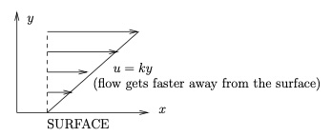
To check this is a solution of the NavierStokes and continuity equations, we substitute in the expressions. The continuity equation ([eqn-incompressibledef]) is readily satisfied, whilst the NavierStokes equations ([eqn-navierstokes]) give
$$0=−\frac{∂p}{∂x}, 0=−\frac{∂p}{∂y}, 0=−\frac{∂p}{∂z},$$
and thus $p$ is constant everywhere in space.
For a Newtonian fluid contained between parallel plates moving tangentially, we obtain a shear flow in the gap. The velocity varies linearly across the gap and matches the plate velocity at each of the two plates. This is called Couette flow and it is an exact solution of the NavierStokes and continuity equations:
- $ρ∂u/∂t$: The flow is steady so this term is zero.
- $ρu⋅∇u$: Since $u$ is directed tangential to the plates, $u⋅∇$ is a derivative in the tangential direction; however, $u$ varies only in the direction normal to the plates. Therefore, $u⋅∇u$ is zero for this flow.
- $−∇p$: The pressure is uniform, so this term is zero.
- $μ∇^{2}u$: The flow has a linear profile so $∇^{2}u$ is zero.
- $∇⋅u$: The flow only varies in the direction normal to the plates and the normal component of the velocity is zero, meaning that this term is zero.
FigureShear flow would be generated under the block.fig-couette-flow
0.10.80.1 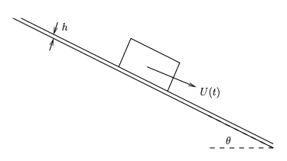
ExampleHagenPoiseuille flow (or Poiseuille flow).sec-poiseuille Poiseuille flow is the characteristic flow seen when an incompressible Newtonian fluid flows steadily along a cylindrical pipe whose length is long compared with its diameter. To find the fluid velocity we use cylindrical polar coordinates $(r,θ,z)$, and assume that the pipe wall is at $r=a$. We denote the fluid velocity components as $(u,v,w)$ in the three coordinate directions, i.e. $u=u\hat{r}+v\hat{θ}+w\hat{z}$, and assume a no-slip boundary condition at the pipe wall:
$$u=v=w=0 at r=a.$$
We also assume that the flow is steady, is axisymmetric, has no swirl (i.e.no azimuthal flow), is fully-developed, and we neglect gravity.
- Steady flow:
$$\frac{∂u}{∂t}=\frac{∂v}{∂t}=\frac{∂w}{∂t}=\frac{∂p}{∂t}=0;$$
- Axisymmetric flow:
$$\frac{∂u}{∂θ}=\frac{∂v}{∂θ}=\frac{∂w}{∂θ}=\frac{∂p}{∂θ}=0;$$
- No swirl:
$$v=0;$$
- Fully-developed flow means the fluid velocity doesn’t change as we move along the pipe (we ignore end effects since the pipe length is long compared to the diameter), and also that the axial pressure gradient is constant, i.e.
$$\begin{aligned}&\frac{∂u}{∂z}=\frac{∂v}{∂z}=\frac{∂w}{∂z}=0 \\ &\frac{∂p}{∂z}=−G(constant).\end{aligned}$$
Since the fluid is incompressible and Newtonian we take as our starting point the NavierStokes and continuity equations in cylindrical polar coordinates Remark [navier-stokes-continuity-cylindrical]. The continuity equation is
$$∇⋅u=\frac{1}{r}\frac{∂(ru)}{∂r}+\frac{1}{r}\frac{∂v}{∂θ}+\frac{∂w}{∂z}=0,$$
and applying assumptions 2 (or 3) and 4 in the list above, we get
$$\frac{1}{r}\frac{∂(ru)}{∂r}=0 ⇒ u=\frac{A}{r},$$
where $A$ is constant. Applying the boundary conditions ([eq-poiseuillebc]) gives $A=0$, and therefore $u=0$, so the velocity is axial $u=(0,0,w)=w\hat{z}$.
Neglecting time-dependence and gravity, the NavierStokes equations ([eqn-navierstokes]) are:
$$ρ\left(u⋅∇\right)u=−∇p+μ∇^{2}u.$$
We take the terms individually:
- Since $u=w\hat{z}$,
$$u⋅∇=w\frac{∂}{∂z} ⇒ \left(u⋅∇\right)u=w\frac{∂(w\hat{z})}{∂z},$$
- and this equals zero by the fully developed assumption (4 above).
- The pressure gradient equals
$$∇p=\frac{∂p}{∂r}\hat{r}−G\hat{z}.$$
- Since the $θ$- and $z$-derivatives of $w$ vanish,
$$∇^{2}u=∇^{2}\left(w\hat{z}\right)=\left(∇^{2}w\right)\hat{z}=\frac{1}{r}\frac{∂}{∂r}\left(r\frac{∂w}{∂r}\right)\hat{z}.$$
- Note that the formula used here for $∇^{2}w$ is standard and can be looked up (so you don’t need to remember it, though you should be aware that the gradient operator $∇$ takes a different form in polar coordinates).
Thus the three components of the NavierStokes equation ([eq-navierstokes-simppoiseuille]) are
- $r$-component:
$$0=−\frac{∂p}{∂r}.$$
- $θ$-component:
$$0=0.$$
- $z$-component:
$$0=G+\frac{μ}{r}\frac{∂}{∂r}\left(r\frac{∂w}{∂r}\right).$$
Solving the $z$-component gives the axial velocity component $w$:
$$\begin{aligned}&\frac{∂}{∂r}\left(r\frac{∂w}{∂r}\right)=0−\frac{G}{μ}r \\ ⇒ &r\frac{∂w}{∂r}=−\frac{Gr^{2}}{2μ}+A \\ ⇒ &\frac{∂w}{∂r}=−\frac{Gr}{2μ}+\frac{A}{r} \\ ⇒ &w=−\frac{Gr^{2}}{4μ}+Alnr+B.\end{aligned}$$
We require $A=0$ for regularity of the solution at $r=0$, and since the boundary condition ([eq-poiseuillebc]) has $w=0$ at $r=a$, we must set $B=Ga^{2}/(4μ)$. Therefore the fluid velocity in Poiseuille flow is given by
$$u=v=0 w=\frac{G}{4μ}\left(a^{2}−r^{2}\right),$$
which is illustrated in Figure [fig-poiseuille-flow].
FigureSketch of Poiseuille flow velocity profile.fig-poiseuille-flow
0.10.80.1 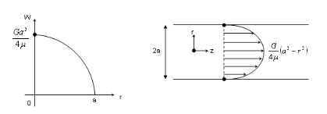
The celebrated HagenPoiseuille formula can be derived from ([eq-poiseuille-flow-profile]):
$$ΔP=\frac{8μLQ}{πa^{4}}.$$
This relates the volumetric flux $Q$ and pressure drop $ΔP$ along a circular pipe of length $L$ and radius $a$ in a Newtonian fluid with shear viscosity $μ$ for steady, fully developed flow. You will derive this result in Exercise .12.
We now consider two generalisations:
- Womersley flow: This is pipe flow driven by an axial pressure drop along the pipe that oscillates sinusoidally in time (Poiseuille flow was driven by a constant pressure gradient). Unlike Poiseuille flow, the exact profile of the flow depends on a parameter called the Womersley parameter (which depends on the frequency). Figure [fig-womersley-flow] shows an example. The flow is:
  - Unidirectional axial flow (purely along the pipe)
  - Axisymmetric
  - Flow direction oscillates in time. Sometimes the flow goes in both directions at once, which can be seen in Figure [fig-womersley-flow].
- If we add the velocity field of Poiseuille flow ([eq-poiseuille-flow-profile]) onto the Womersley flow velocity field, we obtain the flow that would be driven by a pressure gradient that oscillates about a non-zero mean. Flow profiles of this sort can be seen in blood flow, since the beating of the heart provides a pressure gradient that can be approximated by a constant plus sinusoidally varying component.
- Dean flow: This is a steady flow driven by a steady prescribed pressure drop along the pipe, but the pipe is curved, see Figure [fig-dean-flow]. Within the pipe the flow is predominantly in the axial direction, but the centrifugal force due to the curvature drives a secondary flow across the centre of the pipe towards the outside of the bend, and then back around the walls of the pipe towards the inside of the bend. This secondary flow forms Dean vortices. This is thought to provide a possible explanation as to why the disease atherosclerosis in arteries is more common on the inside of bends in arteries, since the cells lining the artery walls are more healthy in conditions of high stress. Figure [fig-dean-flow] shows shows the secondary flow in the transverse cross section, which are termed Dean vortices.
FigureSketch of Womersley flow velocity profile.fig-womersley-flow
0.10.80.1 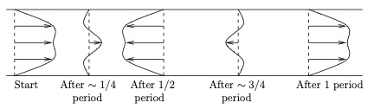
FigureSketch of Dean flow velocity profile: (a) longitudinal cross-section; (b) transverse cross-section.fig-dean-flow
0.10.80.1 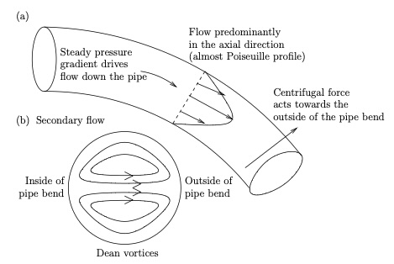
ExampleChannel flow.sec-exact-solutions-5 This is the characteristic flow seen between two fixed parallel plates driven by a steady pressure gradient. The assumptions are:
- Parallel fixed plates
- Two-dimensional flow
- Steady flow
- Fully developed flow
The resulting profile is shown in Figure [fig-channel-flow]. The flow is parabolic and looks similar to a cross-section of Poiseuille flow. See also the cartoon of channel flow between two plates.
FigureSketch of channel flow velocity profile.fig-channel-flow
0.10.80.1 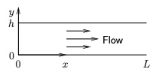
ExampleAxisymmetric Couette flow.sec-exact-solutions-6 This is the characteristic flow that is observed between cylinders that are rotating relative to one another. We assume:
- Coaxial cylinders, rotating at different constant angular velocities
- Two-dimensional flow (no dependence on $z$-coordinate)
- Axisymmetric flow
- Steady flow
The resulting flow is illustrated in Figure [fig-axisym-couette-flow].
FigureSketch of axisymmetric Couette flow.fig-axisym-couette-flow
0.10.80.1 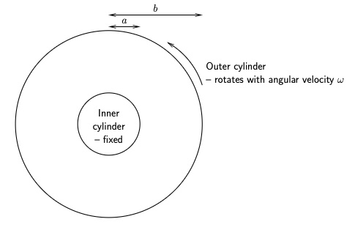
ExampleStokes boundary layer.example-stokes-boundary-layer
FigureSketch of set up for Stokes boundary layer.fig-stokes-boundary-layer-setup
0.10.80.1 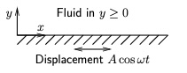
In this question you will investigate the flow field generated next to a flat oscillating plate. Assume that the plate is at $y=0$ with an incompressible Newtonian fluid of density $ρ$ and kinematic viscosity $ν$ in $y>0$, and that the plate oscillates purely in the $x$-direction with displacement $Acosωt i$ at time $t$, as shown in Figure [fig-stokes-boundary-layer-setup]. You may also assume that the plate and volume of fluid are large enough that you can neglect their boundaries (that is, the plate occupies the whole plane $y=0$ and the fluid occupies the whole of $y>0$) and that the plate has been oscillating long enough so that the whole fluid is oscillating periodically.
- Write down the equations and boundary conditions governing the flow.
- Solution.The fluid is governed by the NavierStokes and continuity equations:
$$\frac{∂u}{∂t}+u⋅∇u=−\frac{1}{ρ}∇p+ν∇^{2}u, ∇⋅u=0.$$
- At $y=0$ the boundary conditions are
$$u=−Aωsinωt, v=w=0.$$
- Write down assumptions about the components of the fluid flow and their dependence on the spatial coordinates $x$, $y$ and $z$. Use this to simplify the the governing equations and boundary conditions.
- Solution.We assume this is a two-dimensional flow, with $w=0$ and all components not depending on $z$. In addition we assume the velocity components do not depend on $x$ (because translating the problem in the $x$-direction is the same problem). Thus we have $u(y,t)$, $v(y,t)$, $w=0$ and $p(y,t)$.
- The continuity equation is
$$\frac{∂u}{∂x}+\frac{∂v}{∂y}+\frac{∂w}{∂z}=0.$$
- The first and third terms are zero by assumption, and therefore
$$\frac{∂v}{∂y}=0.$$
- Hence $v$ is constant, and the boundary condition $v=0$ at $y=0$ implies that $v=0$ everywhere. The three components of the NavierStokes equation simplify to
$$\begin{aligned}&\frac{∂u}{∂t}+0+0+0=0+ν\left(0+\frac{∂^{2}u}{∂y^{2}}+0\right), \\ \\ &0+0+0+0=−\frac{1}{ρ}\frac{∂p}{∂y}+ν\left(0+0+0\right), \\ \\ &0+0+0+0=0+ν\left(0+0+0\right).\end{aligned}$$
- Thus $p$ is constant in space and the only non-trivial equation is
$$\frac{∂u}{∂t}=ν\frac{∂^{2}u}{∂y^{2}},$$
- together with boundary conditions $u=−Aωsinωt$ at $y=0$.
- Make the assumption that the flow and pressure are sinusoidal, that is $u(x,t)=u(x)e^{iωt}+\overline{u(x)}e^{−iωt}$ and $p(x,t)=P(x)e^{iωt}+\overline{P(x)}e^{−iωt}$. Use this to simplify and solve the governing equations to find the velocity field.
- Solution.The periodic assumption simplifies to $u=U(y)e^{iωt}+\overline{U(y)}e^{−iωt}$ (the other components are not needed). Substituting into the governing equation,
$$iωUe^{iωt}−iω\overline{U(y)}e^{−iωt}=ν\left(\frac{d^{2}U}{dy^{2}}e^{iωt}+\frac{d^{2}\overline{U}}{dy^{2}}e^{−iωt}\right).$$
- The coefficients of $e^{iωt}$ must balance and the coefficients of $e^{−iωt}$ must balance. Therefore
$$iωU=ν\frac{d^{2}U}{dy^{2}}, and −iω\overline{U}=ν\frac{d^{2}\overline{U}}{dy^{2}}.$$
- These two equations are the complex conjugates of one another, so we only need to solve one of them, which gives the general solution
$$U=C_{1}e^{\sqrt{\frac{iω}{ν}}y}+C_{2}e^{−\sqrt{\frac{iω}{ν}}y}.$$
- The function $e^{\sqrt{\frac{iω}{ν}}y}→∞$ as $y→∞$, and thus $C_{1}=0$. The boundary condition $u=−Aωsinωt=(Aωi/2)e^{iωt}−(Aωi/2)e^{−iωt}$ at $y=0$. Hence $U=Aωi/2$, meaning that $C_{2}=Aωi/2$. Hence
$$\begin{aligned}u=&\frac{Aωi}{2}e^{−\sqrt{\frac{iω}{ν}}y+iωt}−\frac{Aωi}{2}e^{−\sqrt{\frac{−iω}{ν}}y−iωt} \\ \\ =&−\frac{Aω}{2i}\left(e^{−(1+i)\sqrt{\frac{ω}{2ν}}y+iωt}−e^{−(1−i)\sqrt{\frac{ω}{2ν}}y−iωt}\right) \\ \\ =&−Aωe^{−\sqrt{\frac{ω}{2ν}}y}\frac{\left(e^{i(−\sqrt{\frac{ω}{2ν}}y+ωt)}−e^{−i(−\sqrt{\frac{ω}{2ν}}y+ωt)}\right)}{2i} \\ \\ =&−Aωe^{−\sqrt{\frac{ω}{2ν}}y}sin\left(ωt−\sqrt{\frac{ω}{2ν}}y\right).\end{aligned}$$
- Sketch the velocity profile at time $t$.
- Solution.The velocity profile is a sinusoidal function whose amplitude decays exponentially with the distance from the surface.
- FigureStokes boundary layer flow.fig-stokes-boundary-layer
- 0.10.80.1 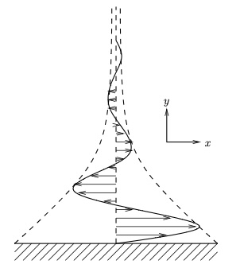
- This is a famous exact solution of the NavierStokes equations, and the flow we have found here is characteristic of the flow that exists near an oscillating boundary. Note that the flow decays away from the wall, and for this reason it is often described as a boundary later, and the solution is called Stokes boundary layer flow.
ExampleLow-Reynolds-number flow past a sphere (non-examinable).sec-low-Reynolds-number-sphere This section is non-examinable.
FigurePhotographs of a sphere moving through a fluid with $Re=0.1$. The top photograph is in the reference frame in which the sphere is stationary, and the bottom photograph is in a fixed frame, (note the shadow cast by the sphere is not indicative of the flow). Taken from [], and see also Figs. 25, 51, 56, 58 from this book, which show the flow for higher Reynolds numbers.fig-low-reynolds-sphere
0.10.80.1 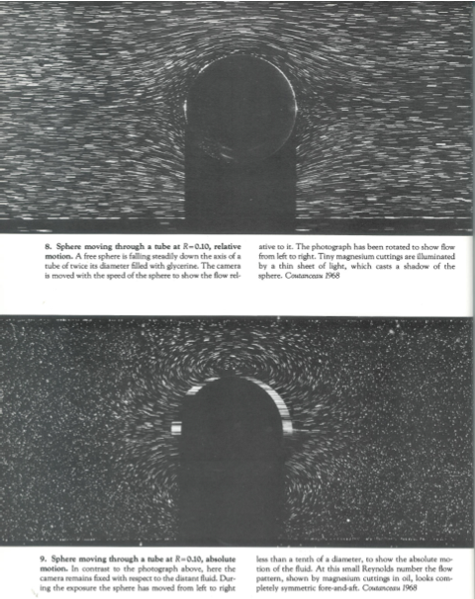
FigureSketches of the flow field around of a fixed sphere in a moving fluid for (a) low, (b) moderate and (c) high Reynolds numbers.fig-sphere-through-fluid
0.10.80.1 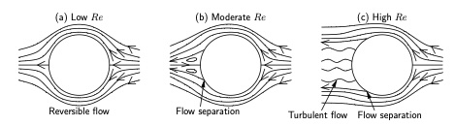
In this section we find the flow around a sphere moving through a fluid at a low Reynolds number, using a Stokes streamfunction. We use this to find the drag on the sphere. Figure [fig-low-reynolds-sphere] shows two photographs of the same flow, but visualised in two different ways, and Figure [fig-sphere-through-fluid] shows sketches of the flow for a range of Reynolds numbers.
The calculation shows that the drag force experienced by an object moving through a fluid at low Reynolds numbers can be derived from the Stokes equations. This analysis shows that the Stokes drag on a sphere is $6πμUa$ in the direction opposing motion, which holds as long as $ρUa/μ≪1$. This is a famous classical result in fluid mechanics.
This principle is used in a falling ball viscometer in which a small spherical ball of known radius $a$ and mass $m$ is dropped into a fluid, whose viscosity $μ$ we wish to measure. Once the ball has reached its terminal falling velocity $U$, the forces on it must be in equilibrium, meaning that the force of gravity balances the drag force. Assuming the sphere is small enough and going slowly enough and the fluid is viscous enough that the flow has a low Reynolds number, the drag is given by $6πμUa$ and the force of gravity is $mg$, where $g$ is the acceleration due to gravity. Thus
$$μ=\frac{mg}{6πUa},$$
and so measuring the terminal velocity and substituting into this equation gives an estimate of the viscosity of the fluid.
We assume the flow is axisymmetric and work in a moving reference frame centred on the sphere using spherical coordinates. For axisymmetric flow with no swirl, we can write the velocity in terms of a Stokes streamfunction $Ψ(r,θ)$, defined by
$$\begin{equation*}
\boldsymbol{u}= \nabla \times \left(\frac{\Psi}{r\sin\theta}\hat\boldsymbol{\phi}\right),
\end{equation*}$$
which is the axisymmetric analogue of the two-dimensional streamfunction of Section [sec-streamfunction]; in particular, $Ψ$ is constant along streamlines. The velocity components are then
$$\begin{aligned}u_{r}=&\frac{1}{r^{2}sinθ}\frac{∂Ψ}{∂θ}, \\ u_{θ}=&−\frac{1}{rsinθ}\frac{∂Ψ}{∂r}, \\ u_{ϕ}=&0.\end{aligned}$$
Taking the curl of the velocity, the vorticity is given by
$$\begin{equation*}
\boldsymbol{\omega}=-\frac1{r\sin\theta}\left(\mathcal{L}_s\left(\Psi\right)\right)\hat\boldsymbol{\phi},
\end{equation*}$$
where the differential operator $L_{s}$ is a variant of the Laplacian operator, defined by its action on a function $A$ by
$$L_{s}\left(A\right)=\frac{∂^{2}A}{∂r^{2}}+\frac{sinθ}{r^{2}}\frac{∂}{∂θ}\left(\frac{1}{sinθ}\frac{∂A}{∂θ}\right).$$
At low Reynolds numbers, we take the curl of the Stokes equation ([low-reynolds-number]) to give
$$∇^{2}ω=0,$$
and, after some work, we may show this is equivalent to
$$L_{s}^{2}Ψ=0.$$
We need boundary conditions on $Ψ$, which are given by the following:
- No-slip conditions on the surface of the sphere ($r=a$). Using the expressions for $u_{r}$ and $u_{θ}$ above, these become
$$\begin{aligned}&u_{r}=0 ⇒ \frac{∂Ψ}{∂θ}=0, \\ &u_{θ}=0 ⇒ \frac{∂Ψ}{∂r}=0.\end{aligned}$$
- As $r→∞$ we must have uniform flow with velocity $U$ in the direction $θ=π$. Using the expressions for the velocity components $u_{r}$ and $u_{θ}$ above, these become
$$\begin{aligned}&u_{r}∼−Ucosθ ⇒ \frac{∂Ψ}{∂θ}∼−Ur^{2}sinθcosθ, \\ &u_{θ}∼Usinθ ⇒ \frac{∂Ψ}{∂r}∼−Ur\sin^{2}θ.\end{aligned}$$
- Combining these we get
$$Ψ∼−\frac{1}{2}Ur^{2}\sin^{2}θ+C,$$
- where $C$ is constant. Adding a constant onto the streamfunction does not affect the velocity, and thus we may arbitrarily set $C=0$, giving
$$Ψ∼−\frac{1}{2}Ur^{2}\sin^{2}θ as r→∞.$$
Thus we have to solve ([eq-stokes-eq-streamfunction-axisym]) subject to the $∂Ψ/∂r=∂Ψ/∂θ=0$ on $r=a$ and ([eq-stokes-behaviour-infty]) as $r→∞$. We try a separable function
$$Ψ=f(r)g(θ),$$
and the condition ([eq-stokes-behaviour-infty]) implies that $g(θ)=\sin^{2}θ$ (or a multiple thereof). Substituting ([eq-separablePsi]) into ([eq-stokes-eq-streamfunction-axisym]) and using ([eq-definitionofLs]), after some algebra we obtain
$$\frac{d^{4}f}{dr^{4}}−\frac{4}{r^{2}}\frac{d^{2}f}{dr^{2}}+\frac{8}{r^{3}}\frac{df}{dr}−\frac{8f}{r^{4}}=0.$$
We try $f∝r^{α}$ and obtain
$$\begin{aligned}&α(α−1)(α−2)(α−3)r^{α−4}−\frac{4}{r^{2}}α(α−1)r^{α−2}+\frac{8}{r^{3}}αr^{α−1}−\frac{8}{r^{4}}r^{α}=0 \\ ⇒ &α(α−1)(α−2)(α−3)−4α(α−1)+8α−8=0 \\ ⇒ &(α−4)(α−2)(α+1)(α−1)=0.\end{aligned}$$
Thus $α=4,2,1$ or $−1$, and so the general solution of ([eq-fourth-order]) is
$$f(r)=C_{1}r^{4}+C_{2}r^{2}+C_{3}r+\frac{C_{4}}{r}.$$
- Enforcing the behaviour ([eq-stokes-behaviour-infty]) as $r→∞$, we need $f∼−Ur^{2}/2$, and so $C_{1}=0$, $C_{2}=−U/2$. Thus
$$f(r)=−\frac{1}{2}Ur^{2}+C_{3}r+\frac{C_{4}}{r}.$$
- Applying the boundary condition $∂Ψ/∂θ=0$ at $r=a$,
$$\begin{aligned}&{\left.\frac{∂Ψ}{∂θ}\right|}_{r=a}=0 \\ ⇒ &f(a)g^{′}(θ)=0 \\ ⇒ &\left(−\frac{1}{2}Ua^{2}+C_{3}a+\frac{C_{4}}{a}\right)\left(2sinθcosθ\right)=0\end{aligned}$$
- which must be true for all values of $θ$. Thus
$$−\frac{1}{2}Ua^{2}+C_{3}a+\frac{C_{4}}{a}=0.$$
- Applying the boundary condition $∂Ψ/∂r=0$ at $r=a$,
$$\begin{aligned}&{\left.\frac{∂Ψ}{∂r}\right|}_{r=a}=0 \\ ⇒ &f^{′}(a)g(θ)=0 \\ ⇒ &\left(−Ua+C_{3}−\frac{C_{4}}{a^{2}}\right)\left(\sin^{2}θ\right)=0,\end{aligned}$$
- which must be true for all $θ$. Thus
$$−Ua+C_{3}−\frac{C_{4}}{a^{2}}=0.$$
Equations ([eq-condition1]) and ([eq-condition2]) have the solution $C_{3}=3Ua/4$ and $C_{4}=−Ua^{3}/4$. Thus
$$Ψ=−\frac{U}{4r}\left(a^{3}−3ar^{2}+2r^{3}\right)\sin^{2}θ,$$
and we can substitute this into the expressions for the components of the velocity field to obtain the velocity:
$$\begin{aligned}&u_{r}=\frac{1}{r^{2}sinθ}\frac{∂Ψ}{∂θ}=−\frac{U}{2}\left(2−\frac{3a}{r}+\frac{a^{3}}{r^{3}}\right)cosθ=−\frac{U}{2}{\left(1−\frac{a}{r}\right)}^{2}\left(2+\frac{a}{r}\right)cosθ, \\ &u_{θ}=−\frac{1}{rsinθ}\frac{∂Ψ}{∂r}=\frac{U}{4}\left(4−\frac{3a}{r}−\frac{a^{3}}{r^{3}}\right)sinθ=\frac{U}{4}\left(1−\frac{a}{r}\right)\left(4+\frac{a}{r}+\frac{a^{2}}{r^{2}}\right)sinθ, \\ &u_{ϕ}=0.\end{aligned}$$
We can also find the pressure using the Stokes equation in the form $∇p=μ∇^{2}u$. After a lot of algebra we obtain
$$\frac{∂p}{∂r}=−\frac{3μUa}{r^{3}}cosθ, \frac{1}{r}\frac{∂p}{∂θ}=−\frac{3μUa}{2r^{3}}sinθ, \frac{1}{rsinθ}\frac{∂p}{∂ϕ}=0,$$
which we solve to find
$$p=p_{0}+\frac{3μUa}{2r^{2}}cosθ,$$
where $p_{0}$ is constant.
Perhaps the most interesting application of this solution is to find the drag on the sphere, which is the total force of the fluid on the sphere, retarding the motion. Since the stress is the force per unit area on the sphere, the drag equals the integral of the stress over the surface. We find the stress using
$$\begin{equation}
\boldsymbol{\tau}=\boldsymbol{\sigma}\hat\boldsymbol{r},\quad\mathrm{where}\quad
\boldsymbol{\sigma}=-p \boldsymbol{I}+2\mu \boldsymbol{e}\quad\mathrm{and}\quad
\hat\boldsymbol{r}=\left(\begin{array}{c}1\\0\\0\end{array}\right).\label{eq-stressonstokessphere}
\end{equation}$$
We use the expression for $e$ in spherical polar coordinates ([eq-eincylsph]), and then ([eq-stressonstokessphere]) gives the stress on the surface as
$$\begin{align*}
\boldsymbol{\tau}=&\left.\left(\begin{array}{c}
-p+2\mu\frac{\partial u_r}{\partial r}\\
\mu\left(r\frac{\partial(u_\theta/r)}{\partial r}+\frac1r\frac{\partial u_r}{\partial\theta}\right)\\
\mu\left(\frac{\partial(u_\phi/r)}{\partial r}+\frac1{r\sin\theta}\frac{\partial u_r}{\partial\phi}\right)
\end{array}\right)\right|_{r=a}\\
=&\left.\left(-p+2\mu\frac{\partial u_r}{\partial r}\right)\right|_{r=a}\hat\boldsymbol{r}
+\left.\mu\left(r\frac{\partial(u_\theta/r)}{\partial r}+\frac1r\frac{\partial u_r}{\partial\theta}\right)\right|_{r=a}\hat\boldsymbol{\theta}\\
&+\left.\mu\left(\frac{\partial(u_\phi/r)}{\partial r}+\frac1{r\sin\theta}\frac{\partial u_r}{\partial\phi}\right)\right|_{r=a}\hat\boldsymbol{\phi}.
\end{align*}$$
On substituting in the expressions for the velocity components $u_{r}$, $u_{θ}$, $u_{ϕ}$, we find that
$$\begin{equation*}
\boldsymbol{\tau}
=\left(-p_0-\frac{3\mu U}{2a}\cos\theta\right)\hat\boldsymbol{r}+\frac{3\mu U}{2a}\sin\theta\hat\boldsymbol{\theta}+0\hat\boldsymbol{\phi}
=-p_0\hat\boldsymbol{r}+\frac{3\mu U}{2a}\left(\sin\theta\hat\boldsymbol{\theta}-\cos\theta\hat\boldsymbol{r}\right).\label{eq:tauworking}
\end{equation*}$$
We express the bracket $(\sin\theta\hat\boldsymbol{\theta}-\cos\theta\hat\boldsymbol{r})$ in this equation in terms of Cartesian coordinates, using the conversion formulae
$$\begin{equation*}
\hat\boldsymbol{r}=\cos\phi\sin\theta\boldsymbol{I}+\sin\phi\sin\theta\boldsymbol{j}+\cos\theta\boldsymbol{k},\quad
\hat\boldsymbol{\theta}=\cos\phi\cos\theta\boldsymbol{I}+\sin\phi\cos\theta\boldsymbol{j}-\sin\theta\boldsymbol{k}.
\end{equation*}$$
Substituting this into the expression for $τ$, we obtain the stress
$$\begin{equation*}
\boldsymbol{\tau}=-p_0\hat\boldsymbol{r}-\frac{3\mu U}{2a}\boldsymbol{k}.
\end{equation*}$$
The drag equals the integral of $τ$ over the surface of the sphere. The integral of the term $-p_0\hat\boldsymbol{r}$ is zero because this force cancels on opposite sides of the sphere, but the term $-\frac{3\mu U}{2a}\hat\boldsymbol{k}$ is always in the same direction; thus the total drag force is this term times the area, which is
$$\begin{equation*}
\left(-\frac{3\mu U}{2a}\hat\boldsymbol{k}\right)\times\left(4\pi a^2\right)=-6\pi\mu Ua\hat\boldsymbol{k}.
\end{equation*}$$
Thus the drag force is $\boxed{6πμUa}$ in the direction opposing motion. This is called the Stokes drag and it is a famous result in fluid mechanics.
Remarksec-low-Reynolds-number-sphere-11 This derivation is extremely complicated in terms of the algebra, and you would certainly not be asked to reproduce something so long-winded as this in this course. However, you should understand the concepts, and be able to follow the general argument. In fact the mathematics presented here is very elegant indeed, and it is amazing that an exact solution exists and can be calculated.
Remarksec-low-Reynolds-number-sphere-12 Notice that in the course of the derivation ([eq-separablePsi]), we made the assumption that $Ψ$ is separable. Thus we have not rigorously shown that the solution we found was unique, that is there might be other solutions to this problem that satisfy the boundary conditions at $r=a$ and the condition as $r→∞$.
Remarksec-low-Reynolds-number-sphere-13 It is instructive to compare this with the inviscid, irrotational flow past a sphere, for which
$$Ψ=−\frac{1}{2}U\left(r^{2}−\frac{a^{3}}{r}\right)\sin^{2}θ.$$
The two solutions agree in the far field, but they differ near the sphere: the Stokes solution satisfies the no-slip condition and has non-zero vorticity. Note that for any real fluid (i.e. one with viscosity), the Stokes solution would only be seen at low Reynolds numbers.
ExampleWomersley flow (non-examinable).example-womersley-flow This section is non-examinable.
Womersley flow occurs in pipes in which there is an imposed oscillating pressure gradient. Characteristics of this flow are often seen in blood flow in arteries, since the flow and pressure gradient are unsteady. As for the derivation of Poiseuille flow, we consider a long, circular cylindrical pipe of radius $a$, and work in cylindrical polar coordinates centred on the axis of the pipe. We make the following assumptions:
- The flow is fully developed; thus $∂u/∂z=0$.
- The flow is axisymmetric; thus $∂u/∂θ=∂p/∂θ=0$.
- The flow has a symmetry in a diameter of the cross-section. In turn this means there is no swirl in the flow, and thus $u_{θ}=0$.
The derivation proceed similarly to that of Poiseuille flow (so we cover it quite briefly here). With the assumptions, the continuity equation reduces to
$$\frac{1}{r}\frac{∂}{∂r}\left(ru_{r}\right)=0,$$
which gives $u_{r}∝1/r$, whereupon the boundary condition implies that the constant of proportionality is zero, and hence $u_{r}=0$. Thus the only flow component is the axial flow, $u_{z}$, which, according to the assumptions, is a function of $r$ and $t$ only (and does not depend on either $θ$ or $z$). The radial and azimuthal components of the NavierStokes equation reduce to the equations
$$\frac{∂p}{∂r}=\frac{∂p}{∂θ}=0,$$
and thus $p$ is a function of $z$ and $t$ only. The axial component of the NavierStokes equation is
$$ρ\frac{∂u_{z}}{∂t}=−\frac{∂p}{∂z}+μ\frac{1}{r}\frac{∂}{∂r}\left(r\frac{∂u_{z}}{∂r}\right).$$
Consider what happens to the three terms in this equation at fixed values of $t$ and $r$ as $z$ alone is varied. Since $u_{z}$ is not a function of $z$, the only term that can vary is $\frac{∂p}{∂z}$, while the other two terms stay constant. Since equality must be maintained this shows that, in fact, $\frac{∂p}{∂z}$ must be fixed as $z$ varies, and thus $p=A(t)z+B(t)$, where $A$ and $B$ are unknown functions of time. We set $G(t)=−A(t)$ to be the pressure gradient of the flow at time $t$.
In Poiseuille flow $G$ is fixed in time, but in Womersley flow we set $G(t)=G_{0}cosωt$, where $G_{0}$ is constant (by fixing the origin of time we may fix $G_{0}$ to be real and positive). We can write this as
$$G(t)=\frac{G_{0}}{2}e^{iωt}+c.c.,$$
where $c.c.$ denotes the complex conjugate. We try a solution of the form
$$u_{z}(r,t)=U(r)e^{iωt}+c.c.,$$
where $U$ is a complex-valued function, and, substituting this into ([eq-axialNS]), we obtain
$$\begin{aligned}&ρiωUe^{iωt}−ρiω\overline{U}e^{−iωt}=\frac{G_{0}}{2}e^{iωt}+\frac{G_{0}}{2}e^{−iωt}+μ\frac{1}{r}\frac{∂}{∂r}\left(r\frac{∂U}{∂r}\right)e^{iωt}+μ\frac{1}{r}\frac{∂}{∂r}\left(r\frac{∂\overline{U}}{∂r}\right)e^{−iωt} \\ ⇒ &\left\{ρiωU−\frac{G_{0}}{2}−μ\frac{1}{r}\frac{∂}{∂r}\left(r\frac{∂U}{∂r}\right)\right\}e^{iωt}+\left\{−ρiω\overline{U}−\frac{G_{0}}{2}−μ\frac{1}{r}\frac{∂}{∂r}\left(r\frac{∂\overline{U}}{∂r}\right)\right\}e^{−iωt}=0.\end{aligned}$$
This equation must be true for all values of $t$, which means that both of the expressions in brackets $\{\}$ must be be zero. Since the two bracketed expressions are complex conjugates of one another, we only need to consider the first bracket. Thus
$$iωρU−\frac{G_{0}}{2}−μ\frac{1}{r}\frac{d}{dr}\left(r\frac{dU}{dr}\right)=0 ⇒ \frac{d^{2}U}{dr^{2}}+\frac{1}{r}\frac{dU}{dr}−\frac{iωρ}{μ}U=−\frac{G_{0}}{2μ}.$$
This is a linear, second-order, non-constant-coefficient, non-homogeneous ordinary differential equation for $U$. We can therefore solve it as a complementary function $U_{cf}$ plus a particular integral $U_{pi}$. The particular integral is given by
$$U_{pi}=\frac{G_{0}}{2iωρ}.$$
To find the complementary function we must solve
$$\frac{d^{2}U_{cf}}{dr^{2}}+\frac{1}{r}\frac{dU_{cf}}{dr}−\frac{iωρ}{μ}U_{cf}=0,$$
and substituting $s=(\sqrt{−iω/ν})r$ and simplifying, we remove the coefficients on the left-hand side to obtain
$$\frac{d^{2}U_{cf}}{ds^{2}}+\frac{1}{s}\frac{dU_{cf}}{ds}+U_{cf}=0.$$
This equation is the standard form of a special equation called Bessel’s equation. The two linearly independent solutions are called Bessel functions of order zero, and they are denoted $J_{0}$ and $Y_{0}$, see Figure [fig-bessel-functions-first-kind] and Figure [fig-bessel-functions-second-kind].
FigureBessel functions of the first kind $J_{0}$, $J_{1}$ and $J_{2}$ (from Wikipedia entry on Bessel functions).fig-bessel-functions-first-kind
0.10.80.1 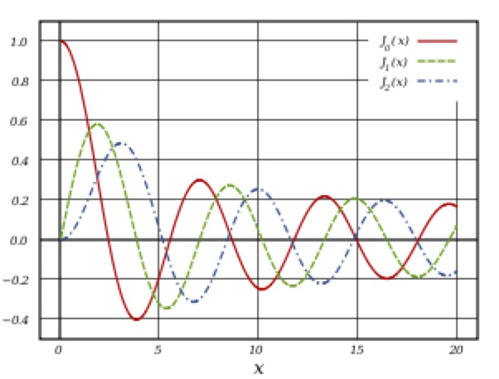
FigureBessel functions of the second kind $Y_{0}$, $Y_{1}$ and $Y_{2}$ (from Wikipedia entry on Bessel functions).fig-bessel-functions-second-kind
0.10.80.1 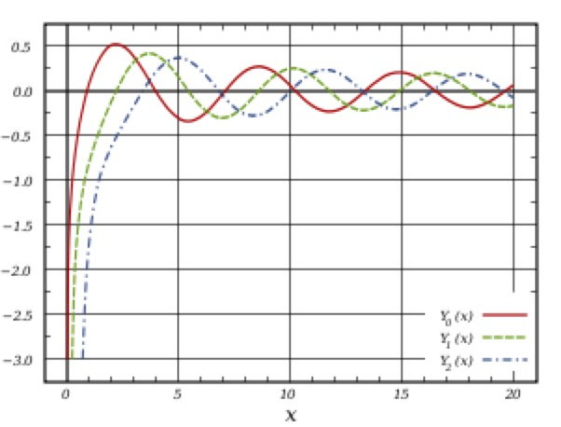
We therefore obtain the complementary function
$$U_{cf}=C_{1}J_{0}(s)+C_{2}Y_{0}(s),$$
where $C_{1}$ and $C_{2}$ are constants of integration, and thus
$$\begin{aligned}U=U_{cf}+U_{pi}=&C_{1}J_{0}\left(\sqrt{\frac{−iω}{ν}}r\right)+C_{2}Y_{0}\left(\sqrt{\frac{−iω}{ν}}r\right)+\frac{G_{0}}{2iωρ} \\ =&C_{1}J_{0}\left(\sqrt{−i}α\frac{r}{a}\right)+C_{2}Y_{0}\left(\sqrt{−i}α\frac{r}{a}\right)+\frac{G_{0}}{2iωρ},\end{aligned}$$
where the Womersley number $α$ is a dimensionless parameter defined by
$$α=\sqrt{\frac{ω}{ν}}.$$
To find the constants $C_{1}$ and $C_{2}$ we apply the boundary conditions and regularity conditions at the origin $r=0$ (as we did for Poiseuille flow):
- At $r=0$: The function $Y_{0}(x)$ tends to infinity as $x→0$ and so contributions from $Y_{0}((\sqrt{−iω/ν})r)$ are not allowed, meaning that $C_{2}$ must be set to zero.
- At $r=a$: The no-slip boundary condition is $u_{z}=0$ at the wall for all times, which from ([eq-ansatz-uz]) means that $U$ must also be zero at $r=a$. Substituting into the solution for $U$ gives
$$C_{1}=−\frac{G_{0}}{2iωρJ_{0}(\sqrt{−i}α)}.$$
Hence
$$U=\frac{G_{0}}{2iωρ}\left(1−\frac{J_{0}(\sqrt{−i}αr/a)}{J_{0}(\sqrt{−i}α)}\right),$$
and, substituting this into ([eq-ansatz-uz]), we get
$$u_{z}=−\frac{iG_{0}}{2ωρ}\left(1−\frac{J_{0}(\sqrt{−i}αr/a)}{J_{0}(\sqrt{−i}α)}\right)e^{iωt}+c.c.$$
This is Womersley flow, which was first described by Womersley in 1955. The nondimensionalised flow profile is
$$u_{z}^{*}=−\frac{i}{2}\left(1−\frac{J_{0}(\sqrt{−i}αr^{*})}{J_{0}(\sqrt{−i}α)}\right)e^{it^{*}}+c.c.,$$
where $u_{z}^{*}=u_{z}/(G_{0}/(ωρ))$, $r^{*}=r/a$, $t^{*}=ωt$. This nondimensionalisation shows that the flow is characterised by a single parameter, the Womersley number, $α$ (as opposed to 4 dimensional parameters: $ρ$, $μ$, $a$ and $ω$). Sketches of the flow profiles for different values of $α$ are given in Figure~\reffig:womersley and some movies will be shown in the lecture.
FigureSnapshots of sketches of Womersley flow profiles for various Womersley numbers. (a) Low Womersley number (profile is Poiseuille flow multiplied by a time-dependent factor), (b) intermediate Womersley number, (c) high Womersley number (profile is flat across the interior with a boundary layer in which the flow oscillates rapidly).fig-womserley-number-effect
0.10.80.1 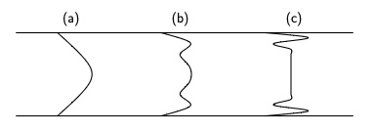
Remarkexample-womersley-flow-9 We may do a similar analysis for any prescribed periodic pressure gradient $G(t)$. To do this we decompose $G(t)$ into a Fourier series sum of terms of different frequencies. We solve for the flow generated by each component of $G(t)$ individually. The total flow is the sum of these flow components.
Remarkexample-womersley-flow-10 In the human arterial system the Womersley number of the fundamental harmonic is different in different arteries and it takes values up to about 20.
Remarkexample-womersley-flow-11 For small Womersley numbers we use the Taylor series expansion of the Bessel function:
$$J_{0}(z)=1−\frac{z^{2}}{4}+…$$
to find an approximation of $u_{z}$.
$$\begin{aligned}u_{z}=\frac{iG_{0}}{2ωρ}\left(\frac{iα^{2}}{4}−\frac{i}{4}{\left(\frac{αr}{a}\right)}^{2}+…\right)e^{iωt}+c.c.≈&−\frac{G_{0}}{8μ}\left(a^{2}−r^{2}\right)e^{iωt}+c.c. \\ =&−\frac{G_{0}}{4μ}\left(a^{2}−r^{2}\right)cosωt,\end{aligned}$$
which is a Poiseuille flow profile (multiplied by an oscillating amplitude). This flow is called quasi-steady, because this is the solution that we would obtain if we neglected the time-derivative term in the NavierStokes equation.
Remarkexample-womersley-flow-12 For large Womersley numbers we use the standard asymptotic expansions for the Bessel function, which is:
$$J_{0}(z)≈\sqrt{\frac{2}{πz}}cos\left(z−\frac{π}{4}\right)$$
when $|z|≫1$. Letting $z=x+iy$, where $x$ and $y$ are real, we can expand the cosine function:
$$J_{0}(z)≈\sqrt{\frac{1}{2πz}}\left(e^{ix−iπ/4}e^{−y}+e^{−ix+iπ/4}e^{y}\right)≈\sqrt{\frac{1}{2πz}}e^{ix−iπ/4}e^{−y}=\sqrt{\frac{1}{2πz}}e^{iz−iπ/4}.$$
where the second approximation is valid if $y≪0$ (which is the case we have). Substituting into ([eq-womsersley-flow]), we obtain
$$\begin{aligned}u_{z}≈&−\frac{iG_{0}}{2ωρ}\left(1−\sqrt{\frac{a}{r}}e^{−\sqrt{i}α(1−r/a)}\right)e^{iωt}+c.c. \\ =&−\frac{iG_{0}}{2ωρ}\left(1−\sqrt{\frac{a}{r}}e^{−\frac{α}{\sqrt{2}}(1−\frac{r}{a})}e^{−i\frac{α}{\sqrt{2}}(1−\frac{r}{a})}\right)e^{iωt}+c.c.\end{aligned}$$
Away from the boundaries, $\frac{α}{\sqrt{2}}(1−\frac{r}{a})$ is large and so the exponential terms in the bracket in this expression are very small, and
$$u_{z}≈−\frac{iG_{0}}{2ωρ}e^{iωt}+c.c.=\frac{G_{0}}{ωρ}sinωt.$$
This type of flow is called plug flow, since at any fixed time the profile is uniform across the interior.
Near the walls of the pipe the exponential terms become important. At the walls themselves, the flow is zero, and, as we move away, the expression for the velocity shows there are rapid oscillations that decrease in magnitude as we move away from the wall.
Thus we see that the flow is divided into two distinct regions. There is the core in which the dominant balance is between the pressure gradient and the inertial term (the time-derivative term), and in which the viscosity plays a minor role. Sometimes this is termed an inviscid core. The other region is the boundary layer, in which the viscosity is important. The width of the boundary layer is of the order of magnitude $α^{−1}a$ (often we would just say loosely that the boundary layer has width $α^{−1}a$). Within a few $α^{−1}a$’s away from the boundary, the flow is affected by the presence of the boundary, but further away the effect is negligible.
Another way that we could find the flow for large Womersley number is to use boundary layer analysis in the boundary, and an inviscid flow method (such as potential flow analysis) in the interior, and match the two solutions at the edge of the boundary layer. Since we have the exact solution valid for all Womersley numbers, this method of separating into the boundary layer and core regions is not necessary to find the solution. However, in many problems, no solution can be found in the general case, but a solution can be found in the particular case when one parameter is large or small. It is surprising how often such solutions are possible in real world problems, and this method often provides significant insight into the problem.
ExercisesPractice ExercisesPractice Exercisesws-viscousflows
RemarkSolutions and feedback.remark-solutions-feedback-viscousflows Full solutions to the exercises in this chapter can be found in the solutions to this chapter [solutions-viscousflows] in Appendix [solutions] at the back of the book.
If you would like feedback on your work, the tutor will by default concentrate on the exercises highlighted with a yellow background in the online notes (the homework exercises), unless you specifically ask for feedback on a different exercise instead.
Warningws-viscousflows-2-2 We look to complete worksheets in the week prior to the content being delivered. Once this is done, this disclaimer message will be removed.
Based on Problem 2.1 in [].
Give an order-of-magnitude estimate of the Reynolds number in each of the following situations:
- flow past the wing of a jumbo jet at 150 m/s (roughly half the speed of sound);
- blood flow in a large artery (diameter 2 cm) at 0.3 m/s;
- a thick layer of honey draining off a spoon at 1 cm/s;
- a spermatozoon with tail length ${10}^{−3}$ m swimming at 100 $μ$m/s in water.
Based on Problem 2.2 in []
In this problem you will work through the nondimensionalisation of a typical fluid flow problem to identify the Reynolds number as a key dimensionless parameter.
Consider the two-dimensional steady flow of a viscous incompressible fluid past a circular cylinder of radius $a$. Far from the cylinder, the fluid velocity is uniform with magnitude $U$ in the $x$-direction. The governing equations are the incompressible NavierStokes equations and continuity equation:
$$\left(u⋅∇\right)u=−\frac{1}{ρ}∇p+ν∇^{2}u, ∇⋅u=0,$$
where $u=(u,v)$ is the velocity field, $p$ is the pressure field, $ρ$ is the fluid density, and $ν$ is the kinematic viscosity of the fluid.
- Write down suitable boundary conditions at the cylinder surface and far from the cylinder.
- Introduce nondimensional variables
$$x^{*}=\frac{x}{a}, y^{*}=\frac{y}{a}, u^{*}=\frac{u}{U}, v^{*}=\frac{v}{U}, p^{*}=\frac{p}{ρU^{2}}.$$
- Rewrite the governing equations and boundary conditions in terms of these nondimensional variables.
- You should have found that the nondimensional problem depends only on a single parameter: the Reynolds number. Thus flows at equal Reynolds numbers are geometrically similar, and one only needs to know the Reynolds number to understand the flow.
- This was a particularly simple problem that has an unambiguous length and velocity scale, and so nondimensionalisation of the problem works particularly well. However, it is frequently helpful to nondimensionalise problems before solving so that key dimensionless groups of parameters (such as the Reynolds number) can be identified.
For slowly moving spheres, the resistive force is given by Stokes drag, and equals $3πμDu$, where $D$ is the diameter of the sphere, $μ$ is the dynamic viscosity of the fluid, and $u$ is the speed of the sphere (this is a famous result).
- Check the dimensions of the Stokes drag. Is the dimension what you expect?
- A steel ballbearing of mass $m$, diameter $D$ falls slowly through a viscous fluid of dynamic viscosity $μ$. In this question you can neglect the buoyancy force. What are the other two forces acting on the ballbearing?
- Write down a differential equation for the time-evolution of the velocity $u$ of the ballbearing, assuming that the acceleration due to gravity is $g$.
- Given that the ballbearing is released from rest, solve the differential equation to show that
$$u=u_{t}\left(1−e^{−t/τ}\right),$$
- where $u_{t}$ and $τ$ are constant parameters that you should define. What is the physical significance of $u_{t}$ and $τ$?
- Sketch the velocity as a function of time.
- If the ballbearing has diameter 2 mm and is falling through glycerol at 20$​^{∘}$C, what is its terminal velocity in mm/s and what is the timescale taken to reach the terminal velocity? You may assume that the dynamic viscosity of glycerol at 20$​^{∘}$C is 1.2 Pa s and the density of steel is 8,000 kg/m$​^{3}$.
- Comment on the experimental set up needed to measure the terminal velocity.
A rigid plate of length $L$ is fixed along the line $y=kx$ and has width $W$ in the $z$-direction. An incompressible fluid of density $ρ$ and viscosity $μ$ flows steadily in the shaded region $y>kx$, shown in Figure [plate-sketch].
FigureSketch of plate.plate-sketch
0.250.50.25 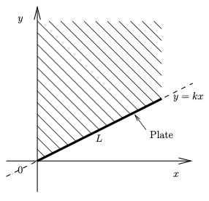
- Given that the velocity field is
$$u=αy+Ax+B, v=−Ay+Dx+C,$$
- what are $A$, $B$, $C$, $D$ in terms of $α$ and $k$? Simplify the velocity components $u$ and $v$. (Note that the fact that the coefficients on the terms $Ax$ in $u$ and $−Ay$ in $v$ are equal and opposite is required to ensure incompressibility of the fluid).
- Find the drag force on the plate.
- Hint.The drag force can be found by changing coordinates from $(x,y)$ to $(ξ,η)$, which are Cartesian coordinates where the $ξ$-axis runs along the plate and the $η$-axis goes from the plate perpendicularly into the fluid. You may use the fact that
$$i=cosθ\hat{ξ}−sinθ\hat{η}, j=sinθ\hat{ξ}+cosθ\hat{η},$$
- where $i$, $j$ are unit vectors in the $x$- and $y$-directions, respectively, and $\hat{ξ}$, $\hat{η}$ are unit vectors in the $ξ$- and $η$-directions, respectively, and $θ$ is the angle between the plate and the $x$-axis. You may use the fact that $cosθ=1/(\sqrt{1+k^{2}})$, $sinθ=k/(\sqrt{1+k^{2}})$ and
$$x=\frac{ξ}{\sqrt{1+k^{2}}}−\frac{kη}{\sqrt{1+k^{2}}}, y=\frac{kξ}{\sqrt{1+k^{2}}}+\frac{η}{\sqrt{1+k^{2}}}.$$
- In this part, find the drag force on the plate by using the stress tensor, and check your answer against the previous part.
In this problem, you will calculate the resultant force on the cube shown in Figure [fig-small-cube] due to the pressure in the surrounding fluid acting on the fluid within the cube. We will consider two different methods of calculating this force.
Note that, in this question, as with the derivation of the NavierStokes equations ([eqn-navierstokes]), you may use some sleight of hand, so as to avoid carefully integrating the force over the surface. However, as in that case, fortunately the errors cancel and the result is correct.
- Assuming that the pressure $p(x,y,z)$ is uniform over the surface $x=x_{0}$ and over the surface $x=x_{0}+δ$, calculate the force on the fluid in the cube due to the pressure of the surrounding fluid on these two faces and show that it is approximately
$$−δ^{3}\frac{∂p}{∂x}i=−V\frac{∂p}{∂x}i,$$
- where $V=δ^{3}$ is the volume of the cube.
- Similarly, calculate the force on the fluid in the cube due to the pressure of the surrounding fluid on the faces $y=y_{0}$ and $y=y_{0}+δ$, and on the faces $z=z_{0}$ and $z=z_{0}+δ$. Hence show that the total force on the fluid in the cube due to the pressure of the surrounding fluid is given by
$$−V\frac{∂p}{∂x}i−V\frac{∂p}{∂y}j−V\frac{∂p}{∂z}k=−V∇p.$$
- Check that you get the same result using the stress tensor of an inviscid fluid ([eq-inviscidstress]).
A viscous incompressible fluid flows steadily between two stationary rigid boundaries at $y=±h$ under a constant pressure gradient $P=−dp/dx$.
- Write down the boundary conditions to apply at each of the plates.
- The velocity is steady and therefore independent of $t$. Explain why it is also reasonable to assume that the velocity profile is independent of $x$ and $z$, and also that the $z$-component of the velocity is zero $w=0$.
- Use the continuity equation to show that the $y$-component of the velocity is also zero ($v=0$).
- Hence the only non-zero component of the velocity is the $x$-component, $u$, and this only depends on $y$, $u(y)$. Check that the profile
$$u=\frac{P}{2μ}\left(h^{2}−y^{2}\right)$$
- satisfies the boundary conditions.
- The velocity profile increases as $P$ increases and decreases as $μ$ increases. Explain why this is to be expected. Thus, although you cannot yet prove this is the correct velocity profile (you will soon be able to do so), this profile does look reasonable from what you already know.
- Calculate the three components of the stress vector, the force per unit area that the fluid exerts, on each of the two plates. You may assume that the pressure equals $p_{0}$ at $x=0$.
- Compare the stresses on the two plates. Why is this to be expected?
Based on Exercises 6.1 and 6.2 in [].
In this exercise, you will find an expression for force per unit volume acting on an incompressible Newtonian fluid. You will do this by finding the force acting on a small blob of the fluid as an integral over its volume. First you will find a new expression for the stress vector at the blob’s surface, which makes the rest of the calculation easier. with normal $\hat{n}$, and use this to find an expression for the force on a blob of fluid.
- Recall that $τ=σ⋅\hat{n}$ is the stress vector acting on a surface with normal $\hat{n}$, and this is given by
$$τ_{i}=−pn_{i}+μ\sum_{j=1}^{3}{n_{j}}\left(\frac{∂u_{i}}{∂x_{j}}+\frac{∂u_{j}}{∂x_{i}}\right).$$
- Show that this is identical to
$$τ=−p\hat{n}+μ\left[2(\hat{n}⋅∇)u+\hat{n}×(∇×u)\right].$$
- Hint.You may use the fact that
$$\hat{n}×\left(∇×u\right)=∇(\hat{n}⋅u)−(\hat{n}⋅∇)u,$$
- where, in the first bracket, the operator $∇$ acts on $u$ but not $n$.
- Hence show that the force on a blob of incompressible fluid of volume $V$ due to the surrounding fluid is given by
F=S​τdS=V​−∇p+μ∇2udV,
- where $S$ is the surface of the blob of fluid.
- Hint.Use the following vector calculus identities:
&S​ϕndS=V​−∇ϕdV,&S​F×ndS=−V​∇×FdV,&S​(n⋅∇)ϕdS=V​∇2ϕdV,&∇2F=∇(∇⋅F)−∇×(∇×F).
- Deduce that, if the blob is small, the net force on it per unit volume of fluid equals $−∇p+μ∇^{2}u$.
Based on Exercise 6.7 in [].
In this exercise, you will consider the general deformation of a fluid element in an incompressible Newtonian fluid. You will show that the deformation can be expressed as a combination of three types of motion: translation, rotation and pure strain.
Note that, if the fluid were also compressible, there would be a fourth type of motion, namely expansion or contraction.
- Let $P$ be a point in the fluid with position vector $x$, and let $Q$ be a nearby point with position vector $x+s$. Explain why the velocity at point $Q$ can be expressed in terms of that at point $P$ as
$$u_{Q}=u_{P}+(s⋅∇)u.$$
- Show that
$$u_{Q}=u_{P}+\frac{1}{2}(∇_{x}×u)×s+\frac{1}{2}∇_{s}(\sum_{i=1}^{3}{\sum_{j=1}^{3}{e_{ij}}}s_{i}s_{j}),$$
- where $∇_{x}$ denotes differentiation with respect to the components of $x$, $∇_{s}$ denotes differentiation with respect to the components of $s$, and
$$e_{ij}=\frac{1}{2}\left(\frac{∂u_{i}}{∂x_{j}}+\frac{∂u_{j}}{∂x_{i}}\right)$$
- You may use the fact that $(∇×f)×g=g⋅∇f−∇(g⋅f)$, where, in the second term on the right-hand side, the operator $∇$ acts on $f$ but not $g$
- Explain why the three terms on the right-hand side of the expression in the previous part represent translation, rotation and pure strain, respectively.
Based on Exercise 6.8 in [].
In this problem, you will apply the equation from the previous problem Exercise .8 to a shear flow $u=(βy,0,0)$.
- Use ([eq-pq]) to decompose $u$ into its local (i) translational, (ii) rotational, and (iii) pure straining components. For (iii), find the eigenvalues and eigenvectors, which give the principle directions of strain. Sketch each of the components (ii) and (iii).
- Note that this example is a special case in which the rotational and pure straining components are uniform over the fluid domain. More generally, both will vary.
In this problem, you will derive the Cauchy equation ([eqn-cauchy-equation]) for the conservation of linear momentum in an incompressible fluid that is not necessarily Newtonian (the NavierStokes equation only applies to Newtonian fluids).
- Consider a volume $V(t)$ moving with the fluid that, at the time $t$ is the small cube of fluid as shown in Figure [fig-small-cube], and apply the Reynolds Transport Theorem ([eqn-RTT]) to the fluid in this volume.
An incompressible Newtonian fluid with density $ρ$ and shear viscosity $μ$ flows in a space with a typical lengthscale $L$ and velocity scale $U$.
- Perform a nondimensionalisation of the NavierStokes ([eqn-navierstokes]) and continuity ([eqn-incompressibledef]) equations, using a scale $P$ for the pressure and $T$ for time, and writing the gravitational acceleration as $g=g\hat{g}$, where $\hat{g}$ is a unit vector in the direction of $g$.
- Choose a suitable timescale $T$ so that the inertial terms balance and multiply the NavierStokes equation by a suitable factor so that the nondimensional viscous term has coefficient 1. What do you notice about the coefficient of the inertial terms?
- Hence, in the case of a low-Reynolds-number flow, $Re≪1$, show that, to leading order, the equations simplify to one of the following three cases:
$$0=−∇p+ρg,$$
- or
$$0=−∇p+μ∇^{2}u+ρg, ∇⋅u=0,$$
- or
$$0=−∇p+μ∇^{2}u, ∇⋅u=0.$$
- Specify the conditions under which each of these equations is obtained. In the latter two cases, we term the equations governing the fluid velocity the Stokes equations.
- In the case of a high-Reynolds-number flow, $Re≫1$, show that, to leading order, the equations simplify to one of the following three cases:
$$0=−∇p+ρg,$$
- or
$$ρ\frac{Du}{Dt}=−∇p+ρg, ∇⋅u=0,$$
- or
$$ρ\frac{Du}{Dt}=−∇p, ∇⋅u=0.$$
- Specify the conditions under which each of these equations is obtained. In the latter two cases, we term the equations governing the fluid velocity the Euler equations.
In this exercise you will review the derivation of Poiseuille flow and prove the HagenPoiseuille formula ([hagen-poiseuille-formula]).
- Review the derivation Example [sec-poiseuille], making your own notes. Use the flow profile to prove the formula ([hagen-poiseuille-formula]).
A Newtonian incompressible fluid of density $ρ$ and shear viscosity $μ$ surrounds a circular cylinder of radius $a$. Working in cylindrical polar coordinates, the cylinder surface is at $r=a$.
The NavierStokes and continuity equations in cylindrical polar coordinates read:
$$\begin{aligned}&ρ\left(\frac{∂u_{r}}{∂t}+u_{r}\frac{∂u_{r}}{∂r}+\frac{u_{θ}}{r}\frac{∂u_{r}}{∂θ}+u_{z}\frac{∂u_{r}}{∂z}−\frac{u_{θ}^{2}}{r}\right) \\ =&−\frac{∂p}{∂r}+μ\left(∇^{2}u_{r}−\frac{u_{r}}{r^{2}}−\frac{2}{r^{2}}\frac{∂u_{θ}}{∂θ}\right), \\ &ρ\left(\frac{∂u_{θ}}{∂t}+u_{r}\frac{∂u_{θ}}{∂r}+\frac{u_{θ}}{r}\frac{∂u_{θ}}{∂θ}+u_{z}\frac{∂u_{θ}}{∂z}+\frac{u_{r}u_{θ}}{r}\right) \\ =&−\frac{1}{r}\frac{∂p}{∂θ}+μ\left(∇^{2}u_{θ}+\frac{2}{r^{2}}\frac{∂u_{r}}{∂θ}−\frac{u_{θ}}{r^{2}}\right), \\ &ρ\left(\frac{∂u_{z}}{∂t}+u_{r}\frac{∂u_{z}}{∂r}+\frac{u_{θ}}{r}\frac{∂u_{z}}{∂θ}+u_{z}\frac{∂u_{z}}{∂z}\right) \\ =&−\frac{∂p}{∂z}+μ∇^{2}u_{z}, \\ &\frac{1}{r}\frac{∂}{∂r}\left(ru_{r}\right)+\frac{1}{r}\frac{∂u_{θ}}{∂θ}+\frac{∂u_{z}}{∂z}=0,\end{aligned}$$
where the Laplacian is defined by its action on a function $A(r,θ,z)$:
$$∇^{2}A=\frac{1}{r}\frac{∂}{∂r}\left(r\frac{∂A}{∂r}\right)+\frac{1}{r^{2}}\frac{∂^{2}A}{∂θ^{2}}+\frac{∂^{2}A}{∂z^{2}},$$
- In the case that the surface of the cylinder is porous and there is a uniform suction inside it, which induces a steady flow into the cylinder with inflow velocity $U$ at the surface, you may assume that the flow is steady, two-dimensional and axisymmetric. With these assumptions, use the continuity equation to show that
$$u_{r}=−\frac{Ua}{r}.$$
- Show that the NavierStokes equations reduce to
$$\frac{∂p}{∂r}=\frac{ρa^{2}U^{2}}{r^{3}}.$$
- Solve this to find the pressure field, given that the far-field pressure is $p_{0}$.
In this exercise, you will derive the equations for flow in a circular pipe, driven by an oscillating pressure gradient
$$\frac{∂p}{∂z}=−G_{0}cosωt.$$
- In cylindrical polar coordinates $(r,θ,z)$ the continuity equation is
$$\frac{1}{r}\frac{∂(ru_{r})}{∂r}+\frac{1}{r}\frac{∂u_{θ}}{∂θ}+\frac{∂u_{z}}{∂z}=0,$$
- and the NavierStokes equations are
$$\begin{aligned}&ρ\left(\frac{∂u_{r}}{∂t}+u_{r}\frac{∂u_{r}}{∂r}+\frac{u_{θ}}{r}\frac{∂u_{r}}{∂θ}+u_{z}\frac{∂u_{r}}{∂z}−\frac{u_{θ}^{2}}{r}\right) \\ =&−\frac{∂p}{∂r}+μ\left(∇^{2}u_{r}−\frac{u_{r}}{r^{2}}−\frac{2}{r^{2}}\frac{∂u_{θ}}{∂θ}\right)+ρf_{r}, \\ &ρ\left(\frac{∂u_{θ}}{∂t}+u_{r}\frac{∂u_{θ}}{∂r}+\frac{u_{θ}}{r}\frac{∂u_{θ}}{∂θ}+u_{z}\frac{∂u_{θ}}{∂z}+\frac{u_{r}u_{θ}}{r}\right) \\ =&−\frac{1}{r}\frac{∂p}{∂θ}+μ\left(∇^{2}u_{θ}+\frac{2}{r^{2}}\frac{∂u_{r}}{∂θ}−\frac{u_{θ}}{r^{2}}\right)+ρf_{θ}, \\ &ρ\left(\frac{∂u_{z}}{∂t}+u_{r}\frac{∂u_{z}}{∂r}+\frac{u_{θ}}{r}\frac{∂u_{z}}{∂θ}+u_{z}\frac{∂u_{z}}{∂z}\right) \\ =&−\frac{∂p}{∂z}+μ∇^{2}u_{z}+ρf_{z},\end{aligned}$$
- where the Laplacian is defined by its action on a function $A(r,θ,z)$:
$$∇^{2}A=\frac{1}{r}\frac{∂}{∂r}\left(r\frac{∂A}{∂r}\right)+\frac{1}{r^{2}}\frac{∂^{2}A}{∂θ^{2}}+\frac{∂^{2}A}{∂z^{2}},$$
- and $f=(f_{r},f_{θ},f_{z})$ represents the body forces per unit mass acting on the fluid.
- Stating your assumptions, use the continuity equation to show that $u_{r}$ is everywhere zero.
- Simplify the NavierStokes equations, and use them to show that
$$u_{z}=U(r)e^{iωt}+c.c.,$$
- where
$$\frac{d^{2}U}{dr^{2}}+\frac{1}{r}\frac{dU}{dr}−\frac{iρω}{μ}U=−\frac{G_{0}}{2μ}.$$
- You may neglect gravity.
- Make the substitution $s=e^{−iπ/4}αr$, where $α=\sqrt{ρω/μ}$, to obtain the canonical form
$$\frac{d^{2}U}{ds^{2}}+\frac{1}{s}\frac{dU}{ds}+U=−\frac{iG_{0}}{2ρω}$$
- Find a particular integral to this equation, i.e. any solution that satisfies the inhomogeneous equation
- The complementary function can be written in terms of a special function of which you are probably not aware called a Bessel function. Regularity implies that we pick the Bessel functions of the the first kind, which are shown in Figure [fig-bessel-functions-first-kind].
- Examples of the solution for three different Womersley numbers are shown in Figure [fig-womersley-example-1], Figure [fig-womersley-example-10] and Figure [fig-womersley-example-100]. The solution for small Womersley numbers resembles the Poiseuille flow profile, while that for large Womersley numbers is plug (uniform) flow across the core of the pipe with boundary layers exhibiting rapid spatial oscillations.
- FigureWomersley flow profile for $α=1$.fig-womersley-example-1
- 0.250.50.25
- FigureWomersley flow profile for $α=10$.fig-womersley-example-10
- 0.250.50.25
- FigureWomersley flow profile for $α=100$.fig-womersley-example-100
- 0.250.50.25
A Newtonian incompressible fluid of density $ρ$ and shear viscosity $μ$ flows in three dimensions. In spherical polar coordinates $(r,θ,ϕ)$, the continuity equation is
$$\frac{1}{r^{2}}\frac{∂(r^{2}u_{r})}{∂r}+\frac{1}{rsinθ}\frac{∂(u_{θ}sinθ)}{∂θ}+\frac{1}{rsinθ}\frac{∂u_{ϕ}}{∂ϕ}=0,$$
and the NavierStokes equations are
$$\begin{matrix}ρ\left(\frac{∂u_{r}}{∂t}+u_{r}\frac{∂u_{r}}{∂r}+\frac{u_{θ}}{r}\frac{∂u_{r}}{∂θ}+\frac{u_{ϕ}}{rsinθ}\frac{∂u_{r}}{∂ϕ}−\frac{u_{ϕ}^{2}+u_{θ}^{2}}{r}\right)=−\frac{∂p}{∂r}+μ\left(∇^{2}u_{r}−\frac{2u_{r}}{r^{2}}−\frac{2}{r^{2}sinθ}\frac{∂}{∂θ}\left(u_{θ}sinθ\right)+\frac{2}{r^{2}sinθ}\frac{∂u_{ϕ}}{∂ϕ}\right)+ρf_{r}, \\ ρ\left(\frac{∂u_{θ}}{∂t}+u_{r}\frac{∂u_{θ}}{∂r}+\frac{u_{θ}}{r}\frac{∂u_{θ}}{∂θ}+\frac{u_{ϕ}}{rsinθ}\frac{∂u_{θ}}{∂ϕ}+\frac{u_{r}u_{θ}−u_{ϕ}^{2}cotθ}{r}\right)=−\frac{1}{r}\frac{∂p}{∂θ}+μ\left(∇^{2}u_{θ}−\frac{u_{θ}}{r^{2}\sin^{2}θ}+\frac{2}{r^{2}}\frac{∂u_{r}}{∂θ}−\frac{2cosθ}{r^{2}\sin^{2}θ}\frac{∂u_{ϕ}}{∂ϕ}\right)+ρf_{θ}, \\ ρ\left(\frac{∂u_{ϕ}}{∂t}+u_{r}\frac{∂u_{ϕ}}{∂r}+\frac{u_{θ}}{r}\frac{∂u_{ϕ}}{∂θ}+\frac{u_{ϕ}}{rsinθ}\frac{∂u_{ϕ}}{∂ϕ}+\frac{u_{r}u_{ϕ}+u_{ϕ}u_{θ}cotθ}{r}\right)=−\frac{1}{rsinθ}\frac{∂p}{∂ϕ}+μ\left(∇^{2}u_{ϕ}−\frac{u_{ϕ}}{r^{2}\sin^{2}θ}+\frac{2}{r^{2}sinθ}\frac{∂u_{r}}{∂ϕ}+\frac{2cosθ}{r^{2}\sin^{2}θ}\frac{∂u_{θ}}{∂ϕ}\right)+ρf_{ϕ},\end{matrix}$$
where the Laplacian is defined by its action on a function $A(r,θ,ϕ)$:
$$∇^{2}A=\frac{1}{r^{2}}\frac{∂}{∂r}\left(r^{2}\frac{∂A}{∂r}\right)+\frac{1}{r^{2}sinθ}\frac{∂}{∂θ}\left(sinθ\frac{∂A}{∂θ}\right)+\frac{1}{r^{2}\sin^{2}θ}\frac{∂^{2}A}{∂ϕ^{2}},$$
and $f=(f_{r},f_{θ},f_{ϕ})$ represents the body forces per unit mass acting on the fluid.
- A sphere of radius $a$ sits in an infinite vat of fluid of density $ρ$ and shear viscosity $μ$. The pressure is $p_{0}$ in the far field and the surface of the sphere is at a constant pressure $p_{1}$. Find the fluid pressure and velocity fields. You may neglect gravity.
- What is the volumetric flux of fluid leaving the sphere?
ExercisesProblems set 7 to hand inProblems set 7 to hand inch-viscousflows-12
Please hand in the problems in this Section for Set 7 (due in the week commencing 1 Dec).
It might help to try Exercise .6 before attempting this problem.
A viscous incompressible fluid flows steadily along an infinitely long pipe of radius $a$ under a constant pressure gradient $P=−dp/dz$. Work in cylindrical polar coordinates $(r,θ,z)$ with corresponding velocity components $(u_{r},u_{θ},u_{z})$ with the axis of the pipe aligned with $r=0$.
- Write down the boundary conditions to be applied.
- The velocity is steady and therefore independent of $t$. Explain why it is also reasonable to assume that the velocity profile is independent of $θ$ and $z$, and also that the $θ$-component of the velocity is zero.
- Use the continuity equation to show that the $r$-component of the velocity is also zero ($u_{r}=0$).
- In cylindrical polar coordinates, the continuity equation for an incompressible fluid is
$$\frac{1}{r}\frac{∂}{∂r}(ru_{r})+\frac{1}{r}\frac{∂u_{θ}}{∂θ}+\frac{∂u_{z}}{∂z}=0.$$
- Hence the only non-zero component of the velocity is the $z$-component, $u_{z}$, and this only depends on $r$, $u_{z}(r)$. Check that the profile
$$u_{z}=\frac{P}{4μ}\left(a^{2}−r^{2}\right)$$
- satisfies the boundary conditions.
- Note that we also need to check that the velocity is smooth at $r=0$. This is easier to see if we rewrite the velocity profile in Cartesian coordinates. Converting to Cartesian coordinates, the flow is $u=(0,0,u_{z})$ with
$$u_{z}=\frac{P}{4μ}\left(a^{2}−(x^{2}+y^{2})\right),$$
- which is smooth at $r=0$. Note, however, that for example the profile
$$u_{z}=\frac{P}{4μ}\left(a−r\right)$$
- would not be smooth at $r=0$.
- The velocity profile increases as $P$ increases and decreases as $μ$ increases. Explain why this is to be expected. Thus, although you cannot yet prove this is the correct velocity profile (you will soon be able to do so), this profile does look reasonable from what you already know.
- Calculate the three components of the stress vector, the force per unit area that the fluid exerts, on the inside of the pipe. You may assume that the pressure equals $p_{0}$ at $z=0$. You may also assume that the rate-of-strain tensor in cylindrical polar coordinates is given by ([eq-strainrate-cyl]), and that, being a Newtonian fluid, the stress tensor is given by ([eq-Newtonianstress-incompressible-vectorform]).
- You should have found that the normal stress is radially outward, while the shear stress points along the pipe in the direction of increasing $z$. Explain why you would expect these directions.
Based on Exercise 6.6 in [].
Consider an incompressible Newtonian fluid flowing with velocity $u=Ω×x$, where $Ω$ is a constant vector. Since $Ω$ is constant, for simplicity you may assume that $Ω=Ωk$.
- Calculate the velocity components in Cartesian coordinates in the case $Ω=Ωk$.
- Show that this flow is incompressible.
- Find the components of the stress tensor.
- Without doing a calculation, explain why you would have expected this answer.
Based on problem 2.8 in [].
An incompressible Newonian fluid fills $R^{3}$. An infinite solid cylinder of radius $a$ is placed in the fluid with its axis on the line $r=0$ in cylindrical polar coordinates.
- The cylinder rotates at constant angular velocity $Ω$ about its axis. In the resulting flow, explain why it is reasonable to assume that $p=p(r)$ and $u=(u_{r}(r),u_{θ}(r),0)$.
- Hence perform a calculation to show that $u_{r}=0$.
- You may use the continuity equation in cylindrical polar coordinates:
$$\frac{1}{r}\frac{∂}{∂r}(ru_{r})+\frac{1}{r}\frac{∂u_{θ}}{∂θ}+\frac{∂u_{z}}{∂z}=0.$$
- The NavierStokes equations in cylindrical polar coordinates are
$$\begin{aligned}&ρ\left(\frac{∂u_{r}}{∂t}+u_{r}\frac{∂u_{r}}{∂r}+\frac{u_{θ}}{r}\frac{∂u_{r}}{∂θ}+u_{z}\frac{∂u_{r}}{∂z}−\frac{u_{θ}^{2}}{r}\right) \\ =&−\frac{∂p}{∂r}+μ\left(∇^{2}u_{r}−\frac{u_{r}}{r^{2}}−\frac{2}{r^{2}}\frac{∂u_{θ}}{∂θ}\right)+ρf_{r}, \\ &ρ\left(\frac{∂u_{θ}}{∂t}+u_{r}\frac{∂u_{θ}}{∂r}+\frac{u_{θ}}{r}\frac{∂u_{θ}}{∂θ}+u_{z}\frac{∂u_{θ}}{∂z}+\frac{u_{r}u_{θ}}{r}\right) \\ =&−\frac{1}{r}\frac{∂p}{∂θ}+μ\left(∇^{2}u_{θ}+\frac{2}{r^{2}}\frac{∂u_{r}}{∂θ}−\frac{u_{θ}}{r^{2}}\right)+ρf_{θ}, \\ &ρ\left(\frac{∂u_{z}}{∂t}+u_{r}\frac{∂u_{z}}{∂r}+\frac{u_{θ}}{r}\frac{∂u_{z}}{∂θ}+u_{z}\frac{∂u_{z}}{∂z}\right) \\ =&−\frac{∂p}{∂z}+μ∇^{2}u_{z}+ρf_{z},\end{aligned}$$
- where the Laplacian is defined by its action on a function $A(r,θ,z)$:
$$∇^{2}A=\frac{1}{r}\frac{∂}{∂r}\left(r\frac{∂A}{∂r}\right)+\frac{1}{r^{2}}\frac{∂^{2}A}{∂θ^{2}}+\frac{∂^{2}A}{∂z^{2}},$$
- and $f=(f_{r},f_{θ},f_{z})$ represents the body forces per unit mass acting on the fluid, which you may neglect in this question.
- Show that the flow
$$u=\left(0,\frac{a^{2}Ω}{r},0\right)$$
- satisfies the NavierStokes equations and boundary conditions.
- If the fluid and cylinder are initially at rest, and the cylinder suddenly starts rotating with angular velocity $Ω$ at time $t=0$, explain qualitatively how you would expect the flow to evolve with time.
ExercisesProblems set 8 to hand inProblems set 8 to hand inproblems-set-8
Please hand in the problems in this Section for Set 8 (the final set of problems, due in the week commencing 8 Dec).
Warningproblems-set-8-2-2 We look to complete worksheets in the week prior to the content being delivered. Once this is done, this disclaimer message will be removed.
A tethered sphere of radius $a$ is surrounded by a flowing incompressible Newtonian fluid of density $ρ$ and shear viscosity $μ$. In the far field, the fluid velocity is uniform and equal to $U$ (right to left).
FigureFlow profiles of a sphere surrounded by a flowing fluid.problems-set-8-3-1-2
010 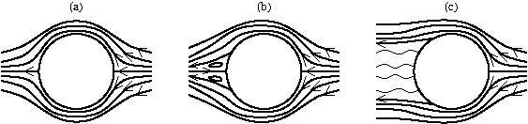
- Write down an expression for the Reynolds number $Re$ of the fluid.
- Describe what you can infer about the Reynolds number in each case (a), (b) and (c) from these pictures. Explain your reasoning.
A Newtonian viscous fluid flows steadily in the $+x$-direction in two dimensions between plates at $y=±d$. You may neglect gravity in this problem.
- Write down the boundary conditions at each plate.
- Make the assumption that the flow is fully developed and use the continuity equation to show that $v=0$ everywhere.
- Simplify the NavierStokes equations using the assumptions and $v=0$ to show that
$$μ\frac{∂^{2}u}{∂y^{2}}=−G,$$
- where $G$ is a constant that you should specify.
- Solve this applying the boundary conditions to find the flow profile.
- Find the stress exerted by the fluid on both plates. If each plates has (large) area $A$, what is the $x$-component of the tethering force required to keep each plate fixed in place?
A long cylindrical pipe with slowly varying radius $R(z)$ is aligned with its axis pointing in the $z$-direction. A much narrower cylinder of constant radius $a$ is placed coaxially within the larger cylinder. The narrow cylinder has porous walls and emits fluid at a constant velocity $U$ perpendicular to its surface. A fluid flows steadily in the gap between the two cylinders.
FigureWavy-walled pipe with inner cylinder that emits fluid.problems-set-8-5-2-2
0.20.60.2 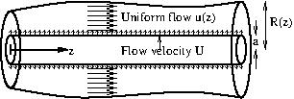
In this question, you will work in cylindrical polar coodinates $(r,θ,z)$, centred on the axis of the pipe.
Despite the fact that there is flow out from the inner cylinder in the radial direction, you may assume that the flow in the annular gap between the cylinders is unidirectional along the pipe in the $+z$-direction. (In reality there will be a thin layer next to the inner cylinder in which this is not true.) Furthermore, you may assume that the flow is uniform across the cross-section, that is $u=(u(z),0,0)$.
- Consider a narrow slice of the cylinder between $z$ and $z+dz$. Find an expression for the volumetric flux of fluid through the surfaces $z$ and $z+dz$.
- Now find an expression for the volumetric flux of fluid through the section of the inner cylinder between $z$ and $z+dz$.
- Now use the principle of mass conservation to show that
$$\frac{du}{dz}=\frac{2(aU−RR^{′}u)}{R^{2}−a^{2}}.$$
- Note that you can actually solve this equation by instead considering the volume between $z=0$ and $z=z_{0}$. This volume has four surfaces: the inner cylinder surface $r=a$, the outer cylinder surface $r=R(z)$, and the two cross-sectional surfaces at $z=0$ and $z=z_{0}$. The inner cylinder surface gives a volume flux in of $2πaUz_{0}$, the outer cylinder surface gives no volume flux, the surface $z=0$ gives a volume flux in of $π(R(0)^{2}−a^{2})u(0)$, and the surface $z=z_{0}$ gives a volume flux out of $π(R(z_{0})^{2}−a^{2})u(z_{0})$. Equating total volume flux in and volume flux out gives
$$2πaUz_{0}+π(R(0)^{2}−a^{2})u(0)=π(R(z_{0})^{2}−a^{2})u(z_{0}),$$
- and hence
$$u(z_{0})=\frac{2aUz_{0}+(R(0)^{2}−a^{2})u(0)}{R(z_{0})^{2}−a^{2}}.$$
- This is true for all $z_{0}$, hence (setting $z=z_{0}$)
$$u=\frac{2aUz+(R(0)^{2}−a^{2})u(0)}{R(z)^{2}−a^{2}}.$$
- This was not asked for in this question.
- Write down an expression for the Reynolds number of this flow, explaining your reasoning. You may assume that the pipe has length $L$ and that $R_{0}$ is a typical value of $R(z)$. Your answer should be in terms of the problem parameters $ρ$, $μ$, $a$, $U$, $L$ and $R_{0}$.
- State in a sentence the conditions under which it might be appropriate to assume that the velocity is uniform across the cross section. You do not need to do a calculation.
- In reality, in a sentence, what would you observe in the flow near the outer wall?
AppendixSolutionsSolutionssolutions
SectionKinematicsKinematicssolutions-kinematics
SolutionsSolutionsSolutionssolutions-kinematics-2
2.3Exercises
Exercise2.3.2Derivation of the material derivative.ex-material-derivative
This is the chain rule. Denote the three components of $x=(x_{1},x_{2},x_{3})$. Then we differentiate through both outer arguments of $f$:
$$\begin{aligned}\frac{∂f(x(X,t),t)}{∂t}|_{X}&=\frac{∂f}{∂t}|_{x}+\sum_{i=1}^{3}{\frac{∂x_{i}(X,t)}{∂t}}|_{X}\frac{∂f}{∂x_{i}}\end{aligned}$$
The factor,
$$\frac{∂x_{i}}{∂t}|_{X}=\frac{dx_{i}}{dt}≡u_{i},$$
corresponds to the velocity component in each direction. Then
$$\frac{∂f(x(X,t),t)}{∂t}|_{X}=\frac{∂f}{∂t}+u⋅∇f,$$
as desired.
Exercise2.3.3Eulerian and Lagrangian descriptions.ex-eulerian-lagrangian
A particle moves with the velocity of the fluid. Then it must satisfy the equations
$$\frac{dx}{dt}=−y(t), \frac{dy}{dt}=x(t) ⇒ \frac{d^{2}x}{dt^{2}}=−\frac{dy}{dt}=−x(t).$$
Trying solutions of the form $x(t)=e^{λt}$ gives $λ=±i$, so the general solution is
$$x(t)=Ae^{it}+Be^{−it},$$
or, equivalently,
$$x(t)=Ccost+Dsint,$$
where $C$ and $D$ are constants, and
$$y(t)=−\frac{dx}{dt}=Csint−Dcost.$$
Setting $x(0)=x_{0}$ and $y(0)=y_{0}$ gives $C=x_{0}$ and $D=−y_{0}$, so
$$x(t)=(x_{0}cost−y_{0}sint,x_{0}sint+y_{0}cost).$$
This is a circular path of radius $\sqrt{x_{0}^{2}+y_{0}^{2}}$ going anticlockwise around the origin. The velocity is
$$u(t)=(−x_{0}sint−y_{0}cost,x_{0}cost−y_{0}sint).$$
This flow is an example of rigid-body rotation, that is the fluid is moving with a velocity field that would be attainable for a rigid body, and there is no relative motion of the fluid particles.
Exercise2.3.4Eulerian and Lagrangian descriptions.ex-hw-eulerian-lagrangian2

$$\begin{aligned}a=&\frac{Du}{Dt} \\ =&\frac{∂u}{∂t}+(u⋅∇)u \\ =&0+\left(u\frac{∂u}{∂x}+v\frac{∂u}{∂y}+w\frac{∂u}{∂z}\right)e_{x}+\left(u\frac{∂v}{∂x}+v\frac{∂v}{∂y}+w\frac{∂v}{∂z}\right)e_{y}+\left(u\frac{∂w}{∂x}+v\frac{∂w}{∂y}+w\frac{∂w}{∂z}\right)e_{z} \\ =&u\frac{∂u}{∂x}e_{x} \\ =&U\left(1+\frac{x}{L}\right)\frac{U}{L}e_{x} \\ =&\frac{U^{2}}{L}\left(1+\frac{x}{L}\right)e_{x}\end{aligned}$$
- We have
$$\frac{dx}{dt}=u(x)=U\left(1+\frac{x}{L}\right).$$
- Solving by separation of variables gives,
$$\begin{aligned}&\int_{0}^{x}{\frac{dx}{1+x/L}}=\int_{0}^{t}{U} dt \\ ⇒ &Lln\left(1+\frac{x}{L}\right)=Ut \\ ⇒ &x(t)=L\left(e^{Ut/L}−1\right).\end{aligned}$$
- The velocity is
$$\begin{aligned}\frac{dx}{dt}=&\frac{d}{dt}\left(L\left(e^{Ut/L}−1\right)\right) \\ =&L\frac{U}{L}e^{Ut/L} \\ =&Ue^{Ut/L}.\end{aligned}$$
- The acceleration is
$$\begin{aligned}\frac{d^{2}x}{dt^{2}}=&\frac{d}{dt}\left(Ue^{Ut/L}\right) \\ =&\frac{U^{2}}{L}e^{Ut/L}.\end{aligned}$$
- The velocity is
$$Ue^{Ut/L}=U\left(1+\frac{x}{L}\right),$$
- as expected. This is the same as the Eulerian velocity at the particle position. The acceleration is
$$\begin{aligned}\frac{U^{2}}{L}e^{Ut/L}=&\frac{U^{2}}{L}\left(1+\frac{x}{L}\right),\end{aligned}$$
- which is the same as the particle acceleration, as expected from the definition.
- The particle reaches $x=L$ when
$$\begin{aligned}&L\left(e^{Ut/L}−1\right)=L \\ ⇒ &e^{Ut/L}=2 \\ ⇒ &t=\frac{L}{U}ln(2).\end{aligned}$$
Exercise2.3.5Particle paths and streamlines.ex-hw-particle-paths-streamlines
- Particle paths are the trajectories of individual fluid particles, which are found by solving the ODE
$$\frac{dx}{dt}=u(x,t).$$
- Streamlines are curves that are instantaneously tangent to the velocity field, and therefore satisfy
$$\frac{dx}{ds}=u(x,t),$$
- where $s$ is a parameter along the streamline. The two coincide if the flow is steady, i.e. $u(x,t)=u(x)$.

- FigurePathline, showing the particle positions at times $t$ and $t+dt$.lagrange-problem
- 0.10.80.1 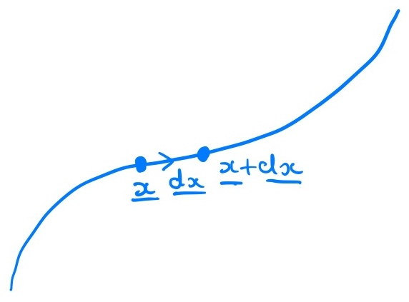
- Figure [lagrange-problem] shows the particle at $x=x(t)$ and at $x(t+dt)=x+dx$. Since the curve is a pathline, $dx=u(x,t) dt+O(dt^{2})$; in particular, $|dx|=O(dt)$, so all of the remainder terms in the Taylor series are $O(dt^{2})$. Following the value of $f$ along the pathline,
$$\begin{aligned}\frac{dF}{dt}&=\lim_{dt→0}\frac{1}{dt}\left(f(x+dx,t+dt)−f(x,t)\right) \\ &=\lim_{dt→0}\frac{1}{dt}\left(dx⋅∇f(x,t)+dt \frac{∂f}{∂t}(x,t)+O(dt^{2})\right) \\ &=\lim_{dt→0}\frac{1}{dt}\left(dt u(x,t)⋅∇f(x,t)+dt \frac{∂f}{∂t}(x,t)+O(dt^{2})\right) \\ &=\frac{∂f}{∂t}+u⋅∇f=\frac{Df}{Dt}.\end{aligned}$$
- The value of $f$ carried by the particle, $F(t)$, is constant for all $t$ if and only if $\frac{dF}{dt}=0$. Since this holds for every pathline, $f$ is preserved following the flow if and only if $\frac{Df}{Dt}=0$.
- The two points $x=x(s,t)$ and $x+dx=x(s+ds,t)$ lie on the same streamline at the same time, and could be sketched as in Figure [lagrange-problem], with the parameter $s$ in place of $t$. Since the curve is a streamline, $dx=u(x,t) ds+O(ds^{2})$, so $|dx|=O(ds)$. Following the value of $f$ along the streamline,
$$\begin{aligned}\frac{dG}{ds}&=\lim_{ds→0}\frac{1}{ds}\left(f(x+dx,t)−f(x,t)\right) \\ &=\lim_{ds→0}\frac{1}{ds}\left(dx⋅∇f(x,t)+O(ds^{2})\right) \\ &=\lim_{ds→0}\frac{1}{ds}\left(ds u(x,t)⋅∇f(x,t)+O(ds^{2})\right) \\ &=u⋅∇f.\end{aligned}$$
- Hence $G(s)$ is constant along the streamline if and only if $u⋅∇f=0$. Compared with the previous part, time is frozen here, so there is no $\frac{∂f}{∂t}$ term. If both the flow and $f$ are steady, then the streamlines and pathlines coincide (see the first part) and $\frac{Df}{Dt}=u⋅∇f$, so the two conditions are the same.
Exercise2.3.6Streamlines, pathlines and streaklines.ex-hw-streamlines-pathlines-streaklines
- The streamlines are given by
$$\frac{∂y}{∂x}=te^{−4x} ⇒ y=y_{0}−\frac{t}{4}e^{−4x},$$
- for any constant $y_{0}$. Different values of $y_{0}$ give different streamlines. See Figure [flowvisualisationproblem] for a sketch.
- FigureSketch of streamlines, pathline and streaklines.flowvisualisationproblem
- 010 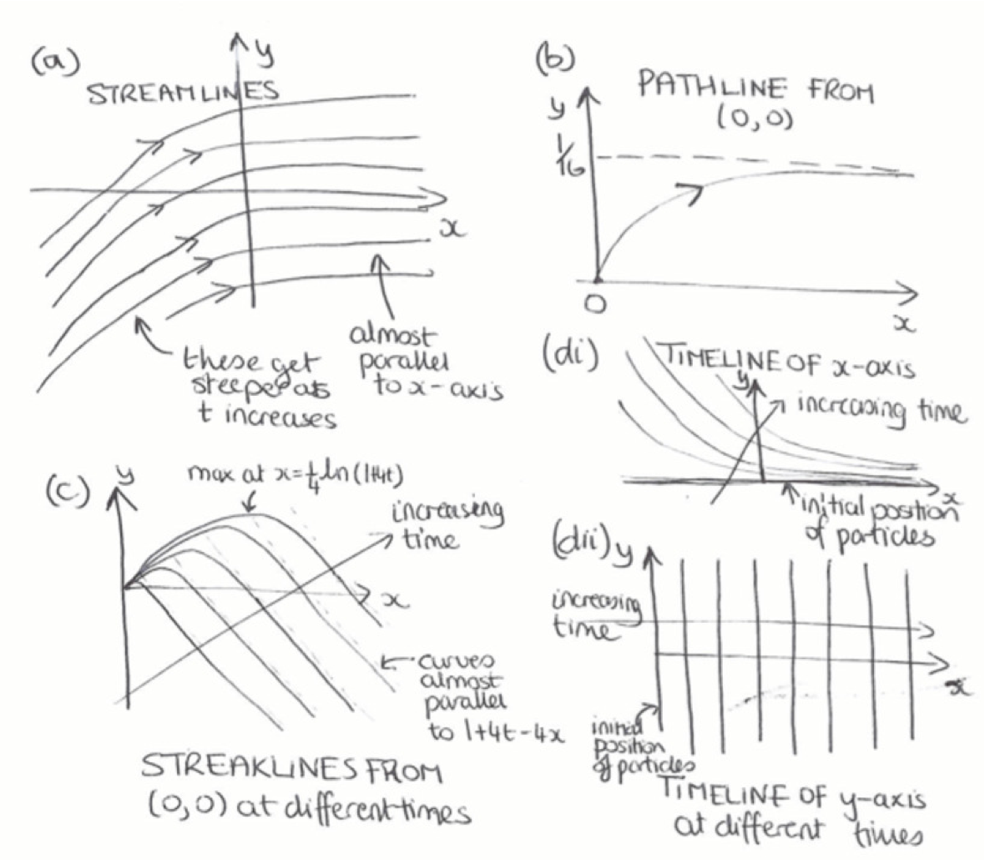
- The pathlines for a particle starting from $(x_{0},y_{0})$ are given by
$$\begin{aligned}&\frac{dx}{dt}=1, \frac{dy}{dt}=te^{−4x} \\ ⇒ &x=x_{0}+t, y=y_{0}+\frac{1}{16}e^{−4x_{0}}−\frac{1+4t}{16}e^{−4(x_{0}+t)}.\end{aligned}$$
- Eliminating $t$:
$$y=y_{0}+\frac{1}{16}e^{−4x_{0}}−\frac{1+4x−4x_{0}}{16}e^{−4x}.$$
- This is a general pathline. For the particular particle that starts from $(0,0)$:
$$y=1/{16}\left(1−(1+4x)e^{−4x}\right).$$
- See Figure [flowvisualisationproblem] for a sketch.
- Suppose the particle that started at $(x_{0},y_{0})$ hits the special point $(0,0)$ at time $t_{1}$. From the pathline equation:
$$0=x_{0}+t_{1}, 0=y_{0}+1/{16}e^{−4x_{0}}−{1+4t_{1}}/{16}e^{−4(x_{0}+t_{1})}.$$
- Solving for $x_{0}$ and $y_{0}$:
$$x_{0}=−t_{1}, y_{0}=−1/{16}\left(e^{4t_{1}}−1−4t_{1}\right).$$
- At time $t$ the particle is at:
$$x=t−t_{1}, y=1/{16}\left((1+4t_{1})−(1+4t)e^{−4(t−t_{1})}\right).$$
- Eliminating $t_{1}$ gives the streakline at time $t$:
$$y=1/{16}\left((1+4t)(1−e^{−4x})−4x\right).$$
- See Figure [flowvisualisationproblem] for a sketch. Note that the streamlines, pathlines and streaklines are all very different.
- From the pathline equation, a particle starting from $(x_{0},0)$ reaches
$$x=x_{0}+t, y=1/{16}e^{−4x_{0}}−{1+4t}/{16}e^{−4(x_{0}+t)}$$
- at time $t$. Eliminating $x_{0}$ gives the timeline:
$$y=1/{16}\left(e^{4t}−1−4t\right)e^{−4x}.$$
- See Figure [flowvisualisationproblem] for a sketch.
- From the pathline equation, a particle starting from $(0,y_{0})$ reaches
$$x=t, y=y_{0}+1/{16}−{1+4t}/{16}e^{−4t}$$
- at time $t$. Since $y_{0}$ can take any value, the timeline is just the line $x=t$. See Figure [flowvisualisationproblem] for a sketch.
SectionEquations of motionEquations of motionsolutions-equations
SolutionsSolutionsSolutionssolutions-equations-2
3.6Exercises
Exercise3.6.1Bump lemma.ex-bump
This proof assumes that the function $f$ is not pathological (e.g. it cannot oscillate infinitely fast, take different values for rational vs. irrational, etc.). That’s what we mean by "sufficiently smooth".
Assume that there exists a point $x_{0}∈Ω$ where $f(x_{0})≠0$. Suppose without loss of generality $f>0$ here. Since $f$ is sufficiently smooth (and in particular, it is continuous), then there exists a non-trivial neighbourhood of $x_{0}$, say $V_{0}$, where $f>0$ everywhere. Then V0​f dV>0, contradicting the assumption. Therefore $f$ must be zero everywhere.
Exercise3.6.2Leibniz’s rule.ex-hw-leibnitz-rule
- The first circled element is associated with the quantity:
$$\frac{1}{Δt}\int_{a(t)}^{b(t)}{[}f(x,t+Δt)−f(x,t)] dx.$$
- This is essentially the finite-difference version of the first term on the RHS.
- The second circled element is associated with the quantity:
$$−f(a(t),t)[a(t+Δt)−a(t)]\frac{1}{Δt}.$$
- This is the area of the left-hand (blue) rectangle, which is lost from the integral as the lower limit moves to the right, hence the minus sign.
- The third circled element is associated with
$$f(b(t),t+Δt)[b(t+Δt)−b(t)]\frac{1}{Δt}.$$
- This is the area of the right-hand (pink) rectangle, which is gained as the upper limit moves to the right. Notice that for small $Δt$, the rectangle height $f(b,t+Δt)$ is approximately $f(b,t)$.
- Let $I(t)=\int_{a(t)}^{b(t)}{f}(x,t) dx$. Splitting the range of integration,
$$\begin{aligned}I(t+Δt)&=\int_{a(t+Δt)}^{b(t+Δt)}{f}(x,t+Δt) dx \\ &=\int_{a(t)}^{b(t)}{f}(x,t+Δt) dx+\int_{b(t)}^{b(t+Δt)}{f}(x,t+Δt) dx \\ & −\int_{a(t)}^{a(t+Δt)}{f}(x,t+Δt) dx.\end{aligned}$$
- Subtracting $I(t)$ and dividing by $Δt$ gives
$$\begin{aligned}\frac{I(t+Δt)−I(t)}{Δt}&=\int_{a(t)}^{b(t)}{\frac{f(x,t+Δt)−f(x,t)}{Δt}} dx \\ & +\frac{1}{Δt}\int_{b(t)}^{b(t+Δt)}{f}(x,t+Δt) dx \\ & −\frac{1}{Δt}\int_{a(t)}^{a(t+Δt)}{f}(x,t+Δt) dx.\end{aligned}$$
- These three terms correspond to the circled regions 1, 3 and 2 of Figure [ex-fig-leibnitz] respectively. We take the limit $Δt→0$ in each.
- First term. For small $Δt$, the integrand is the difference quotient of $f$ in time, which is approximately $\frac{∂f}{∂t}$. Since $\frac{∂f}{∂t}$ is continuous, this approximation improves uniformly across the interval as $Δt→0$, and the first term tends to
$$\int_{a(t)}^{b(t)}{\frac{∂f}{∂t}} dx.$$
- Second term. For small $Δt$, the interval from $b(t)$ to $b(t+Δt)$ is narrow, with width approximately $\dot{b} Δt$, and across it $f(x,t+Δt)$ is close to $f(b(t),t)$. We may therefore approximate the integral by the area of a single rectangle (a one-term Riemann sum):
$$\frac{1}{Δt}\int_{b(t)}^{b(t+Δt)}{f}(x,t+Δt) dx≈f(b(t),t) \frac{b(t+Δt)−b(t)}{Δt}.$$
- Since $f$ is continuous, the error in this approximation is small compared with $Δt$, and so disappears in the limit. The term therefore tends to $f(b(t),t) \dot{b}(t)$.
- Third term. In the same way, this tends to $−f(a(t),t) \dot{a}(t)$.
- Adding the three limits gives Leibniz’s rule ([eqn-leibnitz-rule]).
- In one dimension, with $a(t)$ and $b(t)$ moving with the fluid (so $\dot{a}=u(a,t)$ and $\dot{b}=u(b,t)$), Reynolds’ Transport Theorem reads
$$\frac{d}{dt}\int_{a(t)}^{b(t)}{f} dx=\int_{a(t)}^{b(t)}{\left[\frac{∂f}{∂t}+\frac{∂}{∂x}(fu)\right]}dx.$$
- Integrating the second term gives
$$f(b,t)u(b,t)−f(a,t)u(a,t)=f(b,t)\dot{b}−f(a,t)\dot{a},$$
- which are exactly the second and third terms of Leibniz’s rule.
Exercise3.6.3Derivation of governing equations.ex-hw-euler-check
The proof of the continuity equation is given in Theorem [thm-mass] and the proof of the momentum equation is given in Theorem [thm-momentum], so make sure you can follow these arguments and produce your own notes.
The derivation of the Euler equations, as given in Definition [def-euler] requires the additional assumption of an incompressible fluid of constant density, following Theorem [def-incompressible]. Incompressibility implies that $∇⋅u=0$, and this equation then replaces the continuity equation.
Exercise3.6.4Pressure field in uniform flow.ex-hw-fluid-pressure-uniform-velocity
- The fluid has a uniform velocity, which means that all components of $∇u$ vanish. The Euler equation simplifies to
$$ρ\frac{∂u}{∂t}=−∇p−ρgk,$$
- where
$$\frac{∂u}{∂t}=(b, 3t^{2}, e^{t}).$$
- Hence, the pressure is given by solving the equation,
$$∇p=−ρ\frac{∂u}{∂t}−ρgk=−ρ( b, 3t^{2}, e^{t}+g ),$$
- which is a vector equation. Splitting into components, we obtain
$$\frac{∂p}{∂x}=−ρb, \frac{∂p}{∂y}=−3ρt^{2}, \frac{∂p}{∂z}=−ρ(e^{t}+g).$$
- Solving sequentially, the first equation gives
$$p=−ρbx+f_{1}(y,z,t).$$
- Substituting into the second equation,
$$\frac{∂f_{1}}{∂y}=−3ρt^{2} ⇒ f_{1}=−3ρt^{2}y+f_{2}(z,t),$$
$$p=−ρbx−3ρt^{2}y+f_{2}(z,t).$$
- The third equation then implies
$$\frac{∂f_{2}}{∂z}=−ρ(e^{t}+g) ⇒ f_{2}=−ρ(e^{t}+g)z+f_{3}(t),$$
$$p=−ρbx−3ρt^{2}y−ρ(e^{t}+g)z+f_{3}(t).$$
- Using $p=p_{0}$ at the origin gives $f_{3}(t)=p_{0}$ for all $t$. Hence
$$p=p_{0}−ρ\left(bx+3t^{2}y+(e^{t}+g)z\right).$$
- The pressure is constant on parallel planes normal to the vector $(b, 3t^{2}, e^{t}+g)$, as illustrated below:
- FigureContours of the pressure field at fixed $t$.fig-pressure-contours
- 010 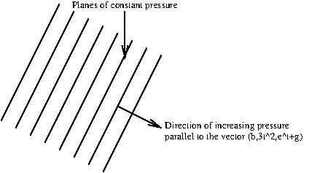
Exercise3.6.5Piston problem.ex-hw-piston-fluid-problem
We assume that the fluid pressure at the open end of the pipe is atmospheric pressure. Since the fluid moves as a rigid body, the velocity field has no spatial gradients, and hence the Euler equation reduces to
$$ρ\frac{∂u}{∂t}=−∇p,$$
where the velocity is uniformly $u=(\dot{X}(t),0)$.
Solving for $p$ and using the fact that $p$ is atmospheric pressure at $x=L$, we have
$$p(x,t)=ρ\frac{d^{2}X}{dt^{2}}(L−x)+p_{\text{atm}}.$$
At the piston $x=X$, note that atmospheric pressure applies in addition to $F$, meaning that the force on the fluid is
$$F+Ap_{\text{atm}},$$
and hence the fluid pressure is
$$\frac{F}{A}+p_{\text{atm}}.$$
Then
$$\frac{F}{A}+p_{\text{atm}}=ρ\frac{d^{2}X}{dt^{2}}(L−X)+p_{\text{atm}} ⇒ \frac{d^{2}X}{dt^{2}}=\frac{F}{Aρ(L−X)}.$$
Note that the atmospheric pressure cancels in this problem, and this is common to problems of this type, because atmospheric pressure acts uniformly on all surfaces exposed to the atmosphere and therefore does not lead to a resultant force or affect the dynamics. This motivates the introduction of a gauge pressure, $p_{\text{gauge}}$, whereby a uniform and constant baseline pressure is chosen, in this case $p_{\text{atm}}$, with the gauge pressure given by $p_{\text{gauge}}=p−p_{\text{atm}}$. Since the pressure only appears as a gradient in the governing equations, using the gauge pressure does not affect the result. Introducing a gauge pressure can make the algebra simpler.
Exercise3.6.6Using streamlines: The clepsydra.ex-bernoulli-streamline
- The fluid velocity at the surface of the jar satisfies $u⋅n=0$, so that no fluid leaves or enters the jar through its sides. This means that the flow next to the boundary of the jar must be parallel to this boundary, meaning that streamlines are parallel to the boundary. Equivalently, the boundary $r=a(z)$ is a streamline.
- We apply Bernoulli’s equation to equate the energy at a point at the edge of the free surface at $z=h(t)$ and the fluid leaving the hole at $z=0$. At the free surface, the pressure is atmospheric, $p=p_{\text{atm}}$, and the speed is $u_{S}\sqrt{1+a^{′2}}$. At the hole, the pressure is also atmospheric, $p=p_{\text{atm}}$, and the velocity is $u$. Thus, Bernoulli’s equation for the streamline joining the two points gives
$$\frac{p_{\text{atm}}}{ρ}+\frac{1}{2}u_{S}^{2}(1+a^{′2})+gh=\frac{p_{\text{atm}}}{ρ}+\frac{1}{2}u^{2}.$$
- Assuming that $u_{S}≪u$, this simplifies to
$$gh=\frac{1}{2}u^{2}.$$
- The volume flux out of the hole is $πa_{h}^{2}u$, while the rate of decrease of the volume of fluid in the jar is $πa(h(t))^{2}u_{S}$. Conservation of mass therefore gives
$$πa^{2}u_{S}=πa_{h}^{2}u,$$
- or
$$u_{S}=\frac{a_{h}^{2}}{a^{2}}u.$$
- Using the result from part (b) to eliminate $u$ gives
$$u_{S}=\frac{a_{h}^{2}}{a^{2}}\sqrt{2gh}.$$
- We require $u_{S}$ to be independent of time so that equally spaced intervals are traversed in equal times. Hence,
$$a={\left(\frac{a_{h}^{2}\sqrt{2g}}{u_{S}}\right)}^{1/2}h^{1/4}.$$
- The terms in the brackets are constant, so we have that the radius of the jar must vary as the fourth root of the height.
Exercise3.6.7Verifying Reynolds’ Transport Theorem.ex-rtt-stretching-cube
- Integrating over $V(t)$,
$$\begin{aligned}I(t)&=\int_{0}^{1}{\int_{0}^{e^{−t/2}}{\int_{0}^{e^{t}}{(}}}x^{2}+y) dx dy dz \\ &=\underset{x^{2}\text{ term}}{\underset{⏟}{\frac{e^{3t}}{3}⋅e^{−t/2}}}+\underset{y\text{ term}}{\underset{⏟}{e^{t}⋅\frac{e^{−t}}{2}}}=\frac{1}{3}e^{5t/2}+\frac{1}{2}.\end{aligned}$$
- Therefore
$$\frac{dI}{dt}=\frac{5}{6}e^{5t/2}.$$
- Here $\frac{∂f}{∂t}=0$ and
$$fu=\left((x^{2}+y)x, −1/2(x^{2}+y)y, 0\right),$$
- so
$$∇⋅(fu)=(3x^{2}+y)−1/2(x^{2}+2y)=5/2x^{2}.$$
- Hence
V(t)​∂f∂t+∇⋅(fu)dx dy dz&=52010e−t/20etx2 dx dy dz&=52⋅e3t3⋅e−t/2=56e5t/2,
- in agreement with the previous part.
- As a check, we can also follow the Lagrangian route used in the proof of Theorem [thm-RTT]. Mapping back to the fixed cube $V(0)$,
I(t)&=V(0)​fx(X,t) J dX dY dZ&=010101X2e2t+Ye−t/2et/2 dX dY dZ&=13e5t/2+12,
- which is now an integral over a fixed domain, so the time derivative can be taken inside the integral.
Exercise3.6.8Measuring airspeed with a Pitot tube.ex-bernoulli-pitot
- The tube is sealed at its far end by the water in the manometer, so once the water has settled, no air flows into the tube. The air arriving at the tip must therefore come to rest there: the tip is a stagnation point.
- The flow is steady and inviscid, so Theorem [thm-bernoulli-steady] applies along the streamline that runs from far upstream to the tip. Far upstream the pressure is $p_{∞}$ and the speed is $U$; at the tip the pressure is $p_{0}$ and the speed is zero. Changes in height along the streamline are small, so the gravity terms cancel. Hence
$$\frac{p_{∞}}{ρ_{\text{air}}}+\frac{1}{2}U^{2}=\frac{p_{0}}{ρ_{\text{air}}},$$
- which gives
$$p_{0}=p_{∞}+\frac{1}{2}ρ_{\text{air}}U^{2}.$$
- The pressure $p_{0}$ is called the stagnation pressure.
- The water is at rest, so from Example [ex-bernoulli-hydrostatics] the quantity $p+ρ_{w}gz$ is the same everywhere in the water. The water surface in the arm connected to the Pitot tube is at $z=h_{1}$, where the pressure is $p_{0}$, and the surface in the open arm is at $z=h_{2}$, where the pressure is $p_{∞}$. Then
$$p_{0}+ρ_{w}gh_{1}=p_{∞}+ρ_{w}gh_{2},$$
- so that $p_{0}−p_{∞}=ρ_{w}g(h_{2}−h_{1})=ρ_{w}gΔh$.
- Combining the two previous parts,
$$\frac{1}{2}ρ_{\text{air}}U^{2}=p_{0}−p_{∞}=ρ_{w}gΔh,$$
- and so
$$U=\sqrt{\frac{2ρ_{w}gΔh}{ρ_{\text{air}}}}.$$
- With the given values, $Δh=0.75−0.25=0.5$ m, so
$$p_{0}−p_{∞}=1000×10×0.5=5000\text{ Pa}, U^{2}=\frac{2×5000}{1}={10}^{4}{\text{ m}}^{2}/{\text{s}}^{2},$$
- so $U=100$ m/s, or $360$ km/h. This is roughly the take-off speed of a passenger jet.
SectionPotential flowsPotential flowssolutions-potentialflows
SolutionsSolutionsSolutionssolutions-potentialflows-2
4.7Exercises

Potential flows, part 1.
Exercise4.7.1Basic calculations.ex-hw-streamfunction-flux-compute
- (i) From Example [example-potential-uniform] and Subsection [subsec-complex-examples], with $α=π/4$,
$$f(z)=Ue^{−iα}z=Ue^{−iπ/4}z.$$
- (ii) The complex velocity is $f^{′}(z)=u−iv=Ue^{−iπ/4}$, so
$$u=U\left[cos(π/4), sin(π/4)\right]=\frac{U}{\sqrt{2}}[1,1].$$
- (iii) We expect the flux through the circle to be zero, since as much fluid enters one side as leaves the other. With $n=[cosθ,sinθ]$ and $ds=dθ$,
r=1​u⋅n ds=U202π(cosθ+sinθ) dθ=0.
- (iv) Parametrising the plate by $r(t)=[t,1−t]$, $0≤t≤1$, the tangent is $r^{′}(t)=[1,−1]$, so the unit normal pointing away from the origin is
$$n=\frac{[1,1]}{\sqrt{2}},$$
- and $ds=|r^{′}(t)| dt=\sqrt{2} dt$. The flux is then
$$\int_{0}^{1}{\frac{U}{\sqrt{2}}}[1,1]⋅\frac{[1,1]}{\sqrt{2}} \sqrt{2} dt=\sqrt{2} U.$$
- This makes sense: the flow is everywhere normal to the plate, with speed $U$, and the plate has length $\sqrt{2}$.
- (i) From ([eqn-complex-linesource]),
$$f(z)=\frac{Q}{2π}logz.$$
- (ii) The complex velocity is
$$\begin{aligned}u−iv=f^{′}(z)&=\frac{Q}{2πz}=\frac{Q}{2πr}e^{−iθ} \\ &=\frac{Q}{2πr}(cosθ−isinθ),\end{aligned}$$
- so
$$u=\frac{Q}{2πr}[cosθ,sinθ]=\frac{Q}{2π}\frac{[x,y]}{x^{2}+y^{2}}.$$
- (iii) On the unit circle, $r=1$, $n=[cosθ,sinθ]$ and $ds=dθ$, so
r=1​u⋅n ds&=02πQ2π[cosθ,sinθ]⋅[cosθ,sinθ] dθ&=Q2π02πdθ=Q.
- This is the definition of the source strength: all of the fluid produced at the origin crosses the circle.
- (iv) As in part (a), parametrise the plate by $r(t)=[t,1−t]$, $0≤t≤1$, with $n=[1,1]/\sqrt{2}$ and $ds=\sqrt{2} dt$. On the plate, $x=t$ and $y=1−t$, so $x+y=1$ and $x^{2}+y^{2}=t^{2}+(1−t)^{2}$. Hence
$$\begin{aligned}\text{flux}&=\int_{0}^{1}{\frac{Q}{2π}}\frac{[x,y]}{x^{2}+y^{2}}⋅\frac{[1,1]}{\sqrt{2}} \sqrt{2} dt \\ &=\frac{Q}{2π}\int_{0}^{1}{\frac{x+y}{x^{2}+y^{2}}} dt \\ &=\frac{Q}{2π}\int_{0}^{1}{\frac{dt}{t^{2}+(1−t)^{2}}} \\ &=\frac{Q}{2π}⋅\frac{π}{2}=\frac{Q}{4}.\end{aligned}$$
- This makes sense: the source sends fluid out equally in all directions, and the plate spans a quarter of the directions seen from the origin (from $θ=0$ to $θ=π/2$), so it receives a quarter of the flux. In Exercise .2, you will see that this follows immediately from the streamfunction, $ψ=Qθ/(2π)$.
- (i) From Subsection [subsec-complex-examples],
$$f(z)=\frac{z^{2}}{2}.$$
- (ii) The complex velocity is $f^{′}(z)=z=x+iy=u−iv$, so
$$u=[x,−y].$$
- (iii) On the unit circle, $[x,y]=[cosθ,sinθ]$, $n=[cosθ,sinθ]$ and $ds=dθ$, so
r=1​u⋅n ds&=02π[cosθ,−sinθ]⋅[cosθ,sinθ] dθ&=02π(cos2θ−sin2θ) dθ=02πcos2θ dθ=0.
- Fluid enters the circle near the $y$-axis and leaves near the $x$-axis, with no net flux.
- (iv) As in part (a), parametrise the plate by $r(t)=[t,1−t]$, $0≤t≤1$, with $n=[1,1]/\sqrt{2}$ and $ds=\sqrt{2} dt$. On the plate, $u=[t,−(1−t)]$, so
$$\begin{aligned}\text{flux}&=\int_{0}^{1}{[}t,−(1−t)]⋅\frac{[1,1]}{\sqrt{2}} \sqrt{2} dt \\ &=\int_{0}^{1}{(}2t−1) dt=[t^{2}−t]_{0}^{1}=0.\end{aligned}$$
- This is consistent with Theorem [thm-flux-streamlines]: the streamfunction $ψ=xy$ is zero at both ends of the plate, $(0,1)$ and $(1,0)$.
- (i) From ([eq-line-vortex-complex-potential]),
$$f(z)=−\frac{iΓ}{2π}logz.$$
- (ii) The complex velocity is
$$\begin{aligned}u−iv=f^{′}(z)&=−\frac{iΓ}{2πz}=−\frac{iΓ}{2πr}(cosθ−isinθ) \\ &=\frac{Γ}{2πr}(−sinθ−icosθ),\end{aligned}$$
- so
$$u=\frac{Γ}{2πr}[−sinθ,cosθ]=\frac{Γ}{2π}\frac{[−y,x]}{x^{2}+y^{2}}.$$
- (iii) On the unit circle, $n=[cosθ,sinθ]$ and $ds=dθ$, so
r=1​u⋅n ds&=Γ2π02π[−sinθ,cosθ]⋅[cosθ,sinθ] dθ&=0.
- The integrand is zero: the flow is everywhere tangent to the circle, so no fluid crosses it.
- (iv) As in part (a), parametrise the plate by $r(t)=[t,1−t]$, $0≤t≤1$, with $n=[1,1]/\sqrt{2}$ and $ds=\sqrt{2} dt$. On the plate, $−y+x=2t−1$ and $x^{2}+y^{2}=t^{2}+(1−t)^{2}$, so
$$\begin{aligned}\text{flux}&=\int_{0}^{1}{\frac{Γ}{2π}}\frac{[−y,x]}{x^{2}+y^{2}}⋅\frac{[1,1]}{\sqrt{2}} \sqrt{2} dt \\ &=\frac{Γ}{2π}\int_{0}^{1}{\frac{2t−1}{t^{2}+(1−t)^{2}}} dt.\end{aligned}$$
- The denominator is $2t^{2}−2t+1$, whose derivative is $2(2t−1)$, so
$$\text{flux}=\frac{Γ}{4π}[log(2t^{2}−2t+1)]_{0}^{1}=\frac{Γ}{4π}(log1−log1)=0.$$
- Alternatively, under $t↦1−t$ the numerator changes sign while the denominator is unchanged, so the integral is zero. This is consistent with Theorem [thm-flux-streamlines]: the streamfunction $ψ=−(Γ/2π)logr$ takes the same value at both ends of the plate, which are both at distance $r=1$ from the origin.
Exercise4.7.2Evaluation of the flux.ex-hw-potential-fluxcalc
This is a nice question to do because there is a simple recipe. For each of the complex potentials in the previous question, find the imaginary part to obtain the streamfunction. Then evaluate the difference in streamfunction values at the start and end values of the desired curve.
For uniform flow, $ψ(r,θ)=Ursin(θ−α)|$. For the case of a circle, the flux is:
$$|ψ(1,2π)−ψ(1,0)|=0.$$
For the case of a plate,
$$|ψ(1,0)−ψ(1,π/2)|=U|sin(−π/4)−sin(π/4)|=\sqrt{2}U.$$
For source flow, $ψ=(Q/2π)θ$ once you convert the logarithm into its real and complex parts. Then for the circle:
$$|ψ(1,2π)−ψ(1,0)|=Q.$$
For the case of the plate,
$$|ψ(1,0)−ψ(1,π/2)|=\frac{Q}{4}.$$
(Actually calculating the above might convince you the route of calculating flux by integrals is possible!).
For the stagnation point, $ψ=(r^{2}/2)sin2θ$. For the circle,
$$|ψ(1,2π)−ψ(1,0)|=0.$$
For the case of the plate,
$$|ψ(1,0)−ψ(1,π/2)|=0.$$
For the case of the line vortex, $ψ=−Γ/(2π)logr$, and for the circle,
$$|ψ(1,2π)−ψ(1,0)|=0,$$
while for the plate,
$$|ψ(1,0)−ψ(1,π/2)|=0.$$
Exercise4.7.3Doublet.ws-potentialflows-2-5
- The complex potential is the sum of a line source and line sink:
$$f(z)=\frac{Q}{2π}[log(z−a)−log(z+a)].$$
- Therefore the complex velocity is given by
$$f^{′}(z)=\frac{Q}{2π}\left[\frac{1}{z−a}−\frac{1}{z+a}\right].$$
- Stagnation points are where $f^{′}(z)=0$. There are no stagnation points. The streamfunction is given by
$$Imf=\frac{Q}{2π}(θ_{1}−θ_{2}),$$
- where $θ_{1}$ and $θ_{2}$ are angles measured relative to the positions about $±a$. Thus,
$$θ_{1,2}=\tan^{−1}\left(\frac{y}{x∓a}\right).$$
- The streamlines are given where $ψ$ is constant. The streamlines are shown below.
- FigureStreamlines for a sink and sourcews-potentialflows-2-5-3-2-2
- 010 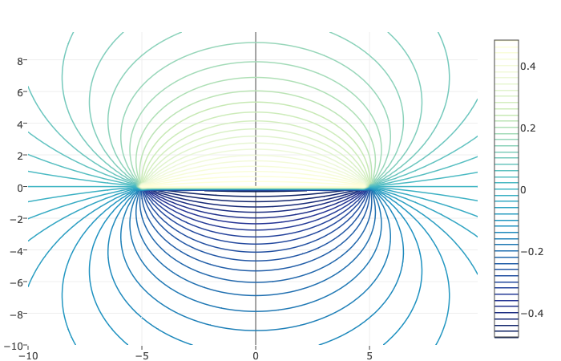
- Expanding the logarithms for small $a$ gives
$$logz−logz+log(1−a/z)−log(1+a/z)∼−\frac{2a}{z}.$$
- Thus in the limit $a→0$, we have
$$f(z)∼−\frac{Qa}{π}\frac{1}{z}.$$
- Therefore, we let both $a→0$ and $Q→∞$ in a fashion such that $m=aQ$ is fixed. We then have the potential
$$f(z)=\frac{μ}{z}$$
- where $μ=−Qa/π.$

Potential flows, part 2.
Exercise4.7.4Single source in a semi-infinite flow.ex-hw-image-planar01

010 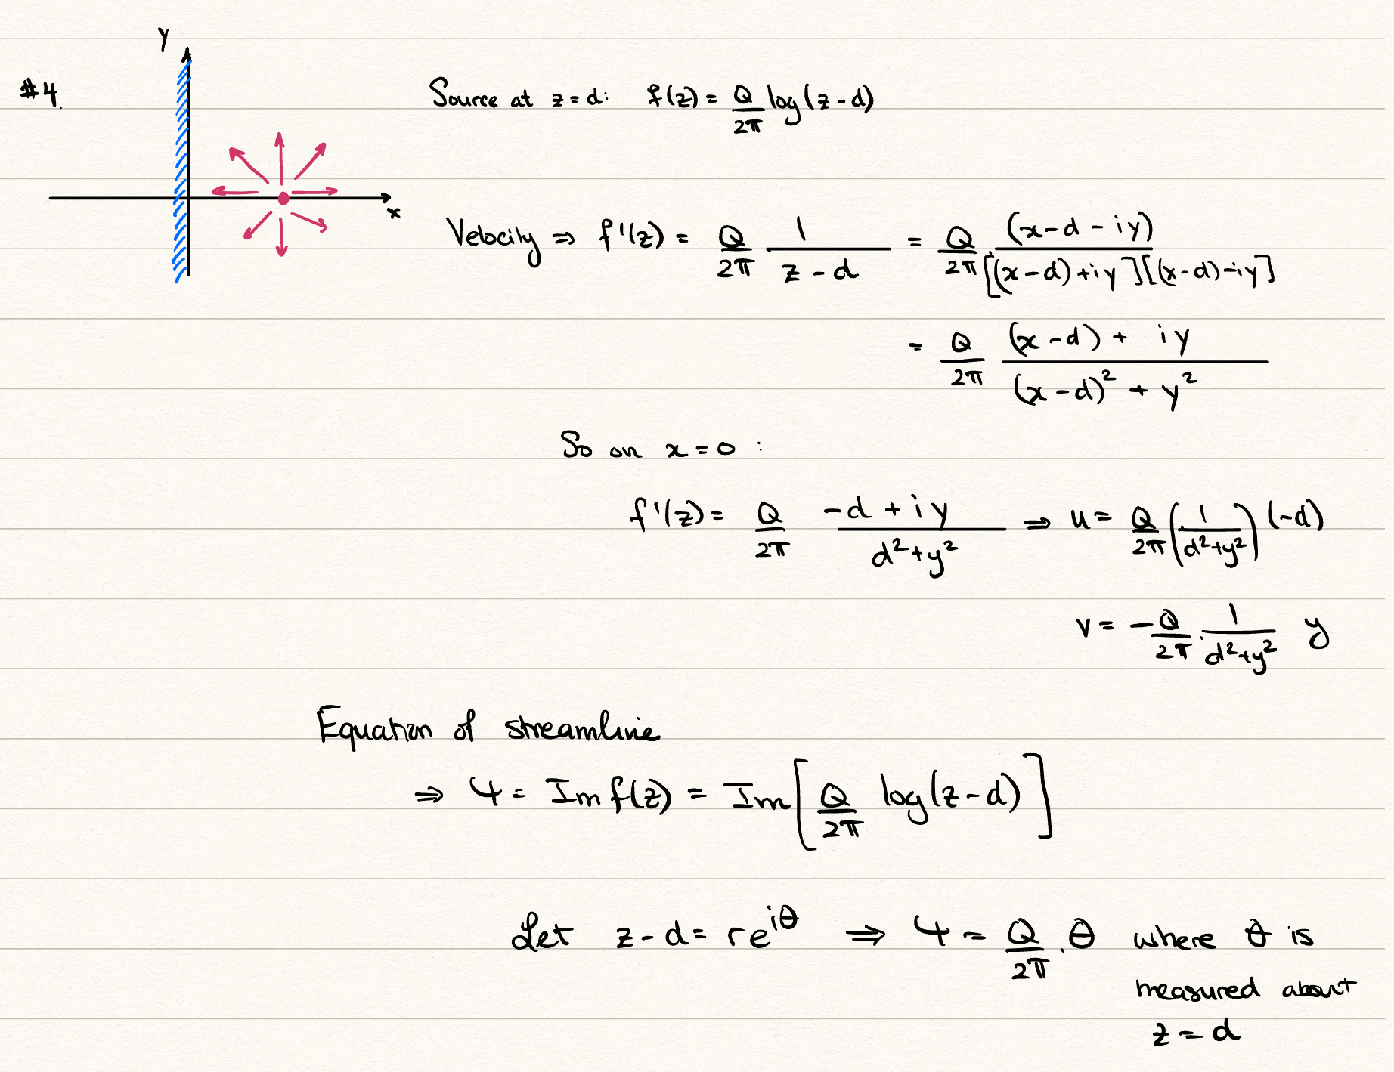
Exercise4.7.5A source in a semi-infinite flow.ps-image-planar02

- 010 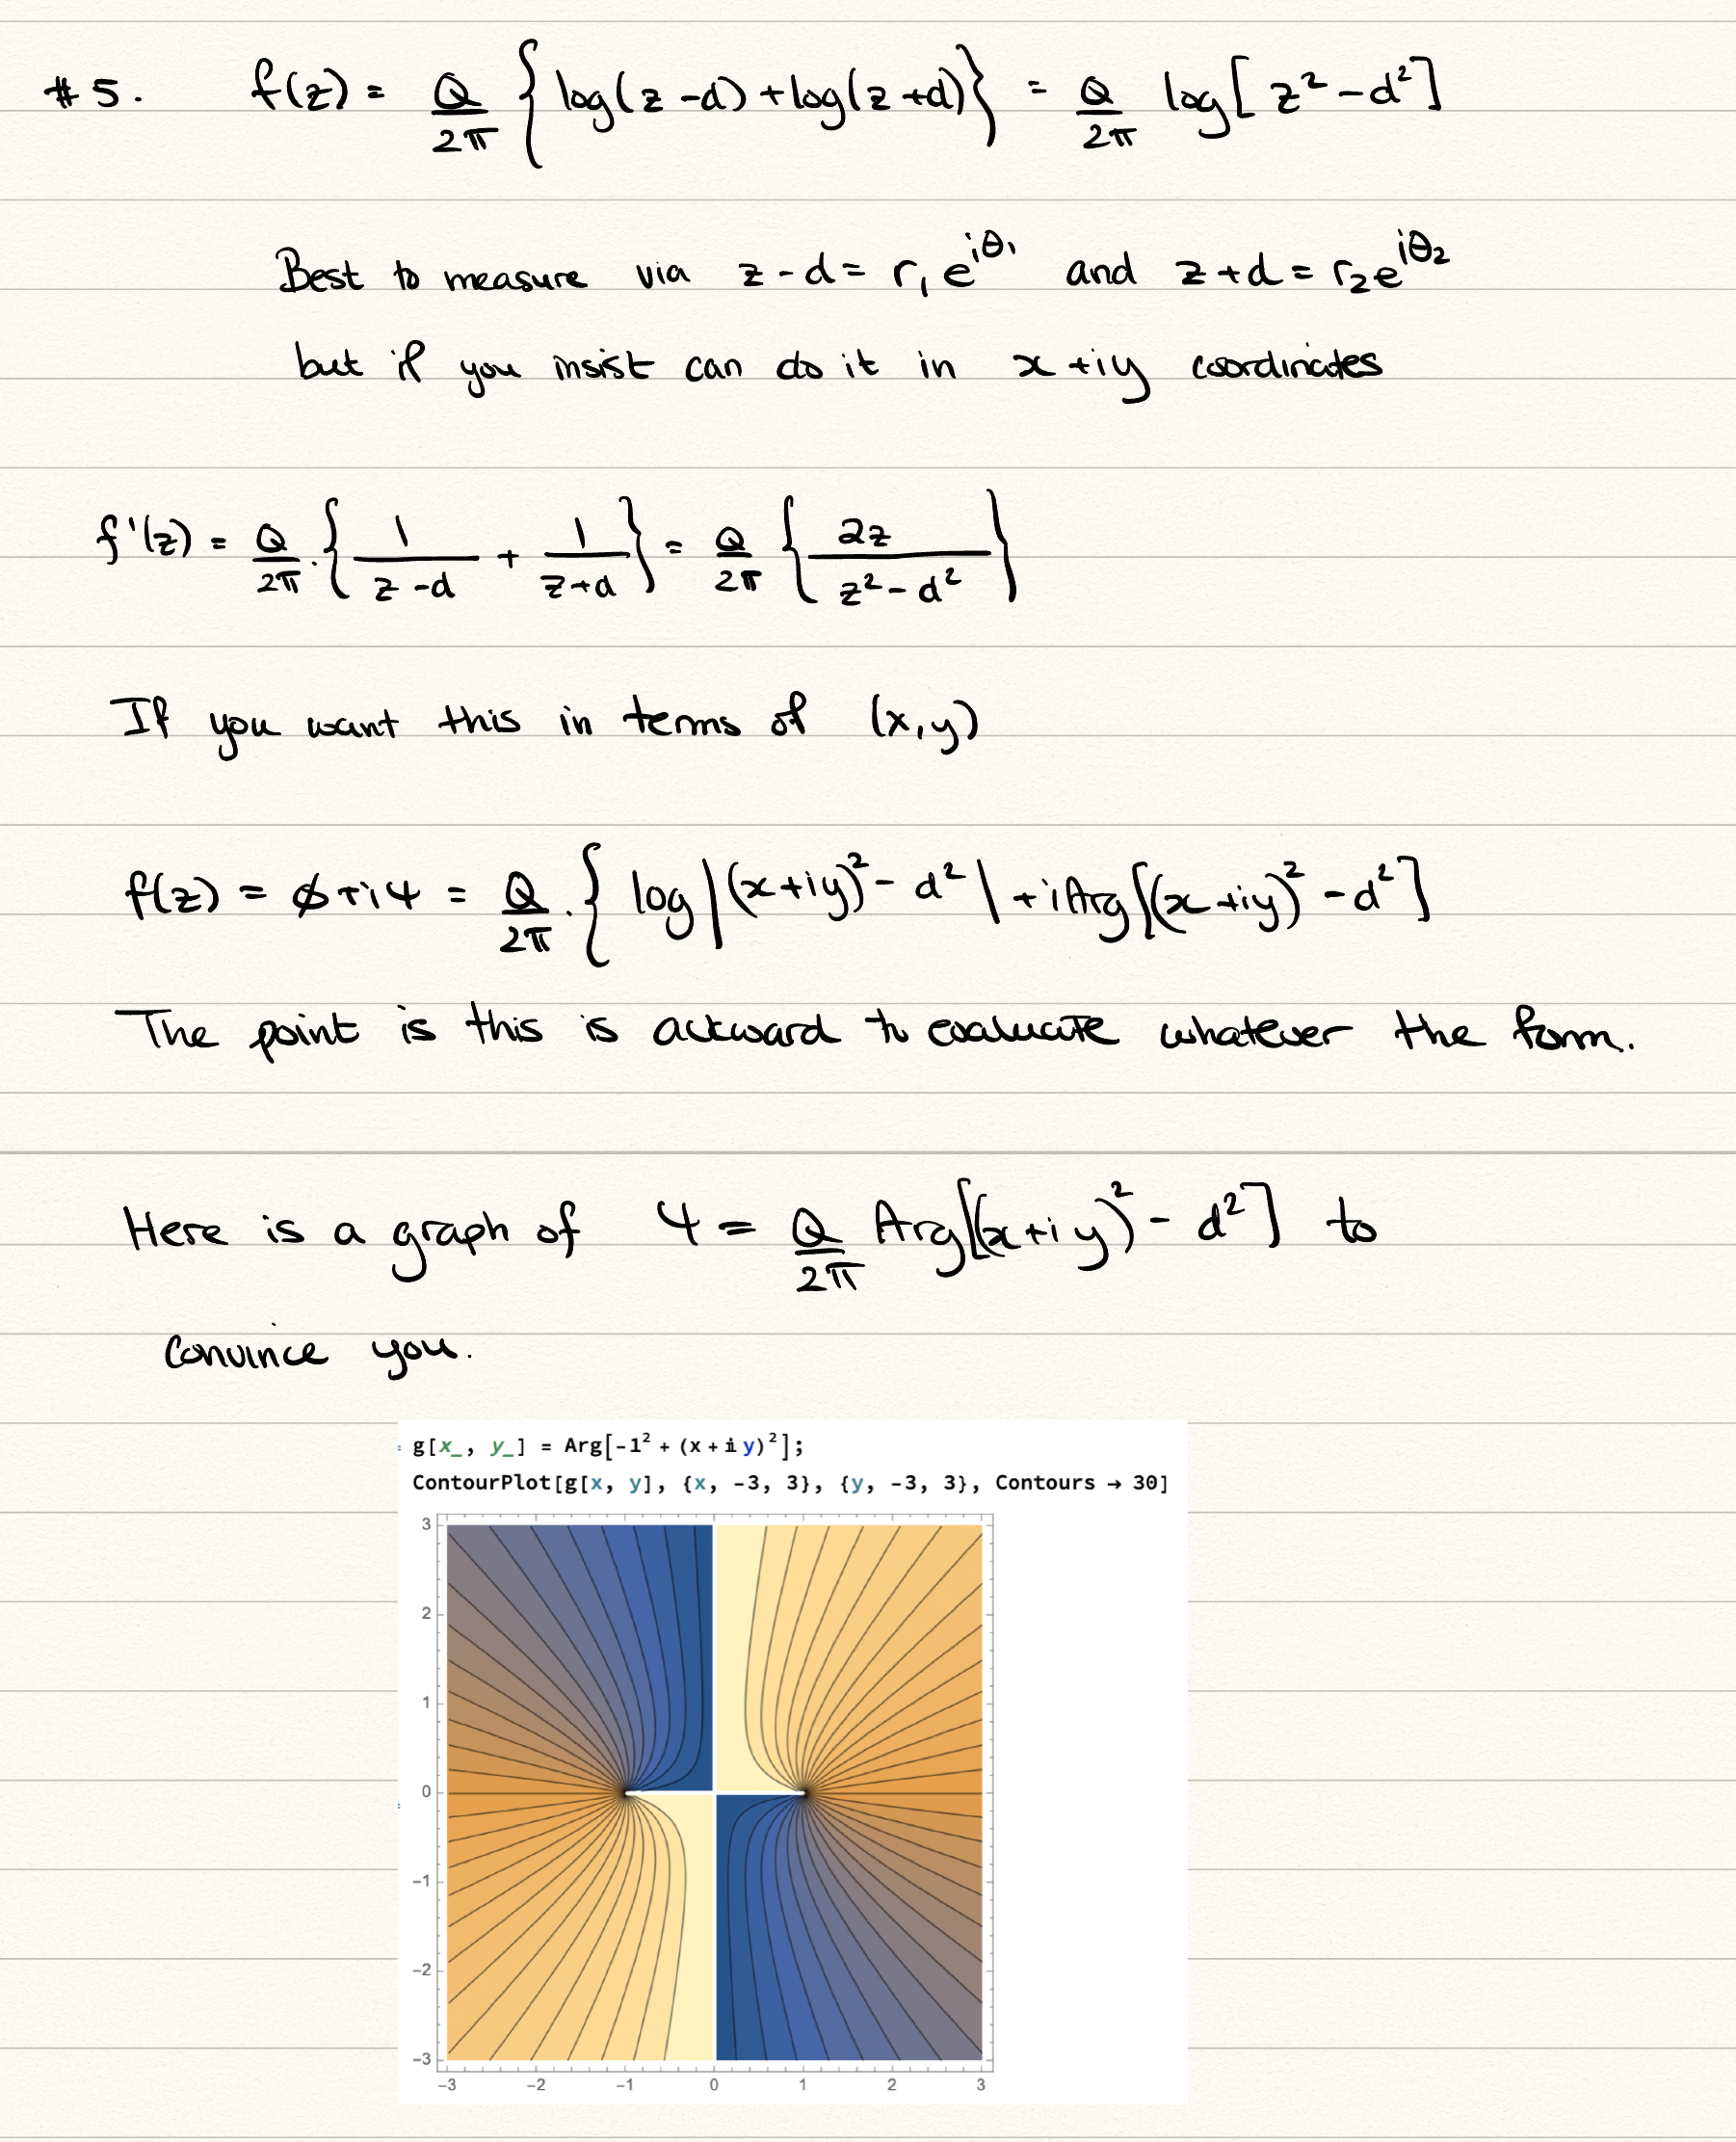
- Since $ψ=\frac{Q}{2π}Arg(z^{2}−d^{2})$, a streamline $ψ=\text{constant}$ is a curve on which $Arg(z^{2}−d^{2})=β$ is constant. With $z=x+iy$,
$$z^{2}−d^{2}=(x^{2}−y^{2}−d^{2})+2ixy.$$
- Writing $z^{2}−d^{2}=|z^{2}−d^{2}|e^{iβ}$, the real and imaginary parts are $|z^{2}−d^{2}|cosβ$ and $|z^{2}−d^{2}|sinβ$. Taking their ratio,
$$\frac{2xy}{x^{2}−y^{2}−d^{2}}=tanβ.$$
- Multiplying out and writing $k=cotβ$, the streamlines are
$$x^{2}−2kxy−y^{2}=d^{2}.$$
- This is a conic with $A=1$, $B=−2k$ and $C=−1$, so $B^{2}−4AC=4k^{2}+4>0$, and each streamline is a hyperbola. Since $A+C=0$, these are rectangular hyperbolae, and all of them pass through the two sources at $(±d,0)$. The limiting case $tanβ=0$ gives $xy=0$ away from the sources, i.e. the coordinate axes; in particular, the wall $x=0$ is a streamline, as required.
Exercise4.7.6Two vortices and a dividing boundary.ex-hw-image-planar03

010 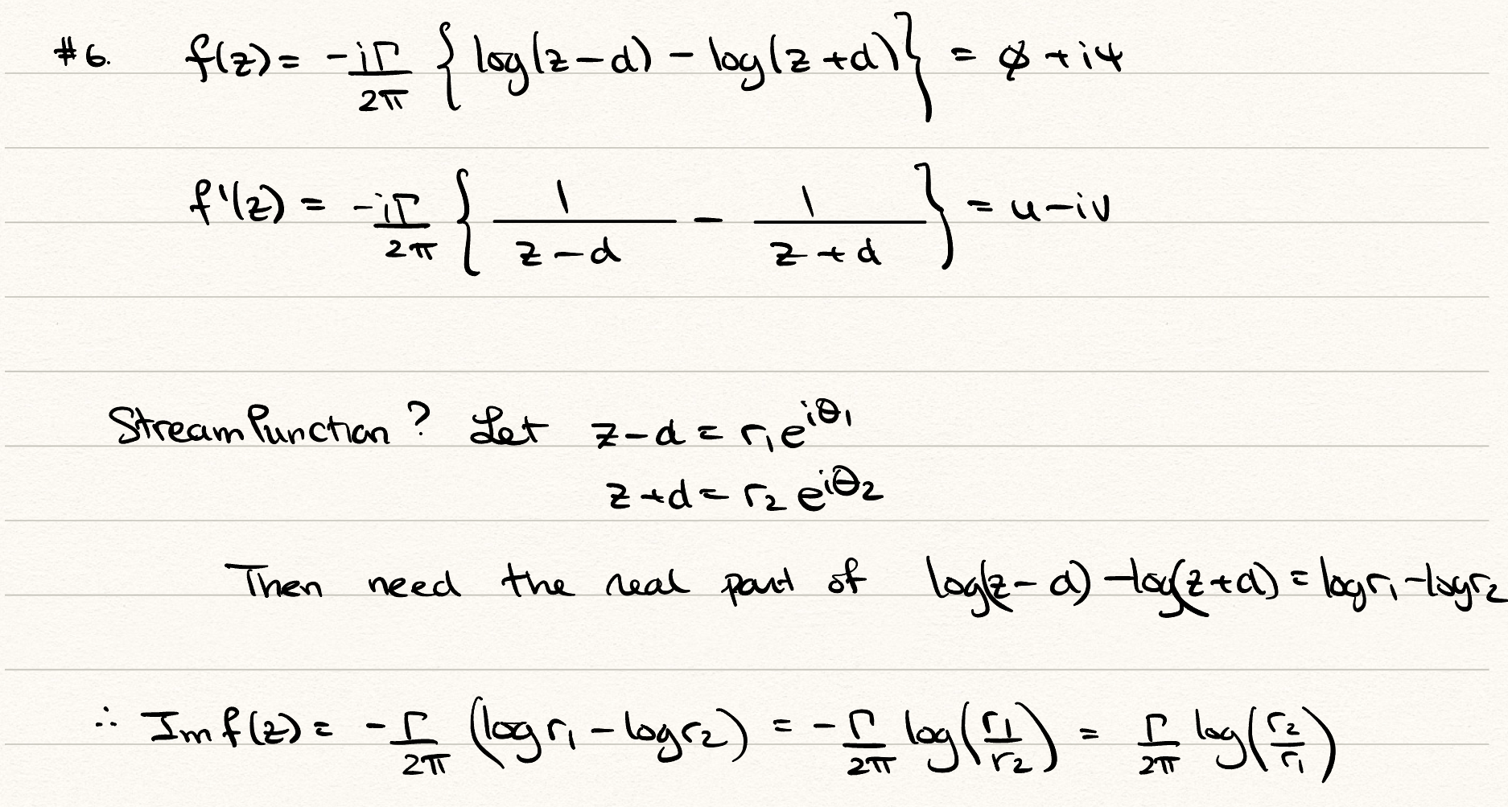
Exercise4.7.7A line source in a flow; stagnation points.ex-hw-linesource-stagnation
The potential is given by
$$f(z)=Uz+\frac{Q}{2π}[log(z−ai)+log(z+ai)]=Uz+\frac{Q}{2π}log(z^{2}+a^{2}).$$
The complex velocity is then
$$f^{′}(z)=U+\frac{Qz}{π(z^{2}+a^{2})}.$$
A stagnation point requires $f^{′}(z)=0$ and so we solve the resultant quadratic to obtain
$$z=\frac{−Q±\sqrt{Q^{2}−(2aπU)^{2}}}{2πU}.$$
Setting $β=Q/(2πaU)$, there are two real roots if $β>1$. Hence this is the case of two stagnation points along the axis. If $β<1$, then there two complex conjugate points, and hence only one stagnation point in the flow field.
Figure$β=0.94$ex-hw-linesource-stagnation-3-3
0.150.70.15 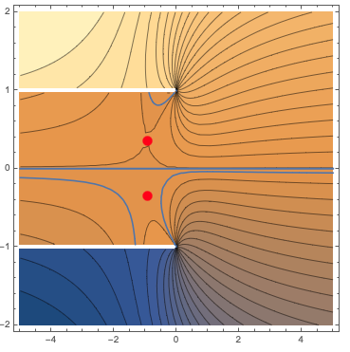
Figure$β=1.3$ex-hw-linesource-stagnation-3-4
0.150.70.15 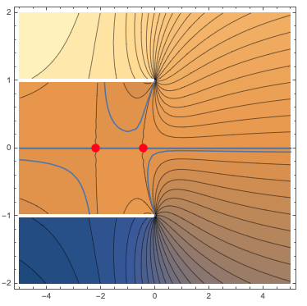
Exercise4.7.8The exponential and sinusoidal conformal maps.ps-conformal-check-exp-sin
For the exponential map, $ζ=e^{πz/h}$, we want to check the outputs of points A, B, C, D listed on the figure. These are as follows.
TableExponential mapps-conformal-check-exp-sin-3-2
$z$-plane | $ζ$-plane
$−∞+ih$​ | $0^{−}$​
$∞+ih$​ | $−∞$​
$∞$​ | $+∞$​
$−∞$​ | $0^{+}$​
When thinking of the map, the most important step is to just verify that the line, $z=t+ih$, is mapped to $ζ=−e^{πt/h}$, so the effect of shifting vertically by $ih$ is to negate the values as compared to evaluating on $z=t$. To verify the region the fluid is in, simply "walk" from ABCD in the $z$-plane, and remark on the orientation of the fluid relative to your journey (the fluid is on the right). The direction is preserved also in the $ζ$-plane.
The potential that corresponds to a single source is found by using method of images in the $ζ$ plane and mapping backwards. It is
$$\begin{aligned}F(ζ)&=\frac{Q}{2π}\left[log(ζ−d)+log(ζ+\overline{d})\right], \\ f(z)&=\frac{Q}{2π}\left[log(e^{πz/h}−d)+log(e^{πz/h}+\overline{d})\right],\end{aligned}$$
For the trigonometric map, $ζ=sin(πz/2a)$, the work is similar.
TableTrigonometric mapps-conformal-check-exp-sin-3-6
$z$-plane | $ζ$-plane
$−a+i∞$​ | $−∞$​
$−a$​ | $−1$​
$0$​ | $0$​
$a$​ | $1$​
$a+i∞$​ | $∞$​
The potential that corresponds to a single source is found by using method of images in the $ζ$ plane and mapping backwards. It is
$$\begin{aligned}F(ζ)&=\frac{Q}{2π}\left[log(ζ−d)+log(ζ+\overline{d})\right], \\ f(z)&=\frac{Q}{2π}\left[log(sin(πz/2a)−d)+log(sin(πz/2a)+\overline{d})\right],\end{aligned}$$
Exercise4.7.9Elementary conformal maps.ex-hw-conformal-elementary
A conformal map is a mapping $ζ=g(z)$ where $g$ is analytic and its derivative is nonzero in some region of the complex plane.
The map from the wedge to the upper half-plane is given in the notes near ([eqn-conformal-wedge-map]). It is $ζ=z^{π/α}$. The points where the mapping is not conformal are the critical points listed in the figure Figure [fig-conformal-wedge]. Point A at infinity is mapped directly to +infinity. The origin is mapped to the origin. And the point, B, found via $z=re^{iα}$, is sent to $ζ=−r^{π/α}$ and then afterwards $r→∞$.
Exercise4.7.10Flow past a flat plate.ws-potentialflows-3-9

- 010 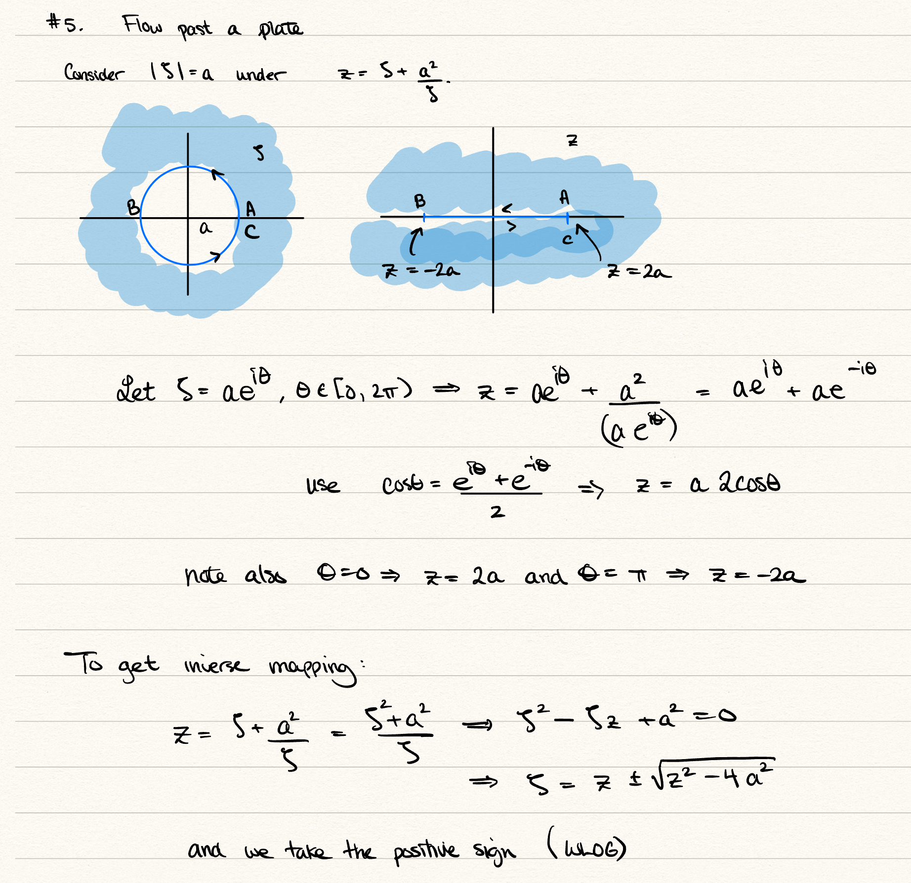

- 010 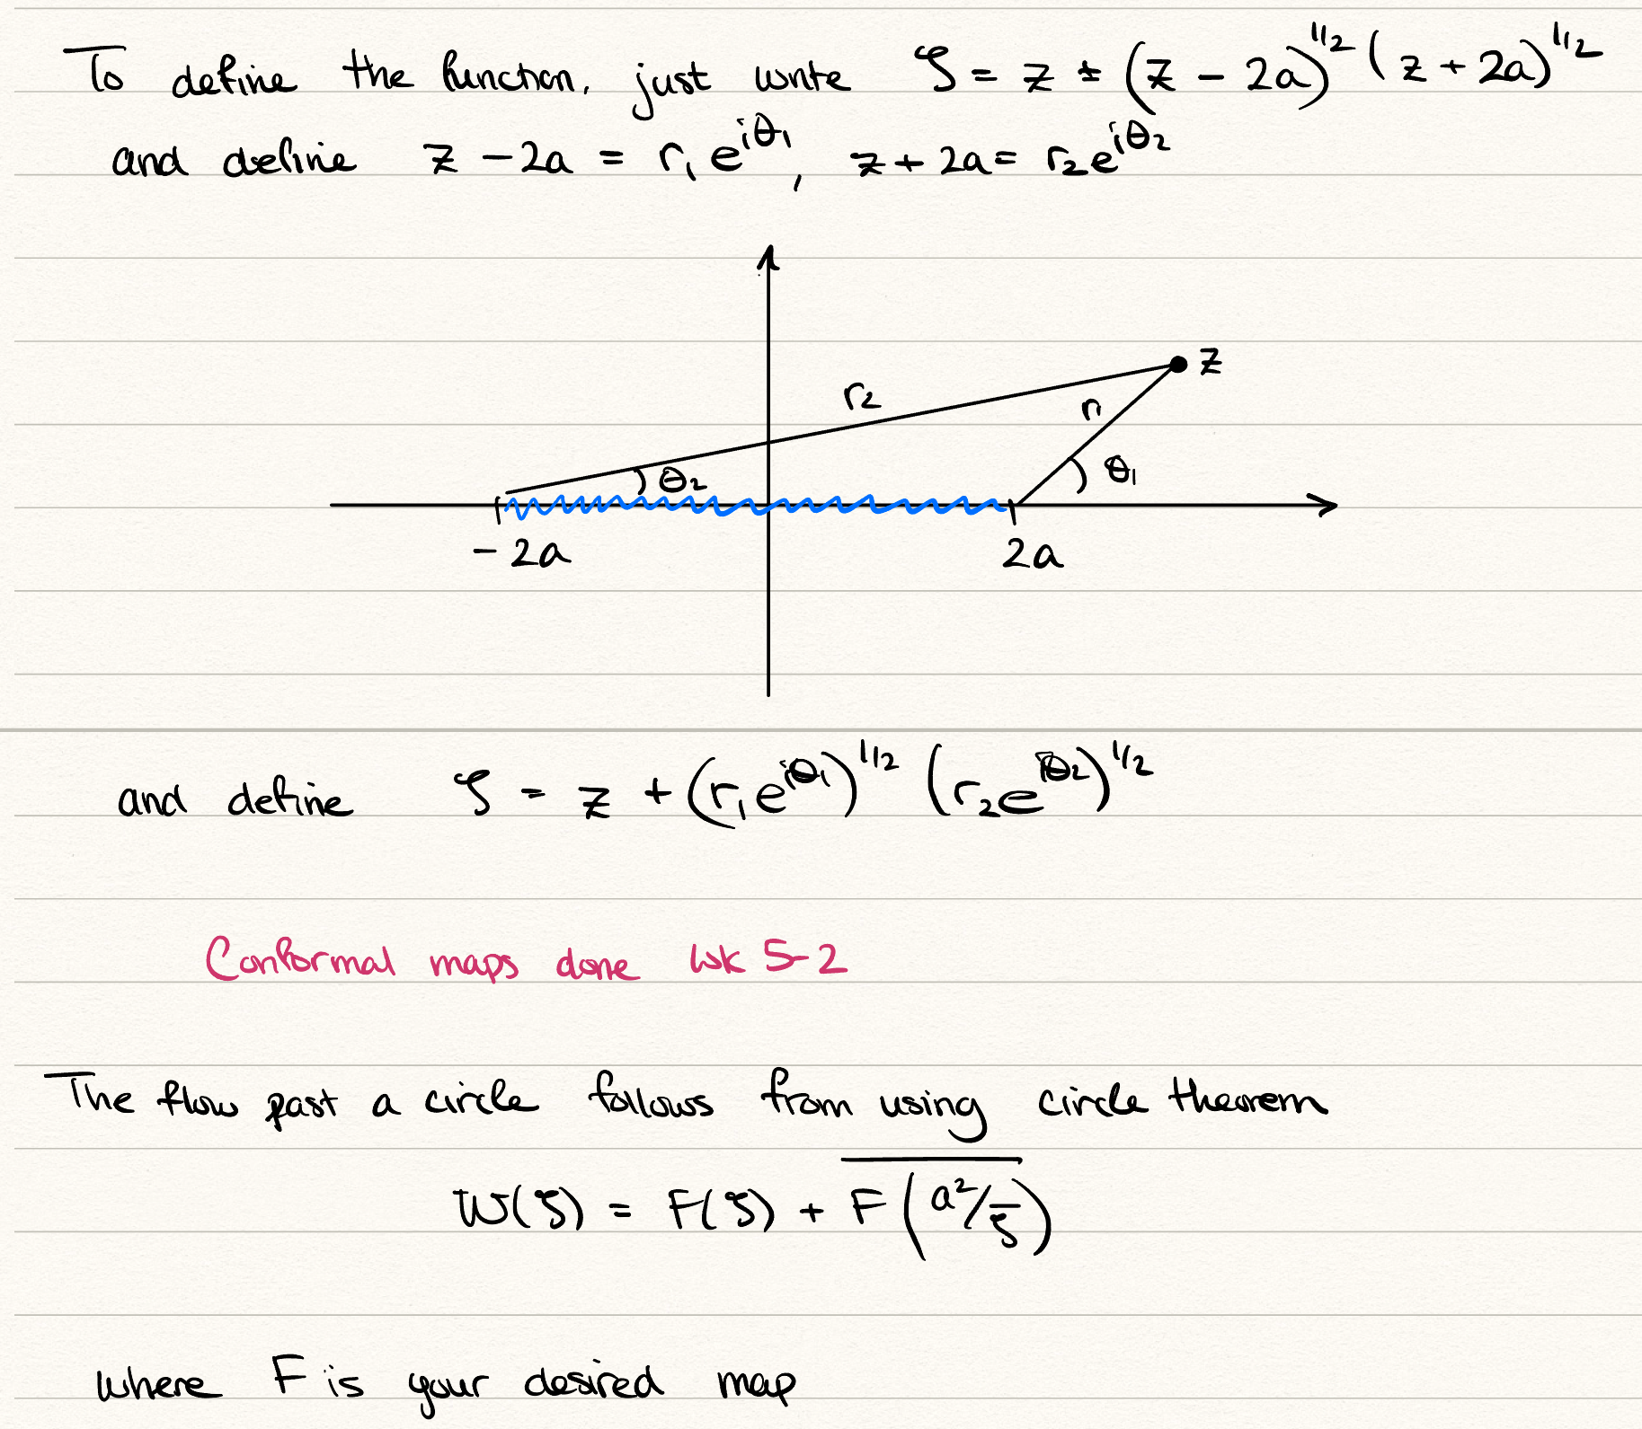
- First, construct the complex potential $F(ζ)$ of uniform flow plus a source. Use the Circle Theorem (Theorem [thm-circle-theorem]) to obtain the corresponding flow past a circular cylinder of radius $a$. Finally, use the map from part (b) to obtain the flow in the $z$-plane.
- FigureConstruction of the flow past a flat plate. There are two typos in the sketch: in the Circle Theorem step, the second term should read $\overline{F(a^{2}/\overline{ζ})}$, and the final map should read $ζ=g(z)=\frac{1}{2}\left(z+\sqrt{z−2a}\sqrt{z+2a}\right)$, as in part (b).fig-ex-flatplate-solution
- 010 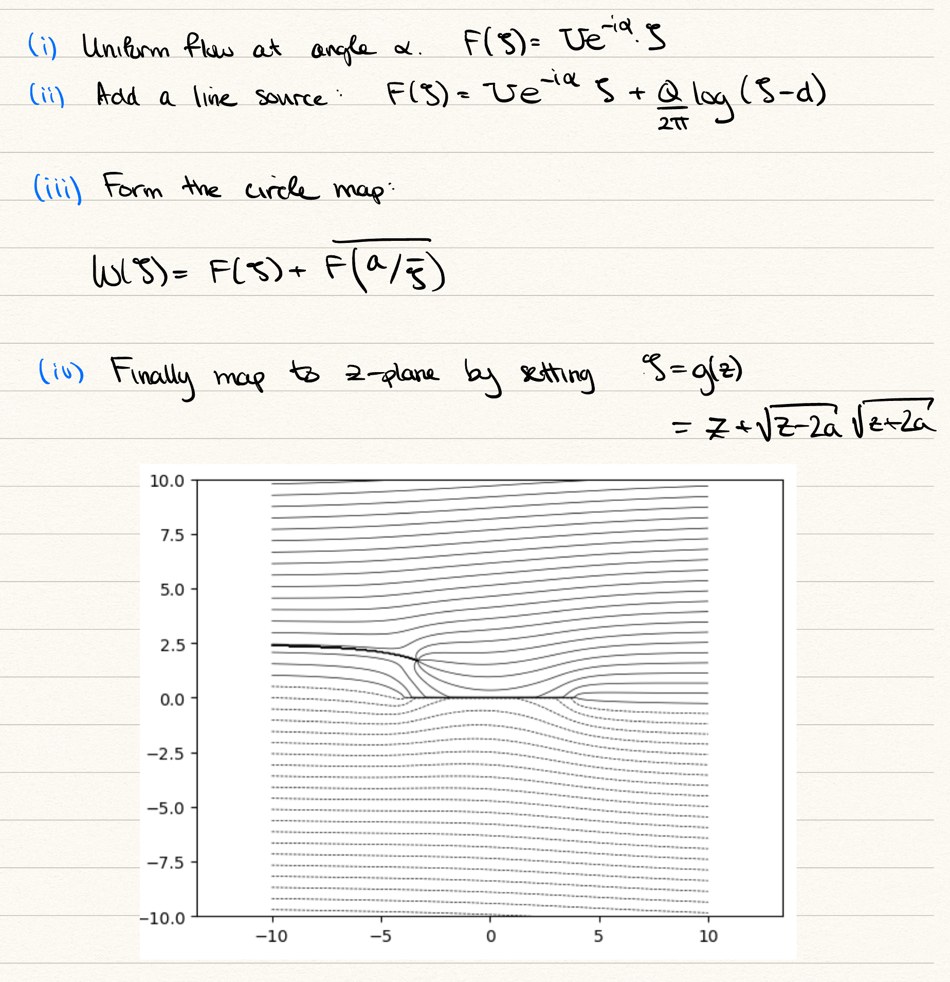
SectionWater wavesWater wavessolutions-waves
SolutionsSolutionsSolutionssolutions-waves-2
5.5Exercises
Exercise5.5.1Derivation of the kinematic condition.exercises-water-waves-2
By the definition of the material derivative, we have that
$$\frac{D(y−η)}{Dt}=\frac{∂(y−η)}{∂t}+(u,v)⋅∇(y−η)=−\frac{∂η}{∂t}+(u,v)⋅(−η_{x},1).$$
Equating the above to zero for the case of $y=η(x,t)$ yields the desired result.
Exercise5.5.2Stokes waves in finite depth.ex-waterwaves-finite
Note that the finite-depth linear wave theory was derived as part of the problem class, so you can examine the video there for more details. Firstly, we look to linearise the two surface boundary conditions,
$$\begin{matrix}\frac{∂ϕ}{∂y}=\frac{∂η}{∂t}+\frac{∂ϕ}{∂x}\frac{∂η}{∂x}, \\ \frac{∂ϕ}{∂t}+\frac{1}{2}|∇ϕ|^{2}+gη=0,\end{matrix}$$
which are imposed on $y=η(x)$. The quadratic terms can be ignored by assuming that the fluid is linearised about a small disturbance. Hence $η$ is assumed to be small. Similarly, the velocity terms are expanded about $y=0$. For example,
$$\frac{∂ϕ}{∂x}|_{y=η}=\frac{∂ϕ}{∂x}|_{y=0}+\frac{∂^{2}ϕ}{∂x^{2}}|_{y=0}η+….$$
Thus we can approximate this quantity to leading order by
$$\frac{∂ϕ}{∂x}|_{y=η}∼\frac{∂ϕ}{∂x}|_{y=0}.$$
Therefore, both kinematic and dynamic conditions are simplified in this manner, yielding
$$\begin{matrix}\frac{∂ϕ}{∂y}=\frac{∂η}{∂t}, \\ \frac{∂ϕ}{∂t}+gη=0,\end{matrix}$$
now imposed on $y=0$.
We substitute now the ansatzes
$$η=Acos(kx−ωt), ϕ=f(y)sin(kx−ωt),$$
into the governing equations.
Written in terms of $f$, we must now solve the following system:
$$\begin{matrix}f^{″}+k^{2}f=0, \\ f^{′}(−h)=0, \\ f^{′}(0)=(ω)A, \\ −(ω)f(0)+gA=0.\end{matrix}$$
Now instead of writing the solution for $f$ in terms of the two exponentials $e^{±ky}$, it is better to write the general solution of the second-order ODE as
$$f(y)=Bcosh[k(y−y_{0})],$$
where $y_{0}$ is constant. We can then see that if $y_{0}=−h$, then the boundary condition $f^{′}(−h)=0$ is satisfied.
The last two boundary conditions, evaluated on $y=0$ yield
$$\left(\begin{matrix}ω & −ksinh(kh) \\ g & −(ω)cosh(kh)\end{matrix}\right)\left(\begin{matrix}A \\ B\end{matrix}\right)=0.$$
For there to be non-trivial solutions, we thus need
$$(ω)^{2}=gktanh(kh),$$
and therefore there are two possible wave speeds, namely
$$c=∓{\left(\frac{g}{k}tanh(kh)\right)}^{1/2},$$
and both are simply negatives of one another; so represent left and rightwards propagating waves of the same speed.
Exercise5.5.3Linear waves in a current.ex-waterwaves-current
- We begin with the governing equations as shown in Theorem [thm-waterwaves-governing].
- On the channel bottom, we expect that the vertical velocity is zero, hence
$$\frac{∂ϕ}{∂y}=0, y=−h,$$
- while at upstream infinity, we expect the the velocity to be uniform and of speed $U$. Hence in terms of the potential,
$$ϕ∼Ux, x→−∞.$$
- Indeed, this suggests that we should linearise about the uniform flow, with
$$ϕ=Ux+\hat{ϕ},$$
- where $\hat{ϕ}$ is the approximation, which we expect to be small (as is standard in linear problems, we often ignore the hat notation).
- The linearisation process for the kinematic condition remains largely the same, except we would produce:
$$\frac{∂η}{∂t}+\left[U+\frac{∂\hat{ϕ}}{∂x}\right]\frac{∂η}{∂x}=\frac{∂\hat{ϕ}}{∂y}.$$
- Again quadratic terms are ignored, and we see that the requisite condition becomes (dropping the hat):
$$\frac{∂η}{∂t}+U\frac{∂η}{∂x}=\frac{∂ϕ}{∂y}, y=η(x,t).$$
- The linearisation of Bernoulli’s equation is done similarly.
- When considering the Bernoulli equation,
$$\frac{∂ϕ}{∂t}+\frac{1}{2}|∇ϕ|^{2}+\frac{p}{ρ}+gy=F(t),$$
- it is prudent to take the choice of $F(t)$ so that the inertial term is removed. Specifically, if we take
$$F(t)=\frac{U^{2}}{2}+\frac{p_{\text{atm}}}{ρ},$$
- this would remove the leading term from inertia.
- The only difference with the usual linearisation process is the inertial term:
$$|∇ϕ|^{2}=\left|{\left(U+\frac{∂\hat{ϕ}}{∂x}\right)}^{2}+{\left(\frac{∂\hat{ϕ}}{∂y}\right)}^{2}\right|=2U\frac{∂\hat{ϕ}}{∂x}+…$$
- so now Bernoulli’s equation yields (dropping hats):
$$\frac{∂ϕ}{∂t}+U\frac{∂ϕ}{∂x}+gη=0, y=0,$$
- where we have placed the boundary condition on $y=0$ as standard.
- At this point, the linear solution follows similar steps to the case of finite depth with zero current. We have $η=Acos(kx−ωt)$ and $ϕ=f(y)sin(kx−ωt)$.
- Written in terms of $f$, we must now solve the following system:
$$\begin{matrix}f^{″}+k^{2}f=0, \\ f^{′}(−h)=0, \\ f^{′}(0)=(ω−Uk)A, \\ −(ω−Uk)f(0)+gA=0,\end{matrix}$$
- The first two equations yield the typical solution for the case of finite depth:
$$f(y)=Bcosh[k(y+h)].$$
- The last two conditions yield
$$\left(\begin{matrix}ω−Uk & −ksinh(kh) \\ g & −(ω−Uk)cosh(kh)\end{matrix}\right)\left(\begin{matrix}A \\ B\end{matrix}\right)=0.$$
- For there to be non-trivial solutions, we thus need
$$(ω−Uk)^{2}=gktanh(kh),$$
- and therefore there are two possible wave speeds, namely
$$c_{±}=U∓{\left(\frac{g}{k}tanh(kh)\right)}^{1/2}.$$
- In the deep water limit, if $U<\sqrt{g/k}$ this yields subcritical solutions, and it is possible to have a wave pattern that is non-trivial upstream of the flow.
Exercise5.5.4Fluids of different densities.ex-waterwaves-density
The kinematic condition(s) must be exactly the same form as the usual kinematic condition, since the density of the fluids play no role. They arise from setting $\frac{D(y−η)}{Dt}=0,$ for both fluids. This gives,
$$η_{t}+\frac{∂ϕ_{i}}{∂x}\frac{∂η}{∂x}=\frac{∂ϕ_{i}}{∂y}⇒\frac{∂η}{∂t}=\frac{∂ϕ_{i}}{∂y} \text{on }y=0,$$
after linearising, and as imposed on $i=1,2$.
The dynamic condition expresses the fact that the pressures are equal at the interface between the two fluids. Therefore at the interface, we have (ignoring quadratic terms), from Theorem [thm-bernoulli-unsteady-potential]
$$\begin{aligned}\frac{∂ϕ_{1}}{∂t}+\frac{p_{1}}{ρ_{1}}+gη&=B_{1}, \\ \frac{∂ϕ_{2}}{∂t}+\frac{p_{2}}{ρ_{2}}+gη&=B_{2}.\end{aligned}$$
However at the interface, we need the pressures to be equal. Therefore we can set $p_{1}=p_{2}$. Subtracting the two equations then yields
$$ρ_{1}\left(\frac{∂ϕ_{1}}{∂t}+gη\right)+\left(\frac{p}{ρ_{1}}−\frac{p}{ρ_{2}}−B_{1}+B_{2}\right)=ρ_{2}\left(\frac{∂ϕ_{2}}{∂t}+gη\right)$$
as applied on $y=0$. We are free to pick the constants, so we pick them so as to completely zero the expression in the second group of brackets. Thus
$$ρ_{1}\left(\frac{∂ϕ_{1}}{∂t}+gη\right)=ρ_{2}\left(\frac{∂ϕ_{2}}{∂t}+gη\right)$$
on $y=0$.
So now the natural question is to ask how the linearisation procedure changes with the two fluids of different densities. Gain, we set $η=Acos(kx−ωt)$ and $ϕ_{i}=f_{i}(y)sin(kx−ωt)$. The equation for $f$ is similarly given by $f^{″}=k^{2}f,$ and this time, we must select different exponential powers so as to ensure the fluid is bounded either as $y→∞$ or as $y→−∞$. This essentially yields
$$\begin{aligned}f_{1}=Be^{ky},& y<0, \\ f_{2}=Ce^{−ky},& y>0,\end{aligned}$$
for constants $B$ and $C$.
The remaining boundary conditions are:
$$\begin{matrix}f_{1}^{′}(0)=(ω)A, \\ f_{2}^{′}(0)=(ω)A, \\ ρ_{1}(−ωf_{1}(0)+gA)=ρ_{2}(−ωf_{2}(0)+gA),\end{matrix}$$
thus
$$\begin{matrix}Bk=ωA, \\ −Ck=ωA, \\ ρ_{1}(−ωB+gA)=ρ_{2}(−ωC+gA),\end{matrix}$$
which in matrix form is
$$\left(\begin{matrix}ω & −k & 0 \\ ω & 0 & k \\ g(ρ_{1}−ρ_{2}) & −ωρ_{1} & ωρ_{2}\end{matrix}\right)\left(\begin{matrix}A \\ B \\ C\end{matrix}\right)=\left(\begin{matrix}0 \\ 0 \\ 0\end{matrix}\right).$$
Expanding the determinant about the first row yields
$$\begin{matrix}ω∣\begin{matrix}0 & k \\ −ωρ_{1} & ωρ_{2}\end{matrix}∣+k∣\begin{matrix}ω & k \\ g(ρ_{1}−ρ_{2}) & ρ_{2}ω\end{matrix}∣ \\ =ω^{2}k(ρ_{1}+ρ_{2})−k^{2}g(ρ_{1}−ρ_{2})=0,\end{matrix}$$
which gives the desired result.
Exercise5.5.5Fluids with surface tension.ex-waterwaves-surfacetension
This question was done in the problem class recording on 11 November 2025, accessed here.
Very little changes in the linearisation procedure with surface tension, as the only difference is the Bernoulli equation, which is linearised to give
$$\frac{∂ϕ}{∂t}+gη=\frac{T}{ρ}\frac{∂^{2}η}{∂x^{2}},$$
evaluated on $y=0$.
Thus in this equation, we use the same ansatzes as for the previous few questions. The system of equations is
$$\begin{matrix}f^{″}+k^{2}f=0, \\ f(−∞)\text{ is bounded}, \\ f^{′}(0)=(ω)A, \\ −(ω)f(0)+[g+(T/ρ)k^{2}]A=0,\end{matrix}$$
The derivation must be exactly the same as for infinite-depth gravity waves, and the only difference is that instead of $g$, we can substitute $g+(T/ρ)k^{2}$ when we impose the boundary conditions and apply the determinant condition.
Previously for deep-water gravity waves, we had $ω^{2}=gk$. So now we must have
$$ω^{2}=\left(g+\frac{T}{ρ}k^{2}\right)k,$$
as desired.
Exercise5.5.6The dispersion relation (simple).exercises-water-waves-7

$$η(x,t)=2sin\left[\frac{(k_{1}+k_{2})x−(ω_{1}+ω_{2})t}{2}\right]cos\left[\frac{(k_{1}−k_{2})x−(ω_{1}−ω_{2})t}{2}\right]$$
- Substituting these expressions, we have
$$η=2sin(kx−ωt)cos(Δkx−Δωt).$$
- The point here is that $Δk,Δω≪1$, so the cosine term is very nearly 1. This yields the standard travelling sinusoidal wave. However, over long timescales, notably when $t$ is large, the cosine term is no longer constant. This yields a slowly varying envelope or amplitude multiplying the sine,
- This part is quite straightforward. The maxima of the cosines are found at multiples of $2π$ in the argument. For example, the first maxima lies at $Δkx−Δωt=0,$ hence $x(t)=(Δk/Δω)t.$
- This is indeed equivalent to a particle that moves with velocity $Δk/Δω$. In the limit the perturbations to the quantities tends to zero, we can informally note that this leads to the notion of the group velocity,
$$v_{g}=\frac{dω}{dk}.$$
SectionViscous flowsViscous flowssolutions-viscousflows
SolutionsSolutionsSolutionssolutions-viscousflows-2
6.9Practice Exercises
Exercise6.9.1Reynolds number estimation.ws-viscousflows-3
- The kinematic viscosity of air at standard temperature and pressure is about $1.5×{10}^{−5} {\text{m}}^{2}/\text{s}$. The wingspan of a jumbo jet is about $60 \text{m}$, so the Reynolds number is approximately
$$\text{Re}=\frac{UL}{ν}=\frac{150×60}{1.5×{10}^{−5}}=6×{10}^{8}.$$
- The kinematic viscosity of blood is about $2.4×{10}^{−6} {\text{m}}^{2}/\text{s}$. The diameter of the artery is about $0.02 \text{m}$, so the Reynolds number is approximately
$$\text{Re}=\frac{UL}{ν}=\frac{0.3×0.02}{2.4×{10}^{−6}}=2500.$$
- Although this is above 2000, blood flow in arteries is typically laminar.
- The kinematic viscosity of honey is about $0.007 {\text{m}}^{2}/\text{s}$. The thickness of the layer is about $0.005 \text{m}$, so the Reynolds number is approximately
$$\text{Re}=\frac{UL}{ν}=\frac{0.01×0.005}{0.007}≈0.007.$$
- The kinematic viscosity of water at room temperature is about ${10}^{−6} {\text{m}}^{2}/\text{s}$. The length of the tail is about ${10}^{−3} \text{m}$, so the Reynolds number is approximately
$$\text{Re}=\frac{UL}{ν}=\frac{100×{10}^{−6}×{10}^{−3}}{{10}^{−6}}=0.1.$$
Exercise6.9.2Nondimensionalisation.ws-viscousflows-4
- At the cylinder surface, we have the no-slip and no-penetration boundary conditions:
$$u=v=0.$$
- Far from the cylinder, the velocity approaches the uniform flow:
$$u→U, v→0 \text{as }\sqrt{x^{2}+y^{2}}→∞.$$
- We have:
$$\frac{U^{2}}{a}\left(u^{*}⋅∇^{*}\right)u^{*}=−\frac{U^{2}}{a}∇^{*}p^{*}+\frac{νU}{a^{2}}∇^{*2}u^{*}, \frac{U}{a}∇^{*}⋅u^{*}=0,$$
- which simplify to
$$Re\left(u^{*}⋅∇^{*}\right)u^{*}=−Re∇^{*}p^{*}+∇^{*2}u^{*}, ∇^{*}⋅u^{*}=0,$$
- where
$$Re=\frac{ρUa}{μ}$$
- is the Reynolds number of the flow. The boundary conditions become:
$$u^{*}=v^{*}=0$$
- at $x^{*2}+y^{*2}=1$ and
$$u^{*}→1, v^{*}→0 \text{as }\sqrt{x^{*2}+y^{*2}}→∞.$$
Exercise6.9.3Falling ball viscometer.ps-falling-ball-viscometer
- The dimensions of the terms are as follows:
$$[3π]=1, [μ]=ML^{−1}T^{−1}, [D]=L, [u]=LT^{−1},$$
- meaning that
$$\left[3πμDu\right]=1×ML^{−1}T^{−1}×L×LT^{−1}=MLT^{−2}.$$
- Thus the expression $3πμDu$ for the Stokes drag has the dimensions of force, as expected.
- Gravity and fluid drag
- Newton’s second law gives
$$m\frac{du}{dt}=mg−3πμDu.$$
- We have
$$\frac{du}{dt}+\frac{3πμD}{m}u=g,$$
- for which the integrating factor is $e^{\frac{3πμD}{m}t}$, and
$$ue^{\frac{3πμD}{m}t}=∫ge^{\frac{3πμD}{m}t}dt=\frac{mg}{3πμD}e^{\frac{3πμD}{m}t}+c,$$
- where $c$ is a constant of integration. Hence
$$u=\frac{mg}{3πμD}+ce^{−\frac{3πμD}{m}t}$$
- The initial condition is $u=0$ at $t=0$, and, substituting this into the above equation, $0=\frac{mg}{3πμD}+c$, giving $c=−\frac{mg}{3πμD}$. Hence
$$u=\frac{mg}{3πμD}\left(1−e^{−\frac{3πμD}{m}t}\right).$$
- We substitute $u_{t}=\frac{mg}{3πμD}$ and $τ=\frac{m}{3πμD}$. With these substitutions we get
$$u=u_{t}\left(1−e^{−t/τ}\right).$$
- The physical significance of these choices is that $u_{t}$ is the terminal velocity of the sphere and $τ$ is the timescale over which the velocity of the sphere approaches the terminal velocity. Every $τ$ units of time, the velocity of the sphere becomes closer to the terminal velocity $u_{t}$ by a factor $e≈2.7$.

- FigureSketch of velocity as a function of time.ball-low-re
- 0.10.80.1 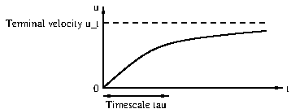
- Using the fact that the volume of a sphere is $πD^{3}/6$, where $D$ is the diameter, we have $m=πρ_{s}D^{3}/6$, where $ρ_{s}=8,000$ kg/m$​^{3}$. Thus
$$\begin{aligned}u_{t}=&\frac{mg}{3πμD}=\frac{mg}{3πμD}=\frac{ρ_{s}gD^{2}}{18μ} \\ =&\frac{8000×9.81×(4×{10}^{−6})}{18×1.2}=0.0146 \text{m/s}=14.6 \text{mm/s}.\end{aligned}$$
- The timescale $τ$ is given by
$$τ=\frac{m}{3πμD}=\frac{ρ_{s}D^{2}}{18μ}=\frac{8000×4×{10}^{−6}}{18×1.2}=0.00148 \text{s}.$$
- The ball would attain its terminal velocity very quickly (in much less than a second), and since $u_{t}$ is on order of centimetres per second, a container of about 10 cm deep would be suitable for measurement. In fact this idea is commonly used to measure the viscosity of fluids (since the viscosity can be calculated from the terminal velocity); this is called a falling ball viscometer.
Exercise6.9.4Stress on a plate.ps-stress-plate
- We apply no-slip boundary conditions at the plate. Thus if $y=kx$ then we must have $u=0$ and $v=0$. Hence
$$0=αkx+Ax+B, 0=−Akx+Dx+C,$$
- for all $x$, which implies that $αk+A=0$, $B=0$, $−Ak+D=0$ and $C=0$. Solving, we obtain
$$A=−αk, B=0, D=−αk^{2}, C=0.$$
- Hence
$$u=α\left(y−kx\right), v=αk\left(y−kx\right).$$
- We perform the coordinate transform illustrated in Figure [plate-coordinates] from the $(x,y)$-plane to the $(ξ,η)$-plane:
- FigureSketch of plate.plate-coordinates
- 010 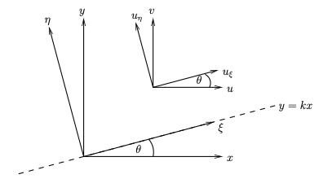
- We use
$$\begin{aligned}u=&ui+vj \\ =&u\left(cosθ\hat{ξ}−sinθ\hat{η}\right)+v\left(sinθ\hat{ξ}+cosθ\hat{η}\right) \\ =&\left(ucosθ+vsinθ\right)\hat{ξ}+\left(−usinθ+vcosθ\right)\hat{η} \\ =&\frac{α(y−kx)+αk^{2}(y−kx)}{\sqrt{1+k^{2}}}\hat{ξ}+\frac{−αk(y−kx)+αk(y−kx)}{\sqrt{1+k^{2}}}\hat{η} \\ =&α\sqrt{1+k^{2}}(y−kx)\hat{ξ} \\ =&α\sqrt{1+k^{2}}\sqrt{1+k^{2}}η\hat{ξ} \\ =&α(1+k^{2})η\hat{ξ}\end{aligned}$$
- and so the velocity components are $u_{ξ}=α(1+k^{2})η$ and $u_{η}=0$.
- Thus the shear stress is given by
$$μ\frac{∂u_{ξ}}{∂η}=μα(1+k^{2}),$$
- and hence the drag force equals
$$μα(1+k^{2})LW.$$
- We have the normal vector to the plate
$$\hat{n}=\frac{1}{\sqrt{1+k^{2}}}(−k,1,0).$$
- The rate-of-strain tensor is given by
$$e=\left(\begin{matrix}−αk & \frac{1}{2}α(1−k^{2}) & 0 \\ \frac{1}{2}α(1−k^{2}) & αk & 0 \\ 0 & 0 & 0\end{matrix}\right).$$
- Hence the stress tensor equals
$$σ=−pI+2μe=\left(\begin{matrix}−p−2μαk & μα(1−k^{2}) & 0 \\ μα(1−k^{2}) & −p+2μαk & 0 \\ 0 & 0 & −p\end{matrix}\right).$$
- The stress on the surface is given by
$$\begin{aligned}τ=&σ\hat{n} \\ =&\frac{1}{\sqrt{1+k^{2}}}\left(kp+2μαk^{2}+μα(1−k^{2}),−μkα(1−k^{2})−p+2μαk,0\right) \\ =&\frac{1}{\sqrt{1+k^{2}}}\left(kp+μα(1+k^{2}),−p+μkα(1+k^{2}),0\right) \\ =&\frac{1}{\sqrt{1+k^{2}}}\left(p(k,−1,0)+μα(1+k^{2})(1,k,0)\right) \\ =&−p\hat{n}+μα(1+k^{2})\hat{t},\end{aligned}$$
- where $\hat{t}$ is the unit tangential vector to the plate in the $(x,y)$-plane.
- This is the pressure pushing into the plate (direction $−\hat{n}$) plus the drag $μα(1+k^{2})$ along the plate. Hence, the total drag force is the drag times the area:
$$μα(1+k^{2})$$
- which agrees with the previous answer.
Exercise6.9.5Stress on a surface due to the pressure.ps-stress-pressure
- The force on $x=x_{0}$ is pressure times area acting into the cube, which is $δ^{2}p|_{x_{0}}i$, while the force on $x=x_{0}+δ$ equals $−δ^{2}p|_{x+δ}i$. Hence the contribution to the force from these two faces is
$$δ^{2}p|_{x_{0}}i−δ^{2}p|_{x+δ}i≈−δ^{3}\frac{∂p}{∂x}i=−V\frac{∂p}{∂x}i.$$
- The force on $y=y_{0}$ is $δ^{2}p|_{y_{0}}j$ and that on $y=y_{0}+δ$ is $−δ^{2}p|_{y+δ}j$. This gives a contribution
$$δ^{2}p|_{y_{0}}j−δ^{2}p|_{y+δ}j≈−δ^{3}\frac{∂p}{∂y}j=−V\frac{∂p}{∂y}j.$$
- Similarly, the force on $z=z_{0}$ is $δ^{2}p|_{z_{0}}k$ and that on $z=z_{0}+δ$ is $−δ^{2}p|_{z+δ}k$. This gives a contribution
$$δ^{2}p|_{z_{0}}k−δ^{2}p|_{z+δ}k≈−δ^{3}\frac{∂p}{∂z}k=−V\frac{∂p}{∂z}k.$$
- Hence the total force on the fluid in the cube due to the pressure of the surrounding fluid is given by
$$−V\frac{∂p}{∂x}i−V\frac{∂p}{∂y}j−V\frac{∂p}{∂z}k=−V∇p.$$
- The unit normal to the face $x=x_{0}$ is $\hat{n}=−i$, and hence the stress at a point in this face is
$$τ=σ\hat{n}=−pI(−i)=pi.$$
- Hence the force on this face equals $δ^{2}p_{x=x_{0}}i$. Similarly, the unit normal to the face $x=x_{0}+δ$ is $\hat{n}=i$, and hence the stress at a point in this face is
$$τ=σ\hat{n}=−pI(i)=−pi.$$
- Hence the force on this face equals $−δ^{2}p_{x=x_{0}+δ}i$. Thus the contribution to the force from these two faces is
$$δ^{2}p|_{x_{0}}i−δ^{2}p|_{x+δ}i≈−δ^{3}\frac{∂p}{∂x}i=−V\frac{∂p}{∂x}i.$$
- The contributions from the other faces can be calculated similarly, and the total force on the fluid in the cube due to the pressure of the surrounding fluid is given by
$$−V\frac{∂p}{∂x}i−V\frac{∂p}{∂y}j−V\frac{∂p}{∂z}k=−V∇p.$$
Exercise6.9.6Analysis of flow in a channel.ex-channel-flow
- The no-slip boundary conditions give
$$u(x,−h,z)=0, u(x,h,z)=0$$
- for all $x$ and $z$.
- Since the plates are infinite in the $x$ and $z$ directions, and the pressure gradient is constant, there is no preferred location in these directions, and hence the velocity profile is independent of $x$ and $z$. Furthermore, since there is no pressure gradient in the $z$ direction, there is no driving force for flow in this direction, and hence the $z$-component of the velocity is zero ($w=0$).
- The continuity equation for an incompressible fluid is
$$\frac{∂u}{∂x}+\frac{∂v}{∂y}+\frac{∂w}{∂z}=0.$$
- Since the velocity is independent of $x$ and $z$, the first and third terms are zero, and hence
$$\frac{∂v}{∂y}=0.$$
- Since the plates are rigid boundaries, there is no flow through them, and hence the no-penetration boundary conditions give
$$v(x,−h,z)=0, v(x,h,z)=0$$
- for all $x$ and $z$. Since $v$ is independent of $y$ and zero at both $y=−h$ and $y=h$, it follows that $v=0$ for all $y$.
- At $y=−h$, we have
$$u(−h)=\frac{P}{2μ}\left(h^{2}−(−h)^{2}\right)=\frac{P}{2μ}(h^{2}−h^{2})=0,$$
- and at $y=h$, we have
$$u(h)=\frac{P}{2μ}\left(h^{2}−h^{2}\right)=\frac{P}{2μ}(h^{2}−h^{2})=0.$$
- Hence the profile satisfies the boundary conditions.
- A larger pressure gradient $P$ means a larger driving force for the flow, and hence a larger velocity. A larger viscosity $μ$ means a larger resistance to the flow, and hence a smaller velocity. Therefore, it is to be expected that the velocity profile increases as $P$ increases and decreases as $μ$ increases.
- The pressure at a general point is given by
$$p=p_{0}−Px.$$
- At $y=−h$, the normal stress is given by the pressure, pointing into the plate:
$$τ_{y}=−p=−p_{0}+Px.$$
- (note the negative sign as "into the plate" is in the $−y$-direction). The $x$-component of the shear stress at $y=−h$ is given by
$$τ_{x}=μ\frac{∂u}{∂y}=μ\frac{∂}{∂y}\left[\frac{P}{2μ}(h^{2}−y^{2})\right]=μ\left(−\frac{P}{μ}y\right)=Ph$$
- (note that this is positive since the fluid is pushing the plate in the positive $x$-direction). The $z$-component of the shear stress at $y=−h$ is zero since $w=0$. Hence
$$τ=(Ph,−p_{0}+Px,0).$$
- At $y=h$, the normal stress is given by the pressure, pointing into the plate:
$$τ_{y}=p_{0}−Px$$
- (note the sign change compared to the previous part as "into the plate" is in the $+y$-direction). The $x$-component of the shear stress at $y=h$ is given by
$$τ_{x}=−μ\frac{∂u}{∂y}=−μ\frac{∂}{∂y}\left[\frac{P}{2μ}(h^{2}−y^{2})\right]=−μ\left(−\frac{P}{μ}y\right)=Ph.$$
- Note that the formula used has a negative sign as "into the fluid" is in the $−y$-direction. The overall sign is positive since the fluid is pushing the plate in the positive $x$-direction. (It is good to check signs after this kind of calculation by checking the direction of the force.) The $z$-component of the shear stress at $y=h$ is zero since $w=0$. Hence
$$τ=(Ph,p_{0}−Px,0).$$
- The normal stresses on the two plates are equal in magnitude but opposite in direction, as expected since the pressure acts equally on both plates, but "into the plates" is a different direction.
- The shear stresses on the two plates are equal in magnitude and direction, indicating that the fluid is exerting the same tangential force on both plates in the direction of the flow. This is also expected since the plane $y=0$ is a plane of symmetry.
Exercise6.9.7Force on a blob of fluid.ws-viscousflows-9
- The $i$th component of
$$\hat{n}×\left(∇×u\right)=∇(\hat{n}⋅u)−(\hat{n}⋅∇)u,$$
- is
$$\begin{aligned}{\left[\hat{n}×(∇×u)\right]}_{i}&=\sum_{j=1}^{3}{n_{j}}\frac{∂u_{j}}{∂x_{i}}−(\hat{n}⋅∇)u_{i} \\ &=\sum_{j=1}^{3}{n_{j}}\frac{∂u_{j}}{∂x_{i}}−\sum_{j=1}^{3}{n_{j}}\frac{∂u_{i}}{∂x_{j}}.\end{aligned}$$
- Hence, the $i$th component of the target expression is
$$\begin{aligned}&{\left\{−pn+μ\left[2(\hat{n}⋅∇)u+\hat{n}×(∇×u)\right]\right\}}_{i} \\ &=−pn_{i}+μ\left[2\sum_{j=1}^{3}{n_{j}}\frac{∂u_{i}}{∂x_{j}}+\sum_{j=1}^{3}{n_{j}}\frac{∂u_{j}}{∂x_{i}}−\sum_{j=1}^{3}{n_{j}}\frac{∂u_{i}}{∂x_{j}}\right] \\ &=−pn_{i}+μ\left[\sum_{j=1}^{3}{n_{j}}\frac{∂u_{i}}{∂x_{j}}+\sum_{j=1}^{3}{n_{j}}\frac{∂u_{j}}{∂x_{i}}\right] \\ &=\sum_{j=1}^{3}{\left[−pδ_{ij}+μ\left(\frac{∂u_{i}}{∂x_{j}}+\frac{∂u_{j}}{∂x_{i}}\right)\right]}n_{j} \\ &=\sum_{j=1}^{3}{σ_{ij}}n_{j} \\ &=τ_{i},\end{aligned}$$
- as required.
- We have
f=&S​τdS=&S​−pn+μ2(n⋅∇)u+n×(∇×u)dS.
- We now make use of the vector calculus identities given in the hint. The first term becoems
S​−pndS=V​−∇pdV,
- the second term becomes
S​2μ(n⋅∇)udS=V​2μ∇2udV,
- and for the third term,
S​μn×(∇×u)dS=&−S​μ(∇×u)×ndS=&V​μ∇×(∇×u)dV,=&V​μ∇(∇⋅u)−μ∇2udV.
- Hence, since the fluid is incompressible and $∇⋅u=0$, the third term becomes
$$\begin{equation*}
\\\int_V-\mu\nabla^2\boldsymbol{u}\mathrm{d}V.
\end{equation*}$$
- Combining these three results gives
F=&V​−∇p+2μ∇2u−μ∇2udV=&V​−∇p+μ∇2udV,
- as required.
- If the blob is small, then the integrand in the expression for the force varies little over the volume of the blob, and so
$$F≈\left(−∇p+μ∇^{2}u\right)V,$$
- where $V$ is the volume of the blob. Hence the force per unit volume is given by
$$\frac{F}{V}=−∇p+μ∇^{2}u,$$
- as required.
Exercise6.9.8General deformation of a fluid element.ex-general-deformation-fluid-element
- The velocity at point $Q$ can be expressed as a Taylor series expansion about point $P$:
$$u_{Q}=u_{P}+\left(s⋅∇\right)u+\frac{1}{2!}{\left(s⋅∇\right)}^{2}u+\frac{1}{3!}{\left(s⋅∇\right)}^{3}u+⋯.$$
- Since $Q$ is a nearby point to $P$, the higher order terms in $s$ are negligible, and hence we have
$$u_{Q}=u_{P}+(s⋅∇)u,$$
- as required.
- We have that the $k$th component of the final term of the target expression is
$$\begin{aligned}&{\left\{\frac{1}{2}∇_{s}(\sum_{i=1}^{3}{\sum_{j=1}^{3}{e_{ij}}}s_{i}s_{j})\right\}}_{k} \\ =&\frac{1}{2}\frac{∂}{∂s_{k}}(\sum_{i=1}^{3}{\sum_{j=1}^{3}{e_{ij}}}s_{i}s_{j}) \\ =&\frac{1}{2}(\sum_{i=1}^{3}{e_{ik}}s_{i}+\sum_{j=1}^{3}{e_{kj}}s_{j}) \\ =&\frac{1}{2}\sum_{i=1}^{3}{(}e_{ik}s_{i}+e_{ki}s_{i}) \\ =&\sum_{i=1}^{3}{e_{ik}}s_{i},\end{aligned}$$
- where the final equality uses the fact that the rate-of-strain tensor is symmetric $e_{ij}=e_{ji}$. Substituting for $e_{ik}$ gives
$$\begin{aligned}&\sum_{i=1}^{3}{e_{ik}}s_{i} \\ =&\frac{1}{2}\sum_{i=1}^{3}{\left(\frac{∂u_{i}}{∂x_{k}}+\frac{∂u_{k}}{∂x_{i}}\right)}s_{i}.\end{aligned}$$
- Using the given vector identity, the $k$th component of the second term of the target expression is
$$\begin{aligned}&{\left\{\frac{1}{2}(∇_{x}×u)×s\right\}}_{k} \\ =&\frac{1}{2}{\left\{s⋅∇_{x}u−∇_{x}(s⋅u)\right\}}_{k} \\ =&\frac{1}{2}\left\{\sum_{i=1}^{3}{s_{i}}\frac{∂u_{k}}{∂x_{i}}−\sum_{i=1}^{3}{s_{i}}\frac{∂u_{i}}{∂x_{k}}\right\} \\ =&\frac{1}{2}\sum_{i=1}^{3}{\left(\frac{∂u_{k}}{∂x_{i}}−\frac{∂u_{i}}{∂x_{k}}\right)}s_{i}.\end{aligned}$$
- Hence the $k$th component of the sum of the second and the third terms of the target expression is
$$\begin{aligned}&\frac{1}{2}(∇_{x}×u)×s+\frac{1}{2}∇_{s}(\sum_{i=1}^{3}{\sum_{j=1}^{3}{e_{ij}}}s_{i}s_{j}) \\ =&\frac{1}{2}\sum_{i=1}^{3}{\left(\frac{∂u_{k}}{∂x_{i}}−\frac{∂u_{i}}{∂x_{k}}\right)}s_{i}+\frac{1}{2}\sum_{i=1}^{3}{\left(\frac{∂u_{i}}{∂x_{k}}+\frac{∂u_{k}}{∂x_{i}}\right)}s_{i} \\ =&\sum_{i=1}^{3}{\frac{∂u_{k}}{∂x_{i}}}s_{i},\end{aligned}$$
- which is the $k$th component of $(s⋅∇)u$, thus proving the result.

  - The first term $u_{P}$ represents translation since it is the velocity at point $P$.
  - The second term $\frac{1}{2}(∇_{x}×u)×s$ represents rotation since, setting $Ω=∇_{x}×u/2=ω/2$, this term is of the form $Ω×s$, which is purely rotational motion about point $P$ (see Exercise .2). Note also that this shows that the vorticity $ω$ is twice the local angular velocity of the fluid element, since $Ω=ω/2$. This makes precise the statement in Definition [def-vorticity] that the vorticity measures the local rotation of the flow.
  - The third term $\frac{1}{2}∇_{s}(\sum_{i=1}^{3}{\sum_{j=1}^{3}{e_{ij}}}s_{i}s_{j})$ represents pure strain since it depends on the rate-of-strain tensor $e_{ij}$, which describes how the fluid element is deformed without rotation.
Exercise6.9.9Decomposition of a shear flow.exercise-velocity-decomposition
- (ii) The vorticity
$$ω=(0,0,−β),$$
- and therefore the rotational component is
$$\frac{1}{2}ω×s=\frac{1}{2}β(s_{y},−s_{x},0),$$
- which is clockwise rotation with angular velocity $β/2$, see left sketch in Figure [fig-shear-flow-decomposition].
- (iii) We have the rate-of-strain tensor
$$e=\left(\begin{matrix}0 & β/2 & 0 \\ β/2 & 0 & 0 \\ 0 & 0 & 0\end{matrix}\right).$$
- Hence
$$\frac{1}{2}∇_{s}\left(\sum_{j=1}^{3}{\sum_{i=1}^{3}{e_{ij}}}s_{i}s_{j}\right)=\frac{β}{2}∇_{s}\left(s_{1}s_{2}\right)=\frac{β}{2}\left(s_{y},s_{x},0\right)$$
- (note that we are interchanging between $s=(s_{1},s_{2},s_{3})$ and $(s_{x},s_{y},s_{z})$). The eigenvalues $λ$ of $e$ satisfy
$$−λ^{3}+\frac{1}{4}β^{2}λ=0,$$
- which has solutions $λ=0,±β/2$. The associated eigenvectors are
$$\hat{k}, \left(\frac{1}{\sqrt{2}},\frac{1}{\sqrt{2}},0\right), \left(−\frac{1}{\sqrt{2}},\frac{1}{\sqrt{2}},0\right).$$
- This corresponds to expansion along the line $x=y$ and contraction along $x=−y$, see middle sketch in Figure [fig-shear-flow-decomposition].
- The solution is illustrated in Figure [fig-shear-flow-decomposition].
- FigureSketches showing the decomposition of the flow into rotation (left) and pure straining flow (middle), with the total flow shown on the right.fig-shear-flow-decomposition
- 0.10.80.1 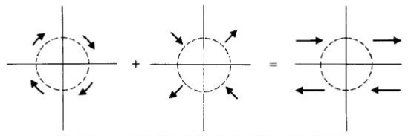
Exercise6.9.10Derivation of the Cauchy equation.ps-Cauchy-equation
- We consider a volume $V$ with surface $S$ consisting of a small cube of side length $δ$, as shown in Figure [fig-small-cube]. We apply the Reynolds Transport Theorem to the fluid in the cube:
ddtV(t)​f dx dy dz=V(t)​∂f∂t+∇⋅(fu) dx dy dz,
- where $f$ is any function, a vector or a scalar.
- Setting $f=ρu$ equal to the momentum per unit volume in the fluid, the integral equals the momentum of the fluid in the cube, and the time derivative is the rate of change of momentum, which is the total force acting on the fluid in the cube.
- The total force equals the sum of the surface forces and body forces. The body force equals the force of gravity: $ρVg$. The surface forces are an integral:
S​τ dS=S​σn dS;
- and we sum the contributions over the six faces in pairs:
  - Front and back faces: The contribution on the back face ($n=−i$) is
$$−δ^{2}{\left.\left(\begin{matrix}σ_{11} \\ σ_{12} \\ σ_{13}\end{matrix}\right)\right|}_{x=x_{0}}$$
  - and on the front face ($n=i$), it is
$$δ^{2}{\left.\left(\begin{matrix}σ_{11} \\ σ_{12} \\ σ_{13}\end{matrix}\right)\right|}_{x=x_{0}+δ}.$$
  - The sum of these is
$$δ^{2}{\left.\left(\begin{matrix}σ_{11} \\ σ_{12} \\ σ_{13}\end{matrix}\right)\right|}_{x=x_{0}+δ}−δ^{2}{\left.\left(\begin{matrix}σ_{11} \\ σ_{12} \\ σ_{13}\end{matrix}\right)\right|}_{x=x_{0}}=δ^{3}\frac{∂}{∂x}\left(\begin{matrix}σ_{11} \\ σ_{12} \\ σ_{13}\end{matrix}\right).$$
  - Left and right faces: In a similar way, the contribution is
$$δ^{3}\frac{∂}{∂y}\left(\begin{matrix}σ_{21} \\ σ_{22} \\ σ_{23}\end{matrix}\right).$$
  - Bottom and top faces: The contribution is
$$δ^{3}\frac{∂}{∂z}\left(\begin{matrix}σ_{31} \\ σ_{32} \\ σ_{33}\end{matrix}\right).$$
- Hence, the surface force is given by
$$δ^{3}\frac{∂}{∂x}\left(\begin{matrix}σ_{11} \\ σ_{12} \\ σ_{13}\end{matrix}\right)+δ^{3}\frac{∂}{∂y}\left(\begin{matrix}σ_{21} \\ σ_{22} \\ σ_{23}\end{matrix}\right)+δ^{3}\frac{∂}{∂z}\left(\begin{matrix}σ_{31} \\ σ_{32} \\ σ_{33}\end{matrix}\right)=δ^{3}∇⋅σ,$$
- Hence
ρVg+δ3∇⋅σ=V(t)​∂(ρu)∂t+∇⋅(ρuu) dx dy dz,
- Since the cube is small, the right-hand side is approximately the volume $V$ times the integrand evaluated at a point in $V$. Dividing by $V=δ^{3}$ gives
$$ρg+∇⋅σ=\frac{∂(ρu)}{∂t}+∇⋅((ρu)u).$$
- Since $ρ$ is constant,
$$ρg+∇⋅σ=ρ\frac{∂u}{∂t}+ρu⋅∇u+ρ(∇⋅u)u.$$
- Since the fluid is incompressible, we have $∇⋅u=0$, and, rearranging, we obtain the Cauchy equation:
$$ρ\left(\frac{∂u}{∂t}+u⋅∇u\right)=∇⋅σ+ρg$$
Exercise6.9.11Limits of low and high Reynolds number.ex-limits-low-high-Reynolds
- We have
$$ρ\frac{∂u}{∂t}+ρu⋅∇u=−∇p+μ∇^{2}u+ρg, ∇⋅u=0,$$
- which, after nondimensionalising, become
$$\frac{ρU}{T}\frac{∂u^{*}}{∂t^{*}}+\frac{ρU^{2}}{L}u^{*}⋅∇^{*}u^{*}=−\frac{P}{L}∇^{*}p^{*}+\frac{μU}{L^{2}}∇^{*2}u^{*}+ρg\hat{g}, \frac{U}{L}∇^{*}⋅u^{*}=0.$$
- We set the coefficients of the two inertial terms equal:
$$\frac{ρU}{T}=\frac{ρU^{2}}{L} ⇒ T=\frac{L}{U}.$$
- Multiplying the NavierStokes equation by $L^{2}/(μU)$, we get
$$Re\frac{Du^{*}}{Dt^{*}}=−\frac{LP}{μU}∇^{*}p^{*}+∇^{*2}u^{*}+\frac{ρL^{2}g}{μU}\hat{g}.$$
- The coefficient multiplying the inertial terms is the Reynolds number $Re$.
- In this case, the inertial terms are small compared to the viscous terms, so we can neglect them. The gravitational acceleration term has order of magnitude $ρL^{2}g/(μU)$. We need to consider the cases in which this is large, order one or small:
  - If $ρL^{2}g/(μU)≫1$, the pressre have a predominantly hydrostatic pressure profile, with the fluid dynamical problem being a small perturbation to the background static problem. Thus the pressure gradient balances this term:
$$\frac{LP}{μU}=\frac{ρL^{2}g}{μU} ⇒ P=ρLg,$$
  - and, to leading order, the NavierStokes equation becomes
$$0=−∇^{*}p^{*}+\hat{g}.$$
  - Once we have solved this problem, we could in principle solve a secondary problem to find the fluid flow. Thus the dimensional problem is
$$0=−∇p+ρg.$$
  - If $ρL^{2}g/(μU)$ is of order 1, the gravitational acceleration term balances the leading-order terms in the equation, and we set
$$\frac{LP}{μU}=1 ⇒ P=\frac{μU}{L}.$$
  - We obtain the leading-order system
$$0=−∇^{*}p^{*}+∇^{*2}u^{*}+\frac{ρL^{2}g}{μU}\hat{g},$$
  - and redimensionalising, we get
$$0=−∇p+μ∇^{2}u,$$
  - and the continuity equation is retained in full:
$$∇⋅u=0.$$
  - If $ρL^{2}g/(μU)≪1$, the gravitational acceleration term is small compared to the leading-order terms in the equation, and we set
$$\frac{LP}{μU}=1 ⇒ P=\frac{μU}{L}.$$
  - We obtain the leading-order system
$$0=−∇^{*}p^{*}+∇^{*2}u^{*},$$
  - and redimensionalising, we get
$$0=−∇p+μ∇^{2}u,$$
  - and the continuity equation is retained in full:
$$∇⋅u=0.$$
- In this case, the viscous terms are small compared to the inertial terms, so we can neglect them. Dividing the NavierStokes equation by $Re$,
$$\frac{Du^{*}}{Dt^{*}}=−\frac{P}{ρU^{2}}∇^{*}p^{*}+\frac{Lg}{U^{2}}\hat{g}.$$
- The gravitational acceleration term now has order of magnitude $Lg/U^{2}$. We need to consider the cases in which this is large, order one or small:
  - If $Lg/U^{2}≫1$, the pressre have a predominantly hydrostatic pressure profile, with the fluid dynamical problem being a small perturbation to the background static problem. Thus the pressure gradient balances this term:
$$\frac{P}{ρU^{2}}=\frac{Lg}{U^{2}} ⇒ P=ρLg,$$
  - and, to leading order, the NavierStokes equation becomes
$$0=−∇^{*}p^{*}+\hat{g}.$$
  - As in the low-Reynolds-number cases, once we have solved this problem, we could in principle solve a secondary problem to find the fluid flow. Thus the dimensional problem is
$$0=−∇p+ρg.$$
  - If $Lg/U^{2}$ is of order 1, the gravitational acceleration term balances the leading-order terms in the equation, and we set
$$\frac{P}{ρU^{2}}=1 ⇒ P=ρU^{2}.$$
  - We obtain the leading-order system
$$\frac{Du^{*}}{Dt^{*}}=−∇^{*}p^{*}+\frac{Lg}{U^{2}}\hat{g},$$
  - and redimensionalising, we get
$$ρ\frac{Du}{Dt}=−∇p+ρg,$$
  - and the continuity equation is retained in full:
$$∇⋅u=0.$$
  - If $Lg/U^{2}≪1$, the gravitational acceleration term is small compared to the leading-order terms in the equation, and we set
$$\frac{P}{ρU^{2}}=1 ⇒ P=ρU^{2}.$$
  - We obtain the leading-order system
$$\frac{Du^{*}}{Dt^{*}}=−∇^{*}p^{*},$$
  - and redimensionalising, we get
$$ρ\frac{Du}{Dt}=−∇p,$$
  - and the continuity equation is retained in full:
$$∇⋅u=0.$$
Exercise6.9.12HagenPoiseuille flow.ex-hagen-poiseuille-flow
- We have that the volumetric flux along the pipe equals ($A$ is a circular cross-section $z=constant$ of the pipe)
Q=&A​w dA=&02π0aG4μa2−r2r dr dθ=&2πG4μ0aa2r−r3 dr=&πG2μa2r22−r440a=&πG2μa42−a44=&πGa48μ,
- where $G=Δp/L$ is the pressure gradient. Rearranging,
$$Δp=\frac{8μLQ}{πa^{4}},$$
- as expected.
Exercise6.9.13Flow outside a cylinder.ws-viscousflows-15
- Axisymmetry implies $u_{θ}=0$ and two-dimensional flow implies $u_{z}=0$. With these assumptions, the continuity equation becomes
$$\frac{1}{r}\frac{∂}{∂r}\left(ru_{r}\right)=0.$$
- Multiplying by $r$ and integrating,
$$ru_{r}=A ⇒ u_{r}=\frac{A}{r},$$
- where $A$ is constant. The boundary condition on $r=a$ reads $u_{r}=−U$, and hence
$$−U=\frac{A}{a} ⇒ A=−aU.$$
- Substituting this in,
$$u_{r}=\frac{−aU}{r}.$$
- We substitute the assumptions into the NavierStokes equations, which state that all $t$, $θ$ and $z$ derivatives are zero and $u_{θ}=u_{z}=0$. The equations become:
$$\begin{aligned}ρu_{r}\frac{∂u_{r}}{∂r}=&−\frac{∂p}{∂r}+μ\left(∇^{2}u_{r}−\frac{u_{r}}{r^{2}}\right), \\ 0=&0, \\ 0=&0,\end{aligned}$$
- and
$$∇^{2}u_{r}=\frac{1}{r}\frac{∂}{∂r}\left(r\frac{∂u_{r}}{∂r}\right)=\frac{∂^{2}u_{r}}{∂r^{2}}+\frac{1}{r}\frac{∂u_{r}}{∂r}.$$
- Hence, the only non-trivial equation is the $r$-component, which reduces to
$$ρu_{r}\frac{∂u_{r}}{∂r}=−\frac{∂p}{∂r}+μ\left(\frac{∂^{2}u_{r}}{∂r^{2}}+\frac{1}{r}\frac{∂u_{r}}{∂r}−\frac{u_{r}}{r^{2}}\right).$$
- Substituting the expression for $u_{r}$,
$$ρ\left(−\frac{aU}{r}\right)\left(\frac{aU}{r^{2}}\right)=−\frac{∂p}{∂r}+μ\left(−\frac{2aU}{r^{3}}+\frac{aU}{r^{3}}+\frac{aU}{r^{3}}\right),$$
- which simplifies to
$$\frac{∂p}{∂r}=\frac{ρa^{2}U^{2}}{r^{3}},$$
- as required.
- We solve the equation, applying the boundary condition as $r→∞$ to find that
$$\frac{∂p}{∂r}=p_{0}−\frac{ρa^{2}U^{2}}{2r^{2}}.$$
Exercise6.9.14Oscillating flow in a pipe.ws-viscousflows-16
- We assume that the flow is axisymmetric and fully developed. The continuity equation reduces to
$$\frac{1}{r}\frac{∂}{∂r}\left(ru_{r}\right)=0,$$
- which implies that
$$u_{r}=\frac{A}{r}$$
- where $A$ is independent of $r$. Regularity at $r=0$ implies that $A=0$, and therefore $u_{r}=0$ everywhere.
- With the assumptions, the NavierStokes equations reduce to
$$\begin{aligned}0=&−\frac{∂p}{∂r}, \\ 0=&0, \\ ρiωUe^{iωt}+c.c.=G_{0}cosωt+\frac{μ}{r}\frac{d}{dr}\left(rU^{′}\right)e^{iωt}+c.c..\end{aligned}$$
- There is thus one non-trivial component, and, taking the part proportional to $e^{iωt}$, we have
$$ρiωU=\frac{1}{2}G_{0}+\frac{μ}{r}\frac{d}{dr}\left(rU^{′}\right),$$
- which, dividing by $μ$, is equivalent to
$$\frac{iρω}{μ}U=\frac{G_{0}}{2μ}+U^{″}+\frac{1}{r}U^{′}.$$
- Rearranging gives the result.
- With this substitution, we have
$$\frac{d}{dr}=e^{−iπ/4}α\frac{d}{ds},$$
- and hence
$$−iα^{2}\frac{d^{2}U}{ds^{2}}−iα^{2}\frac{1}{s}\frac{dU}{ds}−iα^{2}U=−\frac{G_{0}}{2μ},$$
- giving
$$\frac{d^{2}U}{ds^{2}}+\frac{1}{s}\frac{dU}{ds}+U=−\frac{iG_{0}}{2ρω}.$$
- For simplicity, seek a constant solution, and we find
$$U_{PI}=−\frac{iG_{0}}{2ρω}.$$
Exercise6.9.15Solving the NavierStokes equations in spherical polar coordinates.ws-viscousflows-17
- We assume the flow and pressure fields are steady and spherically symmetric. Thus we neglect all $t$, $θ$ and $ϕ$ derivatives, and set $u_{θ}=u_{ϕ}=0$. The continuity equation reduces to
$$\frac{1}{r^{2}}\frac{∂(r^{2}u_{r})}{∂r}=0,$$
- which implies that
$$u_{r}=\frac{A}{r^{2}}$$
- where $A$ is independent of $r$. The NavierStokes equations reduce to
$$\begin{aligned}ρu_{r}\frac{∂u_{r}}{∂r}=&−\frac{∂p}{∂r}+μ\left(\frac{1}{r^{2}}\frac{∂}{∂r}\left(r^{2}\frac{∂u_{r}}{∂r}\right)−\frac{2u_{r}}{r^{2}}\right), \\ 0=&0, \\ 0=&0,\end{aligned}$$
- Substituting the expression for $u_{r}$ into the $r$-component gives
$$−\frac{ρA^{2}}{r^{5}}=−\frac{∂p}{∂r}+μ\left(−\frac{2A}{r^{4}}+\frac{2A}{r^{4}}\right),$$
- which simplifies to
$$\frac{∂p}{∂r}=\frac{ρA^{2}}{r^{5}}.$$
- Integrating and applying the boundary condition as $r→∞$ gives
$$p=p_{0}−\frac{ρA^{2}}{4r^{4}}.$$
- Applying the boundary condition at $r=a$ gives
$$p_{1}=p_{0}−\frac{ρA^{2}}{4a^{4}} ⇒ A=a^{2}\sqrt{\frac{4(p_{0}−p_{1})}{ρ}},$$
- and hence the velocity and pressure fields are
$$\begin{aligned}u_{r}=&\frac{a^{2}}{r^{2}}\sqrt{\frac{4(p_{0}−p_{1})}{ρ}}, \\ p=&p_{0}−\frac{ρa^{4}(p_{0}−p_{1})}{r^{4}}.\end{aligned}$$
6.10Problems set 7 to hand in
Exercise6.10.1Analysis of flow in a pipe.ch-viscousflows-12-3
- The no-slip boundary conditions give
$${\left.u\right|}_{r=a}=0.$$
- Assuming axisymmetric flow implies there is no dependence on $θ$ and that the $θ$-component of the velocity is zero $u_{θ}=0$. Since the pipe is infinitely long in the $z$-direction, and the pressure gradient is constant, there is no preferred location in this directions, and hence the velocity profile is independent of $z$.
- We have no $θ$- or $z$-dependence, meaning that the continuity equation reduces to
$$\frac{1}{r}\frac{∂}{∂r}(ru_{r})=0,$$
- and hence $u_{r}=A/r$, where $A$ is constant. Since the cylinder is a solid boundary, we need $u_{r}=0$ at $r=a$. Therefore, $A=0$, and so $u_{r}=0$ everywhere.
- At $r=a$, we have
$$u_{z}=\frac{P}{4μ}\left(a^{2}−a^{2}\right)=0,$$
- which satisfies the no-slip boundary condition.
- A larger pressure gradient $P$ means a larger driving force for the flow, and hence a larger velocity. A larger viscosity $μ$ means a larger resistance to the flow, and hence a smaller velocity. Therefore, it is to be expected that the velocity profile increases as $P$ increases and decreases as $μ$ increases.
- The pressure at a general point is given by
$$p=p_{0}+Pz.$$
- The stress vector is given by $τ=σn$, with $n=−\hat{r}$ and $σ=−pI+2μe$. Simplifying ([eq-strainrate-cyl]), we have
$$e=\left(\begin{matrix}0 & 0 & \frac{1}{2}\frac{∂u_{z}}{∂r} \\ 0 & 0 & 0 \\ \frac{1}{2}\frac{∂u_{z}}{∂r} & 0 & 0\end{matrix}\right)=\left(\begin{matrix}0 & 0 & −\frac{Pr}{4μ} \\ 0 & 0 & 0 \\ −\frac{Pr}{4μ} & 0 & 0\end{matrix}\right).$$
- Hence,
$$σ=\left(\begin{matrix}−p_{0}−Pz & 0 & −Pr/2 \\ 0 & −p_{0}−Pz & 0 \\ −Pr/2 & 0 & −p_{0}−Pz\end{matrix}\right).$$
- At $r=a$, we have
$$\begin{aligned}τ=&σn \\ =&\left(−pI+2μe\right)(−\hat{r}) \\ =&\left(pI−2μe\right)\hat{r} \\ =&p\hat{r}−μ\frac{∂u_{z}}{∂r}\hat{z}.\end{aligned}$$
- Hence the normal component of the stress vector is
$$τ_{r}=p=p_{0}+Pz,$$
- and the axial component of the shear stress vector is
$$\begin{matrix}τ_{z}=−μ\frac{∂u_{z}}{∂r} \\ =−μ\frac{∂}{∂r}\left[\frac{P}{4μ}(a^{2}−r^{2})\right] \\ =−μ\left(−\frac{P}{2μ}r\right) \\ =\frac{Pa}{2}\end{matrix}$$
- The $θ$-component of the stress vector is zero:
$$τ_{θ}=0.$$
- The normal stress is due to the pressure in the fluid, which acts equally in all directions, and hence the normal stress on the inside of the pipe wall points radially outward into the wall. The shear stress points along the pipe in the direction of increasing $z$ since this is the direction of the flow, and hence the fluid exerts a tangential force on the pipe wall in this direction.
Exercise6.10.2Rotating flow.ex-rotating-flow
- We have
$$u=Ω×x=∣\begin{matrix}i & j & k \\ 0 & 0 & Ω \\ x & y & z\end{matrix}∣=−Ωyi+Ωxj+0k.$$
- Hence the velocity components are
$$u=−Ωy, v=Ωx, w=0.$$
- We have
$$∇⋅u=\frac{∂u}{∂x}+\frac{∂v}{∂y}+\frac{∂w}{∂z}=0+0+0=0,$$
- and hence the flow is incompressible.
- We have
$$\begin{aligned}σ_{11}=&−p+2μ\frac{∂u}{∂x}=−p+0=−p, \\ σ_{12}=&μ\left(\frac{∂u}{∂y}+\frac{∂v}{∂x}\right)=μ(−Ω+Ω)=0, \\ σ_{13}=&μ\left(\frac{∂u}{∂z}+\frac{∂w}{∂x}\right)=μ(0+0)=0, \\ σ_{21}=&μ\left(\frac{∂v}{∂x}+\frac{∂u}{∂y}\right)=μ(Ω−Ω)=0, \\ σ_{22}=&−p+2μ\frac{∂v}{∂y}=−p+0=−p, \\ σ_{23}=&μ\left(\frac{∂v}{∂z}+\frac{∂w}{∂y}\right)=μ(0+0)=0, \\ σ_{31}=&μ\left(\frac{∂w}{∂x}+\frac{∂u}{∂z}\right)=μ(0+0)=0, \\ σ_{32}=&μ\left(\frac{∂w}{∂y}+\frac{∂v}{∂z}\right)=μ(0+0)=0, \\ σ_{33}=&−p+2μ\frac{∂w}{∂z}=−p+0=−p.\end{aligned}$$
- Hence the deviatoric stress tensor is
$$σ=\left(\begin{matrix}−p & 0 & 0 \\ 0 & −p & 0 \\ 0 & 0 & −p\end{matrix}\right),=−pI,$$
- where $I$ is the identity tensor.
- The result shows that the deviatoric stress tensor is zero, meaning there are no viscous stresses in this flow. The only stress is due to the pressure in the fluid. This is as expected since the flow represents a solid body rotation with angular velocity $Ω$. In a solid body rotation, there is no relative motion between adjacent fluid particles, and hence no viscous stresses.
Exercise6.10.3Flow outside a rotating cylinder.ch-viscousflows-12-5
- The flow and pressure are steady since the cylinder rotates at constant angular velocity. The flow and pressure have rotational symmetry and therefore no dependence on $θ$. The flow and pressure are independent of $z$ since the cylinder is infinite in this direction and there is no pressure gradient in this direction. The $z$-component of velocity is zero since there is no motion of the cylinder or pressure gradient in this direction.
- Since there is no $θ$- or $z$-dependence, the continuity equation reduces to
$$\frac{1}{r}\frac{∂}{∂r}(ru_{r})=0,$$
- and hence $u_{r}=A/r$, where $A$ is constant. Since the cylinder is a solid boundary, we need $u_{r}=0$ at $r=a$. Therefore, $A=0$, and so $u_{r}=0$ everywhere.
- Since $u_{r}=u_{z}=0$ and there is no $θ$- or $z$-dependence, the NavierStokes equations reduce to
$$\begin{aligned}&−ρ\frac{u_{θ}^{2}}{r}=−\frac{∂p}{∂r}, \\ &0=μ\left(\frac{1}{r}\frac{∂}{∂r}\left(r\frac{∂u_{θ}}{∂r}\right)−\frac{u_{θ}}{r^{2}}\right), \\ &0=−\frac{∂p}{∂z}.\end{aligned}$$
- The $z$-component shows that $p=p(r)$. Now consider the $θ$-component. Substituting $u_{θ}=a^{2}Ω/r$:
$$\begin{aligned}\frac{1}{r}\frac{∂}{∂r}\left(r\frac{∂u_{θ}}{∂r}\right)−\frac{u_{θ}}{r^{2}} \\ =&\frac{1}{r}\frac{∂}{∂r}\left(r\frac{∂}{∂r}\left(\frac{a^{2}Ω}{r}\right)\right)−\frac{a^{2}Ω}{r^{3}} \\ =&−a^{2}Ω\frac{1}{r}\frac{∂}{∂r}\left(\frac{1}{r}\right)−\frac{a^{2}Ω}{r^{3}} \\ =&a^{2}Ω\frac{1}{r}\left(\frac{1}{r^{2}}\right)−\frac{a^{2}Ω}{r^{3}} \\ =&0.\end{aligned}$$
- Hence this flow satisfies the $θ$-component of the NavierStokes equation.
- The $r$-component of the NavierStokes equation is
$$\begin{aligned}\frac{∂p}{∂r}=&ρ\frac{u_{θ}^{2}}{r} \\ =&ρ\frac{(a^{2}Ω/r)^{2}}{r} \\ =&ρ\frac{a^{4}Ω^{2}}{r^{3}}.\end{aligned}$$
- Hence
$$p(r)=p_{0}+\frac{ρa^{4}Ω^{2}}{2}\left(\frac{1}{a^{2}}−\frac{1}{r^{2}}\right),$$
- for some constant $p_{0}$, and therefore (since we have been able to find a suitable pressure), this component of the NavierStokes equation is also satisfied.
- Hence the flow $u=(0,a^{2}Ω/r,0)$ satisfies the NavierStokes equations. Finally, we check the boundary condition at $r=a$:
$${\left.u\right|}_{r=a}=\left(0,\frac{a^{2}Ω}{a},0\right)=(0,aΩ,0),$$
- which matches the velocity of the cylinder surface.
- Initially, there will be a thin boundary layer of fluid close to the cylinder surface that starts to rotate with the cylinder due to the no-slip boundary condition. As time progresses, viscous diffusion will cause the rotation to spread outwards from the cylinder surface into the fluid. Eventually, the flow will reach a steady state, which is the flow found in the previous part.
6.11Problems set 8 to hand in
Exercise6.11.1problems-set-8-3

$$Re=\frac{ρUa}{μ},$$
- where $U$ is the characteristic velocity, $a$ is the characteristic length scale (the radius of the sphere), $ρ$ is the density of the fluid, and $μ$ is the shear viscosity of the fluid.

  - In case (a), the flow is smooth and steady around the sphere, and the flow is also reversible (leftright symmetry), indicating a low Reynolds number.
  - In case (b), there is some disturbance in the flow behind the sphere, suggesting a moderate Reynolds number, of order 100.
  - In case (c), there is a turbulent wake behind the sphere, indicating a high Reynolds number, $Re≫{10}^{3}$.
Exercise6.11.2Channel flow.problems-set-8-4
- We have $u=v=w=0$ at $y=±d$.
- Fully-developed flow implies the velocity components do not depend on $x$. Thus, the continuity equation reduces to
$$\frac{∂v}{∂y}=0,$$
- implying that $v$ is independent of $y$. The no-slip boundary conditions at each plate implies $v=0$ there. Hence, $v=0$ everywhere.
- The three components of the NavierStokes equations simplify to
$$\begin{aligned}&0=−\frac{∂p}{∂x}+μ\frac{∂^{2}u}{∂y^{2}}, \\ &0=−\frac{∂p}{∂y}, \\ &0=0.\end{aligned}$$
- The $y$-component shows the pressure only depends on $x$, and for the two terms in the $x$-component:
$$\begin{aligned}&−\frac{∂p}{∂x} \text{depends on only}, \\ &μ\frac{∂^{2}u}{∂y^{2}} \text{depends on only}.\end{aligned}$$
- Hence both these terms are constant. Setting
$$G=−\frac{∂p}{∂x},$$
- where $G$ is constant, we have
$$μ\frac{∂^{2}u}{∂y^{2}}=−G.$$
- We have
$$u=−\frac{G}{2μ}y^{2}+C_{1}y+C_{2},$$
- where $C_{1}$ and $C_{2}$ are constants, and, applying the boundary condition at $y=d$,
$$0=−\frac{G}{2μ}d^{2}+C_{1}d+C_{2},$$
- and at $y=−d$,
$$0=−\frac{G}{2μ}d^{2}−C_{1}d+C_{2}.$$
- Subtracting these equations, we see that $C_{1}=0$ and then we find $C_{2}=Gd^{2}/(2μ)$. Hence
$$u=−\frac{G}{2μ}y^{2}+\frac{Gd^{2}}{2μ}=\frac{G}{2μ}\left(d^{2}−y^{2}\right),$$
- and $v=w=0$.
- For the plate at $y=k$, the $x$-component of the stress is
$$τ=−μ\frac{∂u}{∂y}$$
- (the minus sign occurs since the vector into the fluid points in the $−y$-direction) and the $z$-component of the stress is zero since the flow is two-dimensional. The $x$-component equals
$$τ=−μ\left(−\frac{Gd}{μ}\right)=Gd.$$
- For the plate at $y=−k$, the $x$-component of the stress is
$$τ=μ\frac{∂u}{∂y}$$
- (the plus sign occurs since the vector into the fluid points in the $+y$-direction) and the $z$-component of the stress is zero since the flow is two-dimensional. The $x$-component equals
$$τ=μ\left(−\frac{G(−d)}{μ}\right)=Gd.$$
- Thus the stress at both plates is $Gd$ in the $+x$-direction, and the force on the whole plate is $GdA$ in the $+x$-direction. Hence the tethering force to keep each plate fixed is $GdA$ in the $−x$-direction.
- Note that it is very easy to make a sign error on this type of question. I would therefore recommend always reflecting on your answer to see if the direction you get is what you’d expect from the physics. A viscous fluid tries to drag the surface along with the flow, and so the force due to the shear stress is sometimes called the drag force. Thus, the tethering force must oppose this drag force, which is what we found.
Exercise6.11.3Wavy-walled pipe.problems-set-8-5

- FigureWavy-walled pipe planes to apply mass conservation.problems-set-8-5-3-2-1
- 0.20.60.2 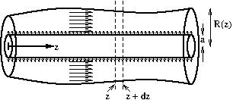
- The volumetric flux into the left-hand surface of this region equals area times velocity:
$$π(R^{2}−a^{2})u$$
- and that out of the right-hand surface equals
$$π\left((R+dR)^{2}−a^{2}\right)(u+du)=π\left({\left(R+R^{′}dz\right)}^{2}−a^{2}\right)\left(u+u^{′}dz\right),$$
- where we used the chain rule to rewrite the increments in terms of $dz$. Note that throughout this equation, we neglect $dz^{2}$ and higher powers, as they are small.
- The area of the inner cylinder in this region is $2πadz$, and thus we have a volumetric flux $2πaUdz$ entering this region from the inner cylinder.
- Since the volume of the pipe between $z$ and $z+dz$ is fixed, the total volumetric flux into this region equals the total volumetric flux out.
- Thus
$$\begin{aligned}&π(R^{2}−a^{2})u+2πaUdz=π\left({\left(R+R^{′}dz\right)}^{2}−a^{2}\right)\left(u+u^{′}dz\right), \\ ⇒ &2πaUdz=π\left((R^{2}−a^{2})u^{′}+2RR^{′}u\right)dz, \\ ⇒ &2aU=(R^{2}−a^{2})u^{′}+2RR^{′}u, \\ ⇒ &u^{′}=\frac{2(aU−RR^{′}u)}{R^{2}−a^{2}},\end{aligned}$$
- thus proving the result.
- A suitable lengthscale is $R_{0}$. Simplifying the differential equation for $u$, by neglecting variations in pipe radius $R^{′}$ and the radius of the inner cylinder $a$, gives
$$\frac{du}{dz}≈\frac{2aU}{R_{0}^{2}},$$
- suggesting a suitable velocity scale is this times $L$ (the velocity that would be attained at the end of the pipe):
$$\frac{2aLU}{R_{0}^{2}}.$$
- Hence the Reynolds number is
$$Re=\frac{ρR_{0}}{μ}\frac{2aLU}{R_{0}^{2}}=\frac{2aLUρ}{μR_{0}}.$$
- Many students did not find an expression for the velocity scale, and just left it as $u(z)$ or similar. This would mean that we do not have an expression for the Reynolds number in terms of the problem parameters. Also, many students did not approximate $R−a$ as $R_{0}$, which simplifies the expression (some did get $R_{0}−a$, but you can go further than this).
- I have added a final sentence to the question to clarify that the answer should be in terms of the problem parameters as very few students attempted to find an order of magnitude for $u(z)$.
- The Reynolds number would need to be large (but not so large that the flow becomes turbulent).
- In the limit of large Reynolds number, we would recover the Euler equation from the NavierStokes equation (see Exercise .11). In this limit we only need a no-penetration condition ($u⋅\hat{n}=0$) and not the full no-slip conditions ($u=0$), and so in this case uniform flow is possible.
- The flow would need to satisfy the no-slip boundary condition at the outer cylinder and the velocity there would therefore tend to zero.
AppendixVector calculusVector calculusbackmatter-3 We write scalar functions as, e.g. $ϕ($
SectionConverting between different coordinate systemsConverting between different coordinate systemssec-converting-between-coordinates
It is often convenient to convert a problem from one coordinate system to another, and, although converting scalar quantities is reasonably straightforward, converting vector quantities (such as the fluid velocity vector) is more complicated. This section briefly goes through how to convert vectors and scalars between different reference frames, as this seems to cause issues for students.
SubsectionConverting between Cartesian coordinates and cylindrical polar coordinatesConverting between Cartesian coordinates and cylindrical polar coordinatessubsec-Cartesian-to-cylindrical-polar
2000
0.5
FigureCylindrical polar coordinates.cylindrical-coords
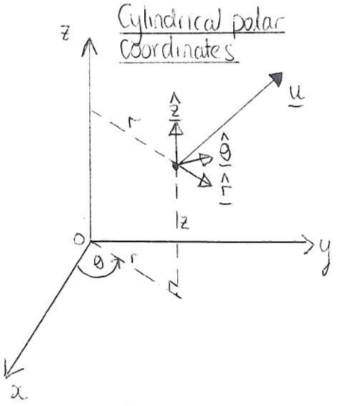
0.5
FigurePlanar view of cylindrical polar coordinates (or plane polar coordinates).cylindrical-coords-planeview
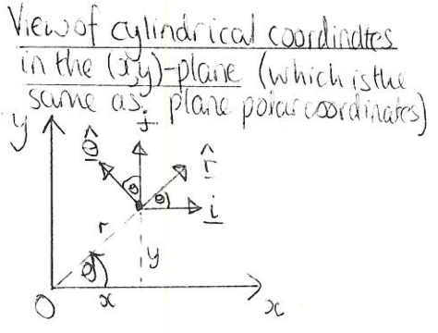
We write a position vector in Cartesians as
$$r=xi+yj+zk,$$
and as
$$r=r\hat{r}+z\hat{z},$$
in cylindrical polars. You need to know the following formulae for conversion from polar to Cartesian coordinates:
$$x=rcosθ, y=rsinθ, z=z,$$
and these formulae for conversion back:
$$r=\sqrt{x^{2}+y^{2}}, θ=arctan\left(\frac{y}{x}\right), z=z.$$
Note that ([eq-cartpol]) can be derived by rearranging ([eq-polcart]), and vice versa. You also need to know the following definitions of the unit vectors:
$$\begin{matrix}\hat{r}=\left(\begin{matrix}cosθ \\ sinθ \\ 0\end{matrix}\right)=cosθi+sinθj, \\ \hat{θ}=\left(\begin{matrix}−sinθ \\ cosθ \\ 0\end{matrix}\right)=−sinθi+cosθj, \\ \hat{z}=\hat{k},\end{matrix}$$
and it might help to know that $\hat{θ}=d\hat{r}/dθ$, which can be used to remember $θ$ if you struggle. In addition, you need to know
$$i=cosθ\hat{r}−sinθ\hat{θ}, j=sinθ\hat{r}+cosθ\hat{θ}, k=\hat{z},$$
which can if necessary be derived by rearranging the formulae ([eq-polarcartunitvectors-r]), ([eq-polarcartunitvectors-theta]) and ([eq-polarcartunitvectors-z]). As you might expect, these equations are all consistent with one another, so if you substitute ([eq-cartpolarunitvectors]) into ([eq-rcart]) and use ([eq-polcart]) to rewrite $x$ and $y$ in terms of $r$ and $θ$, you will end up with ([eq-rpol]).
Scalar and vector quantities are converted as follows:
- Conversion of scalar quantities: To convert a scalar quantity (e.g. lengths, pressures) from Cartesians to polars you substitute ([eq-polcart]) and to go from polars to Cartesians use ([eq-cartpol]). For example if
$$p=x+3y^{2}$$
- in Cartesians then, using ([eq-polcart]),
$$p=rcosθ+3r^{2}\sin^{2}θ$$
- in polars.
- Conversion of vector quantities: To convert a vector from cylindrical polar to Cartesian coordinates you will have a vector written something like this:
$$u=u_{r}(r,θ,z,t)\hat{r}+u_{θ}(r,θ,z,t)\hat{θ}+u_{z}(r,θ,z,t)\hat{z},$$
- where $u_{r}$, $u_{θ}$ and $u_{z}$ are all given scalar expressions. You need to end up with something of this form:
$$u=u_{x}(x,y,z,t)i+u_{y}(x,y,z,t)j+u_{z}(x,y,z,t)k.$$
- Two methods:
  - Substitute the expressions ([eq-polarcartunitvectors-r]), ([eq-polarcartunitvectors-theta]) and ([eq-polarcartunitvectors-z]) into ([eq-upolar]), and then use ([eq-cartpol]) to get everything in terms of the Cartesian coordinates $x$ and $y$. To convert the other way, substitute ([eq-cartpolarunitvectors]) into ([eq-ucart]) and then use ([eq-polcart]) to replace any instances of $x$ or $y$ by $r$ and $θ$.
  - Alternatively, take the dot product of ([eq-ucart]) with $\hat{r}$, $\hat{θ}$ and $\hat{z}$, respectively, and simplify the resulting expressions using ([eq-polarcartunitvectors-r]), ([eq-polarcartunitvectors-theta]) and ([eq-polarcartunitvectors-z]), which gives
$$\begin{matrix}u_{r}=ucosθ+vsinθ, \\ u_{θ}=−usinθ+vcosθ, \\ u_{z}=w.\end{matrix}$$
  - Similarly, taking the dot product of ([eq-upolar]) with $i$, $j$ and $k$, respectively, and simplifying leads to
$$\begin{matrix}u=u_{r}cosθ−u_{θ}sinθ, \\ v=u_{r}sinθ+u_{θ}cosθ, \\ w=u_{z}.\end{matrix}$$
What you need to know: You need to remember the formulae ([eq-polcart]) and ([eq-cartpol]), but you would be given ([eq-polarcartunitvectors-r]), ([eq-polarcartunitvectors-theta]) and ([eq-polarcartunitvectors-z]) or ([eq-cartpolarunitvectors]) in an exam question, but you need to be able to use them to do the conversion yourself.
SubsectionConverting between Cartesian coordinates and plane polar coordinatesConverting between Cartesian coordinates and plane polar coordinatessubsec-Cartesian-plane-polar Two-dimensional plane polars $(r,θ)$ work like the first two coordinates of cylindrical polars. Thus converting between plane polars and Cartesian coordinates works the same as for cylindrical coordinates and Cartesians Subsection [subsec-Cartesian-to-cylindrical-polar], except there is no third dimension.
SubsectionConverting between Cartesian coordinates and spherical polar coordinatesConverting between Cartesian coordinates and spherical polar coordinatessubsec-Cartesian-spherical-polar
FigureSpherical polar coordinates.spherical-coords
0.250.50.25 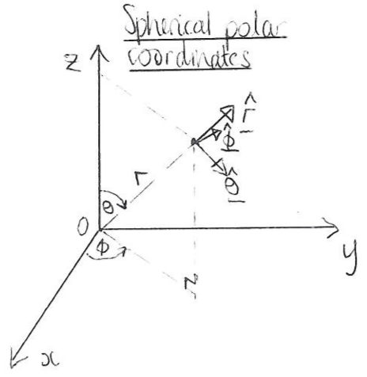
We write a position vector in Cartesians as ([eq-rcart])
$$r=xi+yj+zk,$$
$$r=r\hat{r}.$$
You need the following formulae for conversion from spherical polar to Cartesian:
$$x=rsinθcosϕ, y=rsinθsinϕ, z=rcosθ,$$
and these formulae for conversion back:
$$\begin{matrix}r=\sqrt{x^{2}+y^{2}+z^{2}}, \\ θ=arctan\left(\frac{\sqrt{x^{2}+y^{2}}}{z}\right), \\ ϕ=arctan\left(\frac{y}{x}\right).\end{matrix}$$
The unit vectors in spherical polars are given by
$$\begin{align}
\hat{\boldsymbol{r}}=&\left(\begin{matrix}\sin\theta\cos\phi\\\sin\theta\sin\phi\\\cos\theta\end{matrix}\right)
=\sin\theta\cos\phi\,\boldsymbol{i}+\sin\theta\sin\phi\,\boldsymbol{j}+\cos\theta\,\boldsymbol{k},\label{eq-sphpolarcartunitvectors-r}\\
\hat{\boldsymbol{\theta}}=&\frac{\partial\hat{\boldsymbol{r}}}{\partial\theta}
=\left(\begin{matrix}\cos\theta\cos\phi\\\cos\theta\sin\phi\\-\sin\theta\end{matrix}\right)
=\cos\theta\cos\phi\,\boldsymbol{i}+\cos\theta\sin\phi\,\boldsymbol{j}-\sin\theta\,\boldsymbol{k},\label{eq-sphpolarcartunitvectors-theta}\\
\hat{\boldsymbol{\phi}}=&\left.\frac{\partial\hat{\boldsymbol{f}r}}{\partial\phi}\right/\left|\frac{\partial\hat{\boldsymbol{f}r}}{\partial\phi}\right|=\left(\begin{array}{c}-\sin\phi\\\cos\phi\\0\end{array}\right)=-\sin\phi\,{\boldsymbol{f}i}+\cos\phi\,{\boldsymbol{f}j},\label{eq-sphpolarcartunitvectors-z}
\end{align}$$
and rearranging these leads to
$$\begin{aligned}i=&sinθcosϕ \hat{r}+cosθcosϕ \hat{θ}−sinϕ \hat{ϕ}, \\ j=&sinθsinϕ \hat{r}+cosθsinϕ \hat{θ}+cosϕ \hat{ϕ}, \\ k=&cosθ \hat{r}−sinθ \hat{θ}.\end{aligned}$$
- Conversion of scalar quantities: As with Cartesians to cylindrical polars, to convert a scalar quantity from Cartesians to spherical polars you substitute ([eq-sphcart]) into the expression and to convert the other way use ([eq-cartsph-r]), ([eq-cartsph-theta]) and ([eq-cartsph-z]).
- Conversion of vector quantities: To convert a vector from spherical polar to Cartesian coordinates you will start with a vector written something like this:
$$u=u_{r}(r,θ,ϕ,t)\hat{r}+u_{θ}(r,θ,ϕ,t)\hat{θ}+u_{ϕ}(r,θ,ϕ,t)\hat{ϕ},$$
- and you want to write it like this:
$$u=u_{x}(x,y,z,t)i+u_{y}(x,y,z,t)j+u_{z}(x,y,z,t)k.$$
- As with Cartesians to cylindrical polars, there are two methods:
  - Substitute the expressions ([eq-sphpolarcartunitvectors-r]), ([eq-sphpolarcartunitvectors-theta]) and ([eq-sphpolarcartunitvectors-z]) into ([eq-usph]) and use ([eq-cartsph-r]), ([eq-cartsph-theta]) and ([eq-cartsph-z]) to get everything in terms of the Cartesian coordinates $(x,y,z)$. To convert from Cartesians to sphericals, substitute ([eq-cartsphpolarunitvectors-i]), ([eq-cartsphpolarunitvectors-j]) and ([eq-cartsphpolarunitvectors-k]) into ([eq-ucart2]) and use ([eq-sphcart]) to replace any instances of $(x,y,z)$ with $(r,θ,ϕ)$.
  - Alternatively, take the dot product of ([eq-usph]) with $\hat{i}$, $\hat{j}$ and $\hat{k}$ in turn, and use ([eq-sphpolarcartunitvectors-r]), ([eq-sphpolarcartunitvectors-theta]) and ([eq-sphpolarcartunitvectors-z]) or ([eq-cartsphpolarunitvectors-i]), ([eq-cartsphpolarunitvectors-j]) and ([eq-cartsphpolarunitvectors-k]) to simplify the dot products of the unit vectors. You will end up with the following conversion formulae:
$$\begin{aligned}u_{r}=&usinθcosϕ+vsinθsinϕ+wcosθ, \\ u_{θ}=&ucosθcosϕ+vcosθsinϕ−wsinθ, \\ u_{ϕ}=&−usinϕ+vcosϕ.\end{aligned}$$
  - To convert back, take the dot product of ([eq-ucart2]) with $\hat{r}$, $\hat{θ}$ and $\hat{z}$ in turn, and use ([eq-sphpolarcartunitvectors-r]), ([eq-sphpolarcartunitvectors-theta]) and ([eq-sphpolarcartunitvectors-z]) to simplify to give
$$\begin{aligned}u=&u_{r}sinθcosϕ+u_{θ}cosθcosϕ−u_{ϕ}sinϕ, \\ v=&u_{r}sinθsinϕ+u_{θ}cosθsinϕ+u_{ϕ}cosϕ, \\ w=&u_{r}cosθ−u_{θ}sinθ.\end{aligned}$$
What you need to know: You might have to do some limited converting of expressions between spherical and Cartesian coordinate systems, but we would give you all the formulae ([eq-cartsph-r]), ([eq-cartsph-theta]) and ([eq-cartsph-z]), and ([eq-sphcart]), and the equations for conversion of the unit vectors, as they are difficult to remember.
$$\hat{r}=sinθcosϕi+sinθsinϕj+cosθk.$$
SubsectionGeneral conversionGeneral conversionsubsec-general-conversion In the other cases you need to follow the same general principles as we followed in the previous sections. In the most general case you might have two coordinate systems $S$ and $S^{′}$ with coordinates $(r_{1},r_{2},r_{3})$ and $(r_{1}^{′},r_{2}^{′},r_{3}^{′})$, respectively, and unit vectors $e_{1}$, $e_{2}$, $e_{3}$ and $e_{1}^{′}$, $e_{2}^{′}$, $e_{3}^{′}$, respectively. To convert between the systems, you need to write down three (if in 3D) relationships between $r_{1}$, $r_{2}$, $r_{3}$ and $r_{1}^{′}$, $r_{2}^{′}$, $r_{3}^{′}$, which allows the conversion of scalar quantities. To convert vectors you also need formulae for $e_{1}$, $e_{2}$, $e_{3}$ in terms of and $e_{1}^{′}$, $e_{2}^{′}$, $e_{3}^{′}$. You can convert vectors by substituting the relationships between the unit vectors in and then substituting the relationships between the coordinates. You can only use the alternative methods of converting vectors by taking the dot product if both coordinate systems are orthogonal.
Exercise .4 gives an example of a question involving changing coordinates in a more general case.
SubsectionDifferential operatorsDifferential operatorssubsec-differential-operators The gradient and curl operators are converted as
$$\begin{aligned}∇ϕ&=\frac{∂ϕ}{∂r}e_{r}+\frac{1}{r}\frac{∂ϕ}{∂θ}e_{θ} \\ ∇×u&=\left(\frac{1}{r}\frac{∂(ru_{θ})}{∂r}−\frac{1}{r}\frac{∂u_{r}}{∂θ}\right)k\end{aligned}$$
You would always be given these formulae in an exam question if you needed them.
AppendixList of SymbolsList of Symbolsbackmatter-4
Symbol | Description | Page
Symbol | Description | Page
(Continued on next page)
ReferencesReferences and further readingReferences and further readingrefs-references
Homsy, G. M. (Ed.) (2019). Multimedia Fluid Mechanics Online. Cambridge University Press.
Kreyszig, E. (2007). Advanced engineering mathematics 9th edition. Wiley. US: John Wiley and Sons.
Van Dyke, M. (1982). An Album of Fluid Motion. Parabolic Press.
Acheson, D. J. (1990). Elementary fluid dynamics. Oxford University Press.
Needham, T. (2023). Visual complex analysis. Oxford University Press.
Fornberg, B. and Piret, C. (2019). Complex Variables and Analytic Functions. Society for Industrial and Applied Mathematics.
Shapiro, A. (Ed.) (1961). National Committee for Fluid Mechanics Films. Available at https://web.mit.edu/hml/ncfmf.html.
White, F. M. and Xue H. (2021). Fluid mechanics (ninth edition). McGraw--Hill, New York. Note that this book is available online in the University of Bath’s collection, so you should easily be able to view it.
White, F. M. (2003). Fluid mechanics (fifth edition). McGraw--Hill, New York.
Paterson, A. R. (1983). A first course in fluid dynamics. Cambridge University Press.

